Licking Summer Camp
Est. 1993
Girls Basketball Lake of the Ozark, MO
June 24-25, 2019

Bracket Results
Westminister 52 Jefferson City Red 47
Mendon-Unity, IL 46 Paris 41
Mendon-Unity, IL JV 40 ROVWA, IL 35
Osage JH 47 Osceola JH 27

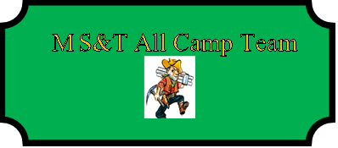

Addi Eger Mendon-Unity, IL SR
Hannah Nilges (MVP) Jefferson City JR
Sarah Linthocum Jefferson City JR
Marissa Abel Highland JR
MacKenzie Wohlers Osceola JR
Bella McCartney Jacksonville Routt, IL SR
Malia Carmack Glasgow SOPH
Brooke Highmark Westminster SOPH
Tory Hamilton Paris SR
Mandy Harper Midwest SR
Jenna Bellis Stover SR
Brooklyn Stiefel Mendon-Unity, IL SOPH
Abigail Posten Crocker SR
Makinley Aeschliman Schuyler County SOPH
Calyn Garza ROWVA JR

