Licking Summer Camp
Est. 1993
Girls Basketball Rolla, MO
July 11-13, 2019
Bracket Results
Palmyra 38 Licking 33
Harrisburg, IL 48 Newburg 35
St. Vincent 58 Green Forest, AR 40
St. James Freshman 57 Licking JV 47
Atchison, KS Freshman 38 St. Louis Flight 33
St. James JH 48 Newburg JH 46
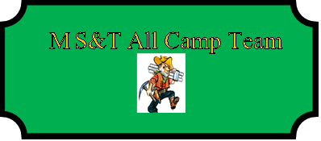

Amy Bryan (Co-MVP) Palmyra SR
Essence Sanders (Co-MVP) Harrisburg, IL SR
Reagan Stone Palmyra SR
Karlee Holland Licking SR
Lydia Klutho STL Notre Dame JR
Claire Affolter Newburg SOPH
Mary Billington Moberly SR
Skyler Brantley Jay, OK JR
Hailey Nix Arkadelphia SOPH
Maddie Carpenter West Frankfort, IL SR
Natile King United-Monmouth, IL SR
Winter Murray Licking SOPH
Summer Sanders Harrisburg IL SR
Jordan Caplinger Atchison, KS FRESH
Kandace George Vienna JR
Michenna Davis Keokuk, IA JR
Lydia Stewart Mt. Pleasant, IA SR
Kylie Benskoetter Jefferson City Helias JR
Hannah Marzee St. James JR
Alyssia Terry Tonkawa, OK SR
Kendall Demeyer Geen Forest, AR SR
Kylie Viebrock Versallies SR
Ashlyn Wightman Gibault, IL SR

