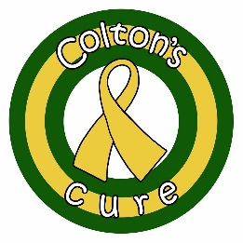
Colton’s Cure Foundation
Pediatric Awareness Grant Application

School Name:
_____________________________________________________________________________________
Advisor(s) Names:
_____________________________________________________________________________________
Email(s):
_____________________________________________________________________________________
Phone:
_____________________________________________________________________________________
Number of Students in the Program:
_____________________________________________________________________________________
Estimated Date for Project and Amount Requested (max-$500):
_____________________________________________________________________________________
Description of project, including how it will raise awareness of pediatric cancer:
_______________________________________________________________________________________________________________________________________________________________________________________________________________________________________________________________________________________________________________________________________________________________________________________________________________________________________________________________________________________________________________________________________________________________________________________________________________________________________________________________________________________________________________________________________________________________________________________________________________________________________________________________________________________________________________________________________________________________________
Advisor Signature: __________________________________________ Date: ______________________
About Colton’s Cure Foundation:
Founded in 2012, Colton’s Cure Foundation is a 501(c)(3) non-profit organization which stands to lighten the burden placed on Wisconsin families who are going through a pediatric cancer/blood disorder diagnosis. We accomplish this through three main avenues, they are:
- Financial Grants – Families apply for a grant through their care team at the hospital, grants are given out each month and families can receive two grants per year.
- Hospital Outreach – Colton’s Cure provides support and care packages to pediatric oncology programs throughout the state. In 2019, we will also begin hosting a summer party at Children’s Hospital of Wisconsin.
- Raising Community Awareness – Colton’s Cure takes part in numerous events each year including an annual water balloon fight and an annual gala celebration. We also partner with other community organizations who are working to raise pediatric cancer awareness.
How we can help:
We are looking to help school programs who have a project or event that is raising awareness of childhood cancer or blood disorders. Colton’s Cure is offering monetary grants through an application process as detailed below. Each school is limited to one grant per school year.
Application Process:
- School Program submits the attached application (applications will continue to be accepted until all grant money has been awarded)
- Applications will be reviewed by the Colton’s Cure Board of Directors on a monthly basis.
- Programs will be notified of the status of their application through email
Questions:
If you have any questions, please contact us at information@coltonscure.org.

