AEA Handbook

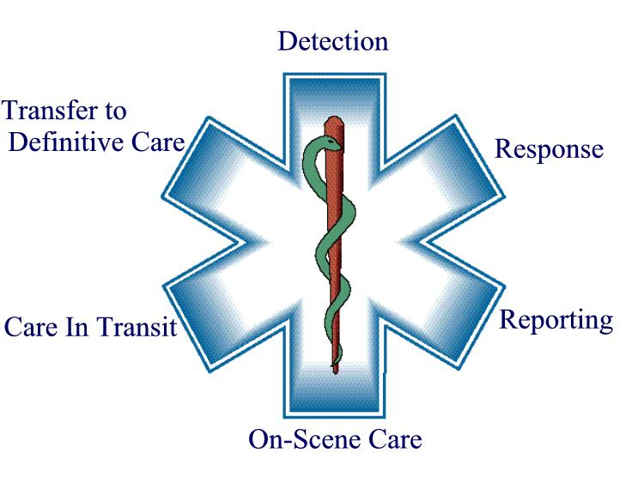

2023 Edition

Table of Contents

Introduction 3
Notes on Use 4
Pathologies 4
A. Cardiovascular 4
1. Cardiac Arrest 4
2. Myocardial Infarction/Acute Coronary Syndrome 10
3. Bradyarrhythmias 11
4. Tachyarrhythmias 14
5. Hypertension 17
B. Respiratory 18
1. Asthma/COPD 18
2. Pulmonary Oedema 20
3. Pulmonary Embolism 21
4. Tuberculosis 22
5. Pneumonia 23
C. Neurologic 24
1. Seizures/Convulsions 24
2. Stroke 25
D. Immunologic 26
1. Anaphylaxis 26
2. Sepsis 27
E. Endocrine/Metabolic 28
1. Diabetic Ketoacidosis/Hyperkalaemia 28
2. Hypoglycaemia 29
F. Toxicologic 30
1. Organophosphates 30
2. BB/CCBs 31
3. Opioids 32
4. Benzodiazepines 33
5. Cocaine 34
6. Tricyclic Anti-Depressants 35
G. Obstetric 36
1. Normal Vaginal Delivery 36
2. Prolapsed Cord 37
3. Premature Labour 38
4. Breech 39
5. Shoulder Dystocia 41
6. Pre-Eclampsia/Eclampsia 42
7. Post-partum Haemorrhage 43
H. Trauma 44
1. Traumatic Brain Injury 44
2. Burns 45
3. Haemorrhage 47
4. Crush Injury/Rhabdomyolysis 48
I. Other 49
1. Pain 49
2. Nausea/Vomiting/Cramping 51
3. Palliative/End-of-Life Situations 52
4. Psychiatric/Mental Disturbances 55
Reference Material 56
1. GCS: 56
2. APGAR: 57
3. Canadian C-spine Rule: 58
4. Neonatal Resources: 59
5. Paediatric Rehydration: 60
6. Major Incident Reminders: 61
7. Other/Troubleshooting: 61
8. CPG Capabilities List 62

Introduction

This little handbook started as a hand-written A6 note pad which I developed as a new graduate. The purpose was to avoid forgetting something while managing a patient! Looking back, on this now well-worn notebook, it became clear updates were needed. AEA scope of practice has expanded, and evidence-based medicine has progressed. And so, this new, updated, digitized version was born! I hope it will assist you as much as it has me.

Notes on Use

This handbook is not comprehensive, nor does it seek to replace clinical judgement or knowledge. Each patient presentation is unique and there are myriadpatient care considerations which simply cannot fit into a small, pocket-sized handbook. This handbook is meant purely as a memory-aid, including basic considerations around the management of specific conditions.
It should also be noted that not every management option mentioned should be used on every patient. For example, under Asthma the medications Hydrocortisone and Methylprednisolone are mentioned. This does NOT mean that in every instance of asthma both medications should be administered. They are simply noted as a reminder should they be indicated. Furthermore, medications containing the ‘*’ symbol may only be administered with consultation as per the latest guidelines (e.g.Naloxone*).In essence, every point mentioned in this reference book should be read with the following in mind: “…if necessary/indicated”.ALS backup is not specifically mentioned, however, should be considered in any of the conditions mentioned. Included algorithms should be followed as per AEA scope of practice. Where advanced interventions are mentioned, ALS backup should be sought.
As an example of how this handbook is intended for use, consider the management of an asthmatic patient. This patient should be managed according to clinical guidelines and one’s knowledge/clinical judgement. Once immediate, life-saving interventions have been performed, this handbookmay be used as a memory-aid to avoid omissions.
Please feel free to distribute and edit this document as you see fit – it is meant as a free resource which can be used as a customizable template and adjusted to any style or qualification – it’s completely up to you! If you have any ideas or suggestions for updates, please let me know so this little handbook can be continually improved.
Caleb Gage
caleb.gage@gmail.com
*References to material can be provided upon request.I do not claim any ownership of the material but have simply compiled information. It remains each health care provider’s responsibility to keep up to date with current, acceptable medical practice.

Pathologies

A. Cardiovascular

1. Cardiac Arrest

Basics
- Highquality CPR:
  - Adequate compression depth (adults: 5cm, paeds:>1/3 AP diameter)
  - Allow full chest recoil
  - Adequate compression rate (100-120/min)
  - Minimize hands-off time (<5-10s)
  - Avoid aggressive ventilations.
- Defibrillate early.
- Ensure high quality CPR before performing other procedures.
- Use metronomefor compressions.
- Ensure timekeeping: stop/swap/analyse every 2min.
- Count CPR cycles out loud.
- Communicate with patient family – allow them to watch if appropriate.
- Ask about legal documentation (i.e. living wills, DNRs)
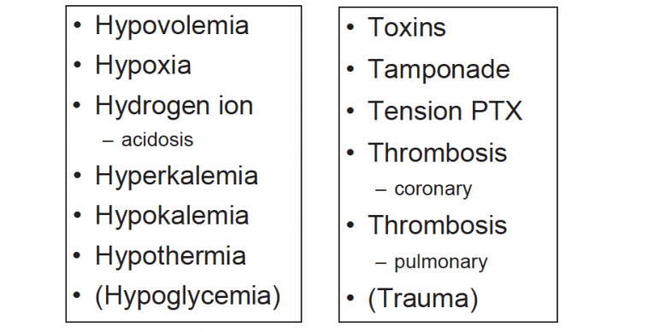
- Assess for reversible causes of cardiac arrest:

Note: Hypoglycaemia and Trauma removed from most guidelines, but are worth assessing.

Pharmacotherapy
Medication | Adult | Paediatric | Contra-Indications
Oxygen | - BVM/BVT at FiO2 1.0 | - BVM/BVT at FiO2 1.0 (Newborn: R/A initially) | - None
Adrenaline | - 1mg IV every 3-5min | - 0.01mg/kg IV every 3-5min | - None
Other relevant medications: Dextrose (Hypoglycaemia), Naloxone* (Opioid OD).

Fluid Therapy
- Patient dependant (i.e. hypovolaemia as reversible cause) - Warmed crystalloid may be considered.
- Post-ROSC hypotension: consider 1-2L warmed crystalloid.
Procedures
- Defibrillation – May use escalating doses. Initial: Adults 120-200J (biphasic), 360J (monophasic), Paeds 4J/kg (max 10J/kg or adult dose).
- Post-ROSC care: optimize oxygenation and ventilation, manage hypotension.
- Needle thoracentesis (adult and paed).
- Precordial thump (witnessed arrest).
- NP/OP tube insertion.
- Oral suctioning.

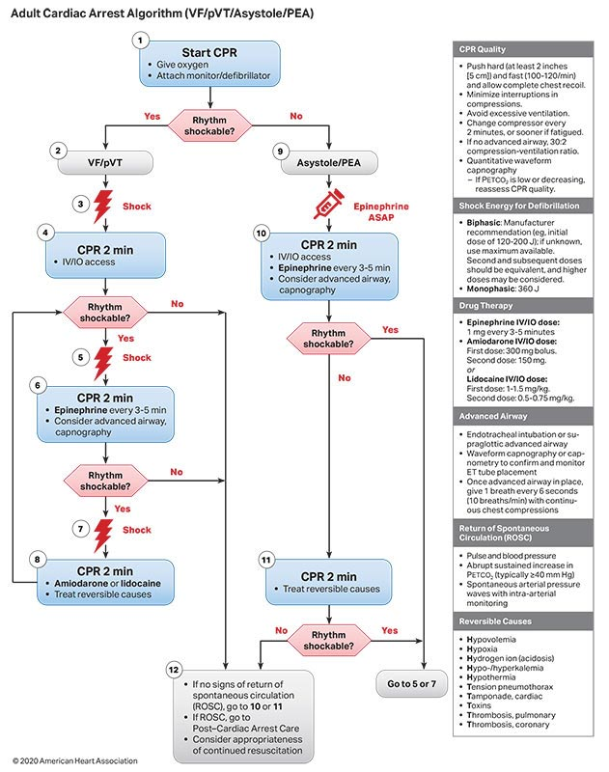
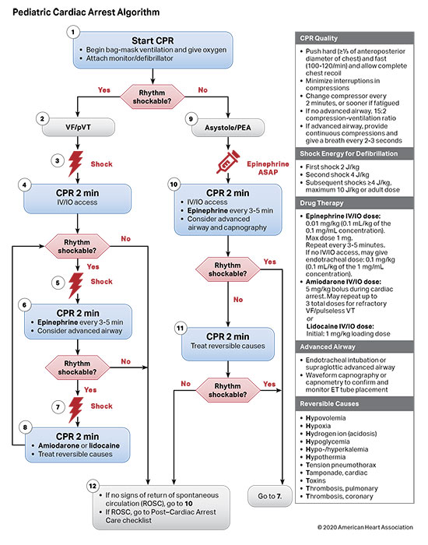
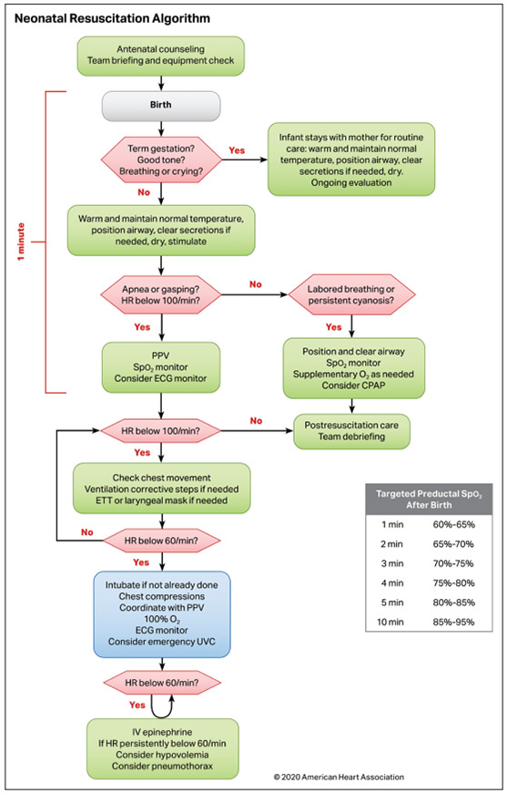

2. Myocardial Infarction/Acute Coronary Syndrome

Basics
- Calm and reassure patient – minimize stress, ensure comfort.
- Minimize on-scene time.
- Transport to appropriate PCI facility – phone ahead.
- Prepare for resuscitation (i.e. apply pads).
- History of risk factors: Age, Obesity, Smoking, Hypertension, Hypercholesterolaemia, Diabetes, Familial History.
- Identify time of symptom onset.
Pharmacotherapy
Medication | Adult | Paediatric | Contra-Indications
Oxygen | - Low flow | - Consult cardiology | - SpO2 >90%
Aspirin | - 162-325mg PO | - Consult cardiology | - Known allergy  - Active pathological bleeding  - Children <18yrs  - Pregnancy  - Renal transplant or severe impairment
Entonox | - Inhaled via self-administration | - Consult cardiology | - Neurologic impairment  - Air entrapment  - Hypotension

Fluid Therapy
- Avoid routine fluid therapy.
Procedures
- None specific.

3. Bradyarrhythmias

Basics
- Pathological or Physiological? HR usually <50bpm(adult) if bradyarrhythmia.
- Stable or Unstable? Monitor and observe if stable/asymptomatic.
- Treat the underlying causefirst!(i.e. hypoxia, drugs/toxins, electrolyte imbalance, ACS).
- Calm and reassure patient if possible.
- Consult cardiologist/backup.
- Be prepared for patient deterioration and resuscitation.
Pharmacotherapy
Medication | Adult | Paediatric | Contra-Indications
Oxygen | - Pro re nata | - Pro re nata | - None

Fluid Therapy
- Warmed crystalloid in small aliquots may be considered depending on cause/comorbidities.
Procedures
- CPR in paeds with HR<60bpm.

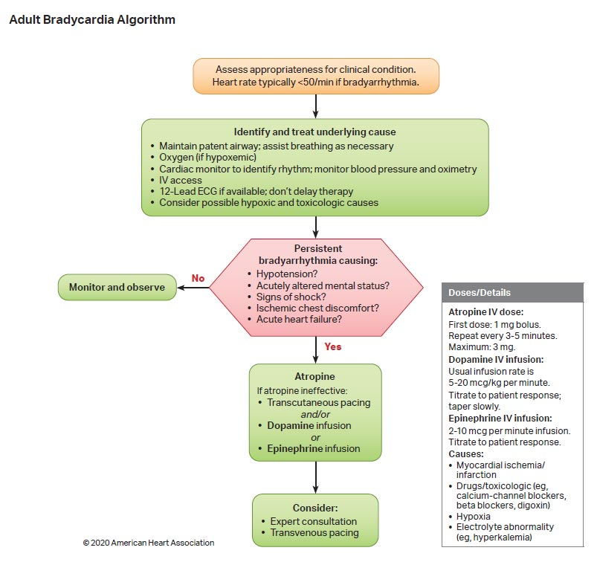

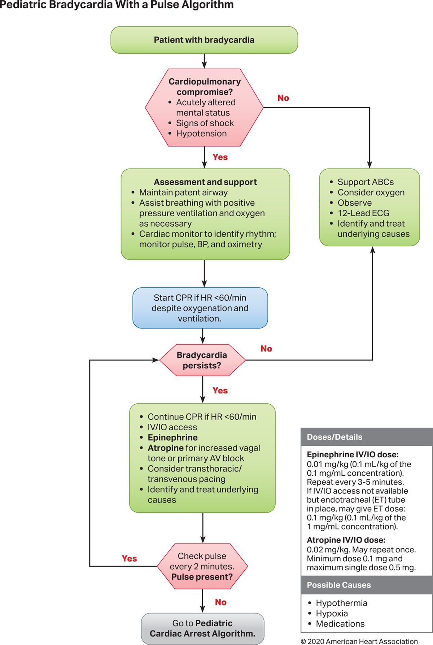

4. Tachyarrhythmias

Basics
- Pathological or Physiological? HR usually >150bpm(adult)if tachyarrhythmia.
- Stable or Unstable? Consider simply monitoring an asymptomatic patient.
- Treat the underlying cause first! (i.e. hypoxia, drugs/toxins, electrolyte imbalance).
- Calm and reassure patient if possible.
- Consult cardiologist/backup.
- Be prepared for patient deterioration and resuscitation.
Pharmacotherapy
Medication | Adult | Paediatric | Contra-Indications
Oxygen | - Pro re nata | - Pro re nata | - None

Fluid Therapy
- Warmed crystalloid in small aliquots may be considered depending on cause/comorbidities.
Procedures
- None specific.

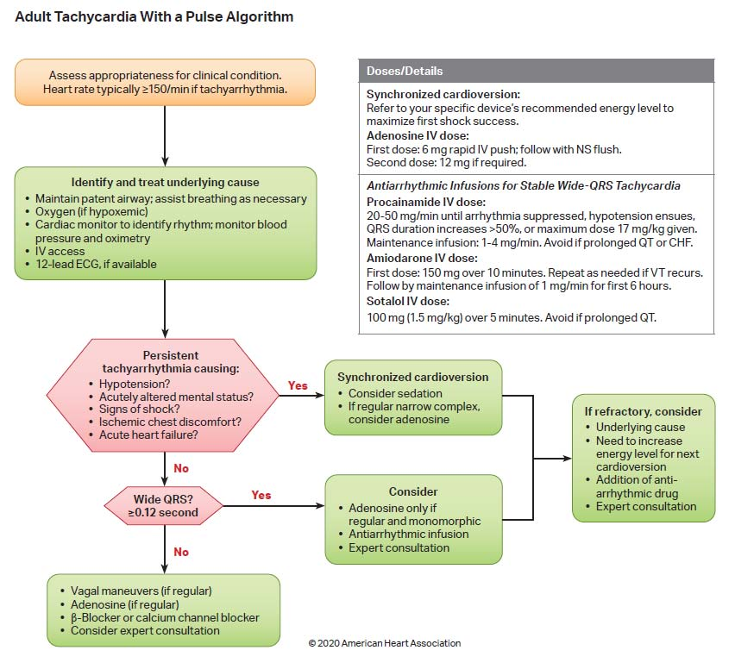

5. Hypertension

Basics
- Thorough history including duration and severity of hypertension.
- Identify likely cause: renal failure, toxins, genetics, medication default, etc.
- Symptomatic? (i.e. neurologic dysfunction, visual disturbances, pulmonary oedema, end-organ dysfunction).
- Measure BPsitting, standing and in both arms.
- Malignant Hypertension: SBP >180mmHg or DBP >120mmHg. These levels likely require management.
- Balance benefit of immediate decrease in BP against risk of decreasing end-organ perfusion.
- Education on lifestyle changes(i.e. if diet and exercise are causal).
- Consult cardiologist or other related specialist.
- Calm and reassure patient – minimize stress, ensure comfort.
Pharmacotherapy
Medication | Adult | Paediatric | Contra-Indications
- None specific

Fluid Therapy
- Avoid IV fluids.
Procedures
- None specific.

B. Respiratory

1. Asthma/COPD

Basics
- Calm and reassure patient while ensuring comfortable positioning (avoid supine).
- Remove allergen if still present.
- Encourage use of personal pump/spacer device.
- Assess blood sugar and hydration status.
- Determine severity(adult and paed):
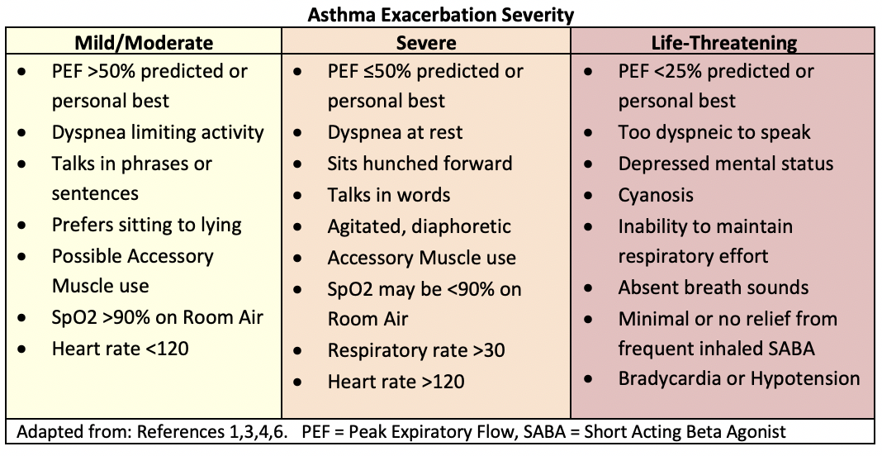
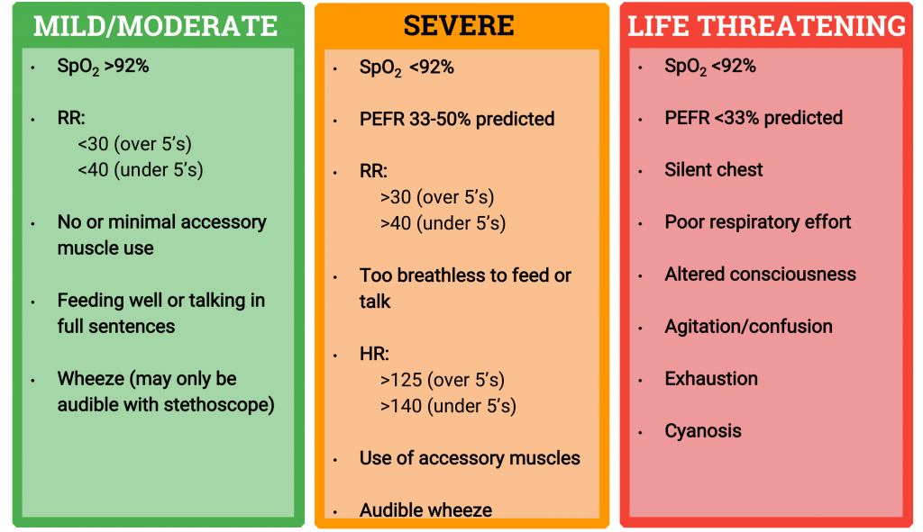

Pharmacotherapy
Medication | Adult | Paediatric | Contra-Indications
Oxygen | - Nebulised | - Nebulised | - None
β2 Stimulants | - Fenoterol: 1.25mg Neb (repeat continuously)  - Salbutamol: 5mg Neb (repeat continuously) | - Fenoterol: 0.5mg Neb (repeat continuously) | - Known allergy  - Neonates
Ipratropium Bromide | - 0.5mg Neb | - >5yrs: 0.5mg Neb  - 1-5yrs: 0.25mg Neb  - <1yr: 0.125mg Neb | - Known allergy
Corticosteroids | - Hydrocortisone: 5mg/kg IV (200-500mg)  - Methylprednisolone: 125mg IV | - Hydrocortisone: 5mg/kg IV (max 200mg)  - Methylprednisolone: 1mg/kg IV (max 30mg) | - None

Fluid Therapy
- Only administer fluids if necessary – prolonged dyspnoea may result in dehydration.
Procedures
- Consider use of Peak Flow Meter in mild cases.
- Nasal capnography may be placed underneath nebuliser mask.

2. Pulmonary Oedema

Basics
- Calm and reassure patient while ensuring comfortable positioning (avoid supine).
- Identify likely cause: CHF, toxins, altitude changes, drowning, etc.
Pharmacotherapy
Medication | Adult | Paediatric | Contra-Indications
Oxygen | - High or low flow | - High or low flow | - None

Fluid Therapy
- Avoid IV fluids.
Procedures
- ETCO2 monitoring.

3. Pulmonary Embolism

Basics
- Consider presence of PE in high-risk patients: DVT, coagulopathies, pregnancy, post-operative, traumatic conditions, etc.
- Rapid transport to appropriate facility.
- Calculate probability (Revised Geneva Score):
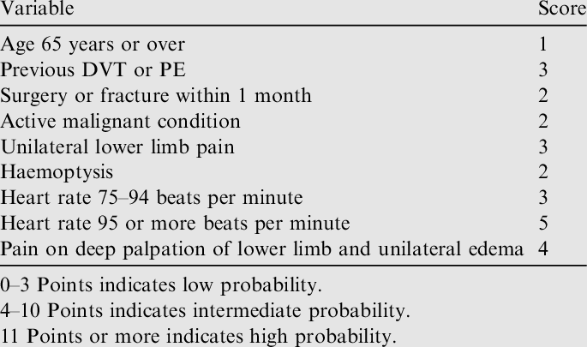
Pharmacotherapy
Medication | Adult | Paediatric | Contra-Indications
Oxygen | - High or low flow | - High or low flow | - None

Fluid Therapy
- No specific indication.
Procedures
- ETCO2 monitoring.

4. Tuberculosis

Basics
- Extra safety precautions: PPE and well-ventilated space.
- Encourage expectoration.
- Position patient comfortably.
- Education regarding condition, management thereof and lifestyle changes if necessary.
- TB not purely a lung pathology and may be present elsewhere.
Pharmacotherapy
Medication | Adult | Paediatric | Contra-Indications
Oxygen | - High or low flow | - High or low flow | - None

Fluid Therapy
- Only administer fluids if necessary – TB may present with dehydration of varying severities.
Procedures
- ETCO2 monitoring.

5. Pneumonia

Basics
- Extra safety precautions: PPE and well-ventilated space.
- Encourage expectoration.
- Position patient comfortably.
- Education regarding condition, management thereof and community acquired pneumonia.
- May complicate with pleural effusion.
Pharmacotherapy
Medication | Adult | Paediatric | Contra-Indications
Oxygen | - High, low flow or Neb | - High, low flow or Neb | - None
Other relevant medications: β2 stimulants and Ipratropium Bromide(bronchospasm).

Fluid Therapy
- Only administer fluids if necessary – Pneumonia may present with dehydration of varying severities.
Procedures
- ETCO2 monitoring.

C. Neurologic

1. Seizures/Convulsions

Basics
- Protect patient from environment.
- Turn lateral for airway protection (suctioning post-convulsion if necessary).
- Look for causes:
  - Hypoglycaemia
  - Hyperthermia
  - Hypoxia
  - Drugs/toxins
  - Trauma
  - Infection
  - Electrolyte imbalance
  - Medication default
  - Developmental pathology (e.g. cerebral palsy)
- Re-assessprimary survey after each convulsion.
- Calm and reassure family members.
Pharmacotherapy
Medication | Adult | Paediatric | Contra-Indications
Oxygen | - High, low flow, BVM | - High, low flow, BVM | - None
Other relevant medications: Dextrose (hypoglycaemia).

Fluid Therapy
- Only administer fluids if necessary – Seizures may be linked with dehydration.
Procedures
- None specific.

2. Stroke

Basics
- Calm and reassure patient – ensure comfort and communication.
- Assess for neurologic deficits.
- May be elevated ICP – maintain adequate oxygenation, MAP, ETCO2.
- Minimize on-scene time.
- Transport to appropriate facility – phone ahead.
- Identify time of symptom onset.
- Cincinnati Prehospital Stroke Scale (abnormal finding = 72% increased likelihood of stroke):
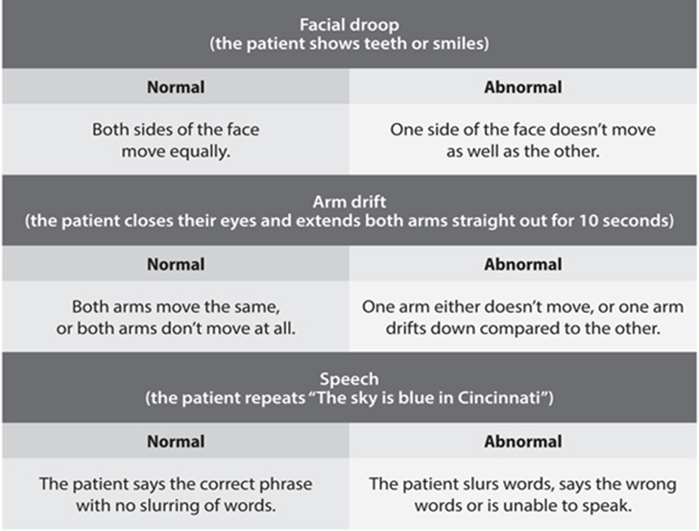
Pharmacotherapy
Medication | Adult | Paediatric | Contra-Indications
- None specific
Other relevant medications: Oxygen (hypoxaemia), Dextrose (hypoglycaemia).

Fluid Therapy
- No specific indication.
Procedures
- None specific.

D. Immunologic

1. Anaphylaxis

Basics
- Calm and reassure patient, ensuring comfortable positioning (avoid supine in case of dyspnoea).
- Remove allergen if still present.
- Encourage use of personal pump/spacer deviceand/or epi-pen.
Pharmacotherapy
Medication | Adult | Paediatric | Contra-Indications
Oxygen | - Neb | - Neb | - None
Adrenaline | - 0.5mg IM every 5-15min. | - 0.01mg/kg IM every 5-15min (max single dose 0.5mg) | - None
β2 Stimulants | - Fenoterol: 1.25mg Neb (repeat continuously)  - Salbutamol: 5mg Neb (repeat continuously) | - Fenoterol: 0.5mg Neb (repeat continuously) | - Known allergy  - Neonates
Ipratropium Bromide | - 0.5mg Neb | - >5yrs: 0.5mg Neb  - 1-5yrs: 0.25mg Neb  - <1yr: 0.125mg Neb | - Known allergy
Corticosteroids | - Hydrocortisone: 5mg/kg IV (200-500mg)  - Methylprednisolone: 125mg IV | - Hydrocortisone: 5mg/kg IV (max 200mg)  - Methylprednisolone: 1mg/kg IV (max 30mg) | - None
Glucagon* | - 1-2mg IV/IM every 5min (consult only) | - 20mcg/kg IV/IM (max 1mg – consult only) | - Known allergy (includes:beef, pork)  - Phaeochromocytoma  - Unknown safety in pregnancy

Fluid Therapy
- Warmed 10ml/kg crystalloid bolus(es) for hypotension.
Procedures
- None specific.

2. Sepsis

Basics
- Identify type and site of infection – source control.
- Thorough history (i.e. travel).
- Antibiotics asap – minimize on-scene time.
- Assess blood glucose and temperature.
- Maintain sterility where possible.
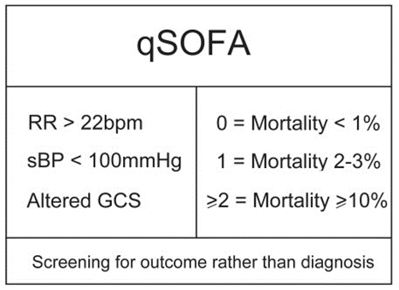
Pharmacotherapy
Medication | Adult | Paediatric | Contra-Indications
Oxygen | - High or low flow | - High or low flow | - None
Other relevant medications: Dextrose (hypoglycaemia).

Fluid Therapy
- Individualize fluid therapy. Warmed 10ml/kg crystalloid bolus(es) for hypotension may be required.
Procedures
- None specific.

E. Endocrine/Metabolic

1. Diabetic Ketoacidosis/Hyperkalaemia

Basics
- Kussmaul breathing and ‘fruity’ breath odour.
- Monitor ECG, ETCO2 and blood glucosecontinually.
- Beware of stroke risk.
- Education regarding condition, management thereof and lifestyle changes if necessary.
- Normal Potassium: 3.5 - 5mmol/L.
- Normal Blood Sugar: 3.5-7.0mmol/L.
Pharmacotherapy
Medication | Adult | Paediatric | Contra-Indications
Oxygen | - Pro re nata | - Pro re nata | - None
β2 Stimulants | - Fenoterol: 5mg Neb  - Salbutamol: 20mg Neb  - Consult recommended | - Fenoterol: 0.5mg Neb  - Consult recommended | - Known allergy  - Neonates

Note: only administer β2 Stimulants ifhyperkalaemic ECG changes are present (peaked T-waves, flattened P-waves, broadened QRS complexes).
Fluid Therapy
- Warmed 10ml/kg crystalloid bolus(es)for rehydration and renal protection.
Procedures
- None specific.

2. Hypoglycaemia

Basics
- Turn lateral for airway protection (suctioning if necessary).
- Identify cause.
- Provide complex carbohydrate(i.e. food)to prevent rebound hypoglycaemia.
- Education regarding condition, management thereof and lifestyle changes if necessary.
- Sugar should be provided by minimally invasive means where possible (i.e. sugar water, coke).
- Normal Blood Sugar: 3.5-7.0mmol/L.
Pharmacotherapy
Medication | Adult | Paediatric | Contra-Indications
Oxygen | - High or low flow | - High or low flow | - None
Glucose | - 25g PO/Buccal(repeat as necessary) | - 25g PO/Buccal(repeat as necessary) | - None
Dextrose 50% | - 1ml/kg diluted to 10% solution IV (repeat as necessary) | - 1ml/kg diluted to 10% solution IV (repeat as necessary) | - None
Glucagon* | - 1-2mg IM/IV/SC (consult only) | - <20kg: 0.5mg IM/IV/SC  - >20kg: 1mg IM/IV/SC  - (consult only) | - Known allergy (includes: beef, pork)  - Phaeochromocytoma  - Unknown safety in pregnancy
Thiamine | - 100mg IM | - 25-50mg IM | - None

Fluid Therapy
- No specific indication, though dehydration may also be present.
Procedures
- None specific.

F. Toxicologic

1. Organophosphates

Basics
- Cholinergic toxidrome.
- Identify causative agent and route of exposure.
- Turn lateral for airway protection (suctioning as necessary).
- Decontaminate patient, equipment, yourself and others.
- Risk of seizures exists.
- Signs:
  - Diarrhoea, diaphoresis
  - Urination
  - Miosis
  - Bradycardia, bronchosecretions
  - Emesis
  - Lacrimation
  - Lethargy
  - Salivation
  - Tremors/Fasciculations
  - Hypotension
  - Unique odour
Pharmacotherapy
Medication | Adult | Paediatric | Contra-Indications
Oxygen | - High flow, BVM | - High flow, BVM | - None

Fluid Therapy
- Warmed 10ml/kg crystalloid bolus(es) for rehydration and correction of hypotension.
Procedures
- ETCO2 monitoring.

2. BB/CCBs

Basics
- Identify causative agent and route of exposure.
- Turn lateral for airway protection (suctioning if necessary).
- Signs:
  - Bradycardia
  - Hypotension
  - Decreased LOC
Pharmacotherapy
Medication | Adult | Paediatric | Contra-Indications
Oxygen | - Low or High flow | - Low or High flow | - None
Glucagon* | - 3-5mg IV followed by 3mg/hr IV infusion (consult only) | - 50-150mcg/kg IV followed by 50mcg/kg/hr IV infusion (consult only) | - Known allergy (includes: beef, pork)  - Phaeochromocytoma  - Unknown safety in pregnancy
Other relevant medications:Activated Charcoal (oral OD),β2 Stimulants (bronchospasm).

Fluid Therapy
- No specific indication.
Procedures
- None specific.

3. Opioids

Basics
- Opioid toxidrome.
- Identify causative agent and route of exposure.
- Turn lateral for airway protection (suctioning if necessary).
- Beware of withdrawal reactions.
- Signs:
  - Cardiovascular depression
  - Decreased LOC
  - Miosis
  - Respiratory depression
  - Vomiting
Pharmacotherapy
Medication | Adult | Paediatric | Contra-Indications
Oxygen | - BVM/BVT/High flow | - BVM/BVT/High flow | - None
Naloxone* | - 0.4mg IV/IM (repeat every 5min up to max 2mg – consult only) | - 0.1mg/kg IV/IM (repeat every 5min up to max 2mg – consult only) | - Known allergy
Other relevant medications:Activated Charcoal (oral OD).

Fluid Therapy
- No specific indication.
Procedures
- ETCO2 monitoring.

4. Benzodiazepines

Basics
- Sedative/Hypnotic toxidrome.
- Identify causative agent and route of exposure.
- Turn lateral for airway protection (suctioning if necessary).
- Signs:
  - Cardiovascular depression
  - Respiratory depression
  - Decreased LOC.
Pharmacotherapy
Medication | Adult | Paediatric | Contra-Indications
Oxygen | - BVM/BVT | - BVM/BVT | - None
Other relevant medications: Activated Charcoal (oral OD).

Fluid Therapy
- No specific indication.
Procedures
- ETCO2 monitoring.

5. Cocaine

Basics
- Sympathomimetic toxidrome.
- Identify causative agent and route of exposure.
- Beware of ACS risk with chest pain.
- Signs:
  - Increased HR and BP
  - Increased RR
  - Mydriasis
  - Paranoia, agitation, aggression
Pharmacotherapy
Medication | Adult | Paediatric | Contra-Indications
Oxygen | - Low flow | - Consult cardiology | - SpO2 >90%
Aspirin | - 162-325mg PO | - Consult cardiology | - Known allergy  - Active pathological bleeding  - Children <18yrs  - Pregnancy  - Renal transplant or severe impairment
Entonox | - Inhaled via self-administration | - Consult cardiology | - Neurologic impairment  - Air entrapment  - Hypotension

Fluid Therapy
- Avoid routine fluid therapy.
Procedures
- None specific.

6. Tricyclic Anti-Depressants

Basics
- Sodium channel blocking.
- Identify causative agent and route of exposure.
- Turn lateral for airway protection (suctioning if necessary).
- Beware of seizures and arrythmias.
- Signs:
  - Tachycardia
  - Decreased LOC
  - Seizures
  - Hypotension
  - Mydriasis
Pharmacotherapy
Medication | Adult | Paediatric | Contra-Indications
Oxygen | - High flow, BVM/BVT | - High flow, BVM/BVT | - None
Other relevant medications: Activated Charcoal (oral OD).

Fluid Therapy
- No specific indication.

Procedures
- ETCO2 monitoring.

G. Obstetric

1. Normal Vaginal Delivery

Basics
- Calm and reassure patient, ensuring good communication and privacy.
- Thorough obstetric history (i.e. maternity card, gestational age,parity/gravidity, complications).
- Left-lateral positioning.
- Encourage maternal breast-feedingpost-delivery.
- Check for PPH.
- Be prepared for neonatal resuscitation.
- Risk of pulmonaryembolism.
Pharmacotherapy
Medication | Adult | Paediatric | Contra-Indications
Entonox | - Inhaled via self-administration | - N/A | - Neurologic impairment  - Air entrapment  - Hypotension

Fluid Therapy
- No specific indication.
Procedures
- APGAR Score – at 1 and 10min. (see reference material).
- Delayed cord clamping.

2. Prolapsed Cord

Basics
- Calm and reassure patient, ensuring good communication and privacy.
- Thorough obstetric history (i.e. maternity card, gestational age,parity/gravidity, complications).
- Coach patient to pant and avoid bearing down(unless delivery imminent).
- Use two fingers to gently push the presenting part off the cord.
- Cover cord with moist, sterile dressing.
- Avoid cord handling.
- Knee to chest or left lateralpositioning.
- Minimize on-scene time.
- Contact receiving facility/obstetrician.
- Be prepared for neonatal resuscitation in case of delivery.
- Risk of pulmonary embolism.
Pharmacotherapy
Medication | Adult | Paediatric | Contra-Indications
- None specific
Relevant medications:Entonox (analgesia).

Fluid Therapy
- No specific indication.
Procedures
- APGAR Score if delivery (see reference material).

3. Premature Labour

Basics
- Calm and reassure patient, ensuring good communication and privacy.
- Thorough obstetric history (i.e. maternity card, gestationalage,parity/gravidity,complications).
- Coach patient to pant and avoid bearing down (unless delivery imminent).
- Knee to chest or left lateral positioning.
- Minimize on-scene time.
- Contact receiving facility/obstetrician.
- Be prepared for neonatal resuscitation.
- Risk of pulmonary embolism.
Pharmacotherapy
Medication | Adult | Paediatric | Contra-Indications
- None specific
Relevant medications: Entonox (analgesia).

Fluid Therapy
- No specific indication.
Procedures
- APGAR Scoreif delivery (see reference material).

4. Breech

Basics
- Calm and reassure patient, ensuring good communication and privacy.
- Thorough obstetric history (i.e. maternity card, gestational age,parity/gravidity, complications).
- Do not apply traction to the newborn.
- Left lateral positioning.
- Minimize on-scene time.
- Contact receiving facility/obstetrician.
- Risk of pulmonary embolism.
Pharmacotherapy
Medication | Adult | Paediatric | Contra-Indications
- None specific
Relevant medications: Entonox (analgesia).

Fluid Therapy
- No specific indication.
Procedures
- APGAR Score (see reference material).
- Vaginal delivery:
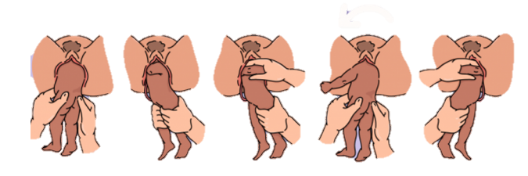
  - Løvset’s Manoeuvre: Support lower limbs and pelvis as delivered. Once umbilicus delivered and shoulders in AP position, apply gentle downward pressure until axilla visible. Deliver anterior arm, rotate and deliver posterior arm. Support body and neck and rotate so back is uppermost. Use Mauriceau’s Manoeuvre to deliver head.

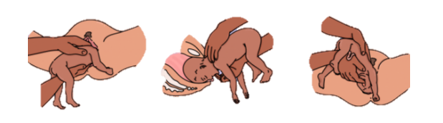
  - Mauriceau’s Manoeuvre: Support baby on forearm, place index and ring fingers on zygomas and middle finger in mouth. Place other hand on shoulders with middle finger on occiput. Gently induce flexion of head to facilitate delivery.

5. Shoulder Dystocia

Basics
- Calm and reassure patient, ensuring good communication and privacy.
- Thorough obstetric history (i.e. maternity card, gestational age, parity/gravidity,complications).
- ‘Turtle Sign’.
- Discourage maternal pushing.
- Avoid use of fundal pressure.
- Minimize on-scene time.
- Contact receiving facility/obstetrician.
- Be prepared for neonatal resuscitation.
- Risk of pulmonary embolism.
Pharmacotherapy
Medication | Adult | Paediatric | Contra-Indications
- None specific
Relevant medications: Entonox (analgesia).

Fluid Therapy
- No specific indication.
Procedures
- Vaginal delivery:
  - Place patient supine, flex thighs towards chest and tilt pelvis forward with suprapubic pressure (McRobert’s Manoeuvre).
  - Attempt to deliver anterior shoulder with gentle posterior head traction.
  - Attempt to deliver posterior shoulder with gentle anterior traction.
  - Delivery of shoulders may be assisted with 180⁰ rotations.
- APGAR Score (see reference material).

6. Pre-Eclampsia/Eclampsia

Basics
- Calm and reassure patient, ensuring good communication and privacy.
- Thorough obstetric history (i.e. maternity card, gestational age, parity/gravidity, complications).
- Search for signs of end-organ dysfunction (i.e. blurred vision, proteinuria).
- Left lateral positioning.
Pharmacotherapy
Medication | Adult | Paediatric | Contra-Indications
Magnesium Sulphate* | - 5g IM in each buttock if prolonged transport (consult only) | - N/A | - None

Fluid Therapy
- Avoid IV fluids.
Procedures
- None specific.

7. Post-partum Haemorrhage

Basics
- >500ml blood loss.
- Calm and reassure patient, ensuring good communicationand privacy.
- Thorough obstetric history (i.e. maternity card, gestational age, parity/gravidity, complications).
- Encourage breastfeeding if possible.
- Minimize on-scene time.
- Focus is on rapid transport, identification of cause and bleeding control.
- Risk of pulmonary embolism.
- Notify receiving facility.
Pharmacotherapy
Medication | Adult | Paediatric | Contra-Indications
Oxygen | - High or low flow | - N/A | - None

Fluid Therapy
- Permissive hypotension: avoid clear fluids unless radial pulses absent.
- If radial pulses absent, administer 200ml aliquots until radial pulses return.
Procedures
- Placenta delivery.
- Uterine massage/compression.

H. Trauma

1. Traumatic Brain Injury

Basics
- GCS Severity:
  - 13-15 Mild
  - 9-12 Moderate
  - <8 Severe
- Minimize secondary brain injury: Hypoxia, Hypotension, Increased ICP, Hyper/hypocapnia, Hypo/hyperthermia, Hypoglycaemia, Seizures, Pain.
- CPP=MAP-ICP.
- Normal values:
  - CPP: 60-80mmHg (minimum to prevent ischaemic brain injury: 55-60mmHg)
  - MAP: 93 (BP 120/80)
  - ICP: 5-15mmHg
- Remove harmful immobilization devices (C-collar, rigid backboard).
- Elevate head 30⁰ (unless hypotensive).
- Aim for ETCO2 35-40mmHg.
- Spinal injuries managed similarly as same principles apply.
Pharmacotherapy
Medication | Adult | Paediatric | Contra-Indications
Oxygen | - High or low flow, BVM/BVT | - High or low flow, BVM/BVT | - None
Analgesics | - (see pain section) | - (see pain section) | - (see pain section)

Note: Analgesia will likely require ALS backup.

Fluid Therapy
- Warmed 10ml/kg crystalloid bolus(es) titrated at normal MAP (80-90) to achieve adequate CPP.
- Permissive hypotension contra-indicated.
Procedures
- Spinal motion restriction.
- ETCO2 monitoring.

2. Burns

Basics
- Identify type and depth (i.e. partial thickness thermal burns).
- Remove source (i.e. continual irrigation for chemicals).
- Temperature management.
- Maintain sterility.
- Applyburnshield.
- Risk of arrythmias: monitor ECG.
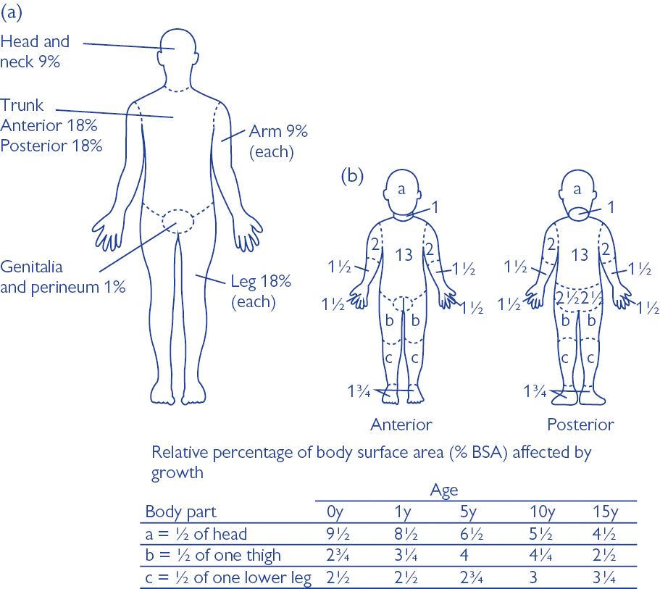
- Calculate BSA%:

Pharmacotherapy
Medication | Adult | Paediatric | Contra-Indications
Oxygen | - Neb or high flow (inhalation burns) | - Neb or high flow (inhalation burns) | - None
Analgesics | - (see pain section) | - (see pain section) | - (see pain section)

Fluid Therapy
- Warmed 10ml/kg crystalloid bolus if initially hypotensive.
- Consensus formula:
  - 2-4ml/kg x BSA%
  - Administer first half in initial 8hrs and second half in next 16hrs.
- Avoid fluid overload.
Procedures
- Moist dressing application.

3. Haemorrhage

Basics
- Traumatic coagulopathy may be present.
- Lethal triad: coagulopathy, hypothermia, metabolic acidosis.
- Identify source.
- Minimise loss.
- Look for signs of early shock. Shock index: HR/SBP. If >1 indicates shock.
- BP ≠ Perfusion.
- Minimize on scene time. Rapid transport to surgical intervention/blood products crucial.
- Avoid IV-line placement on scene should this prolong scene time.
Pharmacotherapy
Medication | Adult | Paediatric | Contra-Indications
Oxygen | - High or low flow | - High or low flow | - None
Other relevant medications:Analgesics (pain).

Fluid Therapy
- Permissive hypotension: avoid clear fluids unless radial pulses absent.
- If radial pulses absent, administer 200ml aliquots until radial pulses return.
Procedures
- Bandaging/splinting.
- Tourniquet placement.
- Pelvic splinting.
- Traction splinting.
- Anti-shock garment.
- Haemostatic agent/bandage application.

4. Crush Injury/Rhabdomyolysis

Basics
- Ensure patient safety from environment.
- Treatment aimed at preserving renal function.
- Analgesia and fluid therapy may be necessary before extrication.
- Risk of arrythmias – continual ECG monitoring.
Pharmacotherapy
Medication | Adult | Paediatric | Contra-Indications
Oxygen | - High or low flow | - High or low flow | - None
Analgesics | - (see pain section) | - (see pain section) | - (see pain section)

Fluid Therapy
- Warmed 10ml/kg crystalloid bolus(es) to assist renal perfusion.
- Aggressive fluid management where required.
Procedures
- As per relevant trauma guidelines.

I. Other

1. Pain

Basics
- Consider total pain: physical, emotional, mental, spiritual, social.
- Consider type of pain (i.e. musculoskeletal, visceral).
- Acute vs. Chronic?
- Use pain scale.
- Use non-pharmacologic methods (education, imagery, distraction, music, scents, communication, heat/cold application, counselling, positioning, bandaging/splinting).
- Calm and reassure patient, ensuring good communication and sympathy.
- Do not leave pain untreated.
Pharmacotherapy
Medication | Adult | Paediatric | Contra-Indications
Entonox | - Inhaled via self-administration | - Inhaled via self-administration | - Neurologic impairment  - Air entrapment  - Hypotension
Methoxyflurane | - 3ml inhaled via self-administration (may repeat once) | - 3ml inhaled via self-administration | - Known allergy  - Altered LOC  - Severe hepatic/renal impairment  - Malignant hyperthermia  - <1yr old

Fluid Therapy
- No specific indication.
Procedures
- None specific.
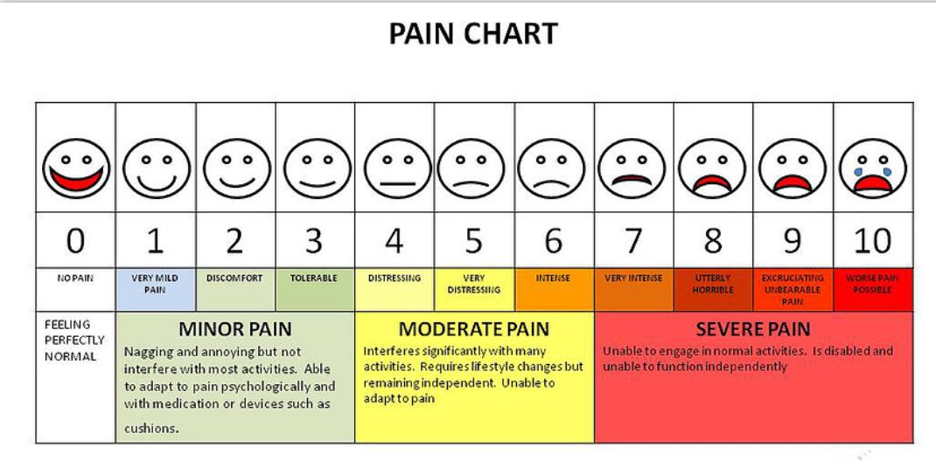

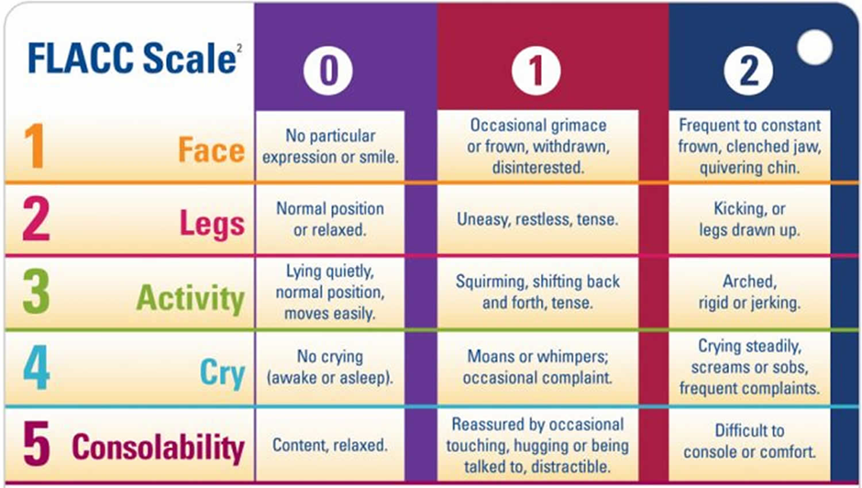

2. Nausea/Vomiting/Cramping

Basics
- Identify source/cause and remove.
- Inhaled isopropyl alcohol as alternative (alcohol swab).
- Ensure patent airwayand avoid aspiration.
- Avoid excess stimulation (i.e. movement, noise).
- Risk of dehydration/electrolyte imbalances.
Pharmacotherapy
Medication | Adult | Paediatric | Contra-Indications
- None specific.

Fluid Therapy
- Consider warm crystalloid fluids if hypovolaemia and/or dehydration present.
Procedures
- Oral suctioning as necessary.

3. Palliative/End-of-Life Situations

Basics
- Aim is improved quality of life and relief of suffering for both patients and families: physical, emotional, mental, spiritual, social.
- Aim is NOT prolonging life at all costs or shortening life.
- Take steps to ensure patient autonomy.
- Establish desired patient/family care goals.
- Avoid unnecessarytransport (meet patient wishes).
- Avoid futile interventions and manage supportively with aim of relieving suffering.
- Avoid any procedures which will unnecessarily cause discomfort.
- Multi-disciplinary approach: consult and involve necessary individuals (i.e. MO, psychologist, counsellor, family members, social worker etc.).
- Ensure thorough, compassionate, honest communication and education regarding condition.
- Ask about legal documentation (Living Wills,Advance Directives,DNRs)
Pharmacotherapy
Condition | Medications
Pain | - Analgesics: (see pain section)
Dyspnoea | - Oxygen: High, low flow or nebulised

Notes: Administration of medications should not automatically result in patient transport. When in doubt, consult.
Fluid Therapy
- Dependant on patient condition.
- Oral fluids preferred if possible to avoid IV placement.
Procedures
- Communication (SILVER):
  - Seeks Information (baseline function, history)
  - Life Values (personality, culture, religion, beliefs)
  - Educate/Extend (provide info on condition and management)
  - Respond (solicit questions, offer support)
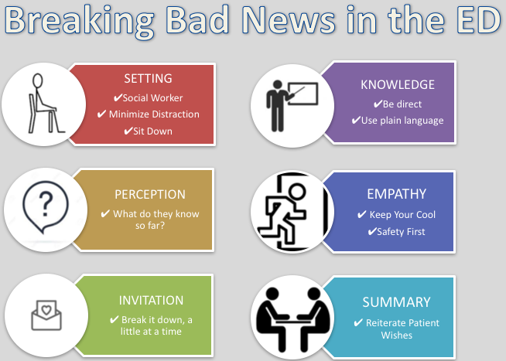
- Breaking bad news (SPIKES):

4. Psychiatric/Mental Disturbances

Basics
- Ensure safety for crew, family, patient and bystanders.
- Ensure thorough, compassionate and honest communication.
- Attempt basic methods to calm patient before using pharmacological interventions.
- Involve police where appropriate.
- Consultation and thorough documentation crucial.
- Rule out other causes (i.e. toxins/substances).
Pharmacotherapy
Medication | Adult | Paediatric | Contra-Indications
- None specific.

Note: Other routes of administration may be used if the scenario allows.
Fluid Therapy
- No specific indication.
Procedures
- None specific.

Reference Material

1. GCS:
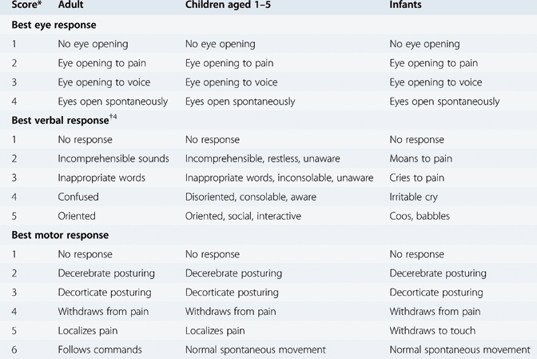

2. APGAR:
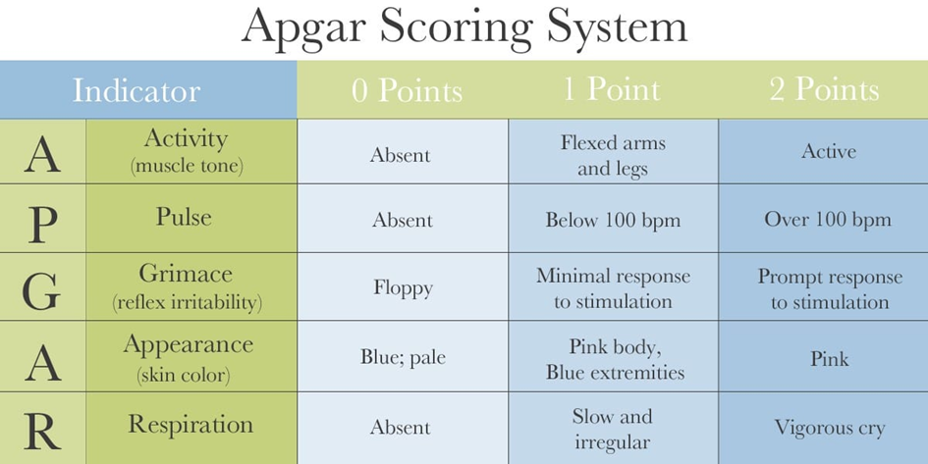

3. Canadian C-spine Rule:
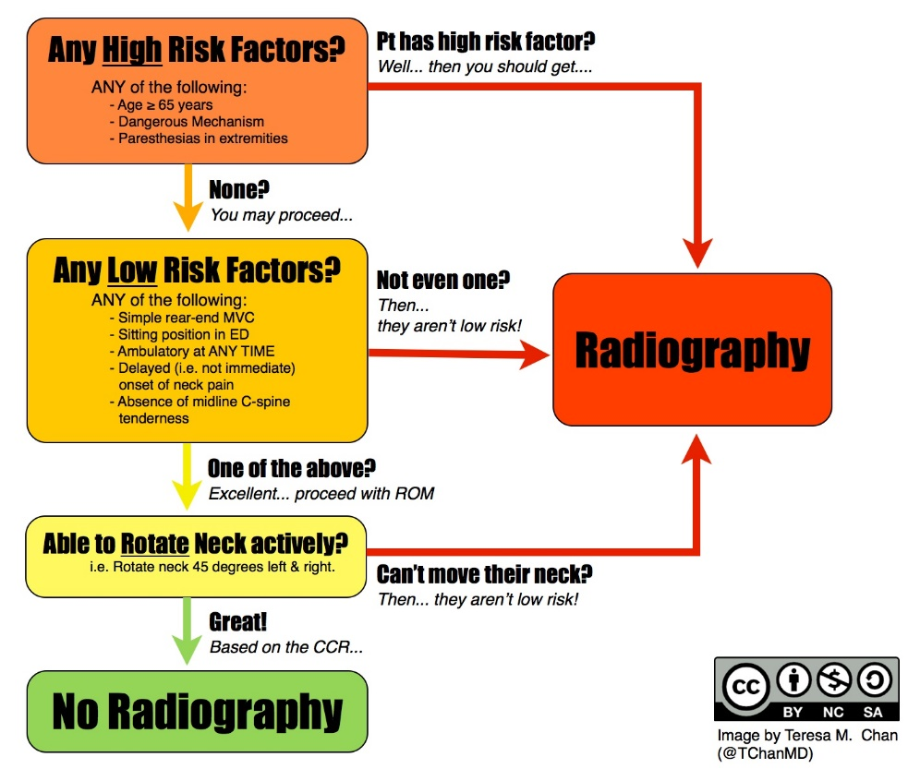

4. Neonatal Resources:

Incubator Temperatures:
Neutral Thermal Environment (NTE) – Neonates Days 1-5
 | 1000-1200g (+/- 0.5⁰C) | 1201-1500g (+/- 0.5⁰C) | 1501-2500g (+/- 1.0⁰C) | >2500g/>36weeks
0-12hrs | 35.0⁰C | 34.0⁰C | 33.3⁰C | 32.8⁰C
12-24hrs | 34.5⁰C | 33.8⁰C | 32.8⁰C | 32.4⁰C
24-96hrs | 34.5⁰C | 33.5⁰C | 32.3⁰C | 32.0⁰C

Neutral Thermal Environment (NTE) – Neonates >5 Days
 | <1500g | 1501-2500g | >2500g />36weeks
5-14 days | 33.5⁰C | 32.1⁰C | 32.0⁰C
14-21 days | 33.1⁰C | 31.7⁰C | 30.0⁰C

DDx:
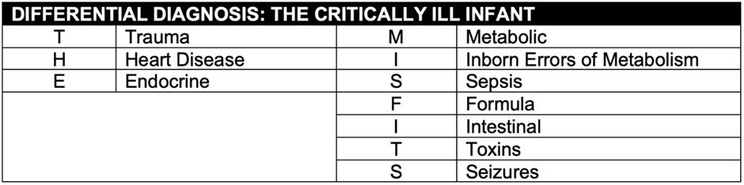

5. Paediatric Rehydration:

Clinical Findings | Degree of Dehydration
Clinical Findings | None (<5%) | Some (5-10%) | Severe (>10%)
General Appearance | Well, Alert | Restless, Irritable | Lethargic or Unconscious
Eyes | Normal | Sunken | Sunken
Thirst | Drinks Normally, Not Thirsty | Drinks Eagerly, Thirsty | Drinks Poorly or is Unable to Drink
Skin Turgor/Pinch | Returns Quickly | Returns Slowly | Returns Very Slowly
Estimated Fluid Deficit | <50ml/kg | 50-100ml/kg | >100ml/kg

Rehydration
Degree of Dehydration | None (<5%) | Some (5-10%) | Severe (>10%)
Replacement Fluids | None. | 15-20ml/kg/hour for first 4 hours. | 20ml/kg/hour for first 4 hours.
Maintenance Fluids | Guided by patient thirst and/or observation. | - 0-3months: 150ml/kg/day  - 3-12months (<10kg): 120ml/kg/day  - 10-20kg: 1000ml + 50ml/kg over 10kg/day  - >20kg: 1500ml + 20ml/kg over 20kg/day  - Ongoing Losses: additional10-15ml/kg/day per stool/vomit
Hospital Admission | No | Yes | Yes

6. Major Incident Reminders:

- Mobilize relevant resources (i.e. fire, rescue, medical, HEMS, HAZMAT, law enforcement/security).
- Set up incident command area.
- Appoint officers (i.e. triage, logistics, communications, safety, medical, rescue, fire, media).
- Set up staging areas: equipment, patients based on triage.
- Notify nearby receiving medical facilities in advance.
- Search scene for hidden patients (walk-around).
- Reports and documentation.
- Debrief.

7. Other/Troubleshooting:

Causes of Coma:
T – Trauma
I – Infection
P – Psychiatric
S – Stroke/Space occupying lesion
A – Alcohol (other drugs/toxins)
E – Endocrine/Environment
I – Insulin (hypo/hyperglycaemia)
O – Oxygen (hypoxia)
U – Uraemia

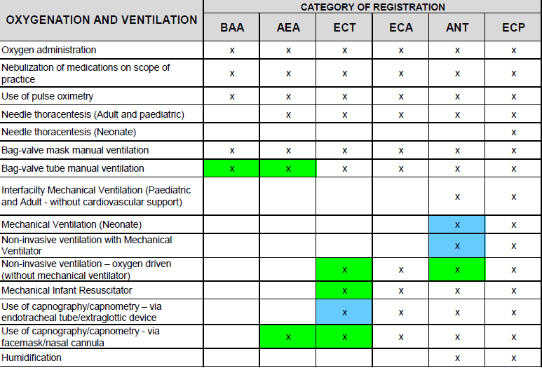
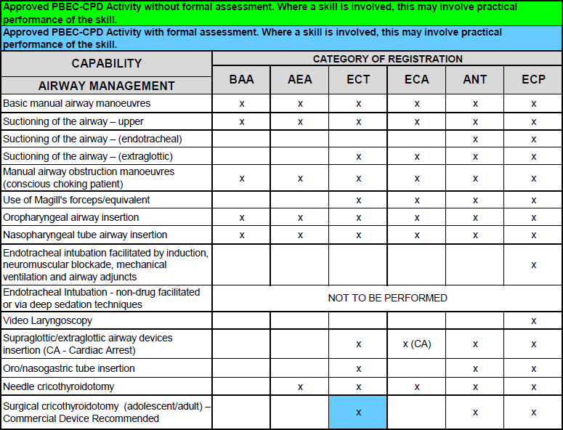
8. CPG Capabilities List
