suicide.  The word caught your attention, didn’t it? The truth is, suicide catches everyone’s attention.  It’s the actions leading up to suicide that go unnoticed.  It’s the healing of those left behind from a suicide that is necessary. |  | The Loved Ones Left Behind is a non-profit organization focused on suicide preventions and helping the ones left behind from a suicidal loss. |  |  | THE  LOVED ONES  LEFT BEHIND  Working together  Today to change their Tomorrow.
 |  | Founded by Mandi brown
“Every 41 seconds someone is left to make sense of it.” |  | Contact Us:  mandi@thelovedonesleftbehind.com  www.thelovedonesleftbehind.com        Copyright@2018 The Loved Ones Left Behind – All Rights Reserved.
Our Mission  Helping empower families recover from a parent’s suicide through financial and emotional support.  Also, to help with suicide prevention.  “every 40 seconds someone in the world dies by suicide.” |  | How Can You Help Us

Whether you help through monetary donations, volunteering your time or services, or spreading our mission through word-of-mouth, thank you. We couldn’t accomplish our goals without the help of supporters like you.
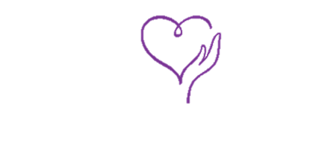

the loved ones left behind (TLOLB)
“On July 3, 2017, I got a text that changed my family’s life forever. The father of my 4 children and my husband of 16 years took his life. My immediate focus was on my children…” Mandi Brown was the recipient of that text. It was in the healing process of her own family when the idea of The Loved Ones Left Behind came to life.
This foundation was started to help pay for counseling or bills for a family so they can focus on the healing process. TLOLB also wants to help those that need suicide help.
If you are passionate about what we’re doing, let us know! We are always looking for volunteers to help us make our vision a reality.
Suicide Prevention & Awareness

