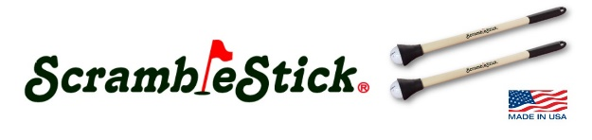
PRESS RELEASE January 31, 2019

Meet the original ScrambleStick® golf ball retriever. This unique golf accessory aids in the play of scramble golf tournaments by allowing scramble teams to retrieve golf balls from their golf cart.
Here’s how it works:
Scramble team players play their ‘best ball’ and use the ScrambleStick® to pick-up their other balls. Simply place the suction cup over the golf ball and lightly push down on the ScrambleStick®. The rigid suction cup ‘holds’ the ball, allowing the golfer to remove it with very little effort.
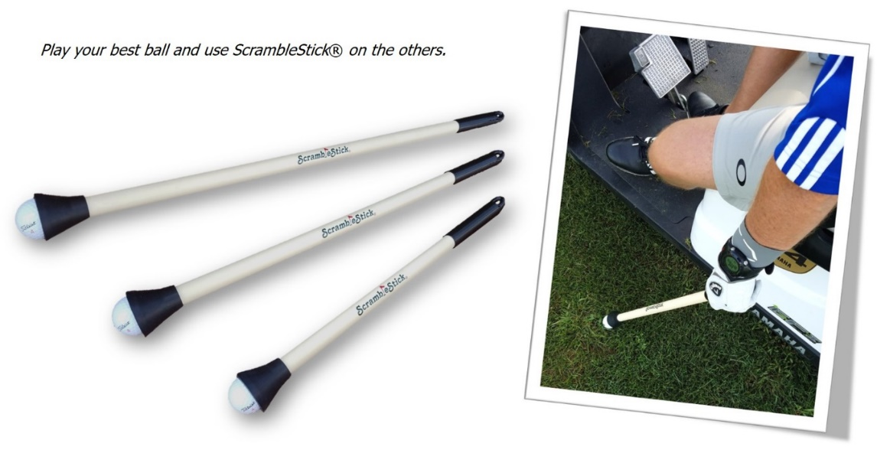
Some of the ScrambleStick® benefits:
- Lightweight design that’s easy to use and fits in a golf bag club slot
- Minimizes physical effort required to retrieve golf balls from golf cart
- Aids to speed scramble tournament play
- Available in three unique sizes: 20” Shorty, 26” and 32”
- Space for promotional advertising (add your school/company logo or custom graphics)
The 2019 golf season is just around the corner and many scramble golf tournaments are in the planning stages. For a limited time, we are offering preseason discounts on ScrambleStick® orders* when you use the corresponding promo coupon code:
- Buy 100 and receive $500 dollars off* when you apply coupon code PRESEASON500.
- Buy 150 and receive $750 dollars off* when you apply coupon code PRESEASON750.
- Buy 200 and receive $1,000 dollars off* when you apply coupon code PRESEASON1000.
- Buy 250 and receive $1,250 dollars off* when you apply coupon code PRESEASON1250.
- Buy 300 and receive $1,500 dollars off* when you apply coupon code PRESEASON1500.
Checkout our website (scramblestickgolf.com) for more details and link to our YouTube channel.
Happy Scrambling!

*Offer good on Preseason Domestic Scramble Tournament orders placed before April 30th, 2019. Minimum 100 to 300 ScrambleStick® purchase. Use the corresponding coupon code at checkout. Mix or match sizes. Offer good through April 30th. Custom graphics available for extra fee. Offer applies to domestic scramble tournaments only. Restrictions apply.

