***

**Medication Lock Box Post -Survey**

In order to ensure that prescription medication is being taken only by those it is prescribed to, it is important to lock up medication in a secure container at home. The Ellensburg Healthy Youth Coalition, in partnership with the Washington State Health Care Authority, Division of Behavioral Health and Recovery, provided local residents lock boxes for this purpose.

1. At what location did you receive your lock box?

____________________________________________________________

1. Please rate your level of awareness about safe storage of prescription drugs.

(Circle one)

|  |  |  |  |  |
| --- | --- | --- | --- | --- |
| 1 | 2 | 3 | 4 | 5    (highly aware) |

(Not aware at all) (Highly aware)

1. Are you currently locking up your medication? **Yes or No**
2. Are you currently using your lock box to lock up your medication? **Yes or No**

For questions or concerns, please contact Sarah Foy by phone at 59-933-7544 or via email at [sarah@healthierkittitas.org](mailto:sarah@healthierkittitas.org)

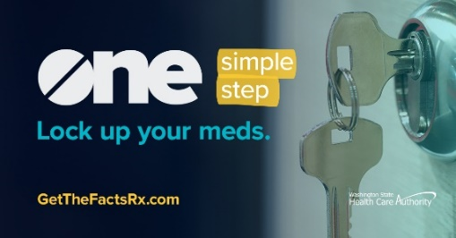

# 

***Thank you for taking this important step to keep your family and community safe!***

**IMPORTANT:** If you have expired or unused medication, make sure to dispose of it at one of the secure disposal sites listed below. Do not throw away or flush unused medication.

