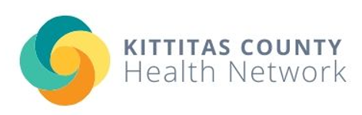

Medication Lock Box Pre-Survey

In order to ensure that prescription medication is being taken only by those it is prescribed to, it is important to lock up medication in a secure container at home. The Ellensburg Healthy Youth Coalition, in partnership with the Washington State Health Care Authority, Division of Behavioral Health and Recovery, is providing lock boxes to local residents to lock up their medication.

- Please rate your level of awareness about safe storage of prescription drugs.

(Circle one)
1 | 2 | 3 | 4 | 5  (highly aware)
(Not aware at all) (Highly aware)

- Are you currently locking up your medication? Yes or No

- Do you currently have a secure, lockable container for your medication? Yes or No

If you would like a secure medication lock box, please write your name and phone number or email address below. Within 90 days, you will be contacted for a short follow-up survey after receiving your lock box.

Name: ____________________________________________________________

Email: _____________________________ Phone: _______________________

For questions or concerns, please contact Sarah Foy by phone at 509-933-7544 or via email at sarah@healthierkittitas.org.

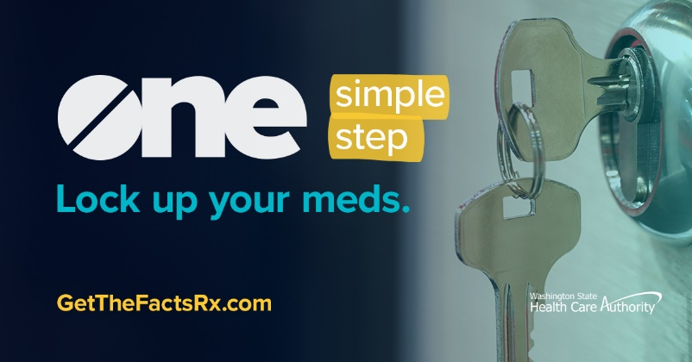
Thank you for taking this important step to keep your family and community safe!

