Our curriculum

**To become an independent , confident individual for my next journey – with all these skills learnt**

WHY??

**To become a successful reader, writer and be able to problem solve**

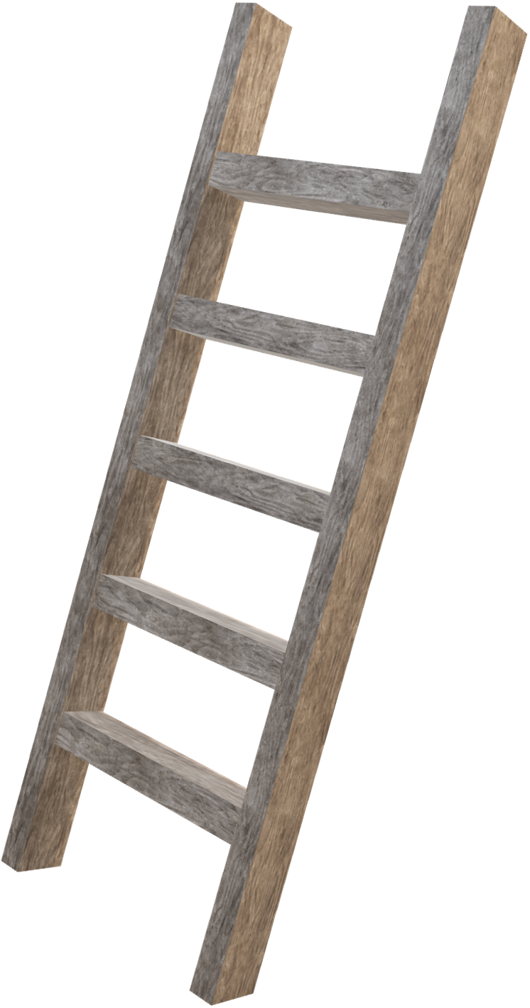

**To have respect and care/ concern for living things and to look after the environment we live in**

**To be able to self -regulate and express my emotions**

**to ensure all children are welcome and children learn about differences and have respect and be kind to each other**

**To be able to look after themselves and others and achieve – I can.**

**To be able to reach their full potential and have an I can attitude and be able to ask for help**

**To have an awareness of the people in the community and who to go to for help**

**To know what they can do and to do more feeling safe and secure in their environment**

**We are with you every step of the way**