A Holistic Approach to Learning

Program Offerings
Volume V

2022-2023

South Dakota School of Massage Therapy, Inc.
100 N. Krohn Place
Sioux Falls, South Dakota 57103
605-321-8838

Table of Contents

History 4
Our Facility 5
Mission, Philosophy 6
700 Hour Program 7
Course Offerings 8-12
Admissions 12-13
Standards of Progress 14-15
Tuition and Fees 16-17
Refund Policy 18-19
Student Conduct Policies 20-27
Tutoring, MBLEX, Licensure 28
Faculty 29-31
School Calendar 32
Testimonials 33

This Catalog may not be copied or reproduced in any way.
*All items may be subject to change.

History

The Beginning
Founded in 1987, the school was set into motion by Robin Jensen, a 1977 graduate of the Boulder School of Massage Therapy. There she received 1,000 hours of instruction, as well as 600 hours of intensive training at the Boulder Center of Polarity Therapy. After she passed, her husband, Dan Jensen continued operations with pride and reverence. In the summer of 2018, the school was purchased with passion by Rebecca Herrmann and Heather Herrick.

Growth
The school roots and origin were homegrown. It outgrew its cozy nest in the basement of the founder’s home after six years of flourishing. It remained across from USF on 22nd street here in Sioux Falls, SD for 29 years. Many amazing and beautiful improvements were made to that facility to be a comfortable learning environment. As of 2019 the school resides in one of the historical School for the Deaf buildings on the East side of Sioux Falls, SD. This building is inviting and spacious.
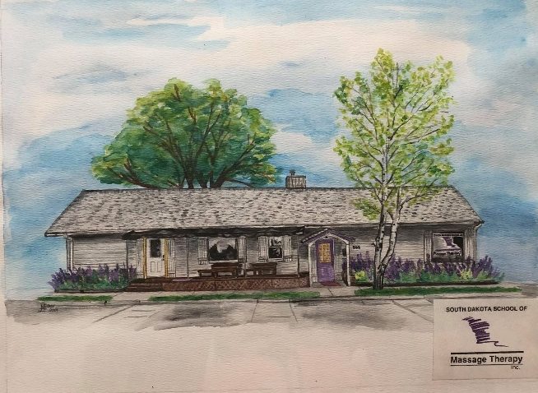
Veteran’s Benefits
In 1995, the curriculum was approved for eligible Veteran’s educational benefits including National Guard and Reserves.

Our Facility

Approximately 2500 sq. ft. of the Historic SD School for the Deaf building is now home to the SD School of Massage Therapy. The main classroom is over 1100 sq. ft. and has ample space for lab and lecture areas. The evolving library and student lounge are cozy and comprehensive.

Our community kitchen consists of over 500 sq. ft., all major appliances, two main level ADA compliant bathrooms and on-site laundry.

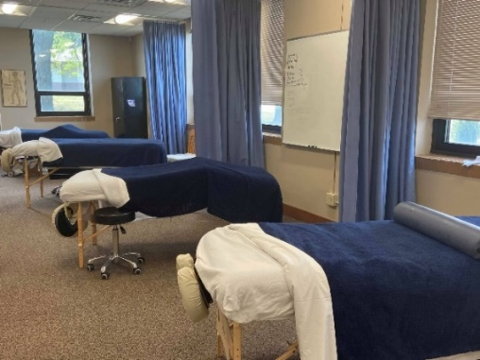
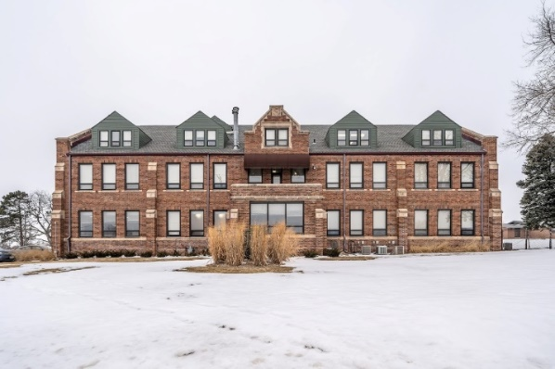
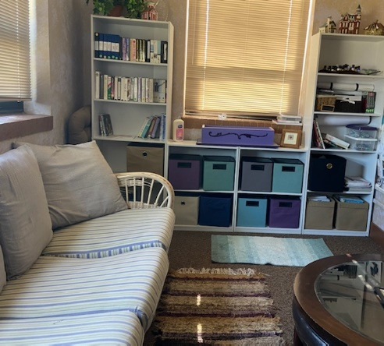
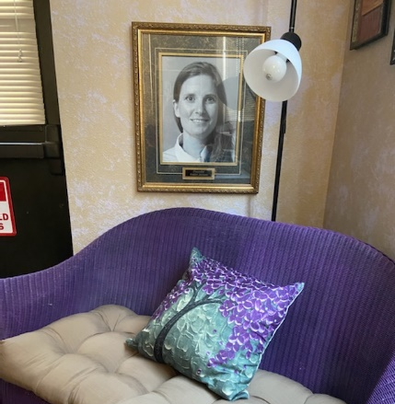
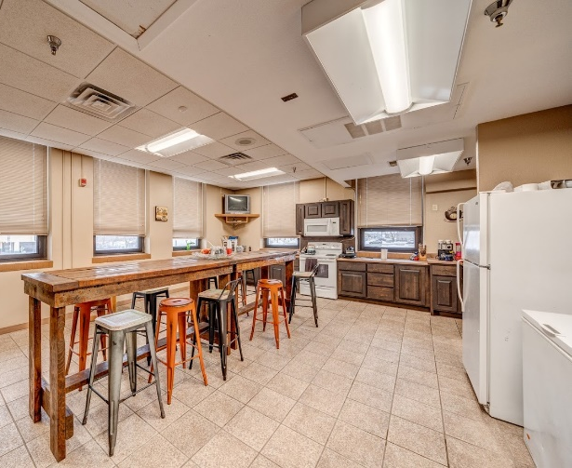

Equipment

Updated technology and equipment gives our students real world application and experience during our interactive hands-on classes.

The school utilizes three full-sized anatomy teaching skeletons, clay model skeletons, and other learning aids for instructional purposes. A variety of massage tables and portable massage chairs are introduced along with oils, lotions, and other massage accessories.

Mission

The South Dakota School of Massage Therapy, Inc. is dedicated to providing a strong foundation which will enable our graduates to successfully pursue a career in massage therapy. We are committed to the professional and personal growth of each person individually, to enhance the well-being and sense of satisfaction in their life. In order to provide the best possible overall experience, we are dedicated to ongoing self-evaluation, improvement of the school, its faculty and curriculum.

Philosophy

The South Dakota School of Massage Therapy, Inc. is a place for men and women to grow, learn and expand their awareness. The school’s philosophy is centered on the concept of the one-room schoolhouse: a holistic approach to learning in an environment which stresses basic core values and promotes development of a sense of who we are. Class size is limited to allow for one-on-one instruction. Each class bonds as a group by taking all classes together in sequence. This creates a sense of community necessary for personal growth, an important component of our program.

700 Hour Program

The 700-hour program includes Swedish massage, specialized massage techniques, and other subjects related to the healing arts. In addition, students receive instruction in anatomy, physiology, pathology, kinesiology, and Zoologik™ Anatomy in Clay lab. Our curriculum includes an emphasis on self-awareness and personal growth as an integral part of becoming a caring professional. A graduating student will have a basic working knowledge of all that is offered and taught at the school. Upon completion of the program students will receive a Certificate of Completion. Alumni CEU discounts available.

- Course of study is completed in 7 months for day class attendees and 11 months for night class attendees.
- Day class students attend Monday and Tuesday 8:00am - 5:30pm and on Wednesdays from 8:00 am - Noon.
- Night class students attend Monday - Thursday 6:00pm - 10:00pm.
- Students must complete 50 hours (second semester) at an approved externship site.
- As a clock hour school, college credits do not transfer into our program.*
- Our teacher/student ratio averages 1:2 depending on class size.

The 700-hour program includes the following courses:
- Massage Therapy l – Basic Swedish Massage 115
- Massage Therapy II – Clinical Application/Assessment 110
- Massage Therapy III – Combined Therapies 150
- Anatomy, Physiology, Lab, Kinesiology, Pathology,
Zoologik™ 225
- Professional Business & Ethics 10
- Pathology 40
- Externship 50

Total Hours 700

*Clock hours are the total number of actual hours a student spends attending class or other instructional activities that count toward completing the program.

Course Offerings

Massage and Technique Courses

Massage Therapy I – Basic Swedish Massage
(115 hours)
Students will learn basic Swedish massage stokes including effleurage, petrissage, friction, vibration, and tapotement. This class includes theory, history, benefits, and contraindications of massage therapy. Through in-class demonstration and supervised practice, students will learn proper draping, use of oils and working with their own breath and body movements. Also includes learning to teach the client proper breathing with their treatment and T.M.J. jaw work. In-class and out-of-class practice required.

Massage Therapy II – Clinical Application/Assessment
(110 hours)
Along with Swedish massage, students are taught manual therapy approaches that address specific tissues and organ systems of enhanced healing on a holistic level. Students will learn the essentials of the effects that various massage techniques have and how to apply them for the
greatest therapeutic benefit in each individual case. As a part of each massage and technique class, each student will be giving as well as receiving treatments as part of their practice.

Massage Therapy III – Combined Therapies
(150 hours)
The student will learn to combine several types or therapies to create a customized treatment for each client. Includes use of Swedish massage, acupressure, foot reflexology, hydrotherapy, aromatherapy, breathing techniques, heated stone therapy, music, and specific physical problem areas. In-class and out-of-class practice required.
Students learn massage therapy techniques.

Course Offerings

Health Basics
(225 hours)

Anatomy
Anatomy is the study of the structure of the human body and the relation of its parts to each other. The student will learn basic anatomy. Skeletons and mannequins are utilized for the instruction. Anatomy is taught concurrently with Physiology.

Physiology
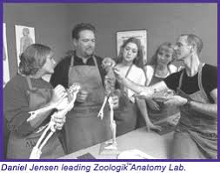
Physiology is the science of the functioning of the body. Students will learn the basic physiological functions of the body at the cellular, tissue, organ, and system levels. Physiology is taught concurrently with Anatomy.

Zoologik™ Anatomy Lab
To gain a hands-on understanding of the human musculoskeletal anatomy, the student will participate in a lab by forming anatomy in clay and attaching it to uniquely designed skeletal models. The Zoologik™ Anatomy Lab is taught concurrently with Anatomy and Physiology.

Kinesiology
In this course the student will learn about the mechanics of movement. It expands upon the basic anatomy and physiology knowledge as related to activity and freedom or restriction of movement. Kinesiology is taught as part of Anatomy and Physiology.

Pathology
Pathology is the study of abnormal conditions in the body. Students will be introduced to common disease processes as they relate to massage therapy. Pathology is taught as part of Anatomy and Physiology.

Course Offerings

Massage Techniques Overview

Introduction to Reflexology
The feet contain a map of the body. There are numerous reflexes found in the feet, each relating to a specific organ or part of the body. History and Theory will be taught, and the student will learn to give a complete foot reflexology treatment. Proper techniques for applying appropriate pressure to specific reflex points will be taught.

Introduction to Heated Stone Therapy
Heated stone therapy involves the use of smooth lava rocks heated to a therapeutic temperature in water. The student will learn to use heated and cold stones with a full body massage. The use of heated stones, along with the massage, adds greater benefits for healing and relaxation.

Introduction to Hydrotherapy/Aromatherapy
Hydrotherapy is the therapeutic use of water. The student will

learn History and Theory and a variety of treatments including use of hot and cold packs and poultices. Use of paraffin wax for hands and feet is also introduced. Aromatherapy: using essential oils, students will learn to make and create their own products for use with clients.

Introduction to Sports Massage
The student will receive a brief introduction to sports massage techniques that are designed to enhance performance, prevent injury, and assist in recovery. The course includes stretches and joint mobilization techniques that can be used with regular massage as well.

Introduction to Thai-Yoga Massage
Students hone their passive stretching skills by learning the basics of Thai-yoga massage to pique their interest in continuing their education after completing the program.

Course Offerings

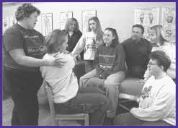

First Aid and CPR
The student will learn the techniques of First Aid as well as life-saving CPR techniques. This 8-hour course is conducted during normal class hours and will result in certification.

On-Site Massage
The student will learn how to use a portable massage chair to apply massage techniques for a brief and modified massage most often used in the workplace. We will go on-site to establishments to practice these techniques.

Self-Care

Personal Growth and Enrichment
Various instructors facilitate weekly classes. These classes are on several different stress management topics to enhance personal and professional growth.
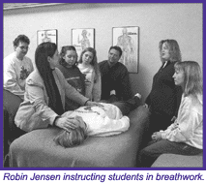

Breathwork
Our emotions affect our bodies, and our bodies can store emotional “memories”. During massage emotions may spontaneously surface. Students will learn how to use guided breathwork to assist in the healing process of emotional release. Each student will participate in facilitating as well as receiving breathwork session.

Course Offerings

Professional Business
The students will learn basic business skills, including creating a business plan, setting up a practice, bookkeeping, record keeping, clinical charting, health assessment and history, goal setting, marketing and client retention. The course includes business ethics, legalities, and integrity.

Guest Speakers
Guest speakers will be incorporated into the course to lecture on related subjects including anatomy, physiology, and various aspects of healing.

Admissions

Requirements for Admission

To apply to the South Dakota School of Massage Therapy Inc. an applicant must have a high school diploma or legal equivalent. Also, he/she must be physically capable of performing all massage techniques taught at the school.

Application Procedure
- Applications may be obtained in person or downloaded from our website.
- Deadline for application is 14 days prior to the first scheduled day of class.
- Each application must include the following:
  - Completed application
  - Three letters of reference
  - Autobiography/letter of intent
- Non-Refundable application fee ($100.00)
  - Wallet-sized photo
  - Official transcripts from high school, colleges or technical training programs attended

Admissions

During the admissions process, we invite you to schedule a tour with our President to learn more about our facility and what our program offers. We would love to know about you and the path that led you here.

If you are accepted into the school but the class you applied for becomes full or is cancelled, the application fee may be applied to the next available class for up to one year.

Transfer of Credit
A copy of your valid certification in CPR and First Aid may be credited towards these program requirements. The certificates must not expire while the student is attending the South Dakota School of Massage Therapy. No other transfer of credit is allowed.

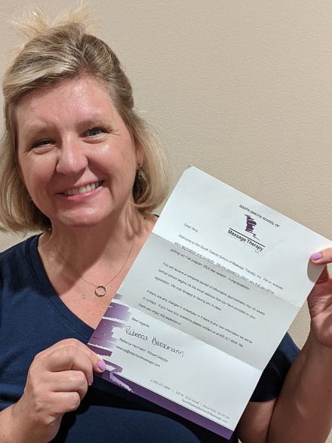

Standards of Progress

Grading System
Grades are based on attendance, participation, and adequate completion of assignments. Students will be given a letter grade for each course based on the following scale:
A+ 98-100 C+ 77-79
A 94-97 C 74-78
A- 90-93 C- 70-73
B+ 87-89 D 69 or ↓ is a
B 84-86 failing grade
B- 80-83
- For certain technique course related to the core curriculum, a designation of satisfactory or unsatisfactory will be given based on demonstration of an acceptable level of skill.
- Students will receive an overall GPA for the entire program.

Student Grade Reports and Evaluations
Students will be given grade reports at the end of each semester or unless requested. Upon completion of the program, each student will receive a transcript of completed coursework.

Satisfactory Progress

Defined as a student who:
- Adheres to all policies and rules of the school.
- Maintains an overall grade point average of ‘C’ or better.
- Maintains 95% attendance in all classes.
- Has missed no more than 25 hours total for the program.
- Completes any make-up work for time missed for any reason, within one week of absence.

Unsatisfactory Progress

Unsatisfactory progress will be defined as failing to meet the minimum acceptable standards as described in the section above. If a student is having difficulty maintaining minimum standards, it is the student’s responsibility to contact the instructor(s) for assistance.

Standards of Progress

Graduation Requirements
A successful graduate shall:
- Complete all coursework with a passing grade or designation of satisfactory, where applicable.
- Have an overall grade average of ‘C’ or above.
- Have an overall attendance record or 95%.
- Have completed all work required outside of class including externship, papers, projects, and any make-up work.
- Return all library materials borrowed. If materials are not returned or are returned damaged, the student must pay the replacement cost of the item(s) before being allowed to graduate.
- Pay all tuition and fees in full.

Student Records
Student Access
Permanent records are kept for each student. Students have the right to request access to his/her file. Such a request should be submitted in writing to the school director. Arrangement will be made for the student to be able to view the file. Student records are property of the South Dakota School of Massage Therapy Inc.

Student Transcripts
Student files are kept in a secure manner. Access to student transcripts can only be given to institutions, individuals, or employers with prior written authorization from the student. Each student will be given one free copy of his/her transcript upon graduation. Additional transcripts may be obtained for a $25.00 fee. In accordance with the law, the graduate must request a transcript in writing.

Placement Assistance
While the school cannot guarantee employment, we have found our graduates to be in high demand. We frequently receive calls from area health professionals and businesses requesting massage therapy referrals and make every effort to make students aware of these opportunities and post them as they become available.

Tuition and Fees

Note: Financing must be arranged for the entire
program before entering.

Required Expenses

- Tuition $8,200.00
- Tuition 6% Sales Tax $533.00
- Non-Refundable Application Fee $100.00
- Non-Refundable Liability Insurance $0-25
- Books/Supplies $500.00
- MBLEX testing fees ($265.00) Included in tuition costs

Optional Expenses

- Massage Table* (range varies) $150-3,000.00
- On-Site Massage Chair Approx. $500.00
- Oils, Linens, Towels* Approx. $30-100.00
- School T-shirt $16.00
- School Sweatshirt $32.00

*South Dakota School of Massage Therapy uses a variety of tables and lotions as introductions for all students to choose what suits them best. Tables, lotions, and accessories can be purchased through the school at a discounted rate.

*During classroom instruction tables and supplies will be provided. Students must obtain their own materials, supplies and massage tables for use in practicing massage skills outside of class.

Tuition and Fees

Tuition Assistance
The South Dakota School of Massage Therapy is approved for eligible veterans’ educational benefits that include National Guards and Reserves or for students eligible for Vocational Rehabilitation. Currently no other tuition assistance is available through the school. Many banks, religious organizations, and various scholarships (high school, local charities, local businesses, and employers) may provide personal financial assistance to students. Information may be obtained from your high school guidance counselor or library.

Payment

- Financing must be arranged for the entire program before entering school.
- Payment Options:
  - Tuition, Insurance, and books paid in full prior to start of the program.
  - Insurance and books paid in full prior to start of the program. Tuition paid in two equal payments, with each 50% payment due prior to the beginning of each semester.
  - Eligible Veterans Educational Benefits (including National Guards and Reserves).
  - Eligible Vocational Rehabilitation Educational Benefits.

Refund Policy

Program Withdrawal and Refund Policy

- If a student elects to withdraw from the school, Program Withdrawal and Refund Policy will apply. All procedures must be followed accurately. In all cases when a student elects to withdraw, notification must be sent in writing, by U.S. mail, registered or certified, return receipt requested to Rebecca Herrmann, c/o the South Dakota School of Massage Therapy, 100 N. Krohn Place, Sioux Falls, South Dakota 57103.
- If 75% or more of the course has been completed, no refund will be given.
- Application fee is non-refundable.

Withdrawal Before Start of Program

In all cases, the application fee is non-refundable. A student may cancel this contract and receive a refund of the tuition paid by giving written notice sent by the close of the 15th business day after the date of execution of the contract (the day it is signed), sent by U.S. Mail, certified or registered, return receipt requested to Rebecca Herrmann, c/o the South Dakota School of Massage Therapy, 100 N. Krohn Place, Sioux Falls, South Dakota 57103. The school will deduct a $250.00 withdrawal fee from the tuition refund owed.

If written notice of cancellation (as specified above) has not been received following the 15th business day after the execution of the contract but is received before the start of the course of instruction, the school will retain a $350.00 withdrawal fee.

The official termination date for a student who has been accepted into the program but does not start will be the date that the student’s letter of cancellation (sent as stated above in this policy) is received by the school.

If the 25th business day after the execution of the contract falls after the start of the course of instruction (see below), The “Withdrawal After Start of the Program” refund policy will apply.

Refund Policy

Withdrawal After Start of Program

In all cases, the application and liability insurance fees are non-refundable, including textbooks. If a student has been accepted by the school and elects to withdrawal after the start of the course, written notice of cancellation must be sent by U.S. Mail, registered, certified, or return receipt requested to Rebecca Herrmann, c/o the South Dakota School of Massage Therapy, 100 N. Krohn Place, Sioux Falls, South Dakota 57103.

The official termination date will be the day the student’s withdrawal letter is received by the school. Tuition will be charged for any and all class time the student was in attendance or absent. If 75% or more of the course has been completed, no refund will be given.

A $500.00 withdrawal fee will be assessed for a withdrawal after the start of course instruction and will be deducted from the net tuition refund owed to the student.

Program Termination

If the school elects to cancel the program, all tuition will be refunded. The application fee will be applied to the next class.

Student Dismissal

If a student is dismissed for violating school policy (see “Grounds for Dismissal” section in the Student Conduct Policies), no tuition refund will be given.

Leave of Absence

An excused leave of absence will be reviewed on a case-by-case basis with the School Director.

Student Conduct Policies

Student Sexual Harassment and Discrimination Policy

The South Dakota School of Massage Therapy is committed to maintaining a safe school environment that is free from harassment and discrimination. The school prohibits, at school or at school-sponsored or school-related activities, student clinic and student externships, sexual harassment and/or discrimination targeted towards any student by anyone. The school also prohibits retaliatory behavior or action against any person who reports, files a complaint, or testifies about, or otherwise supports a complainant in alleging sexual harassment or discrimination.
The South Dakota School of Massage Therapy strongly encourages any student who feels that he/she is being or has been sexually harassed or discriminated against on school grounds or at a school-sponsored or school-related activity by another student or an adult who has experienced off-campus sexual harassment that has a continuing effect on campus to immediately contact his/her instructor or any other available school employee. Any employee who receives a report or observes an incident of sexual harassment shall notify the Vice-President, Heather Herrick. Once notified, she shall take the steps to investigate and address the allegation.
Discrimination shall be defined as any unequitable behavior towards another student on the basis of gender identity or expression, race, orientation, religion, age, ethnicity, color, ancestry, disability, marital status, arrest, or court records.
Examples of Sexual Harassment
Conduct (including electronic communications, acts, or postings) which may constitute sexual harassment includes, but is not limited to, the following:
- Verbal - unwelcome conduct such as the use of suggestive, derogatory, or vulgar comments; the use of sexual innuendos or

Student Conduct Policies

slurs; making unwanted sexual advances, invitations, and/or comments; pestering for dates; making threats; and/or spreading rumors about or rating others as to their sexual activity or performance; threats/demands/pressure to submit to sexual requests in order to keep a job or academic standing or to avoid other loss, and/or offers of benefits in return for sexual favors.
- Visual - unwelcome conduct such as the display of sexually suggestive objects, pictures, posters, written material, cartoons, or drawings; the use of graffiti, texting and/or computer-generated images of a sexual nature; and/or the use of obscene gestures or leering.
- Physical - unwelcome conduct such as unwanted touching, pinching, kissing, patting, or hugging; the blocking of normal movement; stalking; sexual acts or assault; and/or physical interference with work or study directed at an individual because of the individual’s actual or perceived sex, sexual orientation, gender identity or gender expression.
Complaint Process and Disciplinary Actions
Sexual harassment and discrimination complaints by and against students shall be investigated and resolved in accordance with the South Dakota School of Massage Therapy’s complaint policy.
Upon investigation of a sexual harassment or discrimination complaint, any student found to have engaged in aforementioned behavior in violation of this policy shall be subject to disciplinary action. For students’ disciplinary action may include suspension and/or expulsion, provided that, in imposing such discipline, the entire circumstances of the incident(s) shall be considered.

Student Conduct Policies

If a complaint of sexual harassment or discrimination is initially submitted to the Vice-President, he/she shall, within two school days, initiate investigation of the complaint.
In investigating a sexual harassment or discrimination complaint, evidence of past sexual relationships of the victim shall not be considered, except to the extent that such evidence may relate to the victim's prior relationship with the respondent.
In any case of sexual harassment or discrimination involving the Vice-President, the report may instead be submitted to the President who shall determine who will investigate the complaint.
Confidentiality
All complaints and allegations of sexual harassment or discrimination shall be kept confidential except as necessary to carry out the investigation or take other subsequent necessary action.
However, when a complainant or victim of sexual harassment or discrimination notifies the Vice-President of the harassment but requests confidentiality, the Vice-President shall inform him/her that the request may limit the Vice-President’s ability to investigate the harassment or take other necessary action. When honoring a request for confidentiality, the Vice-President will nevertheless take all reasonable steps to investigate and respond to the complaint consistent with the request.
When a complainant or victim of sexual harassment or discrimination notifies the Vice-President of the harassment but requests that the Vice-President not pursue an investigation, the South Dakota School of Massage Therapy will determine whether or not it can honor such a request while still providing a safe and nondiscriminatory environment for all students.

Student Conduct Policies

Attendance

Attendance at all scheduled classes is mandatory.

Lateness

A student will be considered late if he/she arrives at class 5 minutes after roll is taken. Excessive tardiness will be considered violation of school conduct policy (disruptive to a positive learning environment or interfering with other student’s rights) and will be cause for disciplinary action.

Absences

Unexcused: An unexcused absence means that a student did not attend class and did not contact the school. Sleeping through class will be considered an unexcused absence. Each unexcused absence will result in a drop in ½ a letter grade. No credit will be given for any assignment due that day and make-up work will be required.

Excused: An absence may be excused at the discretion of the instructor. Instances under which an absence may be excused are:
- Emergency
- Illness
- Legitimate Conflict (arranged ahead of time)

Student Conduct Policies

Make-Up Work

- In the case of any absence, it is the responsibility of the student to contact the instructor by the next scheduled class period to turn in any make-up work. Any assignment that was due on the day missed must be turned in by the next scheduled class.
- If an absence is arranged ahead of time, any assignment due on the day to be missed must be turned in prior to the absence.
- For any time missed for any reason (absence, tardy, left early) make-up work will be required. This work is separate from any class assignment. The extra work assigned will be equivalent to and will make up for clock hours missed. It is the responsibility of the student to contact the instructor regarding make-up work and to complete it by the due date assigned.
- Instructors do not hand out class lecture notes. Class lecture notes must be obtained from a fellow student.

Student Conduct and Disciplinary Policy

The South Dakota School of Massage Therapy reserves the right to dismiss a student for violations of school policy. In the case of dismissal, refund policy does not apply.

Grounds for Dismissal
- The student is found to be under the influence or is suspected of using drugs or alcohol during school hours. The student will be terminated immediately.
- Behavior which does not reflect positively upon the reputation of the school or the massage therapy profession.
- Behavior which is disruptive to a positive learning environment, or is interfering with other student’s rights including discrimination and sexual harassment.
- The student is not maintaining the minimum acceptable academic standards of progress.

Student Conduct Policies

Student Conduct and Disciplinary Policy

Termination Policy

The school reserves the right to vary or revise disciplinary procedures at its discretion. Students will be treated in a reasonable and fair manner and will be given a fair and sincere opportunity to be heard. A student has the right to request a reevaluation of disciplinary measures.

The student will be terminated immediately if the student is found to be under the influence or is suspected of using drugs or alcohol during school hours.
The process for dismissal for all other misconduct shall be:

First Time Offense
The student will receive a verbal warning.
Second Offense
The student will receive a written notice placing the student under a two-week probation. During this time, the student must show reasonable effort to improve the situation and abide by the conditions set forth for the probationary period.
Third Offense
The student will receive a written withdrawal form dismissing the student from the program.

Complaints or Reevaluation of Disciplinary Measures

Written complaints or requests for reevaluation must be presented in writing to the Vice President. Each situation will be evaluated by the Vice President, and a response will be given within ten days of receipt of the complaint. Unless complaint is sexual harassment or discrimination.

A student may also make an appointment with a faculty or staff member to express his/her concerns. Any discussion will be considered confidential.

Student Conduct Policies

Leave of Absence

Leaving the Program
If a student chooses to leave the program prior to graduation, the following will apply:
- A meeting must be arranged with the School President to discuss the student’s reason(s) for leaving. At this time, an official withdrawal form will be filed with the school.
- Program Withdrawal and Refund Policy will apply.
- If a student simply quits attending classes without notifying the school of his/her intention to withdraw, he/she will be considered enrolled and absent (unexcused) from class. In this case, Program Withdrawal and Refund Policy do not apply unless the student officially requests withdrawal according to the policies stated in this catalog.

Returning to the Program
For any student wishing to return to the program, the following rules apply:
- The school reserves the right to refuse readmission to any student.
- A student who was dismissed by the school for violation of school policy will not be readmitted.
- A student must reapply, be accepted, and must begin the program over. The student will be responsible for the full cost of tuition paid.

Leave of Absence
A leave of absence due to emergency or illness may be arranged and must not exceed two weeks during any semester. Upon returning to class, all missed hours and work must be made up prior to graduation. If circumstances require a longer leave of absence, the student may be required to withdraw and repeat the semester during the next available class within one year. If the student is required to repeat a semester, he/she will owe full tuition for that semester regardless of previous tuition paid. Extenuating circumstances will be considered on a case-by-case basis.

Tutoring Services

Individualized, one-on-one tutoring is available to be scheduled outside of classroom hours with an instructor. This tutoring can be specialized to fix your needs or MBLEX prep for $25/hour to be paid directly to the school.

MBLEX

MBLEX Testing
Students are eligible to sit for the MBLEX exam before completion of this program. Typically, this will occur 3-4 weeks prior to completion. Approximately 30 weeks into the program.

During class we will help students register and sign up to take the MBLEX. The initial fee is covered in your tuition costs. However, if the exam needs to be retaken the student is responsible for the fees.

Licensure

A Note About Licensure
Currently, most all the States in the US have requirements for licensure. SD does require licensure. Where no state law exists, such as in MN, local laws will have varying requirements for the practice of massage therapy and regulation of massage therapy establishments (business sites). In some cases, you may be starting from scratch in your community. Our curriculum has been satisfactory for those graduates wishing to practice in states requiring 700 hours of training or less. We strongly encourage you to become informed regarding the regulation of massage therapy and massage therapy establishments in the city of state where you intend to practice after graduation. If you have questions about licensure, contact the South Dakota Board of Massage Therapy at 605-773-6193 or email massagetherapy@state.sd.us.

Faculty

Rebecca Herrmann, LMT
Rebecca has been a massage therapist since March 2001 after graduating from South Dakota School of Massage Therapy herself. Creating Royal Table Massage Therapy allowed her the flexibility to work with people that shared the same belief in quality of service. Rebecca is trained in many modalities. Her favorites include Swedish, prenatal, massage cupping, foot reflexology and lymphatic drainage. She graduated with a bachelor’s degree in Business Management and Marketing. She is the President, Director, and Instructor at the South Dakota School of Massage Therapy.

Heather Herrick, LMT
Heather has been a massage therapist since September 2001. Heather has been teaching continuing education since 2004 and is the founder of Art of Teaching a NCBTMB educational organization approved for providing continuing education (CEU's). She is VP and head professor at the South Dakota School of Massage Therapy in Sioux Falls, SD. Heather has mastered several massage modalities including but not limited to Thai Massage, Hot and Cold Stone Therapy, Essential Oils, Glide Cupping, Sports Massage, Deep Tissue Massage, Reiki, Myofascial Release Techniques, Prenatal Massage, Deep Relaxation, Hospice Care, Swedish Massage, Paraffin Therapies and Reflexology.

Faculty

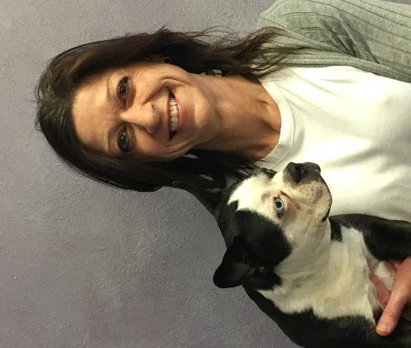
Kelli Nickerson, LMT Registered Dietician
Kelli is a licensed massage therapist after graduating in 2019 from the South Dakota School of Massage Therapy. She has a B.S. in Biology, Chemistry, Nutrition and Dietetics. Kelli is certified in Nutrition, Hot Stone Massage, Cupping and Manual Lymphatic Drainage.

Daniel Jensen, Professor Emeritus
Daniel Jensen is a member of the American Massage Therapy Association (AMTA) and is the Instructor of Anatomy, Zoologik™ Anatomy Lab, Physiology, Kinesiology, and Pathology. Daniel has a BA degree in Exercise Physiology from Augustana College and has had significant education in the study of human anatomy and physiology, biology, chemistry, exercise physiology, kinesiology, biomechanics and stress management. He has studied and attended workshops and seminars in science of fascia, cadaver studies, hip and shoulder segmental bodywork, trigger point and postural assessment. He is also a graduate of the Zoologic™ Muscle Building in Clay course. This provides the students with a hands-on understanding of the human musculoskeletal anatomy. As an endurance athlete and speaker, Daniel has uniquely blended his experiences with his education to offer a comprehensive understanding of anatomy and physiology yet provide students with necessary study aids and lectures to assist in the learning process. Daniel also is a contributing author to the book Chicken Soup for the Traveler’s Soul, is a featured athlete in 3 documentary movies, and has set several physically challenged athlete world records.

Faculty

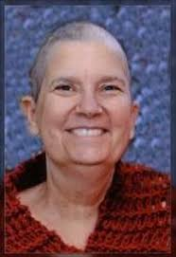
Robin Jensen, LMT (founder, deceased)
Robin Jensen was a member of the American Massage Therapy Association (AMTA) and Associated Bodywork and Massage Professional (ABMP) and was a graduate of the Boulder School of Massage Therapy Boulder, Colorado. Robin received 1,000 hours of instruction at the school, as well as 600 hours of intensive training at the Boulder Center of Polarity Therapy. Robin also graduated from the L.R.T. Rebirthing School in Omaha, Nebraska in 1993 where she studied for two years. Robin has studied and practiced therapeutic bodywork and holistic healing for over 25 years. She studied and attended workshops and seminars in for reflexology, therapeutic touch, sports massage, TMJ, heated stone therapy, Isolated active stretching, and many other areas. She worked with people suffering from mental illness as well as the critically and terminally ill. She has also helped women throughout pregnancy and during labor, doing massage and reflexology.

Calendar

Day classes meet:
Monday’s 8:00 am – 5:30 pm
Tuesday’s 8:00 am – 5:30 pm
Wednesday’s 8:00 am – Noon

Night classes meet:
Monday’s 6:00 pm – 10:00 pm
Tuesday’s 6:00 pm – 10:00 pm
Wednesday’s 6:00 pm – 10:00 pm
Thursday’s 6:00 pm – 10:00 pm

Winter 2022 Day Class
January 31st, 2022 - September 27th, 2022

Spring 2023 Day Class
October 17th, 2022 – June 14th, 2023

Winter 2023-2024 Day Class
July 10th, 2023 – March 6th, 2024

Winter 2023-2024 Night Class
July 10th, 2023 – May 16th, 2024

Community Input

“As a graduate of South Dakota School of Massage Therapy, I would highly recommend the school to anyone who is pursuing a massage therapy career. The hands-on learning is greatly beneficial and is a great way to learn quickly. Their seven-month program is the perfect time frame for a person looking to learn and get on with their career.” - Melinda Schelling, Graduate 2019

”I opened Monday, August 31st, with 12 appointments that week. Things are going well. I would like to thank you and those who helped me in the months I went to school. To your new students – may they realize how special you are.” - Jessica Desmet, Graduate

“We’ve been fortunate to have had the experience of working with several graduates from the South Dakota School of Massage Therapy. We’ve been very pleased with their work and dedication. Our patients enjoy them too.” - Hagen Chiropractic Clinic, Sioux Falls, SD

“Going to the South Dakota School of Massage Therapy provides you with a great taste of massage therapy. You learn about being a massage therapist as a whole life experience and ideas on how to confront all kinds of things related to your career. You will be encouraged and supported through the education process and that is worth so much. I love how much I have grown as a person in many ways because of attending the South Dakota School of Massage Therapy. I love being a licensed Massage Therapist!” -Amy Willison, Royal Table Massage, Sioux Falls, Graduate 2020

South Dakota School of Massage Therapy, Inc.
100 N. Krohn Place
Sioux Falls, South Dakota 57103605-321-8838

