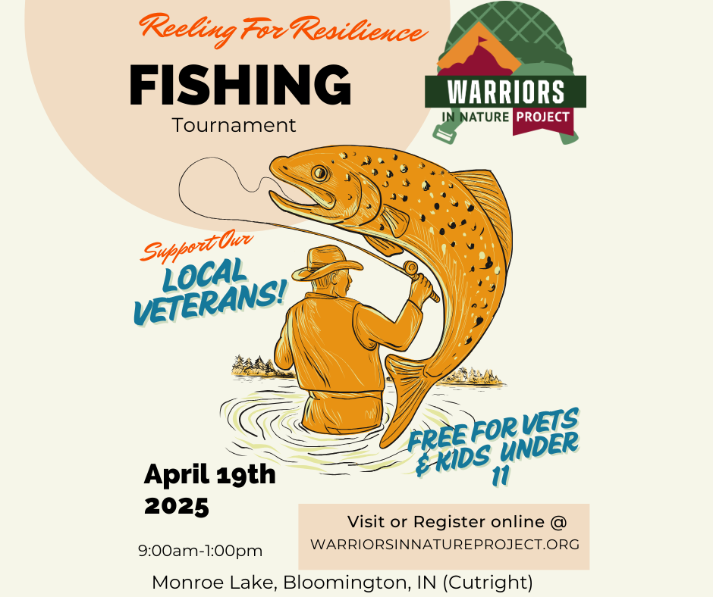

Reeling for Resilience Fishing Tournament

Sponsorship Opportunities

### **Bronze Sponsor - $50**

* **Contribution Use:**
  + Provide bait, tackle, or refreshments for participants.
* **Recognition:**
  + Company name listed on event posters and flyers.
  + Shout-out on social media platforms thanking the sponsor.

### **Silver Sponsor - $100**

* **Contribution Use:**
  + Cover the cost of awards for youth anglers.
* **Recognition:**
  + All Bronze Sponsor benefits plus:
  + Company logo on event posters, flyers, and online registration page.
  + Mention in pre-event emails to participants.

### **Gold Sponsor - $250**

* **Contribution Use:**
  + Fund a portion of adaptive equipment for disabled veterans.
* **Recognition:**
  + All Silver Sponsor benefits plus:
  + Company logo on event t-shirts.
  + Acknowledgment during the award ceremony.
  + Option to set up a promotional booth at the event.

### **Platinum Sponsor - $500**

* **Contribution Use:**
  + Provide lunch for participants or sponsor a specific prize category.
* **Recognition:**
  + All Gold Sponsor benefits plus:
  + Company logo featured prominently on all promotional materials.
  + Dedicated social media post highlighting the sponsorship.
  + Opportunity to present an award during the ceremony.

### **Diamond Sponsor - $1,000**

* **Contribution Use:**
  + Cover major event costs such as permits, insurance, and additional adaptive equipment.
* **Recognition:**
  + All Platinum Sponsor benefits plus:
  + Company banner displayed at the event.
  + Exclusive feature in a press release about the event.
  + Special mention and thank you in all event communications.

### **Thank You from Warriors in Nature Project**

We sincerely appreciate your generous support of the Warriors in Nature Project. Your sponsorship allows us to continue our mission of creating meaningful outdoor experiences for veterans and their families. Together, we can make a positive impact on their lives and build a stronger, more connected community. Thank you for your commitment to our cause.