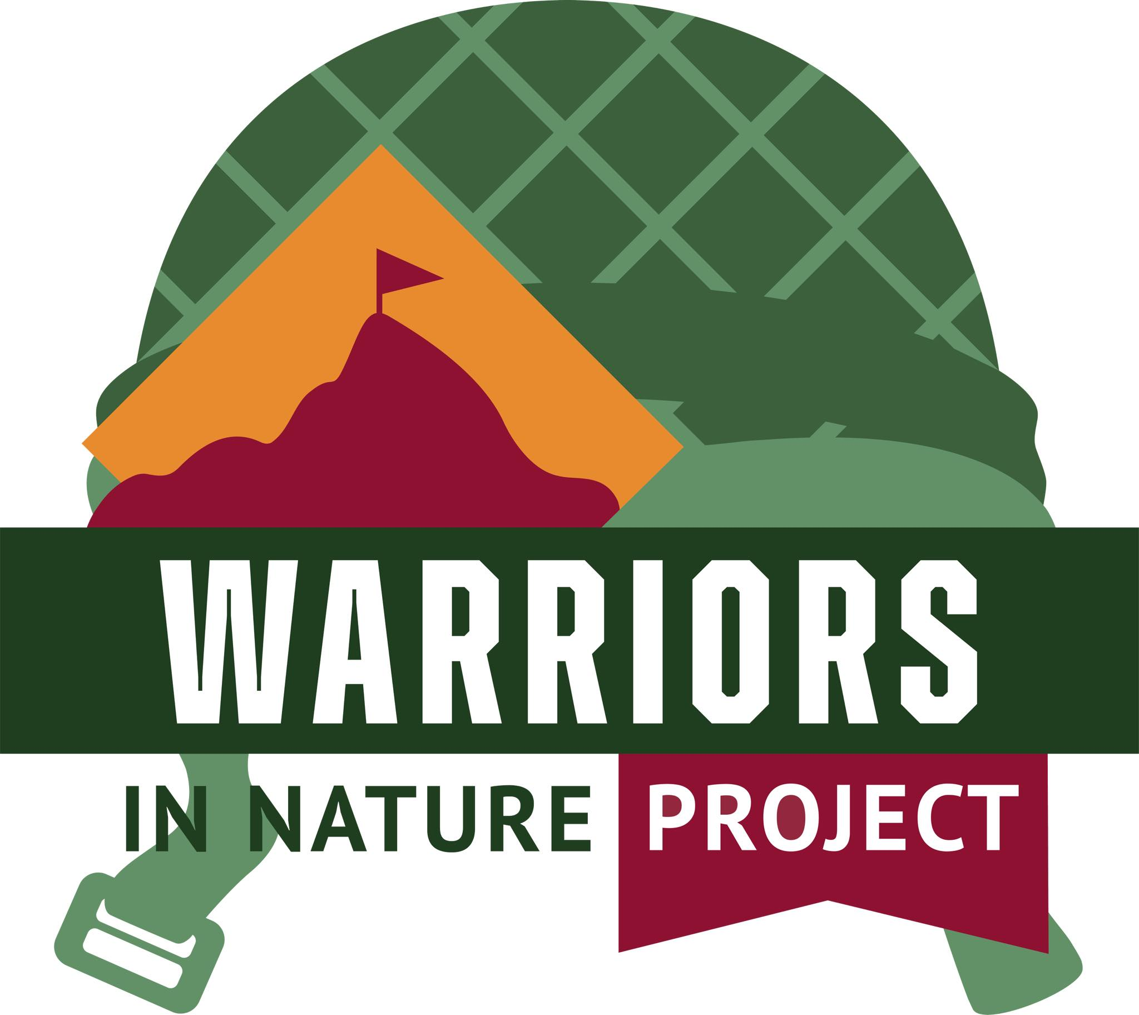

Simply Fitness Paddleboarding Event

June 13, 2025

Sponsorship Opportunities

### **Bronze Sponsor - $50**

* **Contribution Use:**
  + Provide sunscreen, refreshments, or snacks for participants.
* **Recognition:**
  + Company name listed on event posters and flyers.
  + Shout-out on social media platforms thanking the sponsor.

### **Silver Sponsor - $100**

* **Contribution Use:**
  + Cover the cost of safety equipment like life jackets.
* **Recognition:**
  + All Bronze Sponsor benefits plus:
  + Company logo on event posters, flyers, and online registration page.
  + Mention in pre-event emails to participants.

### **Gold Sponsor - $250**

* **Contribution Use:**
  + Fund additional paddleboards for participants.
* **Recognition:**
  + All Silver Sponsor benefits plus:
  + Company logo on event t-shirts.
  + Acknowledgment during the event.
  + Option to set up a promotional booth at the event.

### **Platinum Sponsor - $500**

* **Contribution Use:**
  + Sponsor a specific activity or provide additional safety equipment.
* **Recognition:**
  + All Gold Sponsor benefits plus:
  + Company logo featured prominently on all promotional materials.
  + Dedicated social media post highlighting the sponsorship.
  + Opportunity to present an award or lead an activity during the event.

### **Diamond Sponsor - $1,000**

* **Contribution Use:**
  + Cover major event costs such as permits, insurance, and additional adaptive equipment.
* **Recognition:**
  + All Platinum Sponsor benefits plus:
  + Company banner displayed at the event.
  + Exclusive feature in a press release about the event.
  + Special mention and thank you in all event communications

**Thank You from Warriors in Nature Project**

We sincerely appreciate your generous support of the Warriors in Nature Project. Your sponsorship allows us to continue our mission of creating meaningful outdoor experiences for veterans and their families. Together, we can make a positive impact on their lives and build a stronger, more connected community. Thank you for your commitment to our cause.