Preparing Ornamentation in
Baroque, Classical and Bel Canto Vocal Music

STEP ONE: Know your text: Your number one priority is to be a communicator of the text and music you’re singing. If you don’t know what you’re singing about or how your character feels, you don’t have anything to ornament! Ornamentation comes as a natural result of what your character is feeling in that moment.
- Research your piece and character. If the source material doesn’t provide a specific character, create one using Uta Hagen’s nine questions or another character development method. You need to find out exactly who your character is, how they feel, and what they want.
- Fully translate your text word for word.
- Learn how to properly pronounce your text. If you don’t know IPA, your teacher can help you with this step.
- Speak your text aloud to become familiar with it. Continue to review the text on its own, even after you know the piece well.

STEP TWO: Know which ornaments are appropriate for Baroque, Classical and Romantic stylistic periods.

BAROQUE:
In 19th & 20th century editions of Baroque music, such as the 26 Italian Songs and Arias, edited by John Glenn Paton, you will often find ornamentation written into the music. It’s ok to change these to suit your own preferences. Using the ornaments listed below, there is virtually no limit to what you can create! If you are using an original or scholarly edition of a Baroque score, there may be little to no ornamentation written in, but you are expected to add it. Consult the resources below for more detailed information.

Six basic ornaments and when to use them:
  - passing tone - between ascending or descending thirds 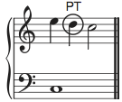
  - neighbor tone – between two notes of the same pitch 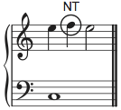 (can be an ascending or descending).

  - appoggiatura – precedes a written note, either above or below it, and serves as a dissonance to accentuate the written note.
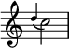
  - trill – often used at cadential points but can be used throughout. 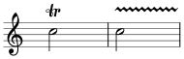
  - turn – often used at cadential points but can be used throughout. 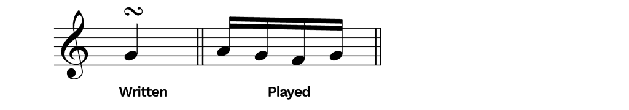
  - melisma (this includes cadenzas) or diminution – group of at least five or six notes sung on a single syllable/word to accentuate that word and/or the feelings of the character. Almost always found at cadential points.

CLASSICAL:
Ornaments in the Classical era are usually written out directly in the music, though this varies by edition. Ornaments can be added to classical pieces, but with more discretion than in Baroque. Consult the resources below for more detailed information. The most common are:
- trill – usually started from above the note in slower tempi and directly on the note in faster tempi. If you don’t have time to prepare the trill with a note before it, then the tempo is probably fast enough that you don’t need the preparation note and can start the trill directly on the written note.
- appoggiatura – if a phrase ends with two notes on the same pitch, an appoggiatura would be appropriate to add. You’ll find these everywhere in Mozart arias, usually at cadential points. Even if one isn’t written in, adding it is encouraged, especially at cadential points.
- turn – can be used throughout and at cadential points. Written out or indicated with a turn symbol. Usually start directly on the written note.
- melisma/cadenza – if a cadenza is not written in the music, it still may be appropriate to add one, especially if there is a fermata over a note anticipating a cadence. This is where listening to informed singers/conductors will be helpful for reference. And as always, ask your teacher for help!

BEL CANTO:
Ornaments in the Bel Canto era are usually written out directly in the music, though this varies by composer and edition. Music is more specifically notated by the composer than in previous eras. Ornaments can be changed, removed or added with discretion. Consult the resources below for more detailed information. The most common are:
- appoggiatura/grace note – appoggiaturas are faster than in previous eras, often notated with a grace note to indicate this faster speed.
- trill – can begin with a grace note, otherwise started directly on the written note. Isolated trills can be started from below.
- turn – often written out instead of indicated with a turn symbol. Usually start directly on the written note.
- melisma/cadenza – usually written in the score, changes are allowed. See the Ricci text below for traditional examples.
- messa di voce – the queen of Bel Canto ornaments! Indicated by < > symbol.
- accent marks such as >, ^, are used frequently above individual notes to indicate detachment from an otherwise continuous legato line.

STEP THREE: Play!
- Now that you know exactly who your character is, how they feel, and what they want, experiment with various ornaments in each phrase of the music (where stylistically appropriate for each era).
- Sit down at the piano with your score in front of you and focus on one phrase at a time. If one ornament doesn’t work, try another. Try as many as you can think of. Which one(s) work best for your character and your voice? Choose ornaments that suit your strengths as a singer. Record yourself singing the ornaments you like best and write them down in your score so you remember them. Note: ornaments must be kept in context of the voice leading and counterpoint of the piece. You will be able to hear it when something doesn’t work.
- Don’t gild the lily! Ornaments need not be overly complex or numerous and shouldn’t interfere with the communication of the words and drama.
- Ask for help from your teacher when you need it. Listen to the ornaments of your favorite professional singers for inspiration. Listen to as many examples as you can.
- For Da Capo arias, little ornamentation is needed in the A section, more is needed in the B section, and the A’ section should have the most ornamentation. The A’ section, or da capo, is where you are repeating your text and music from the A section. Why are you repeating it? The ornaments should reflect the feelings of your character.
- Anytime you repeat text is an opportunity for an ornament. Why is your character repeating the word or phrase?
- Don’t be so worried about doing something wrong or unstylish or unauthentic that you don’t do anything!

IMPORTANT:
Remember that the following musical devices can also be used as ornaments, as each of them are ways to express your text:
- dynamics – repeating the same text at least once? Try varying the dynamic. Messa di voce (indicated by the symbol < >) can be used in music from all eras.
- tempo & rhythm – follow tempo instructions carefully and/or create changes in tempo & rhythm when appropriate, i.e. rubato, rallentando and accelerando
- diction – correct consonant and vowel articulation, and the intention you put behind articulating each syllable can help better communicate exactly what your character feels and can even change the meaning of a phrase. Brightening or darkening a vowel is also part of this.
- harmony: a dissonant passage will be colored differently than a consonant passage
- vibrato – using straight tone and flexibly changing your vibrato width

Resources:

Donington, Robert. Baroque music: style and performance: a handbook. United
Kingdom: Norton, 1982.

Elliott, Martha. Singing in style: a guide to vocal performance practices. United
Kingdom: Yale University Press, 2006.

Ricci, Luigi. Variazioni, cadenze, tradizioni per canto: Voci femminili. Italy: Ricordi, 1937.
(Available in Voci femminili, Voci maschili, Voci miste and Variazioni e Cadenze di G.
Rossini)

Stark, James. Bel Canto: A History of Vocal Pedagogy. United Kingdom: University of Toronto
Press, 1999.

Tosi, Pier Francesco, Agricola, Johann Friedrich. Introduction to the Art of Singing by Johann
Friedrich Agricola. United Kingdom: Cambridge University Press, 1995.

*The above resources quote many treatises and other scholarly works that will inform you of the best historical performance practices for Ornamentation. These books are a good place to start to become familiar with the various treatises written during each musical era.

*The NATS Journal of Singing has many articles available in the archives on the subject of Ornamentation.

