Friends of the Grand Blanc Grid
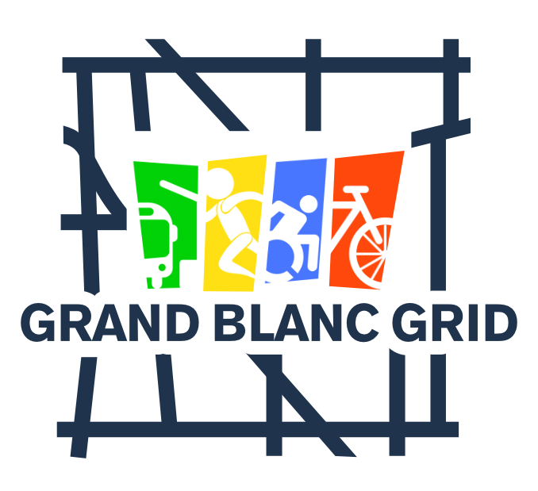

Friends of the Grand Blanc Grid was created to support and encourage the development and maintenance of active transportation pathways.

We are hosting our fifth annual Pumpkin Walk on Friday, October 24, 5:00 - 8:00pm at Physician’s Park. This year we are joining with the City of Grand Blanc’s Halloween celebration. There will also be a Halloween light show and trick-or-treating. This will expand our attendance and your visibility as a sponsor.

WHY SPONSOR THESE EVENTS?

This is your opportunity to support active transportation while bringing recognition to your organization. Your support will be recognized on our Facebook page, website and signage at our community events.

Friends of the Grand Blanc Grid 501(c)3 donations will help build a reserve for matching funds for our grant applications, engineering studies and path maintenance. Learn more at www.grandblancgrid.com

Make checks payable to Friends of the Grand Blanc Grid. All donations are tax deductible.
Tax ID# 84-1970348
Mail checks to: Friends of the Grand Blanc Grid, 5500 Woodfield Pkwy, Grand Blanc, MI 48439
For more information contact Joanie Towarnicky, 585-267-9300 or info@grandblancgrid.com

Friends of the Grand Blanc Grid

Sponsorship Levels | Title  $1,000 | Major  $500 | Pumpkin  $100
Recognition on grandblancgrid.com | X | X | X
Recognition on Grand Blanc Grid and City of Grand Blanc DDA Facebook | X  SOLD OUT | X | X
Logo on Event Signage | X | X
Table at Treat Trail | X | X | x

Yes, I would like to sponsor the Pumpkin Walk.

Organization Name: ________________________________________________________________

Contact: _______________________________ Phone: ___________________________________

Email: _________________________________ Website: __________________________________

I can supply a high resolution version of our logo __________ (y/n)
We would like to sponsor at the _____________________________ level .

