Glass Scrub
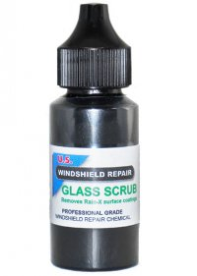
Glass Scrub removes Rain-X™, Aquapel™ or any other coating or treatment that you may find on the surface of a windshield. Repair resins will now adhere completely to glass surface.

Directions:
- Shake bottle well
- Apply one small drop of Glass Scrub next to the pit area of the repair, but do not allow it to make contact with the pit.
- Rub drop with clean paper towel around the pit area or any area that you want resin to adhere to the glass surface.
- Immediately wipe off all residue with a clean piece of paper towel, do not allow it to set.
- Surface is ready for application of resin.
Contents are harmful, avoid contact with skin and eyes, do not breath fumes

