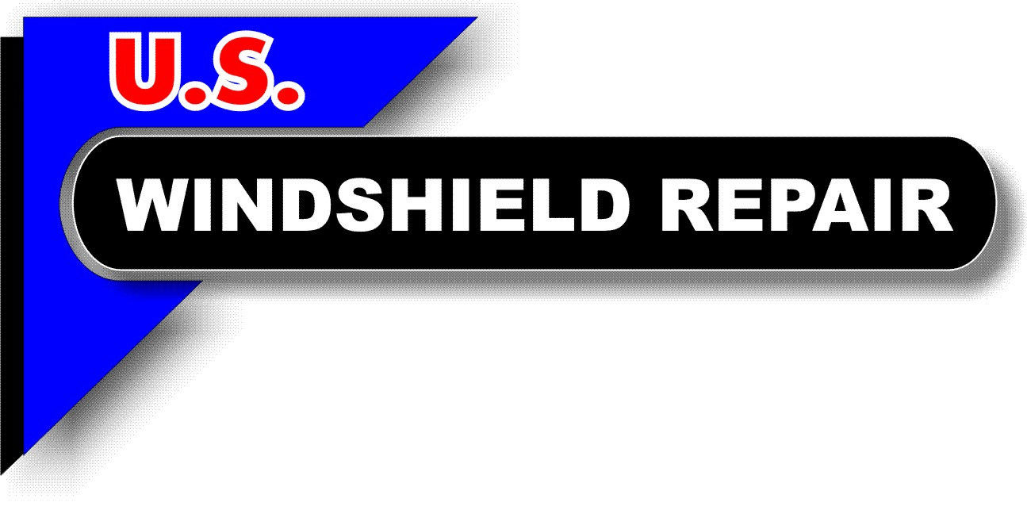

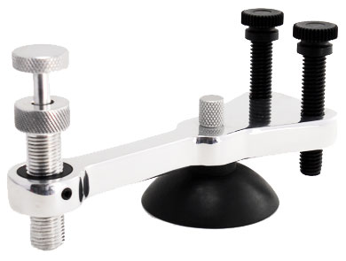
PISTON

CYLINDER
LEVELING BOLTS
Long Crack Repair Tool Set
Operating Instructions

- Use pressure on crack opener from inside of windshield at the tip to determine which direction the crack will travel, then release all pressure
- Drill about ¾ to 1 inch ahead of the tip, tap a bullseye
- Using pressure from the crack opener, cause the crack to connect to the bullseye
- Set up the stone chip injector at the tip and fill like a regular stone chip repair
- Set up holding structure and create a Vaseline path on one side of the crack so that the holding structure will glide alongside it while the injector is filling it
- Holding injector upside down, remove cap and unscrew injector until you see several threads on the piston
- Using seal removal tool (plastic stick) remove white injector seal
- Load injector with 5 to 12 drops of resin depending on length of crack, replace injector seal
- Carefully screw until resin is flush with top of injector seal and no air is in the cylinder
- Load injector into holding structure (injector must be at right angle as it is dual threaded)
- Turn injector until it makes contact with the glass, then turn one half turn further
- Hold cylinder static and turn piston clockwise until the resin pressure causes the white seal to bloat or puff out half way
- Slide injector along the crack, adding pressure as needed to keep the seal bloated
- Use the crack opener to apply pressure at the tip (where you made the bullseye) so that it will open for easier filling. Also use it for tight spots such as those occurring at turns in the crack
- Tab each three inch section by applying a ”bead” of crack resin on the surface and laying a curing tab on top as soon as you have filled it, to protect it
- When the break is completely filled, release almost all the pressure from the crack opener at the tip, we only want to slightly over fill it to compensate for the shrinking that occurs during curing
- Properly cure the repair
- Remove tabs, place in cleaning jar and begin shaving off the excess resin from the surface holding the razor at a 45 degree angle
- Polish repair area and clean windshield
- Replace equipment and you’re ready for next repair

Cleaning Instructions (as needed)

- Remove cap and white seal, pour out unused resin
- Unscrew piston and remove from cylinder
- Place components into cleaning jar filled with 99% alcohol
- Remove components, wipe and begin to reassemble
- Lubricate the red piston seal with one full drop of long crack resin before installing it into the injector cylinder
- Install white injector seal
- Replace cap and injector is ready for use

