

Quick Stick Curing Lamp

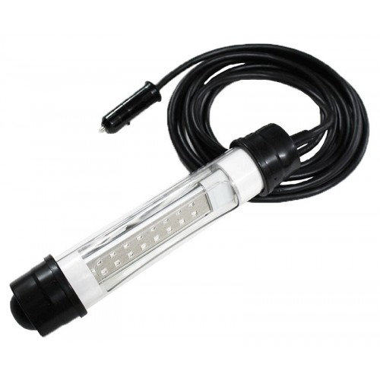

1. Use only with 12 volts (military vehicles and some European vehicles run on 24 volts and will damage lamp)
2. Lamp is instant ON, unplug when not in use
3. Do not look at LED’s, they are intense and can damage your vision
4. Safety Fuse is located in plug
5. Remove plug from cigarette lighter or power outlet, DO NOT PULL ON WIRE as you will damage the plug.