

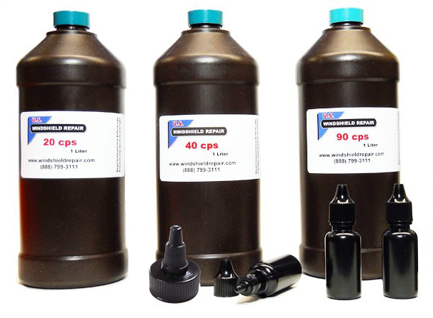
Bulk Resins

Read and follow these instructions to get the most from your resins and the best repairs

- Keep resins from temperature changes (hot /cold). If using dispensing spout to fill smaller bottles, replace the original bottle cap when done, and clean dispensing spout with alcohol.
Windshield repair resin has a one year shelf life when stored properly
Do not use resin that has expired as repairs can fail

- Bulk resin should be stored at ambient temperature (60-70F) and at the time they are poured.

- When filling smaller bottles do not fill to the top, leave some air in the bottle.

- The glass at the repair area should be warm 75-100F and must be dry. Cold resin will not flow or bond properly and hot resin will thin out and cause flowering in stone chips. The complete windshield should be shaded from sunlight if possible, not just the repair area. Sunlight contains UV and can begin curing the resin before it completely fills in the damaged area and properly bonds to the glass.

- Let resin in the repaired area set for one minute before curing it. This allows the acid in the resin to etch the glass surface so that the resin can completely bond to it.

- Curing the resin properly is critical for a perfect repair. Using sunlight or an inexpensive battery powered light with a 4 watt bulb will not properly or fully cure a repair. Use a quality high intensity UV light with the correct UV wavelength (365 nm). Properly cured repairs will look better and have greater strength.

- Use our 90cps or 200cps resin for pit filling. Competitors like to use a much thicker resin for pit filler, but we have found that causes the pits to become brittle, yellow and dry out over a short period of time. Using our 90cps and 200cps resin the pit of your repairs will be flexible and able to handle the expansion and contraction of the surface glass without these problems.

- Remember, the cured resin on the surface is exposed to air, alcohol (found in windshield wiper solution), sunlight and more. For best results, use our pit polish/sealant that both polishes and protects.

- Keep your equipment clean and resins pure. Some technicians apply Vaseline to the suction cups of their holding structure, then handle the injector seals and resin without wiping their hands. It’s very easy to contaminate the resin of you’re not careful. This will ruin a repair.

- Our resins contain acrylic acid, do not let them come into contact with automotive finishes or allow prolonged contact with your skin. Wipe any resin off immediately to prevent irritation. If constant contact is unavoidable, use nitrile gloves for protection and to prevent skin irritation.

