

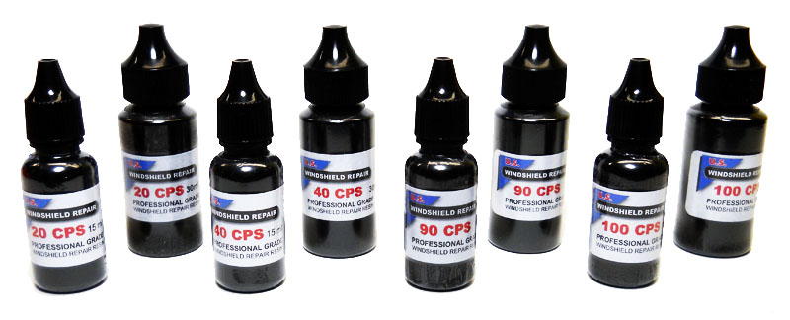

Care and Use Instructions for Windshield repair Resin
Read and follow these instructions to provide the best repairs and extend the shelf life of your resin
Resin Application:
- 10 CPS very thin resin for tight breaks or working in cold weather
- 20 CPS (Stone Chip Resin) #1 resin choice of technicians for all stone breaks including: tight breaks, combination breaks, bulls eyes and partial bulls eyes. Provides excellent cold weather performance. Excellent flow, strong and clear.
- 40 CPS resin original formulation used for stone repairs
- 90 CPS resin best formulation for long cracks and pit filling
- 200CPS resin is our thickest resin. Used primarily for pit filling but can be used for long crack repairs as long as conditions are not too cool as resin will increase in thickness slowing flow rate. Must keep glass temperature warm for best use.

- Do not expose resins to repeated temperature changes. Store in cool dry environment away from sunlight as well as artificial lighting (incandescent). Keep cap on bottle when not in use!

- Resins should be 70-100 degrees Fahrenheit at the time they are injected. Cold resin will not flow well nor bond properly, hot resin thins out and increases risk of flowering (resin traveling beyond damaged area causing a wavy or “halo” distortion) in repairs.

- The glass at the area being repaired should be between 70 to 100degrees Fahrenheit and must be dry. Ideally the whole windshield will be shaded from sunlight, not just the repair area. Sunlight contains UV and can begin curing the resin before it has completely filled the break and bonds to the glass.

- Curing the resin properly is critical for a perfect repair. Using sunlight or a battery powered light with a 4 watt bulb does not properly or fully cure a repair. Proper curing requires a quality curing light with the correct UV wavelength (365mn) and fully powered. Properly cured repairs will look better and have greater strength.

- The cured resin on the surface (pit) is exposed to air, alcohol (found in windshield wiper solution), sunlight and other harsh conditions. Completely finishing the repair and providing long-term protection requires the use of our quality pit polish/sealant which not only polishes but seals the exposed resin.

- Caution: All our resins contain methacrylic ester and acrylic acid to etch the glass surface for superior bonding, contact may cause eye or skin irritation. If contact occurs wash with soap and water immediately.

Having difficulty getting your pit fill resin to stick to the glass? The surface may have been treated and a layer of Rain-X, car wax or other chemical may be preventing proper adhesion. Our Glass Scrub product completely removes Rain-X or any other coatings so the resin achieves 100% surface bonding.

