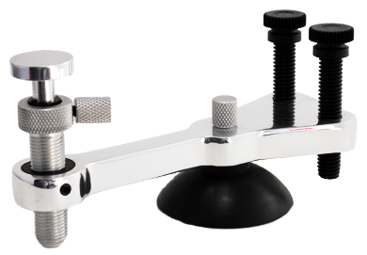
PISTON
LOCK SCREW
CYLINDER
LEVELING BOLTS

Stone Chip Repair Tool Set
Operating Instructions:

1. Place a very small amount of suction cup lubricant on the suction cup, rub it around with your finger. Then apply to windshield firmly. Move holding structure in circular motion to make sure the suction cup is securely attached to the surface.
2. Lifting the end of the holding structure that holds the injector, adjust the leveling bolts so that the platform is level to the surface of the windshield.
3. Holding the injector upside down, remove injector cap. Loosen locking screw on injector one half turn, pull plunger down until it stops.
4. Using seal removal tool (plastic stick) remove white injector seal.
5. Load injector with 3 to 4 drops of 20cps or 40cps resin.
6. Replace seal and carefully push plunger up until resin is almost flush with top of injector seal, then turn locking screw tightly.
7. Thread injector into holding structure (injector must be at right angle to avoid stripping as it is dual threaded).
8. Turn injector until it touches the glass, then turn one full turn further.
9. Loosen lock screw half turn only and while securely holding the injector, pull plunger up until it stops then turn lock screw tightly. This is the vacuum cycle, leave it on for 60 seconds.
10. Holding plunger, loosen lock screw and allow it to slowly lower until it stops, then slightly lift injector while applying pressure to plunger (like using a hypodermic needle or syringe). Looking at base of injector from the side, you will see the injector seal bloat out of the injector indicating pressure. When the seal is about half way out, tighten the lock screw. This is the pressure cycle.
11. As the resin fills the break you may employ techniques such as flexing and tapping to fill the tight spots and legs.
12. For breaks with complex damage at the impact area such as combination breaks, pockets of air can be removed by “cycling” the system from vacuum to pressure and back several times as needed.
13. When the break is completely filled, cure repair while resin is still under pressure using quick cure lamp for 60 seconds.
14. After curing, release pressure by loosening the lock screw one half turn, then pivot the injector and holding structure away from the repair area. Next release suction cup from the windshield surface using the polished screwdriver to break the seal.
15. Place one drop of pit fill resin on pit area, roll tab on (to remove air bubbles from pit area) and cure.
16. Remove injector from holding structure and place cap on it, remove lubricant from suction cup of holding structure (not necessary on pump models) using paper towel. Place both back into kit.
17. After curing, remove tab from pit by lifting at one edge and “peeling it back”, scrape excess resin with razor blade at 90 degree angle.
18. Finally, shake the polish/sealant and apply one drop to pit, polish to a glossy finish with a paper towel and repair is done.

Cleaning Instructions:

1. Remove cap and seal, pour out unused resin.
2. Loose lock screw several turns and pull plunger and collar out of injector cylinder.
3. Remove seal from plunger.
4. Place all components into cleaning jar filled with regular rubbing alcohol then remove.
5. Wipe all components and reassemble.
6. Lubricate the plunger seal with one full drop of stone chip resin and then insert it into the injector.
7. Replace cap and injector is ready for use.

