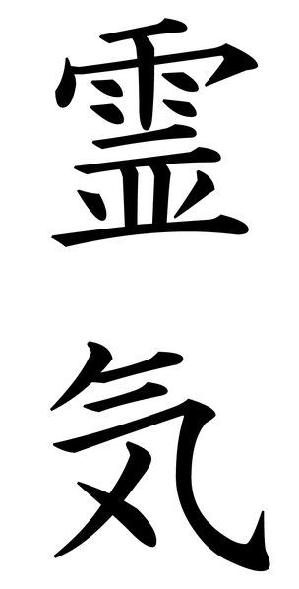
Northwest
Reiki
Association

Northwest Reiki Association thanks you for your donation to help sponsor our website. Please enter your bio information below it will be listed on NWRA website unless you would prefer to remain anonymous.

Name:____________________________________________________

Telephone:________________________________________________

Email:____________________________________________________

Website:__________________________________________________

The above information will not be listed on the site but if people email NWRA with inquires we would be happy to pass it along.

Sponsor’s Bio 50 words or less:

Name:______________________________ (Your website or email address can be linked into your name so when they click on your name they will be directed to that link)

You can also send in a photo of you to be posted on the website. Please email it to nwreikiassociation@gmail.com in jpg format please.

Circle method of payment: Check Money Order PayPal

Annual cost for website sponsor: 50 words / $30.00

I understand that my bio will be posted on the Northwest Reiki Association website. I also understand that the Northwest Reiki Association must approve the content of this bio.

⁭Please do not list me on the website, I prefer to remain anonymous.

Signed: Date:

