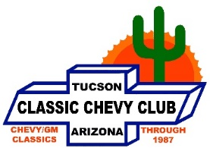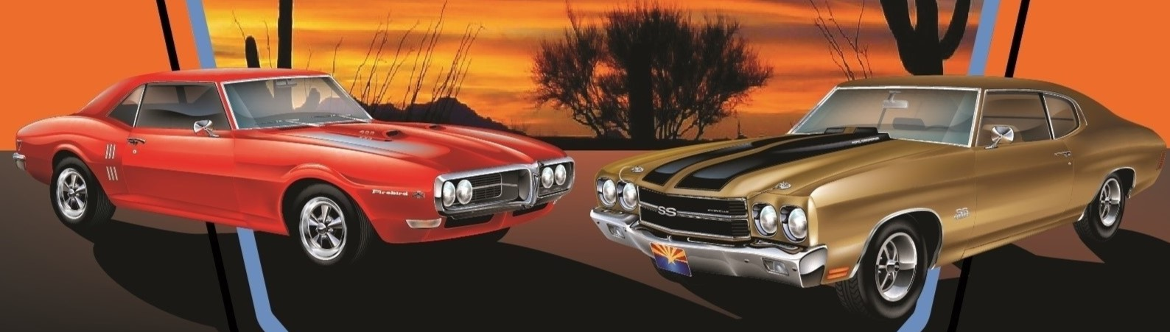

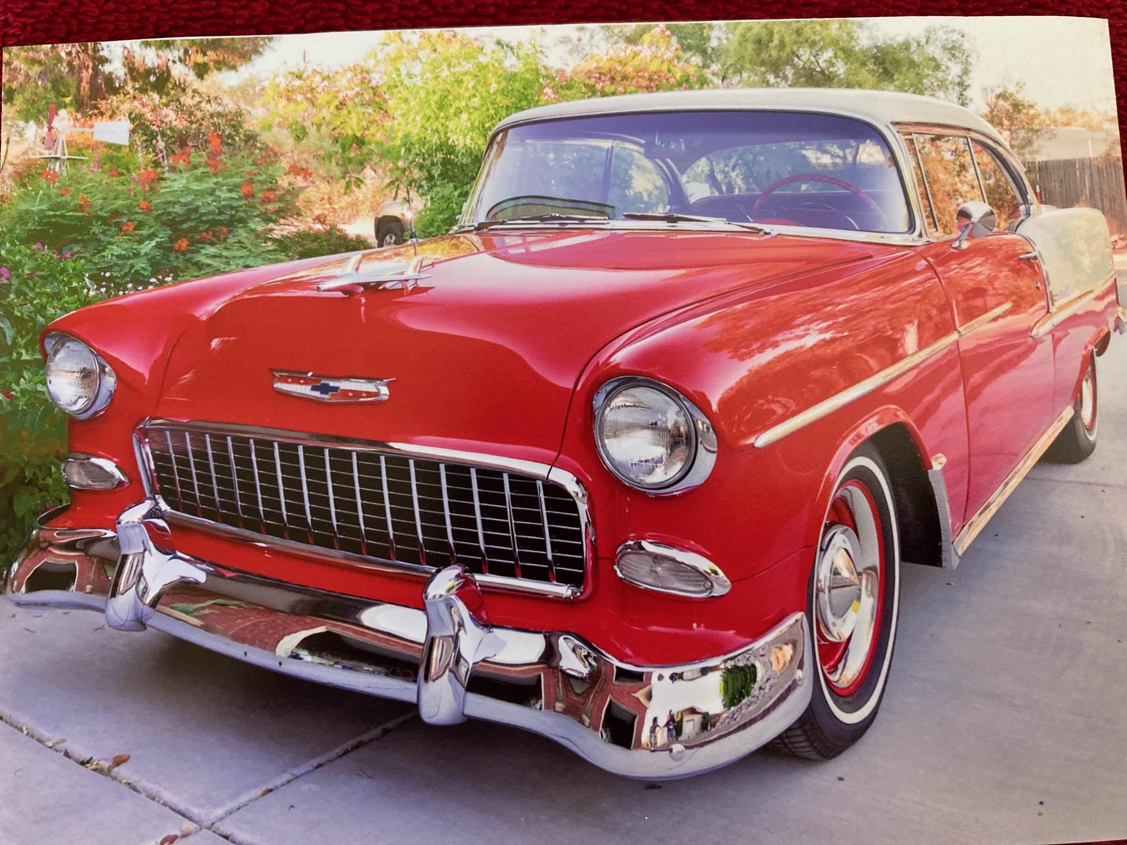

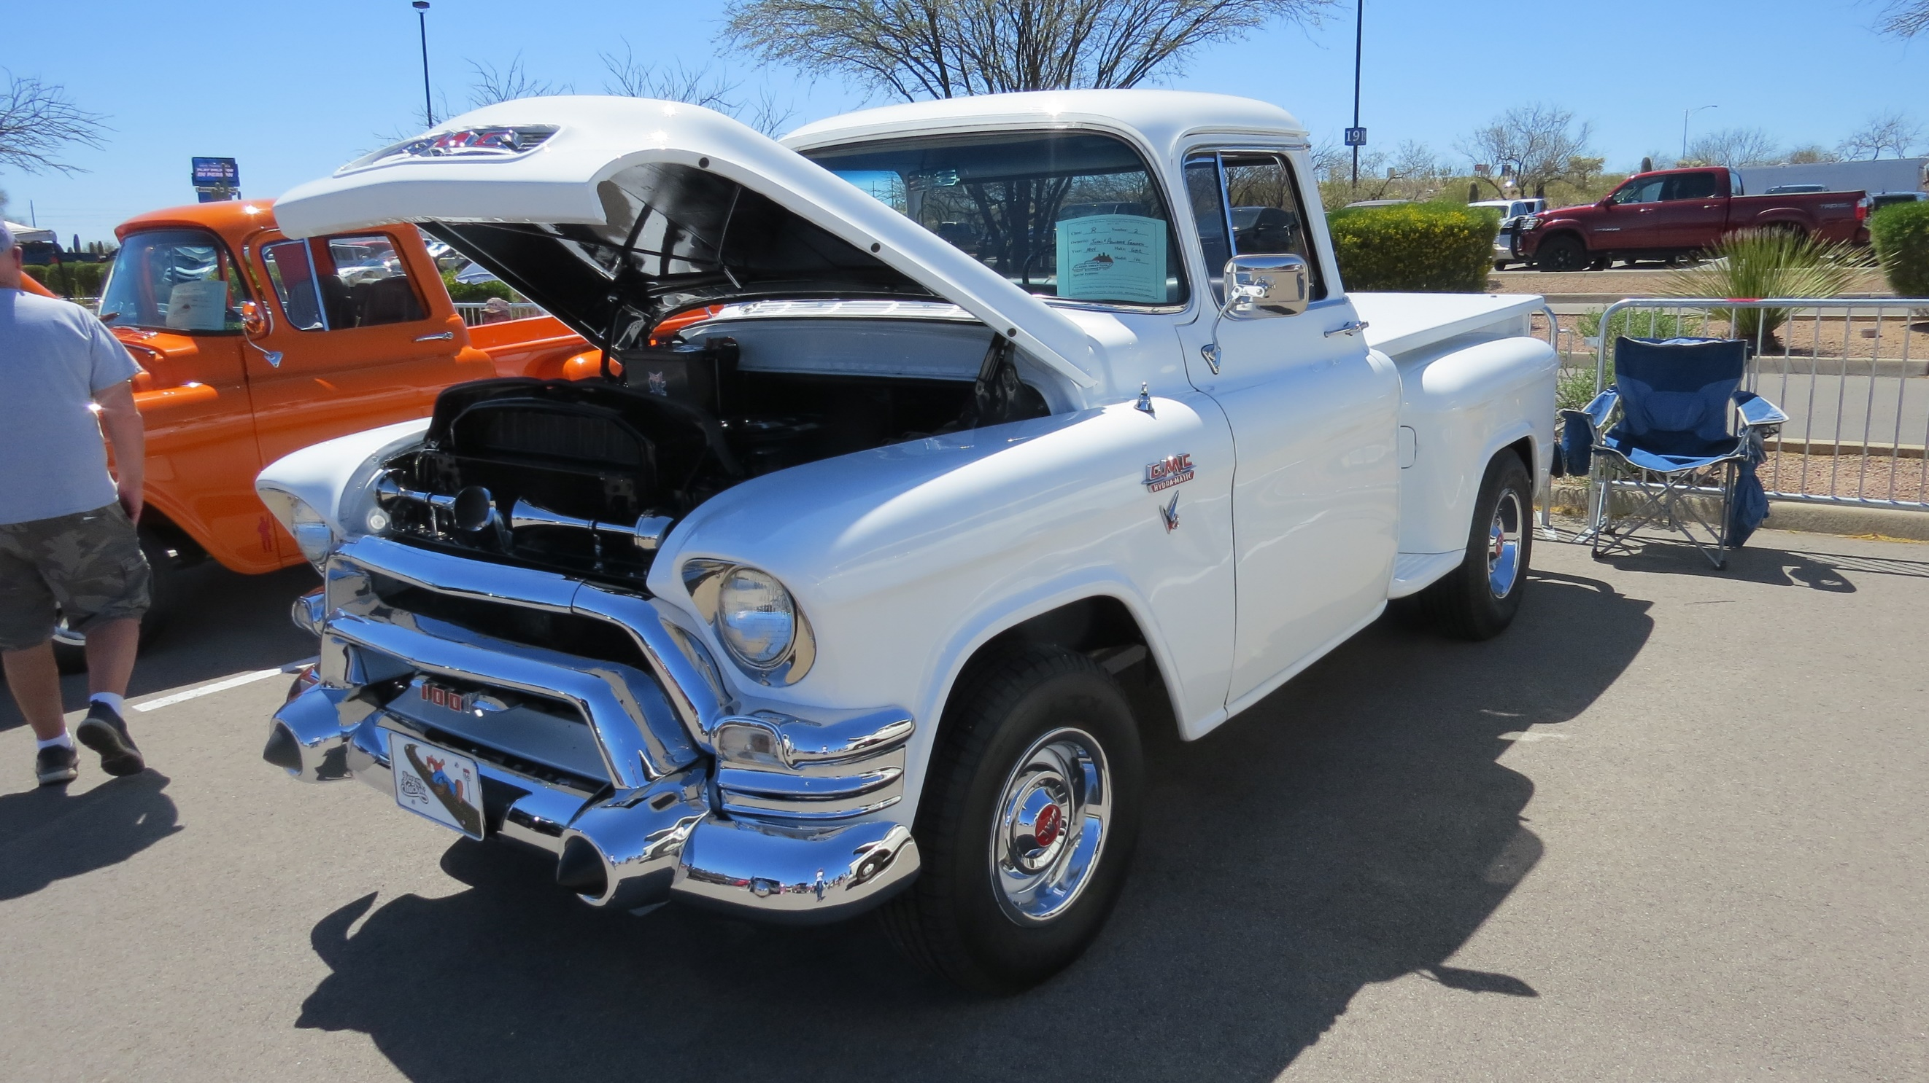

Chevy Showdown

Car Show

36th Annual

**Mission Statement:** The Classic Chevy Club of Tucson is devoted to having a good time while loving, restoring, and preserving classic Chevrolet, and GM vehicles through 1987. Join our club; help with the fun.



John Francen – 1955 GMC – 100 P/U

**PEOPLE’S CHOICE 2023 – BEST NON-CHEVY**

John & Connie Grinnell -1955 Chevy Belair

**PEOPLE’S CHOICE 2023 – BEST CHEVY**

**Saturday, April 6th 2024**

**9am-3pm at Desert Diamond Casino**

1100 W. Pima Mine Rd., Sahuarita, AZ 85756

* 1st & 2nd Place in each class receives a Plaque.
* People’s Choice for favorite “Chevy” & “Non-Chevy” receives a Trophy.
* Best of Show receives a Special Trophy and $100 cash.
* Each vehicle entry includes a dash plaque and a raffle ticket for hourly drawing of your choice.

**Directions**: Exit I-19 at Pima Mine Road, Sahuarita. Drive east & follow signs to Desert Diamond Casino, enter at first driveway. Continue to blue canopy for directions to car show registration area.

Registration opens 7AM and runs to 9AM. Judging starts at 10AM and closes at Noon.

**Host Hotel: Best Western Green Valley Inn;** 111 S. La Cañada Dr., Green Valley. AZ 85614.

Call 1-520-625-2250 for their special Car Show rate before March 6th 2024 (Includes a hot made to order breakfast, in their own restaurant).

**Contacts:** Frank Pella (520) 437-2481; corvair68@icloud.com

Ann Van Orden (770) 778-2963; anntwoychowski@yahoo.com

Visit our website at www.classicchevycluboftucson.com

Come join us for **Arizona’s Largest All GM Car Show.** There will be lots of vendors, raffle gift tickets drawn hourly and DJ music playing your favorite tunes all day. Food sponsored by Desert Diamond Casino and over 175 classic cars & trucks to enjoy.

**A majority of our proceeds will benefit*,*** *Therapeutic Riding of Tucson (TROT), Ronald McDonald House, Children’s Advocacy Center & Aviva Children’s Services*

**Chevy Showdown (Featuring all GM Vehicle’s) 2024-Registration Form**

**Arizona’s Largest all GM Car Show**

**Show is Open to All 1994 and Older:** Buick, Cadillac, Chevrolet, GMC, Oldsmobile, and Pontiacs

**\*\*\*VEHICLE’S OF CLASSIC CHEVY CLUB MEMBERS (HOST) NOT BEING JUDGED\*\*\***

*Saturday, April 6th, 2024 - 9 A.M. to 3 P.M.*

***LOCATION*—Desert Diamond Casino, *1100 W. Pima Mine Rd*, Sahuarita, AZ**

Name(s): Phone: ( ) City: Address: __________________________________________State: ________ Zip:________

Club Affiliation: __________________________________ E-Mail Address: _____________________________________

Vehicle Description: Make: _____________________Model:__________________________ Year: ________ Color:_____________

**Please *Circle* Tee Shirt Size(s): ($18 each) Med Lg XLg XXLg ($2 extra) XXXLg ($4 extra)**

**Total shirts ordered: _____Shirt order Total $_____ Vehicle Registration total $_____ Check Total $_____**

**Make Checks Mail Entry Form -----🡪 Ann Van Orden**

**Payable to-----🡪 *Classic Chevy Club of Tucson* and Check to 5691 W. Sunset Road**

**Tucson, AZ 85743**

SELL ANY MAKE OR MODEL VEHICLE IN OUR CAR CORRAL-$10, (**N.**)______(Add to check total above)

**Vehicle Classification (Please-*Circle One*) or two for additional vehicle**

$10.00 (add above in vehicle registration total) for each additional car registered from same household address.

|  |  |
| --- | --- |
| **A.) 55-56-57 Chevy Cars (Stock)** | **P.) 60-69 Corvair’s** |
| **B.) Pre-55 ALL GM Cars & Trucks (Stock)** | **Q.) 59-72 El Camino’s** |
| **C.) 55 Chevy Cars (Modified)** | **R.) 55-66 Chevy/GMC Trucks (Stock)** |
| **D.) Pre-55 ALL GM Cars & Trucks (Modified)** | **S.) 55-66 Chevy/GMC Trucks (Modified)** |
| **E.) 56 Chevy Cars (Modified)** | **T.) 67-72 Chevy/GMC Trucks (Stock)** |
| **F.) 57 Chevy Cars (Modified)** | **U.) 67-72 Chevy/GMC Trucks (Modified)** |
| **G.) 58-72 Chevy Cars (Stock)** | **V.) 73-94 ALL Late Model GM Cars** |
| **H.) 58-72 Chevy Cars (Modified)** | **W.) 73-94 Late Model Chevy/GM Trucks** |
| **I.) 67-72 Camaro (Stock)** | **X.) 55-72 Buicks** |
| **J.) 67-72 Camaro (Modified)** | **Y.) 55-72 Cadillacs** |
| **K.) 64-72 Chevelle (Stock)** | **Z.) 55-72 Oldsmobiles** |
| **L.) 64-72 Chevelle (Modified)** | **ZA.) 55-72 Pontiacs** |
| **M.) 53-72 Corvettes** | **ZB.) Rustic Unrestored (All GM Cars/Trucks)** |
| **O.) 62-72 Nova’s** | **ZC.) Street Rods (All GM Vehicles)** |

***Notice:*** *CCCT reserves the right to change vehicle classifications due to unintentionally having an incorrect vehicle classification. Participants will be advised of any class changes on or prior to the Day of Show, where possible.*

**Entry Fee: $25.00 Pre-Registration.**

**If post-marked after March 6th & Day of Show (Cash or Check accepted only) $35.00**.

***\*\*\*\*\*\*\*\*\*\*\*\*\*\*\*\*JUDGING WILL BE COORDINATED BY THE HOST CLUB \*\*\*\*\*\*\*\*\*\*\*\*\*\*\*\****

**You must open your hood to be judged**: Trunks will not be judged. *Up to 5 major/obvious changes allowed for* stock *cars*

*(Radial Tires, Power Disc Brakes, A/C, Power Steering, and Radio). Stock* *judging criteria will include appearance, condition, and stock components.* Modified *judging criteria will include appearance, condition, novel design, and craftsmanship. Rarity will not be a judging significant factor.*

***Notice:*** The undersigned and his/her guests do hereby release and discharge Desert Diamond Casino and all its associated businesses, The Classic Chevy Club of Tucson, its officers and members and anyone else connected with this event from any known or unknown damages, injuries, losses, judgment, and/or claims from any cause whatsoever that may be suffered to the entrant or guest and/or his/her vehicle(s) or personal property. For insurance purposes, only vehicles paying entry fees will be permitted in the show area. None of the following are permitted at the show: a) Alcoholic beverages; b) Firearms; c) Excessive noise from exhibiting hydraulics, stereo systems.

*Signature: ___________________________________________________________ Date: ____________________________*