
Saturday, April 3RD 2027
9am-3pm at Desert Diamond Casino
1100 W. Pima Mine Rd., Sahuarita, AZ 85629

39TH ANNUAL
CHEVY SHOWDOWN CAR SHOW



Come join us for Arizona’s Largest all GM Car Show. There will be lots of food truck vendors, raffle gift winners drawn hourly and a live DJ playing your favorite tunes all during the show, and 175 classic GM cars & trucks to enjoy.
Our proceeds will benefit; Therapeutic Riding of Tucson (TROT) and the
Ronald McDonald House of Southern Arizona

- 1st & 2nd Place in each class receives a trophy plaque.
- Each vehicle entry includes dash plaque and a raffle ticket for any hourly drawing.
- Best of Show winner receives a special Kachina Doll trophy and $200 cash.

Special displays from the Military Vehicle Club & Power from the Past Club, for your enjoyment
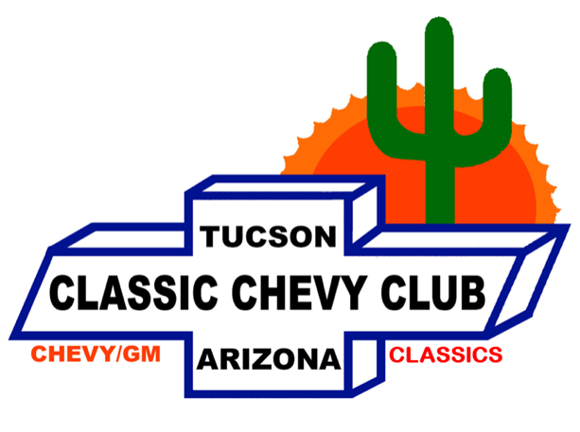





Directions: Exit I-19 at Pima Mine Road, Sahuarita. Drive east & follow signs to Desert Diamond Casino. Show up starts at 7:30am and car show starts at 9am.

Contact: Frank Pella (520) 437-2481; corvair68@icloud.com

Visit our website at www.classicchevycluboftucson.com
(For online registration)

2027 Chevy Showdown (Featuring all GM Vehicle’s)
Arizona’s Largest all GM Car Show

Show is Open to All 1997 and Older: Buick, Cadillac, Chevrolet, GMC, Oldsmobile, and Pontiacs

***VEHICLE’S OF CLASSIC CHEVY CLUB MEMBERS (HOST) NOT BEING JUDGED***

Saturday, April 3RD, 2027 - 9 A.M. to 3 P.M

LOCATION—Desert Diamond Casino, 1100 W. Pima Mine Rd, Sahuarita, AZ

Entry Fee: $30.00 Registration. NOTE: Sorry, No Day of Show Registration

Online registration only: Visit our website at www.classicchevycluboftucson.com
***2027 Chevy Showdown shirts will be offered during the online registration***

Vehicle Classifications

A.) Pre-55 Chevy Cars & Trucks | M.) 59-87 El Caminos
B.) 55-56-57 Chevy Cars (Stock) | N.) 55-59 Chevy/GMC Trucks
C.) 55-56-57 Chevy Cars (Modified) | O.) 60-72 Chevy/GMC Trucks
D.) 58-72 Chevy Cars (Stock) | Q.) 73-97 Chevy/GMC Trucks
E.) 58-72 Chevy Cars (Modified) | R.) Street Rods (All GM Vehicles)
F.) 64-72 Chevelles & Monte Carlos | S.) 72 and older Buicks
G.) 67-72 Camaros | T.) 72 and older Cadillacs and LaSalle
H.) 73-97 Camaros | U.) 72 and older Oldsmobiles
I.) 53-83 Corvettes | V.) 72-and older Pontiacs
J.) 84-97 Corvettes | W.) 73-97 All Later Model GM Cars
K.) 62-79 Novas | X.) Rustic Unrestored (All GM Cars/Trucks)
L.) 60-69 Corvairs

Notice: CCCT reserves the right to change vehicle classifications due to unintentionally having an incorrect vehicle classification. Participants will be advised of any class changes on or prior to the Day of Show, where possible.

****************JUDGING WILL BE COORDINATED BY THE HOST CLUB ****************

You must open your hood to be judged: Trunks will not be judged. Up to 5 major/obvious changes allowed for stock cars
(Radial Tires, Power Disc Brakes, A/C, Power Steering, and Radio). Stock judging criteria will include appearance, condition, and stock components. Modified judging criteria will include appearance, condition, novel design, and craftsmanship. Rarity will not be a judging significant factor.

Notice: By registering, you and your guests do hereby release and discharge Desert Diamond Casino and all its associated businesses, the Classic Chevy Club of Tucson, its officers and members and anyone else connected with this event from any known or unknown damages, injuries, losses, judgment, and/or claims from any cause whatsoever that may be suffered to the entrant or guest and/or his/her vehicle(s) or personal property. For insurance purposes, only vehicles paying entry fees will be permitted in the show area. None of the following are permitted at the show: a) Alcoholic beverages; b) Firearms; c) Excessive noise from exhibiting hydraulics, stereo systems.

