Introduction

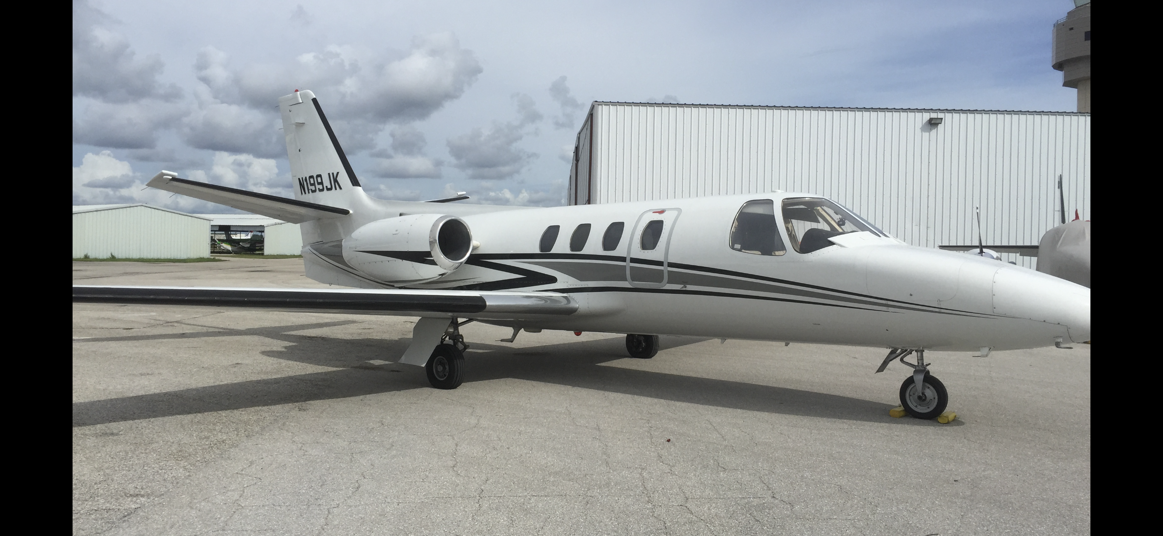
The value of your aircraft is increased when you are able to fly it safely and comfortably:

  - I am able to help you attain your aviation goals by providing the right mix of specific training elements and by giving you the repetition you need to master the skills.

- It is proven that specificity training creates the best environment for learning. If you train in your own aircraft you will learn faster and retain skills longer.

- I will modify my highly successful methods to meet your specific requirements and you will train at the location of your choosing.

Thank you for your interest in this training program for pilots of the Citation CE500 Series and CE525 series aircraft .

Effective pilot training is difficult to find. Instructor turnover is high and many instructors have limited experience with these technically advanced aircraft and the learning challenges associated with training owner operators.

John Watts is a full-time pilot instructor working in the CE500 and CE525, He conducts insurance-approved initial and recurrent programs all over the US specifically in the Cessna Citation aircraft.

John has been teaching pilots of all skill levels for 35+ years.

This Cessna Citation training program is very effective and it has a perfect safety record. It is FAA Industry Training Standards (FITS) approved and FAA Wings approved and it is available from John Watts. Professional sports trainers and the military both believe that specificity training is the most effective way to learn complex tasks and I concur. Whatever your current level of experience may be, he would like the opportunity to bring you to the next level of skill, safety and comfort.

Pilot training in the CE500/525 aircraft requires an emphasis on Scenario Based Training that will develop essential risk management skills, decision-making skills, and other higher-order thinking skills that are crucial in helping to reduce the general aviation accident rate.
Because owner operators learn most effectively in their own aircraft, John will use a 28V DC power supply to convert the aircraft into a ground based Cockpit Procedures Trainer so that effective learning of normal and emergency procedures can take place safely and without distraction.

Program Description

Initial Training is designed to transition you safely and comfortably into the Cessna Citation 500/525 high performance turbo-jet multi-eng aircraft. The following materials will be provided: An aircraft specific weight and balance plotter program.

The 30-hour performance based syllabus is FAA Industry Training Standards (FITS) approved. It is also approved by the FAA as a Wings Educational Seminar. It presumes you are rated and current for instrument flight, have at least 500 Hours PIC time and have reviewed the AFM; however, this is not required.

The initial program includes up to 30 hours of flight and ground training, including aircraft systems and limitations, expanded walk around, CPT (Cockpit Procedures Training), IFR briefing and LOFT (Line Oriented Flight Training) briefs and debriefs.

Completion standards are in accordance with FAA Practical Test Standards for the rating held. Upon successful completion you will receive a Certificate of Completion and endorsements for Biannual Flight Review, Instrument Proficiency Check, High Altitude Operation (when applicable) and FAA Wings.

Training Outline
Systems Introduction (4 hours): Each aircraft system is reviewed from a pilot’s perspective with strategies for their proper use. The purpose of the systems overview is to help you understand how each system will act/interact in a given situation. Normal and abnormal situations are discussed. The systems include Aircraft General, Engine,, Fuel, Electrical, Landing Gear/Brakes, Flight Controls, Environmental Systems, Weight/Balance, Performance, Emergency Procedures, Flight Director/Autopilot, Flight Instruments and Avionics, EFIS, Weather Avoidance equipment, Autopilot Operations, Cabin Pressure System, Anti-Ice and De-ice Systems, Aeronautical Decision Making (ADM) and Risk Management (RM) as they pertain to these elements. This training is conducted in a classroom setting, aircraft expanded walk-around and multiple CPT (cockpit procedures training) sessions.

- Cockpit Procedures Training (CPT) (4 Hours): CPT is designed to allow you to discover everything on the aircraft panel, how it functions and how it is integrated into various flight conditions. The avionics are powered up with an external 28V DC power source and thoroughly reviewed. Each annunciator is discussed including the relevant checklist. Checklists (Normal, Abnormal and Emergency) are reviewed in detail in preparation for the first flight in the aircraft.

- Flight #1 (2 Hours): The first flight in the aircraft is usually conducted in good VFR conditions and is used to “discover” basic power settings and pitch attitudes which can be replicated for various flight regimes. Air work is conducted to explore the aircrafts flight envelope and includes stalls, steep turns, unusual attitudes and other basic maneuvers found in the FAA Practical Test Standards for the rating held. These maneuvers are done using typical realistic scenarios (at a safe altitude). Aeronautical Decision Making (ADM) and Risk Management (RM) will be emphasized as they pertain to these flights.

- Flight #2 (2 Hours): This flight allows you to transition to the VFR approach and landing environment where we will perform practice landings and takeoffs. We will use wind conditions to set up crosswinds and conduct short field operations as well. I will share strategies for determining safe runway length. We will also perform zero thrust landings to a predestinated spot. Aeronautical Decision Making (ADM) and Risk Management (RM) will be emphasized as they pertain to these flights.

- BFR/IPC and Systems Review (4 Hours): This oral review is given as a way to review the information already presented, as well as a thorough review of the FAA regulations governing part 91 operations. It exceeds the requirements for the ground instruction required by the FAA for the Biannual Flight Review.

- Flight #3 (2 hours): Straight and level flight, climbs, turns, descents, basic holds, tracking, DME arcs will be flown in actual or simulated instrument conditions. We will use and integrate each item of avionics in your specific panel (ADF, GPS, RNAV, WAAS, radar altimeter, storm scope, weather radar, weather up/downlink etc) until you know when and how to use them. Aeronautical Decision Making (ADM) and Risk Management (RM) will be emphasized as they pertain to these flights.

- Flight #4 (2 Hours): Precision and non-precision approaches will be flown to published minimums. The concept of the visual descent point (VDP) and Decision Height (DH) will be thoroughly integrated. When you have mastered them (with and without the autopilot) we will do some more with raw data/standby instruments and various other simulated abnormal and emergency conditions. Aeronautical Decision Making (ADM) and Risk Management (RM) will be emphasized as they pertain to these flights.

- Pre LOFT Review (2 Hours): This is a planning session which will make the LOFT portion of your training more effective. We will discuss flight planning and review weight and balance and performance issues. High altitude flight strategies and emergencies are discussed.

- Flights #5, #6, #7, & #8 (8 Hours): Line oriented flight training (LOFT) is your opportunity to put it all together and conduct at least 4 legs of cross-country flight. You pick the places, plan the flights (including fuel calculations and weight/balance), file and fly your aircraft at its service ceiling. We will review all aspects of High Altitude Physiology, pressurization abnormals and emergencies, Aeronautical Decision Making (ADM) and Risk Management (RM) as they pertain to these flights.

Recurrent Training

Recurrent Training is designed to review your safety and comfort level in the Cessna Citation aircraft and bring you to the next level, regardless of your previous experience. You and I will design a challenging 15-hour performance based curriculum from the 30-hour FITS/Wings approved Initial Training syllabus.

This recurrent training program is FITS (FAA Industry Training Standards). We will concentrate on the areas that have the most value to you based on the type and quantity of flying that you do including emergency and abnormal operations, Emergency Escape Procedures, Aeronautical Decision Making (ADM) and Single Pilot Resource Management (SRM). It presumes you are rated and current for instrument flight and that you have read and understand the AFM.

The training includes up to 15 hours of flight & ground training. Completion standards are in accordance with FAA Practical Test Standards for the rating held. Upon successful completion you will receive a Certificate of Completion and endorsements for Biannual Flight Review, Instrument Proficiency Check, and FAA Wings. One day programs are available for qualified pilots who have received approved training within the last 6 months.
These aircraft are full featured and systems oriented. Professional pilots fly many more hours per year in mentored, crew flown aircraft which are, in some cases less complicated than your aircraft. You should consider training at least every 6 months.

Completion Standards

I train to FAA published standards for the rating(s) held and certificates are issued for Initial and Recurrent programs based on performance to these standards. When conducting approved programs, the training is provided in accordance with my approved syllabus. If you and I agree that the standards are consistently met you will receive a certificate; otherwise, we will formulate a strategy for getting you to the required level of proficiency and develop a supplemental training schedule that is likely to be successful for you.

Other Services
If you are purchasing an aircraft at this time I am generally available to provide assistance locating a suitable aircraft and verifying is condition (from a pilot perspective and from a mechanic inspectors (IA's) view). I am also able to perform an aircraft acceptance flight or to relocate the aircraft for you. I can also provide a custom training plan to your insurance broker to help him or her to get you the best value for your insurance dollar. These services are available on an hourly consulting fee basis.
Contact Information

Email: jwatts@watts-air.com Phone: 903-851-6580
Mail: John J. Watts
11363 WLake DR.
Murchison TX 75778

