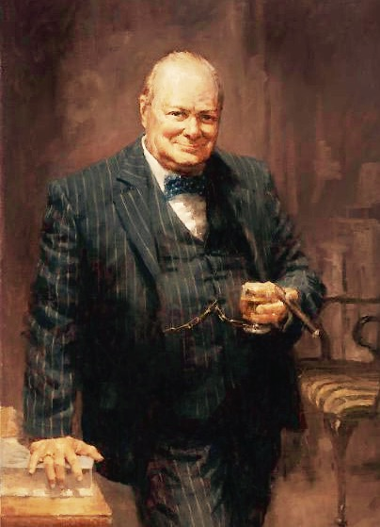
Churchill’s favorite whisky was, perhaps surprisingly,
not a single malt but a blend. Johnnie Walker Label
formed the basis of his daily whisky and water; a drink
which his children called a “Papa Cocktail”.
This consisted simply of a tipple of Johnnie Walker
covering the bottom of the glass, then filled with water
and sipped throughout the day.

CHURCHILL’S WHISK(E)Y

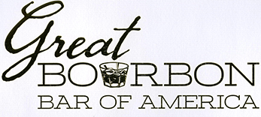

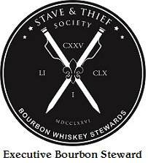
HOW TO DRINK WHISKEY . . .
Neat: Whisk(e)y that is served with No Ice or Mixer.
Straight pour into the glass and is served at room temperature.

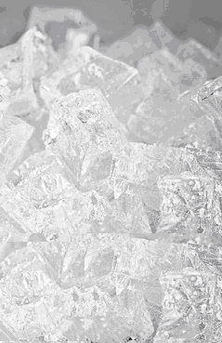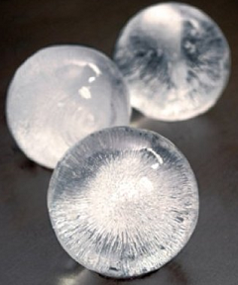
Standard Ice: Sphere Ice:
Standard service ice filtered of all impurities Ice Sphere made with Spring Water

One minute after ice cubes added 35 Degrees Holds that low temperature the longest

Start with 1 or 2 ice cubes, if it isn’t cold Melts quicker than standard ice cubes
enough and it’s a bit too strong, just throw in a & will dilute whisk(e)y by 20%
couple more giving new tastes and aromas

Always start with not enough, it’s easier to add
ice than take it away!

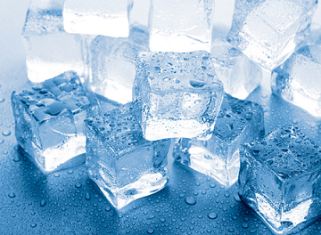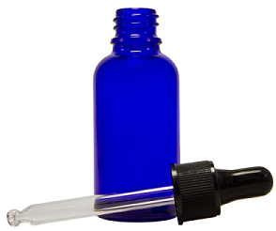

Block Ice: Glass Eye Dropper:

Block Ice made with Spring Water Using Spring Water, this will cut
the flavor of your whisk(e)y
Slow cooling to entire body of whisk(e)y by 50% or more

Releases 10% of water to whisk(e)y Served at room temperature
every 10 minutes while sitting at
room temperature Best used for higher proof whisk(e)y

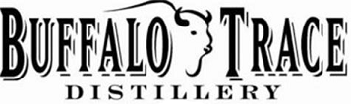

CHURCHILL’S FLINT MICHIGAN Van Winkle CHURCHILL’S FLINT MICHIGAN

Pappy Van Winkle 23 YR 95.6 This very rare, limited edition bourbon takes generations of distilling know-how
to produce. Only the most careful and expensive distilling method can be used to
create a whiskey as special as this one. Each barrel ages for 23 years and is carefully
selected from the heart of the warehouse. This whiskey should be enjoyed neat.
Early aromas of caramel and cream with soft notes of oak, nuts and leather. Features
a sweet taste composed of vanilla, maple and honey joined by complimentary
flavors of citrus and spice. Has a long lasting oaky finish, along with many of
the early flavors, & sweet caramel.

Pappy Van Winkle 20 YR 90.4 The #1 rated Bourbon Whiskey in the world with a 99 out of 100 rating by the
World Spirits Championship. This bourbon is aged 20 years and bottled at 90.4
proof for a wonderfully smooth and rich profile. Pappy Van Winkle was a true
character and like its namesake, this bourbon whiskey is full of character – quite
a remarkable whiskey. Intense and tantalizing. Smooth with a citrus zest note.
Some sherry notes, dried fruits and vanilla. The finish is long and elegant.

Pappy Van Winkle 15 YR 107.0 Expressly produced according to the exclusive Van Winkle family wheated-
recipe and especially selected from barrels in the heart of the aging warehouses,
this bourbon remained undisturbed for 15 years to age in deep-charred heavy
oak untouchable by human hands, unhurried by time. Elegant sweet aroma,
big flavor of leather, oak, & fruitiness. Notes of Spice to smooth finish.

Van Winkle Special 90.4 “A perfect combination of age and proof. The 12 years of aging and medium
Reserve 12 Year proof of 90.4 seem to be just right in creating a very pleasant drink of whiskey.
This fine bourbon can compete with any excellent cognac as an after-dinner
drink.” -Paul Pacult Highlighted by light aromas of dried mango, cocoa, fruit
and spiced peach. Flavors of honey, oak and tobacco dance on the pallet.
The finish is balanced and dry, with a lingering tingle.

Old Rip Van Winkle 107.0 This bourbon whiskey is bottled at nearly barrel proof. Just a splash of Kentucky
10 Year limestone water is added after a decade of aging. Rich, yet smooth, this bourbon
takes a back seat to none. A sweet vanilla nose with caramel, pecan and oak
wood. Smooth, mellow flavor consisting of robust wheat, cherries and oak.
Features a long, smoky wheat finish with hints of fruit, spice and oak tannins.

CHURCHILL’S FLINT MICHIGAN Antique Collection CHURCHILL’S FLINT MICHIGAN

George T. Stagg 144.1 This extremely hearty whiskey ages in new charred oak barrels for no less than
2016 Antique Collection 15 years. Straight out of the barrel, uncut and unfiltered, the taste is powerful,
142 Hand Selected Barrels flavorful & intense. Open it up with a few drops of water. Lush toffee sweetness
15 Years & 4 Months Old At Bottling and dark chocolate with hints of vanilla, fudge, nougat and molasses.

George T. Stagg 129.2 Lush toffee sweetness, dark chocolate with hints of vanilla, fudge, nougat &
2017 Antique Collection molasses. Underlying notes of dates, tobacco, dark berries, spearmint and a hint of coffee
309 Hand Selected Barrels round out the palate. “Espresso, chocolate fudge, and tobacco”
15 Years & 3 Months Old At Bottling

Thomas H. Handy Sazerac 126.2 Uncut and unfiltered Straight Rye Whiskey is bottled directly from the barrel.
2016 Antique Collection Powerful, lush, and boldly spicy. Flavors of toffee, fig cake, and candied fruit,
61 Hand - Picked Barrels followed by mint, cinnamon and clove. The finish ultimately reveals subtle notes 6 Years & 3 Months Old At Bottling of allspice, coconut and nutmeg. Long and warm. “Toffee & Cinnamon”

Thomas H. Handy Sazerac 127.2 Uncut and unfiltered Straight Rye Whiskey is bottled directly from the barrel.
2016 Antique Collection Powerful, lush, and boldly spicy. Flavors of toffee, fig cake, and candied fruit,
72 Hand - Picked Barrels followed by mint, cinnamon and clove. The finish ultimately reveals subtle notes
6 Years & 5 Months Old At Bottling of allspice, coconut & nutmeg. Long & warm. “Fig, allspice, & cinnamon”

Eagle Rare 17 Year Old 90.0 This rare bourbon ages in oak barrels for nearly two decades and is only available 2017 Antique Collection in small quantities once a year, every fall. Sip this polished, well-aged whiskey
36 Barrels Selected By Taste to appreciate why patience is such a virtue. The fragrant aroma has almost a
17 Years 3 Months Old At Bottling wine-like character with hints of almond, cigar boxes and cinnamon. The delicate and dry mid-palate tastes of leather, vanilla and tobacco. This bourbon lingers, finishing with hint of leather and toffee.

William Larue Weller 128.2 Uncut and unfiltered, this hand-bottled bourbon is barrel proof. Weller substitutes
2017 Antique Collection wheat for the traditional rye grain, a production method pioneered by W.L.
155 Hand - Picked Barrels Weller. Fragrant scents of caramel corn, new leather, plums, light toffee and pipe
12 Years 6 Months Old At Bottling tobacco. The palate tastes of marshmallow, salted almonds, nougat, figs and dates. This whiskey finishes smooth, composed and flavorfully sweet.

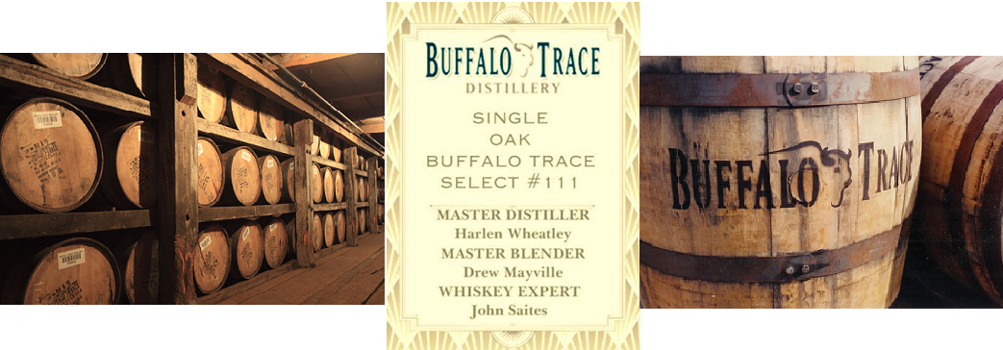

Buffalo Trace barrels age in the middle of the rick house for 7 to 9 Years.
This Single Barrel #111 has been rested for 11 Years and 1 Month
and aged in the back of the rick house.

Each of the barrels has unique characteristics and experimental changes in the mash bill,
types of wood, & barrel toasts. Each barrel is bottled and sold on a limited granted list.
Churchill’s Flint is now offering you this once in a lifetime sampling of this very
Limited Single Oak Buffalo Trace Single Barrel Select #111

These trees were carefully chosen with special consideration for the thickness of the wood grain.
Then, staves were made from these trees and kept close together for seasoning. Not just staves of the same tree,
but staves of the same half of the tree, both bottom and top, were then made into single oak barrels and uniquely charred.The Oak Tree used for this selection was picked from the top of the tree.

This Barrel Select #111 offers a medium amber color with a soft caramel oak nose.
A beautiful toasted oak with a ripe and rich deep flavor.
Smooth notes of dried fruits and vanilla.
Sophisticated and full of character, this is a very special whiskey.
The finish is wonderfully smooth and rich with an elegant touch of oak.

BARREL ID # 08-J-24-L-4-2005 BARREL #111
BUFFALO TRACE BOURBON WHISKEY 94.8 PROOF
ORDER #54258 FRANKFORT KENTUCKY DSP #113 KY

Buffalo Trace Churchill’s Select #111 94.8

Ancient Ancient Age 10 Star 90.0 Aromas of oak wood, clover and honey round out the nose. Strong and
warm flavors of corn, vanilla and spice. Medium body finish.

Ancient Age 90.0 Caramel, toffee, vanilla, with a hint of spice. Toffee & citrus finish.

Blanton’s Single Barrel 93.0 A deep, satisfying nose of nutmeg and spices. Powerful dry vanilla notes
in harmony with hints of honey amid a strong caramel finish.

Benchmark Old No. 8 80.0 Notes of caramel on the nose, with a delicate stone fruit backdrop. A robust
palate with leather notes & dry tobacco. Smooth & calming finish.

Buffalo Trace 90.0 Deep amber whiskey has complex aroma of vanilla, mint, & molasses.
Sweet taste, brown sugar and spice. Long smooth finish.

Buffalo Trace White Dog 125.0 “White Dog” Raw distillate, clear, un-aged, and has a hint of sweet corn.
Sweet aroma, the corn coats the palate with oil and vanilla. Mash #1

Buffalo Trace White Dog 125.0 Seriously spicy, corn sweetness and lingering earthiness. Rye Mash

Bourbon Cream 30.0 This liqueur is rich and sweet. The smooth taste of Buffalo Trace Bourbon
Compliments the creamy vanilla flavor.

Eagle Rare Sng. Bar. 10 YR 90.0 Nose is complex, bold, dry, and delicate with notes of candied almonds
and very rich cocoa. Finish is dry and lingering.

E.H. Taylor Barrel Proof 128.1 Bold & full of spice, toasty vanilla, dried oak and pepper. Long and full
bodied rye character with hints of fruit on the finish.

E.H. Taylor, Jr. Four Grains 100.0 Sweet vanilla & caramel corn, smooth evenness between the four grains.
Slightly smoky flavors and oak tannins with a nice balanced finish.

E.H. Taylor, Jr. Small Batch 100.0 Caramel corn sweetness, mingled with butterscotch and licorice. The aftertaste
is soft mouth-feel that turns into subtle spices of pepper and tobacco.

E.H. Taylor, Jr. Single Barrel 100.0 Aroma carries lightly toasted oak, with dried figs and butterscotch.
Sweetness balance with tobacco and dark spices. Long finish.

E.H. Taylor, Jr. Straight Rye 100.0 Sweet and savory, terrific balance of dark spices and caramel overtones.
Finish is pleasing with oaky dryness, long finish.

Elmer T. Lee 90.0 Nose brings notes of clove, vanilla, & old leather. The flavor balances fruit,
honey, and vanilla with a light spiciness. A long & warm finish.

Hancock’s President’s Reserve 88.9 This single barrel bourbon is full and the palate shows nice, balance of honey,
clover, a slight fruitiness and a dash of spice. Finish is long and warm.

Old Charter 80.0 A complex, well-balanced nose that shows both dry, peppery notes and
a rich honey sweetness. The palate features some tingly spice notes and mellow toffee, very long and very satisfying finish.

Rock Hill Farms Single Barrel 100.0 Seductive aromatic notes of toasted walnut, dried red fruits, spice, cocoa and
marshmallow. Flavors of dark chocolate, chocolate covered almond, coffee,
tobacco and dark caramel. Finish is smooth, silky, toffee sweet & honeyed.

Sazerac Rye 6 YR 90.0 Aroma of clove, vanilla, anise and pepper. Subtle notes of candies spices
and citrus. The big finish is smooth with hints of licorice.

Stagg Jr. 132.5 Rich, sweet, chocolate & brown sugar flavors mingle in perfect balance with the
bold rye spiciness. The boundless finish lingers with hints of cherries, cloves, &
smokiness.

Very Old Barton 86.0 Rich and smooth taste of vanilla, oak, & caramel. Dry & crisp finish.

W.L. Weller Special Reserve 90.0 A sweet nose with a presence of caramel, honey, butterscotch, & soft woodiness.
Features a smooth finish with sweet honeysuckle flair.

W.L. Weller 12 Year 90.0 Aromas of lanolin, almond, creamed corn and toasty vanilla. The mid-palate flavor is heavily wheated, layered & moderately sweet. Long, smooth finish.

Old Weller Antique 107.0 Sweet and unusual floral notes and coupled with vanilla. The taste is very well
balanced with sweet fruit notes, strong vanilla undertone and sharp
spicy tones, with a cinnamon finish.

CHURCHILL’S WHISK(E)Y
Our rotating Bourbon / Whisk(e)y List

1792 Bottled In Bond
1792 Full Proof
1792 High Rye
1792 Port Finish
1792 Single Barrel
1792 Small Batch
Angel’s Envy
Angel’s Envy Cask
Baker’s
Barrell Bourbon
Barterhouse 20 YR
Basil Hayden’s Bourbon
Bib & Tucker Small Batch
Big House
Blood Oath Pact No. 3
Blood Oath Pact No. 4
Booker’s
Bowman Brothers
Breaker
Breaker Port Barrel Finish
Breckenridge
Bulleit Bourbon Barrel Strength
Bulleit
Bulleit 10 YR
Bulleit 95 Rye
Calumet Farm
Calumet Farm Single Barrel
Calumet Farm Single Rack 10 YR
Calumet Farm Single Rack 12 YR
Clyde May’s Cask 10 YR
David Nicholson Reserve
Elijah Craig Barrel Proof
Elijah Craig Small Batch
Evan Williams Single Barrel
FEW Bourbon
FEW Rye
Fighting Cock
Four Roses Yellow
Four Roses Single Barrel
Four Roses Small Batch
Gentry Charleston Lowland
Henry McKenna Single Brl.
CHURCHILL’S WHISK(E)Y
Our rotating Bourbon / Whisk(e)y List

High West Campfire
High West American
High West
High West 36th Vote
High West Bourye Limited
High West Double Rye
High West 2016
High West Yippee Ki – Yay
Hirsch Small Batch Rsv.
Hudson Baby
Hudson Manhattan Rye
I.W. Harper
I.W. Harper 15 YR
Jefferson’s
Jefferson’s Grand Selection Pichon Baron
Jefferson’s Grand Selection Suduiraut
Jefferson’s Ocean Aged Cask 112
Jefferson’s Ocean Aged At Sea
Jefferson’s President Select 16 YR
Jefferson’s Reserve
Jefferson’s Groth Cask
Jefferson’s Old Rum Cask
Jefferson’s Pritchard Hill
Jefferson’s Twin Oak Barrel
Jim Beam
Jim Beam Black
Jim Beam Devil’s Cut
Jim Beam Distiller’s Cut
Jim Beam Single Barrel
Jim Beam Limited
Red Stag By Jim Beam
Kentucky Owl Wise Man’s Bourbon
Knob Creek Single Barrel
Knob Creek Smoked Maple
Knob Creek 2001 Limited
Knob Creek 25th Anv.
Knob Creek
Knob Creek Rye
Larceny
Lexington
Leadslinger
Little Book

CHURCHILL’S WHISK(E)Y
Our rotating Bourbon / Whisk(e)y List

Maker’s Mark
Maker’s Mark 46
Maker’s Mark Cask
Michter’s Bourbon
Michter’s Bourbon 10 YR
Michter’s US*1
Michter’s Sour Mash
Old Fitzgerald BIB
Old Forester Birthday
Old Forester 100
Old Forester 1870
Old Forester 1897
Old Forester 1920
Old Grand Dad
Old Grand Dad 114
Parker’s Heritage
Pikesville Straight Rye
Rabbit Hole Straight
Rabbit Hole Rye
Rabbit Hole Sherry Cask
Rebel Yell Reserve
Rebel Yell 10 YR
Rhetoric 22 YR
Rhetoric 23 YR
Rhetoric 24 YR
Rittenhouse Rye
Smooth Ambler
Smooth Ambler Straight
Smooth Ambler Old 10
Smooth Ambler Old Scout
Smooth Ambler Wheated
Tatoosh Bourbon
Town Branch Bourbon
Town Branch Sherry Cask
Trail’s End Bourbon
WhistlePig Straight
WhistlePig Old World 12
Wild Turkey Forgiven
W. T. Kentucky Spirit
Wild Turkey Rare Breed
Wild Turkey 101
Wild Turkey 81
Wild Turkey Master’s Keep
CHURCHILL’S WHISK(E)Y
Our rotating Bourbon / Whisk(e)y List

Wild Turkey Master’s Keep
Wild Turkey Rye
Wild Turkey 101 Rye
Russell’s Reserve 6 YR
Russell’s Reserve 10 YR
Russell’s Reserve Rye
Russell’s Reserve Single
Woodford Reserve Dbl. Oak
Woodford Reserve
Woodford Reserve VIP
Woodford Reserve 4TH 2008 Release 1838 Sweet Mash
Master’s Collection
Woodford Reserve 11TH 2016 Release Brandy Cask Finish
Master’s Collection
Woodford Reserve 12TH 2017 Release Cherry Wood Smoked Barley
Master’s Collection
Woodford Reserve 2018 Release
Batch Proof
Yellowstone Select
Yellowstone Limited 2016
Yellowstone Limited 2017
Yellowstone Limited 2018

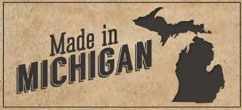

Detroit City Single Barrel New Holland Beer Barrel
Detroit City Butcher’s Bourbon New Holland Cask / Smoke
Flat Lander’s Traverse City Whiskey Co.
Fox River Bourbon Cask Traverse City MI Apple
Grand Trav. Small Batch Traverse City Cherry
Journeyman Featherbone Traverse City Barrel Proof
Journeyman Silver Cross Two James Grass Widow
Mayor Pingree Single Barrel Two James Catcher’s Rye
Mayor Pingree Black
Mayor Pingree Red

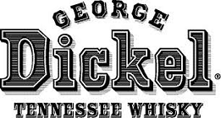

George Dickel Old # 12
George Dickel Old # 8
George Dickel Rye
Jack Daniels 150TH Anniversary AMERICAN BLEND
Gentleman Jack Breuckelen 77 Whiskey
Jack Daniel’s Old No. 7 Imperial
Jack Daniel’s Single Barrel Koval Four Grain
Jack Daniel’s Rested Rye Seagram’s 7 Crown
Jack Daniel’s Fire Stoll & Wolfe
Jack Daniel’s Honey

IRISH CANADIAN
Bushmills Black Velvet
Concannon Canadian Club
Green Spot Caribou Crossing
Hyde No.3 Bourbon Matured Crown Royal
Jameson Crown Royal Black
Jameson Black Barrel Crown Royal Bourbon Mash
Kilbeggan Crown Royal Cornerstone
Knappogue Castle 12 YR Crown Royal Hand Select
Midleton Rare Crown Royal Maple
Paddy Old Crown Royal N. Harvest
Powers Signature Release Crown Royal Regal Apple
Redbreast Crown Royal Special Resv.
Redbreast 15 YR Crown Royal Vanilla
Teeling Single Malt Crown Royal XO
Tipperary Knockmealdowns Entrapment (ORPHaN BARREL)
Tullamore Dew Legacy
Tullamore Dew 18 YR Lot No. 40
Tullamore Dew Phoenix Masterson’s 10 YR
Tullamore Dew Rum Cask Seagram’s VO
Tyrconnell
Yellow Spot 12 YR
FLAVORED WHISK(E)Y’S
Benchmark Peach Dr. Mcgill Peach
Fireball Ginger Devil Ginger Spiced



Red Label 80.0 The bold, versatile label that introduced the world to Johnnie Walker. Enjoyed with
ice, a good mixer, and good company! This is a whisky defined by intense, spicy
flavors. Hint of spice followed by a lingering, smoky finish.

Black Label 80.0 Alexander Walker II crafted a new blend in 1906, “Extra Special Old Highland Whisky”
Printed on a black background before long people of the world were ordering…
“Johnnie Walker Black Label” Black Label is full, nuanced blend. Hints of vanilla &
spiced fruit come across the nose, warm, rich flavor, long smoky finish.

Double Black 80.0 “Black Amplified” full bodied, complex, tones of spiced fruit. Creamy vanilla & orange
zest bring sweetness to the tongue. Long oak, smokiness finish.

Gold Label 80.0 Master Blender handpicked his favorite whiskies, including casks of Clynelish single
malt Scotch whisky whose water source flows from the Kildonan Hills where gold was
found in 1868. Best served with crushed ice and an orange slice as it is neat. Soft,
floral, and silky vanilla tones, creamy peach flavor, & sweet. Long finish.

Platinum 80.0 A contemporary and complex blend of single malt & grain whiskies matured for a
minimum of 18 years. Drawn from a limited number of casks, this luxurious blend
harboring deep layers of flavor that perfectly balanced. Rich dried fruit, malty cereal,
smooth creamy vanilla, fragrant almonds & tangerines. Elegant, contemporary example
of the Speyside style, finished with a hint of Islay smokiness.

Blue Label 80.0 Created to reflect the art of 19th century whisky styles, influenced by the smoke of the
west and the rich, sweet whiskies of the east, its blended from among the most precious
casks in the Johnnie Walker stocks. To be savored in rare company, a slow intense
experience. Best savored neat, finish is long, rich in smoke & pepper.

Swing 80.0 Named for the unique bottle, in which an irregular base allows it to rock back & forth.
It was the last blend of Alexander II, featuring a elevated amount of Speyside malts,
balanced by malts from the northern Highlands and Islay. Bit sweet and then spicy
notes take affect mid palate, smoke & peat. Smooth, smoke spice finish.

Scotch Whisky
#churchillsflint

Aberfeldy 12 80.0 Highland
Aberfeldy 16 80.0 Highland
Aberfeldy 21 80.0 Highland
Aberlour A’Bunadh 120.2 Speyside
Aberlour 16 86.0 Speyside
Aberlour 18 86.0 Speyside
Ancnoc 12 86.0 Highland
Antiquary 21 86.0 Other
Ardbeg AN OA 93.2 Islay
Ardbeg Corryreckan 114.2 Islay
Ardbeg Darkcove 110.0 Islay
Ardbeg Grooves 103.2 Islay
Ardbeg Kelpie “Limited 2017” 103.4 Islay
Ardbeg Uigeadail 108.4 Islay
Ardbeg Ten 92.0 Islay
Ancnoc 12 YR 86.0 Highland
Balvenie Sherry Cask 15 YR 95.6 Speyside
Balvenie Caribbean Cask 14 YR 86.0 Speyside
Balvenie Double Wood 12 YR 80.0 Speyside
BenRiach 16 YR 86.0 Speyside
Bowmore 15 Darkest 86.0 Islay
Buchanan’s Deluxe 12 80.0 Blended
Buchanan’s Special Reserve 18 80.0 Blended
Bruichladdich Black Art 98.4 Islay
Bruichladdich Port Charlotte 100.0 Islay

Scotch Whisky
#churchillsflint

Bruichladdich Octomore 10 114.6 Islay
Bunnahabhain Single Malt 18 YR 92.6 Islay
Chivas Regal Ultis 80.0 Speyside
Chivas Royal Salute 80.0 Blended
Compass Box “Hedonism” 86.0 Various
Compass Box “No Name” 97.8 Blended
Compass Box “Oak Cross” 86.0 Highland
Compass Box “Peat Monster” 92.0 Islay / Highland
Compass Box “The Spice Tree” 92.0 Highland
Compass Box “Hedonism Quindecimus” 92.0 Blended
Dalmore 12 YR 80.0 Highland
Dalmore 15 YR 80.0 Highland
Dalmore 18 YR 86.0 Highland
Dalmore Cigar Malt Reserve 88.0 Highland
Dalwhinnie Distiller’s Edition 86.0 Highland
Dewars White Label 80.0 Various
Famous Grouse 80.0 Various
Glenfarclas 10 YR 80.0 Highland
Glenfarclas 12 YR 86.0 Highland
Glenkinchie 12 YR 86.0 Lowland
Glenfiddich The Original 1963 80.0 Speyside
Glenfiddich 12 YR 80.0 Speyside
Glenfiddich 14 YR 86.0 Speyside
Glenfiddich 15 YR 80.0 Speyside
Glenfiddich 21 YR Gran Reserva 80.0 Speyside

Scotch Whisky
#churchillsflint

Glenmorangie Lasanta 12 YR 92.0 Highland
Glenmorangie Nectar D’Or 92.0 Highland
Glenmorangie Original 86.0 Highland
Glenmorangie Signet 92.0 Highland
Glenmorangie 18 YR 86.0 Highland
Glenrothes Bourbon Cask Reserve 80.0 Speyside
Glenrothes 1995 86.0 Speyside
Glenrothes 1998 86.0 Speyside
Highland Park 12 YR 86.0 Orkney Islands
Highland Park 15 YR 86.0 Orkney Islands
Highland Park 18 YR 86.0 Orkney Islands
Isle Of Jura Prophecy 92.0 Islands
Isle Of Jura Superstition 86.0 Islands
Jura 16 YR 86.0 Jura
Lagavulin Distillers Edition 16 YR 86.0 Islay
Lagavulin 8 YR 96.0 Islay
Laphroaig Lore 96.0 Islay
Laphroaig Select 80.0 Islay
Ledaig 10 YR 92.6 Isle of Mull
Macallan Edition No. 3 96.6 Highland
Macallan Edition No. 2 96.4 Highland
Macallan 12 YR 86.0 Speyside
Macallan Fine Oak 15 YR 86.0 Speyside
Macallan Fine Oak 18 YR 86.0 Speyside
Macallan Fine Oak 21 YR 86.0 Speyside
Macallan Rare Cask 86.0 Speyside
Macallan 18 YR 86.0 Speyside

Scotch Whisky
#churchillsflint

Mackinlay’s Rare 94.6 Other
Mannochmore 25 YR 106.8 Speyside
Monkey Shoulder 86.0 Speyside
Old Pulteney 12 YR 86.0 Highland
Singleton 12 YR 80.0 Speyside
Singleton 15 YR 80.0 Speyside
Singleton 18 YR 80.0 Speyside
Speyburn Companion Cask 92.0 Speyside
Speyburn 10 YR 86.0 Highland
Talisker 10 YR 91.6 Skye
Talisker 18 YR 91.6 Skye
Tamdhu Batch Strength 117.6 Speyside
Tamdhu 16 YR First Editions 104.0 Speyside
Tomatin 18 YR 92.0 Highland
Tullibardine 20 YR 86.0 Highland
Hakushu 12 YR 86.0 Japanese
Hibiki Japanese Harmony 86.0 Japanese
Kavalan 86.0 Taiwan
Kavalan Concertmaster 86.0 Taiwan
King Car Whisky 92.0 Taiwan
Nikka Coffee Grain 90.0 Japanese
Ohishi Whisky 83.6 Japanese
Ohishi Whisky Sherry Cask 84.2 Japanese
Suntory Whisky Toki 86.0 Japanese
Yamazaki 12 86.0 Japanese
Yamazaki 18 86.0 Japanese
Yoichi 15 90.0 Japanese

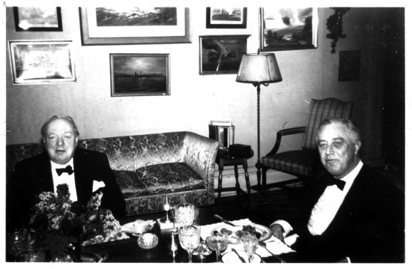
Prime Minister Churchill having dinner on one of his many visits to meet with President Franklin Roosevelt. Although Churchill certainly
drank more alcohol than FDR, the President was a man who liked
two or three or martinis before dinner. Though Churchill did not
care for Roosevelt’s version of a martini, he was known to enjoy one.
His recipe, however, was slightly different. He loved Gin, but was
not a fan of vermouth. Once, when asked how much he wanted in
his martini, he replied:

“I would like to observe the vermouth from across the room while I
drink my martini”

Giving birth to the “Churchill Martini” which is little more gin
poured over ice while vermouth is presented in the same room.

GIN

Bombay Sapphire Slightly spicy lemon with a touch of earthy floral notes. Some juniper, the
finish is long, with heat, coriander, juniper, & citrus.

Hendrick’s Wondrous botanical signature consists of flowers, roots, fruits, and seeds from
the world over. Bulgarian Rosa, Damascena and specially selected cucumbers from the finest producers.

Nolet’s Dry Gin Notes of Turkish rose, peach and raspberry. These botanicals were specially
selected and are individually macerated and then distilled to give the gin its distinctive, all-natural flavor and aroma.

Tanqueray Triple distilled, four botanicals, uniquely balanced, warm finish.

The Botanist Small-batch, artisanal Islay gin using nine of the classic gin aromatics offering
a distinctive floral smooth tasting gin.
VODKA FLAVORED VODKA TEQUILA
Belvedere Poland Ciroc Red Berry Cazadores Reposado
Chopin Poland Smirnoff Blueberry Corazon De Agave Blanco
Ciroc Snap Frost Smirnoff Citrus Corazon De Agave Repo.
Grey Goose Smirnoff Orange Corazon Extra Anejo
Kettle One Smirnoff Peach Don Julio Blanco
Rain Organics Smirnoff Raspberry Jose Cuervo Gold
Stolichnaya Smirnoff Strawberry Patron Silver
Stolichnaya Elit Smirnoff Vanilla 1800 Reposado
Tito’s Handmade Three Olives Cherry Del Maguey Crème De Mezcal
Wheatley Vodka Three Olives Chocolate Del Maguey Vida Mezcal
CLIX Corazon Barrel Aged (Upon Request)

RUM AMARETTO & COGNAC COFFEE & CREAM
Bacardi Limon Remy Martin XO Kahlua
Bacardi Tangerine Remy VSOP Patron XO Café
Bacardi Superior Disaronno Baileys Original
Cachaca 51 Rum Chata
Captain Morgan Spiced
Calypso Coconut
Gosling’s Black Seal
Malibu SCHNAPPS
Malibu Mango Butterscotch
Plantation Pineapple Grape Pucker
Ron Zacapa Centenario 23 YR Goldschlager
Hot Damn
CORDIALS & LIQUEURS AMERICAN Peach Schnapps
Dekuyper Razzmatazz Peppermint
Godiva Milk Chocolate Rumple Minze
Pama Pomegranate Sour Apple
Southern Comfort Watermelon

CORDIALS & LIQUEURS FOREIGN
Absinthe Ordinaire Cointreau Grand Marnier
Benedictine Crème Yvette Jagermeister
Branca Menta Cynar Licor 43
Campari Domaine De Conton Luxardo Maraschino
Chambord Drambuie Pastis Prado
Chartreuse Green Fernet Branca Pimm’s Cup #1
Chartreuse Yellow Frangelico Romana Sambuca

