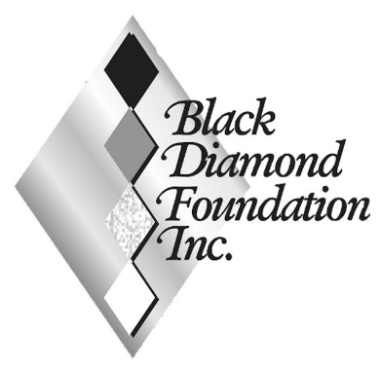
2024 Annual Report

Since our incorporation in the fall of 2002, Black Diamond Foundation has provided 3.4 million dollars in grants to Citrus County Charities.

Your Foundation awarded grants totaling $226,350 in 2024 (excluding BDLGA 4C funds). Over the past 10 years, BDF has distributed an average of $202,600 per year to Citrus County charities. We continue to provide significant help in the areas of food insecurity, homelessness, and child development.

Aspire Relationship Center - $5,000: The Aspire Relationship Center assists Citrus County youth in developing healthy relationships and avoiding unhealthy dependency on drugs, sex, and social media.

Boys & Girls Clubs of Citrus County - $15,000: Our BDF grant helps fund morning day care for low-income children at three different sites.

Citrus County Education Foundation - $16,000: The Citrus County Education Foundation does much more than support the education process in Citrus County public schools. They are a key player in tackling the child homeless problem and child food insecurity. BDF awarded grants to the Educational Foundation for Success mini-grants, First Library, Coastal Camp Citrus, for Golden Citrus Scholarships.

Community Food Bank of Citrus County - $57,000: $63,100 awarded to pay down the mortgage of the Food Bank’s second warehouse and support routine operations. $13,100 via directed donations.

Daystar Life Center - $10,000: Directed donations of $10,000 were provided to Daystar to advance their mission of providing shelter and food assistance.
Mid Florida Homeless Coalition - $25,000: The Coalition assists the 500 to 600 homeless individuals in Citrus County to find temporary and permanent shelter as well as develop the life skills necessary to remain housed.

Nature Coast Ministries - $31,250: The NCM Free Dental Clinic provides comprehensive dental care to low income Citrus County residents. BDF partnered with CCCCF to purchase a new panoramic Xray machine needed by the clinic.

St. Vincent de Paul - $17,000: SVdP provides rehousing services, financial assistance and counseling to Citrus County veterans.

Take Stock in Children - $8,000: Each year, our BDF grant purchases a college scholarship for a Citrus County high achieving low-income student from the state level Take Stock in Children organization.

The Path of Citrus County - $10,000: Grant awarded to assist in the purchase of furniture for the client residences.

YMCA of the Suncoast - $10,500: in directed donations.

Thank you for supporting the Foundation’s Mission:

“to combine the charitable resources and generous instincts of Black Diamond’s residents with our commitment to be good neighbors in Citrus County. Black Diamond Foundation will collect and distribute funds in a manner which enriches the lives of Citrus County residents and demonstrates that the Black Diamond community cares.”

