Mohave Prospectors: Digging for gold

Mohave County Prospectors Association educates community about mining history
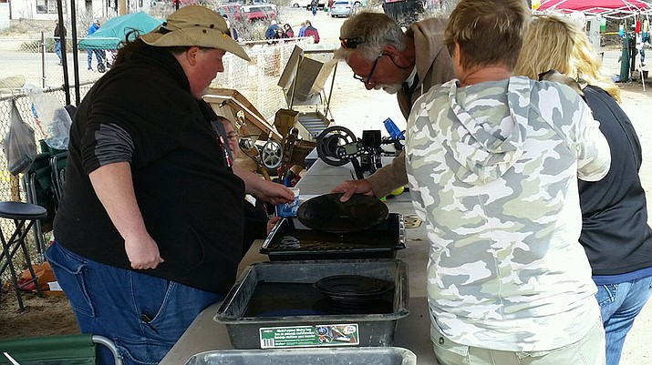
Bryan Murphy, club secretary, is showing booth visitors how to properly pan for gold after purchasing a cup of dirt with $5 worth of gold inside. (Courtesy Photo by Eric Spurr)
By Vanessa Espinoza
• Originally Published: March 25, 2018 6 a.m.
Imagine grabbing the shovel in the tool shed and the pick ax right next to it. Getting inside the truck parked in the driveway and drive about 45 miles outside the Kingman city limits to go to a plot of dirt and start digging for treasure. But digging for what kind of treasure? Gold. This is what the Mohave Prospectors Association is all about.
The Mohave Prospectors Association has been around for 24 years and have dedicated those years to mining for gold and keeping the mining profession alive. Currently they have 150 members but hope to increase that number.
Eric Spurr, treasurer for the prospectors joined when he moved here from Minnesota. He has been a member for little over a year now and says as soon as you find the first piece of gold, it becomes an addiction.
“The first time you find it you have to put in perspective you have a pan of dirt,” Spurr said. “You see some shiny little pieces of gold in there and the first thing that comes to your mind is, ‘I’m probably the first person to ever see this since it was formed millions of years ago.’”
This first thought, the "struck gold" moment, is something Spurr credits Bryan Murphy for. Murphy is the secretary for the prospectors, and has been in the association since 2011.
Murphy said after his first weekend of mining and finding his first gold it took him down the path of “gold fever.”
The prospectors stand with their slogan, “It’s a golden opportunity to pass on our knowledge.”
“We encourage people to learn about miner history because it is a big part of the area out here. I’m still learning,” Spurr said.
The association tries to teach people about mining, metal detecting, panning for gold, looking for different types of minerals and identifying if there’s gold in certain areas.
“It’s not just gold,” Murphy said. “You can collect crystals and all kinds of beautiful stones while you’re out on the claims.”
The prospectors lease land from the Bureau of Land Management outside of the Kingman city limits.
“If you’re not a member, since we lease those claims (land), you cannot go digging in that dirt since we pay for the rights,” Spurr said.
Individuals, clubs and organizations pay a certain amount of money to have the rights to dig for gold in these areas. The prospectors have areas near Lake Havasu and the Grand Canyon. Spurr said you would need a vehicle with four-wheel drive to get out to some of the claims.
The organization also holds Toys for Tots and food bank drives. The club tries to attend events where they can set up information booths to let the community know about the club.
“We try to get our club involved with everything,” Spurr said. “We’re trying to take it from where it’s been and trying to modernize everything we have now.”
Other events the club has are metal detector outings and prize drawings at their meetings. Metal detector outings include looking for colored pennies, dimes or quarters that correlates a certain prize the finder can win.
At the meetings, there are raffle drawings for mining gear. Those that don’t win can keep their raffle tickets for their bi-annual drawing where members have a second chance to win mining gear.
The prospectors are trying to modernize their organization by getting non-profit 501c3 status and hope to soon receive donations, grants and start an outreach program.
“I want to see where we can have adult chaperones in the club to take out six or eight children and show them what they can do,” Spurr said.
Murphy said his favorite thing to see is getting children involved because they learn about geology, local history, how to identify dangerous plants and animals, reading maps and how to use a compass.
“They’re learning something, learning values and hard work because it is hard work sometimes to dig for gold,” Spurr said.
The organization also helps out new members that don’t know anything about mining. Spurr said as a new member, he went out to one of the group outings the club host and other club members were more than happy to help him out.
“They showed me what to do and let me be, if I had any questions they would come and help,” Spurr said.
Community members interested in joining the Mohave Prospectors Association can apply online through their website or sign-up in person at their monthly meetings held the first Thursday of the month at the Kingman Community Foundation (2985 John L Ave).
Applications are also available at The Gold Lady (3582 E. Gordon Dr). Membership fees are $35 per household each year.
The Mohave Prospectors have an open dig coming up May 5. The open dig is open to anyone in the community that doesn’t have a membership to go experience mining.
For more information about joining the club or the open dig, visit mohaveprospectors.com.

