|  |  |  |
| --- | --- | --- |
|  | **CALIBER:** | **NOTES:** |
| **VELOCITY:** |
| **GROUP:** |
| **RANGE TO TARGET:** |
| **BULLET TYPE AND WEIGHT:** |
| **C.O.L.:** |
| **OGIVE:** |
| **POWDER TYPE:** |
| **POWDER CHARGE:** |
| **BRASS:** |
| **CASE LENGTH:** |
| **PRIMER:** |

**LOAD DEVELOPMENT (BULLET SCHEMATIC)**

**LOAD DEVELOPMENT (BULLET SCHEMATIC)**

|  |  |  |
| --- | --- | --- |
|  | **CALIBER:** | **NOTES:** |
| **VELOCITY:** |
| **GROUP:** |
| **RANGE TO TARGET:** |
| **BULLET TYPE AND WEIGHT:** |
| **C.O.L.:** |
| **OGIVE:** |
| **POWDER TYPE:** |
| **POWDER CHARGE:** |
| **BRASS:** |
| **CASE LENGTH:** |
| **PRIMER:** |

**CHRONOGRAPH VELOCITY SHEET**

|  |  |  |  |
| --- | --- | --- | --- |
| **TIME:** | **DATE:** | **AIR TEMP:** | **HUMIDITY:** |
| **CHRONOGRAPH TYPE / DISTANCE:** | | **AMMO TYPE:** | |
| **STRING ONE** | **STRING TWO** | **STRING THREE** | **STRING FOUR** |
| **SHOT 1:** | **SHOT 1:** | **SHOT 1:** | **SHOT 1:** |
| **SHOT 2:** | **SHOT 2:** | **SHOT 2:** | **SHOT 2:** |
| **SHOT 3:** | **SHOT 3:** | **SHOT 3:** | **SHOT 3:** |
| **SHOT 4:** | **SHOT 4:** | **SHOT 4:** | **SHOT 4:** |
| **SHOT 5:** | **SHOT 5:** | **SHOT 5:** | **SHOT 5:** |
| **SHOT 6:** | **SHOT 6:** | **SHOT 6:** | **SHOT 6:** |
| **SHOT 7:** | **SHOT 7:** | **SHOT 7:** | **SHOT 7:** |
| **SHOT 8:** | **SHOT 8:** | **SHOT 8:** | **SHOT 8:** |
| **SHOT 9:** | **SHOT 9:** | **SHOT 9:** | **SHOT 9:** |
| **SHOT 10:** | **SHOT 10:** | **SHOT 10:** | **SHOT 10:** |
| **AVERAGE VELOCITY:** | **AVERAGE VELOCITY:** | **AVERAGE VELOCITY:** | **AVERAGE VELOCITY:** |
| **EXTREME SPREAD:** | **EXTREME SPREAD:** | **EXTREME SPREAD:** | **EXTREME SPREAD:** |
| **STANDARD DEVIATION:** | **STANDARD DEVIATION:** | **STANDARD DEVIATION:** | **STANDARD DEVIATION:** |

**CHRONOGRAPH VELOCITY SHEET**

|  |  |  |  |
| --- | --- | --- | --- |
| **TIME:** | **DATE:** | **AIR TEMP:** | **HUMIDITY:** |
| **CHRONOGRAPH TYPE / DISTANCE:** | | **AMMO TYPE:** | |
| **STRING ONE** | **STRING TWO** | **STRING THREE** | **STRING FOUR** |
| **SHOT 1:** | **SHOT 1:** | **SHOT 1:** | **SHOT 1:** |
| **SHOT 2:** | **SHOT 2:** | **SHOT 2:** | **SHOT 2:** |
| **SHOT 3:** | **SHOT 3:** | **SHOT 3:** | **SHOT 3:** |
| **SHOT 4:** | **SHOT 4:** | **SHOT 4:** | **SHOT 4:** |
| **SHOT 5:** | **SHOT 5:** | **SHOT 5:** | **SHOT 5:** |
| **SHOT 6:** | **SHOT 6:** | **SHOT 6:** | **SHOT 6:** |
| **SHOT 7:** | **SHOT 7:** | **SHOT 7:** | **SHOT 7:** |
| **SHOT 8:** | **SHOT 8:** | **SHOT 8:** | **SHOT 8:** |
| **SHOT 9:** | **SHOT 9:** | **SHOT 9:** | **SHOT 9:** |
| **SHOT 10:** | **SHOT 10:** | **SHOT 10:** | **SHOT 10:** |
| **AVERAGE VELOCITY:** | **AVERAGE VELOCITY:** | **AVERAGE VELOCITY:** | **AVERAGE VELOCITY:** |
| **EXTREME SPREAD:** | **EXTREME SPREAD:** | **EXTREME SPREAD:** | **EXTREME SPREAD:** |
| **STANDARD DEVIATION:** | **STANDARD DEVIATION:** | **STANDARD DEVIATION:** | **STANDARD DEVIATION:** |

**BALLISTIC COEFFICIENT SHEET**

|  |  |  |  |  |
| --- | --- | --- | --- | --- |
| **BULLET BRAND** | **BULLET GRAIN** | **BULLET TYPE** | **G1 BC** | **G7 BC** |
|  |  |  |  |  |
|  |  |  |  |  |
|  |  |  |  |  |
|  |  |  |  |  |
|  |  |  |  |  |
|  |  |  |  |  |
|  |  |  |  |  |
|  |  |  |  |  |
|  |  |  |  |  |
|  |  |  |  |  |
|  |  |  |  |  |
|  |  |  |  |  |

**BALLISTIC COEFFICIENT SHEET**

|  |  |  |  |  |
| --- | --- | --- | --- | --- |
| **BULLET BRAND** | **BULLET GRAIN** | **BULLET TYPE** | **G1 BC** | **G7 BC** |
|  |  |  |  |  |
|  |  |  |  |  |
|  |  |  |  |  |
|  |  |  |  |  |
|  |  |  |  |  |
|  |  |  |  |  |
|  |  |  |  |  |
|  |  |  |  |  |
|  |  |  |  |  |
|  |  |  |  |  |
|  |  |  |  |  |
|  |  |  |  |  |

**DATA ON PREVIOUS ENGAGEMENT SHEET**

|  |  |  |  |  |  |
| --- | --- | --- | --- | --- | --- |
| **DATE** | **TIME** | **LOCATION** | **AMMO TYPE** | **TARGET DISTANCE** | **SHOOTING POSITION** |
|  |  |  |  |  |  |
| **HUMIDITY** | **PRESSURE** | **ANGLE** | **ALTITUIDE** | Target Size: | |
|  |  |  |  |
| **WIND DATA**  12  3  6  9  **SPEED VALUE**  **Under 3 MPH NO VALUE**  **3-5 MPH HALF**  **5-8 MPH FULL**  **8-12 MPH**  **12-15 MPH**  **15-25 MPH** | | | |
| **NOTES:** | | | |

**DATA ON PREVIOUS ENGAGEMENT SHEET**

|  |  |  |  |  |  |
| --- | --- | --- | --- | --- | --- |
| **DATE** | **TIME** | **LOCATION** | **AMMO TYPE** | **TARGET DISTANCE** | **SHOOTING POSITION** |
|  |  |  |  |  |  |
| **HUMIDITY** | **PRESSURE** | **ANGLE** | **ALTITUIDE** | Target Size: | |
|  |  |  |  |
| **WIND DATA**  12  3  6  9  **SPEED VALUE**  **Under 3 MPH NO VALUE**  **3-5 MPH HALF**  **5-8 MPH FULL**  **8-12 MPH**  **12-15 MPH**  **15-25 MPH** | | | |
| **NOTES:** | | | |

**DATA ON PREVIOUS ENGAGEMENT SHEET**

|  |  |  |  |  |  |
| --- | --- | --- | --- | --- | --- |
| **DATE** | **TIME** | **LOCATION** | **AMMO TYPE** | **TARGET DISTANCE** | **SHOOTING POSITION** |
|  |  |  |  |  |  |
| **HUMIDITY** | **PRESSURE** | **ANGLE** | **ALTITUIDE** | Target Size: | |
|  |  |  |  |
| **WIND DATA**  12  3  6  9  **SPEED VALUE**  **Under 3 MPH NO VALUE**  **3-5 MPH HALF**  **5-8 MPH FULL**  **8-12 MPH**  **12-15 MPH**  **15-25 MPH** | | | |
| **NOTES:** | | | |

**DATA ON PREVIOUS ENGAGEMENT SHEET**

|  |  |  |  |  |  |
| --- | --- | --- | --- | --- | --- |
| **DATE** | **TIME** | **LOCATION** | **AMMO TYPE** | **TARGET DISTANCE** | **SHOOTING POSITION** |
|  |  |  |  |  |  |
| **HUMIDITY** | **PRESSURE** | **ANGLE** | **ALTITUIDE** | Pin on targetsTarget Size: | |
|  |  |  |  |
| **WIND DATA**  12  3  6  9  **SPEED VALUE**  **Under 3 MPH NO VALUE**  **3-5 MPH HALF**  **5-8 MPH FULL**  **8-12 MPH**  **12-15 MPH**  **15-25 MPH** | | | |
| **NOTES:** | | | |

**DATA ON PREVIOUS ENGAGEMENT SHEET**

|  |  |  |  |  |  |
| --- | --- | --- | --- | --- | --- |
| **DATE** | **TIME** | **LOCATION** | **AMMO TYPE** | **TARGET DISTANCE** | **SHOOTING POSITION** |
|  |  |  |  |  |  |
| **HUMIDITY** | **PRESSURE** | **ANGLE** | **ALTITUIDE** | Target Size: | |
|  |  |  |  |
| **WIND DATA**  12  3  6  9  **SPEED VALUE**  **Under 3 MPH NO VALUE**  **3-5 MPH HALF**  **5-8 MPH FULL**  **8-12 MPH**  **12-15 MPH**  **15-25 MPH** | | | |
| **NOTES:** | | | |

**DATA ON PREVIOUS ENGAGEMENT SHEET**

|  |  |  |  |  |  |
| --- | --- | --- | --- | --- | --- |
| **DATE** | **TIME** | **LOCATION** | **AMMO TYPE** | **TARGET DISTANCE** | **SHOOTING POSITION** |
|  |  |  |  |  |  |
| **HUMIDITY** | **PRESSURE** | **ANGLE** | **ALTITUIDE** | Target Size: | |
|  |  |  |  |
| **WIND DATA**  12  3  6  9  **SPEED VALUE**  **Under 3 MPH NO VALUE**  **3-5 MPH HALF**  **5-8 MPH FULL**  **8-12 MPH**  **12-15 MPH**  **15-25 MPH** | | | |
| **NOTES:** | | | |

**WIND**

|  |  |
| --- | --- |
| **CLASSIFICATION** | |
| **DIRECTION** | Determine wind direction by observing the direction vegetation is moving, by feeling the wind blow against the body, or by observing the direction of a flag. |
| **VALUE** | Winds are classified according to the direction from which they are blowing in relation to the direction of fire. The clock system indicates wind direction and value. **The target is always 12 o’clock.** |

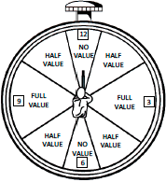

|  |  |
| --- | --- |
| **VELOCITY (OBSERVATION METHOD)** | |
| **Under 3 MPH** | The wind can hardly be felt on the face, but the presence of a slight wind can be detected by drifting smoke. |
| **3 – 5 MPH** | Wind can be felt lightly on the face. |
| **5 – 8 MPH** | Wind keeps tree leaves in constant motion. |
| **8 – 12 MPH** | Wind will raise dust and loose paper. |
| **12 – 15 MPH** | Wind will cause small trees to sway. |
| **15 – 25 MPH** | Wind will cause large trees to sway. |

**FIREARMS SYSTEM ROUND COUNT SHEET FOR:**

PAGE ____ OF ____

|  |  |  |  |  |  |  |
| --- | --- | --- | --- | --- | --- | --- |
| **DTG** | **Ammunition** | **Lot#** | **C.O.L.** | **Bullet Type** | **Bullet Weight** | **Quantity Fired** |
|  |  |  |  |  |  |  |
|  |  |  |  |  |  |  |
|  |  |  |  |  |  |  |
|  |  |  |  |  |  |  |
|  |  |  |  |  |  |  |
|  |  |  |  |  |  |  |
|  |  |  |  |  |  |  |
|  |  |  |  |  |  |  |
|  |  |  |  |  |  |  |
|  |  |  |  |  |  |  |
|  |  |  |  |  |  |  |
|  |  |  |  |  |  |  |

**FIREARMS SYSTEM ROUND COUNT SHEET FOR:**

PAGE ____ OF ____

|  |  |  |  |  |  |  |
| --- | --- | --- | --- | --- | --- | --- |
| **DTG** | **Ammunition** | **Lot#** | **C.O.L.** | **Bullet Type** | **Bullet Weight** | **Quantity Fired** |
|  |  |  |  |  |  |  |
|  |  |  |  |  |  |  |
|  |  |  |  |  |  |  |
|  |  |  |  |  |  |  |
|  |  |  |  |  |  |  |
|  |  |  |  |  |  |  |
|  |  |  |  |  |  |  |
|  |  |  |  |  |  |  |
|  |  |  |  |  |  |  |
|  |  |  |  |  |  |  |
|  |  |  |  |  |  |  |
|  |  |  |  |  |  |  |

**FIREARMS SYSTEM ROUND to TARGET COUNT SHEET FOR:**

PAGE ____ OF ____

|  |  |  |  |  |  |  |  |
| --- | --- | --- | --- | --- | --- | --- | --- |
|  | **DTG** | **Elevation** | **Windage** | **Target Distance (yds)** | **Wind Speed (mph)** | **Wind Direction** | **Target Engaged** |
| **1** |  |  |  |  |  |  |  |
| **2** |  |  |  |  |  |  |  |
| **3** |  |  |  |  |  |  |  |
| **4** |  |  |  |  |  |  |  |
| **5** |  |  |  |  |  |  |  |
| **6** |  |  |  |  |  |  |  |
| **7** |  |  |  |  |  |  |  |
| **8** |  |  |  |  |  |  |  |
| **9** |  |  |  |  |  |  |  |
| **10** |  |  |  |  |  |  |  |
| **11** |  |  |  |  |  |  |  |
| **12** |  |  |  |  |  |  |  |

**FIREARMS SYSTEM ROUND to TARGET COUNT SHEET FOR:**

PAGE ____ OF ____

|  |  |  |  |  |  |  |  |
| --- | --- | --- | --- | --- | --- | --- | --- |
|  | **DTG** | **Elevation** | **Windage** | **Target Distance (yds)** | **Wind Speed (mph)** | **Wind Direction** | **Target Engaged** |
| **1** |  |  |  |  |  |  |  |
| **2** |  |  |  |  |  |  |  |
| **3** |  |  |  |  |  |  |  |
| **4** |  |  |  |  |  |  |  |
| **5** |  |  |  |  |  |  |  |
| **6** |  |  |  |  |  |  |  |
| **7** |  |  |  |  |  |  |  |
| **8** |  |  |  |  |  |  |  |
| **9** |  |  |  |  |  |  |  |
| **10** |  |  |  |  |  |  |  |
| **11** |  |  |  |  |  |  |  |
| **12** |  |  |  |  |  |  |  |

**FIREARMS SYSTEM ROUND COUNT SHEET FOR:**

|  |  |  |  |  |  |  |  |  |
| --- | --- | --- | --- | --- | --- | --- | --- | --- |
| **DTG** | **Powder/Charge** | **Bullet Weight** | **Bullet Type** | **Primer** | **Case Head Stamp** | **Case Length** | **C.O.L.** | **Qty. Fired** |
|  |  |  |  |  |  |  |  |  |
|  |  |  |  |  |  |  |  |  |
|  |  |  |  |  |  |  |  |  |
|  |  |  |  |  |  |  |  |  |
|  |  |  |  |  |  |  |  |  |
|  |  |  |  |  |  |  |  |  |
|  |  |  |  |  |  |  |  |  |
|  |  |  |  |  |  |  |  |  |
|  |  |  |  |  |  |  |  |  |
|  |  |  |  |  |  |  |  |  |
|  |  |  |  |  |  |  |  |  |
|  |  |  |  |  |  |  |  |  |

**(Reload Version)**

PAGE ____ OF ____

**FIREARMS SYSTEM ROUND COUNT SHEET FOR:**

|  |  |  |  |  |  |  |  |  |
| --- | --- | --- | --- | --- | --- | --- | --- | --- |
| **DTG** | **Powder/Charge** | **Bullet Weight** | **Bullet Type** | **Primer** | **Case Head Stamp** | **Case Length** | **C.O.L.** | **Qty. Fired** |
|  |  |  |  |  |  |  |  |  |
|  |  |  |  |  |  |  |  |  |
|  |  |  |  |  |  |  |  |  |
|  |  |  |  |  |  |  |  |  |
|  |  |  |  |  |  |  |  |  |
|  |  |  |  |  |  |  |  |  |
|  |  |  |  |  |  |  |  |  |
|  |  |  |  |  |  |  |  |  |
|  |  |  |  |  |  |  |  |  |
|  |  |  |  |  |  |  |  |  |
|  |  |  |  |  |  |  |  |  |
|  |  |  |  |  |  |  |  |  |

**(Reload Version)**

PAGE ____ OF ____

**BALLISTIC RESULTS FOR:**

|  |  |  |  |  |
| --- | --- | --- | --- | --- |
| **Range** | **Elevation**  **MOA** | **Elevation MILs** | **Wind ADJ. MOA 10 MPH** | **Notes** |
| **0 yds.** |  |  |  |  |
| **50 yds.** |  |  |  |
| **100 yds.** |  |  |  |
| **150 yds.** |  |  |  |
| **200 yds.** |  |  |  |
| **250 yds.** |  |  |  |
| **300 yds.** |  |  |  |
| **400 yds.** |  |  |  |
| **500 yds.** |  |  |  |
| **600 yds.** |  |  |  |

**BALLISTIC RESULTS FOR:**

|  |  |  |  |  |
| --- | --- | --- | --- | --- |
| **Range** | **Elevation**  **MOA** | **Elevation MILs** | **Wind ADJ. MOA 10 MPH** | **Notes** |
| **0 yds.** |  |  |  |  |
| **50 yds.** |  |  |  |
| **100 yds.** |  |  |  |
| **150 yds.** |  |  |  |
| **200 yds.** |  |  |  |
| **250 yds.** |  |  |  |
| **300 yds.** |  |  |  |
| **400 yds.** |  |  |  |
| **500 yds.** |  |  |  |
| **600 yds.** |  |  |  |

**BALLISTIC RESULTS FOR: Hornady BLACK 6.5 Creedmoor 140 Grain BTHP**

|  |  |  |  |  |
| --- | --- | --- | --- | --- |
| **Range** | **Elevation**  **MOA** | **Elevation MILs** | **Wind ADJ. MOA 10 MPH** | **Notes** |
| **0 yds.** | **-** | **-** | **-** | G1 BC=0.580 |
| **50 yds.** | **0.2** | **0.1** |  |
| **100 yds.** | **-** | **-** | **-** |
| **150 yds.** | **0.8** | **0.2** |  |
| **200 yds.** | **1.9** | **0.5** |  |
| **250 yds.** | **3.1** | **0.9** |  |
| **300 yds.** | **4.4** | **1.3** |  |
| **400 yds.** | **7.4** | **2.1** |  |
| **500 yds.** | **10.6** | **3.1** |  |
| **600 yds.** | **14.2** | **4.1** |  |

**BALLISTIC RESULTS FOR: Winchester 6.5 Creedmoor 125 Grain BTHP**

|  |  |  |  |  |
| --- | --- | --- | --- | --- |
| **Range** | **Elevation**  **MOA** | **Elevation MILs** | **Wind ADJ. MOA 10 MPH** | **Notes** |
| **0 yds.** | **-** | **-** | **-** | G1 BC=0.365 |
| **50 yds.** | **0.3** | **0.1** |  |
| **100 yds.** | **-** | **-** | **-** |
| **150 yds.** | **0.7** | **0.2** |  |
| **200 yds.** | **1.7** | **0.5** |  |
| **250 yds.** | **3** | **0.9** |  |
| **300 yds.** | **4.3** | **1.3** |  |
| **400 yds.** | **7.4** | **2.2** |  |
| **500 yds.** | **11.1** | **2.7** |  |
| **600 yds.** | **15.4** | **4.5** |  |

**Vortex Strike Eagle® 5-25x56 FFP EBR-7C (MOA) RETICLE**

**MOA Subtensions**

The EBR-7C MOA reticle is based on minute of angle (MOA) subtensions. MOA measurements are based on degrees and minutes: 360o in a circle, 60 minutes in a degree for a total of 21, 600 minutes. These angular measurements are used to estimate range and correct for bullet drop.

A minute of angle will subtend 1.05” at a distance of 100 yds. (29.1mm at 100m) Strike Eagle® riflescopes with MOA adjustments use .25-minute adjustments which subtend at .26” at 100 yds. (7.3mm at a 100m), 0.52” at 200 yds. (14.6mm at 200 m), .078” at 300 yds. 21.9mm at 300m), etc.

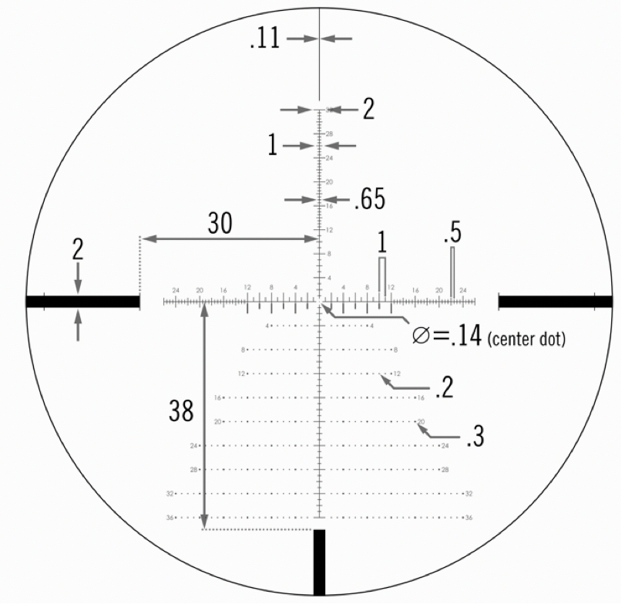

**Vortex Strike Eagle® 5-25x56 FFP RANGING**

**Ranging**

MOA measurements are very effective for ranging using a simple formula. To use this formula, the shooter needs to know the size of the target or nearby object in inches.

**MOA Ranging Formulas**

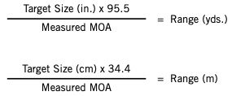

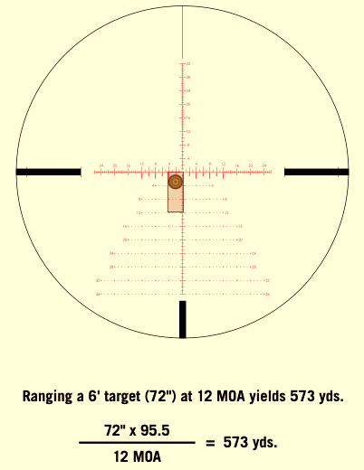**Vortex Strike Eagle® 5-25x56 FFP RANGING (Cont.)**

Using either the vertical or horizontal MOA scale, place the reticle on a target of known dimensions and read the number of MOA spanned. You will obtain maximum accuracy in ranging buy calculating exact MOA measurements. MOA should be estimated in quarters if possible.

Accurate measuring will depend on a very steady hold. The rifle should be solidly braced using a rest, bipod, or sling when measuring. One you have and accurate MOA reading, use the formula to calculate the distance.

NOTE: In the MOA ranging formula, a shooter may substitute 100 for 95.5 in the interest of speedier calculations. Be aware that this will produce a five percent over-estimation error of the yardage distance obtained.

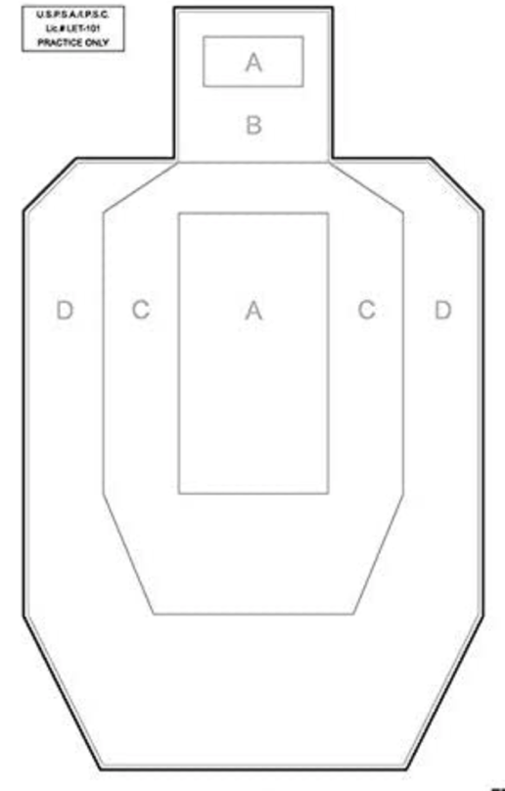**IPSC/USPSA TORSO TARGET DATA SHEET**

|  |  |  |
| --- | --- | --- |
| **DATE** | **TIME** | **LOCATION** |
|  |  |  |
| **HUMIDITY** | **PRESSURE** | **ALTITUIDE** |
|  |  |  |
| **AMMO TYPE** | | **TGT DISTANCE** |
|  | |  |
| **WIND DATA**  **SPEED VALUE**    **Under 3 MPH NO VALUE**  **3-5 MPH HALF**  **5-8 MPH FULL**  **8-12 MPH**  **12-15 MPH**  **15-25 MPH** | | |

**FIREARMS SYSTEM INFORMATION SHEET**

|  |  |  |  |  |  |
| --- | --- | --- | --- | --- | --- |
| **Identifier** | **Manufacturer** | **Model** | **SERIAL #** | **Cartridge** | **Firearm O.A.L.** |
|  |  |  |  |  |  |
| **Barrel / Contour** | **Length / Twist Rate** | **Headspace** | **Case Length** | **Length to Lands** | **Reamer** |
|  |  |  |  |  |  |
| **Bullet** | **Charge / Powder** | **Primer** | **Brass** | **OGIVE** | **O.A.L.** |
|  |  |  |  |  |  |
|  |  |  |  |  |  |
|  |  |  |  |  |  |
|  |  |  |  |  |  |
|  |  |  |  |  |  |
| **Notes:** | | | | | |

**FIREARMS SYSTEM INFORMATION SHEET**

|  |  |  |  |  |  |
| --- | --- | --- | --- | --- | --- |
| **Identifier** | **Manufacturer** | **Model** | **SERIAL #** | **Cartridge** | **Firearm O.A.L.** |
|  |  |  |  |  |  |
| **Barrel / Contour** | **Length / Twist Rate** | **Headspace** | **Case Length** | **Length to Lands** | **Reamer** |
|  |  |  |  |  |  |
| **Bullet** | **Charge / Powder** | **Primer** | **Brass** | **OGIVE** | **O.A.L.** |
|  |  |  |  |  |  |
|  |  |  |  |  |  |
|  |  |  |  |  |  |
|  |  |  |  |  |  |
|  |  |  |  |  |  |
| **Notes:** | | | | | |