The City of Velda City
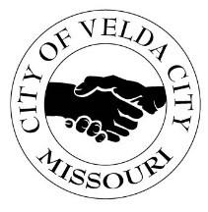
2560 LUCAS & HUNT ROAD; VELDA CITY, MISSOURI 63121
(314)382-6600 office | (314)382-7988 Fax

NOTICE OF PUBLIC HEARING

The City Council of the City of Velda City will hold a Public Hearing:

on July 8, 2026 at 6:00 p.m.
City Hall located at 2560 Lucas & Hunt Road; St. Louis MO 63121.

The purpose of this hearing is to present the 2026-2027 Proposed Budget.

For more information and/or accommodations,
Contact Deborah Nelson, City Clerk
Misconduct and / or inappropriate behavior will not be tolerated.
Date Posted: June 30, 2026 by DN

