**The City of Velda City**

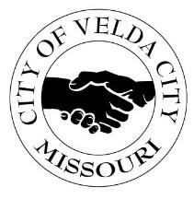2560 LUCAS & HUNT ROAD; VELDA CITY, MISSOURI 63121

**(314)382-6600 office | (314)382-7988 Fax**

**NOTICE OF PUBLIC HEARING**

The City Council of the City of Velda City will hold a Virtual Public Hearing at **5:30 pm on** **September 29, 2025**, via Zoom, for the purpose of setting a Tax Rate on all real, personal, and other tangible property for the 2025 tax year. At this time, citizens may comment on the proposed **2025 property Tax Rate:**

Proposed Tax Rate for General Revenue: 2024 2025*

Residential Real Estate: 0.3690 0.2910

Commercial Real Estate: 0.4850 0.4870

Personal Property: 0.3540 0.3540

*Revenue Estimate

Join Zoom Meeting

<https://us05web.zoom.us/j/83573378892?pwd=byOmOskegYwPOcZvspozK9NcJaqfZf.1>

Meeting ID: 835 7337 8892

Passcode: 1asET7

**Misconduct and / or inappropriate behavior will not be tolerated.**

**Date Posted: September 19, 2025 @ 1:00pm by DN**