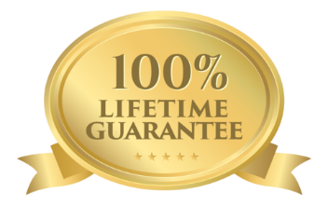
MIMI’S AKC YORKIES

Health Guarantee

All of our puppies are guaranteed to be in good health and free from visible signs of infection and contagious or communicable diseases when purchased.
Within 7 days of Purchase
If your puppy is returned for any reason other than an accident within 7 days of purchase, we will take the puppy back and refund 100% of the purchase price.
Lifetime Genetic Health Guarantee
If your puppy is diagnosed by a suitably qualified veterinarian as having a life threatening or seriously disabling defect of certain congenital/genetic origin any time in its life we will refund 100% of the purchase price or pay for treatment, up to the purchase price, at a Veterinary clinic approved by us. We reserve the right to require a second opinion from a veterinarian of our choice at our expense. If the puppy is euthanized or in any way disposed of, without a second opinion from the seller’s veterinarian, the buyer waives all rights to a refund.
The most common genetic diseases in YORKSHIRE TERRIERS –Progressive Retinal Atrophy and Primary Lens Luxation, as well as Tracheal Collapse and Luxating Patella - are covered by this Guarantee.
Note: This warranty is void in the event of an undetermined or inconclusive diagnosis. Diseases of likely environmental origin (likely to be caused by suboptimal diet, chemicals, or trauma) are not covered.
If your puppy dies and you request a refund, you must have a necropsy performed by a suitably qualified veterinarian at your expense to determine the cause of death. Your puppy will be refunded if the death was caused by a genetic problem or an illness which your puppy had at the time of purchase. For this reason, it is advisable to have your puppy checked by your own veterinarian within 72 hours of purchase.
For the long-term health of your puppy we recommend a diet containing at least 20% raw meaty bones, minimal exposure to food additives, and de-sexing at 12 months of age or older. We also recommend minimising exposure to veterinary drugs (such as flea and heartworm treatments, vaccinations and wormers) to the minimum dosage and frequency needed to safeguard your pet’s health.
Lifetime Rehoming Guarantee
Your puppy also has a lifetime rehoming guarantee with us, so should you have an inability to care for him or her in the future, you can contact us at any stage of your puppy's life. Under no circumstances must your puppy ever be given up to a shelter.
Dated: [TODAY’S DATE] Signed:………………………………………………………..
[YOUR NAME]

