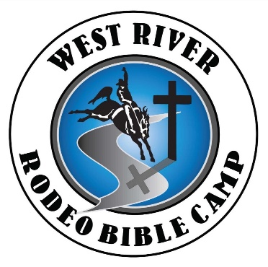

Dear Friend:
On behalf of the youth participants of West River Rodeo Bible camp, a nondenominational Christian youth rodeo camp, we would like to take this opportunity to ask for your help in having another outstanding and succesful year in reaching youth and young people in the region through rodeo and Jesus.
West River Rodeo Bible Camp was organized for the sole purpose of introducing youth and young adults to Jesus Christ, to introduce to or improve their knowledge and skill of rodeo and horsemanship skills and then give them a chance to put this all to test in an actual rodeo competition.
We are asking for your help in supporting our 9th annual West River Rodeo Bible Camp, which will be held June 14th-18t^{h} 2023 at the Morton County Fairgrounds in New Salem ND, by sponsoring a buckle for $150 or by donating items, services, gift certificates, gift cards or a monetary donation. The items donated will be used at one of our annual fundraisers and/or in many other aspects of the camp. All funds raised go directly towards camp expenses, which include, Trophy belt buckles, facility and equipment rentals, meals for campers and volunteers, t-shirts for the campers, transportation, misc. awards and scholarships awarded to campers whom are in need of financial assistance to attend camp.
ALL of our sponsors will be recognized in our rodeo programs and announced at our rodeo and our various fund raisers.If you choose to become a buckle sponsor you will be acknowledged at our various events and our rodeo.
We appreciate your consideration for helping to make West River Rodeo Bible Camp a successful outreach and experience to the youth and young people in the region.
PO Box 503 Mandan ND 58554
Westriverrodeobiblecamp.com

Questions feel free to contact
President Levi Lanning 701-391-1272 Treasurer Jenn Job 701-202-7010
Secretary Amy Lanning 701-391-3340 Board member Karen Hook 701-391-4271

