GCh. Devonshire’s Texas Tea

“Tipsy”
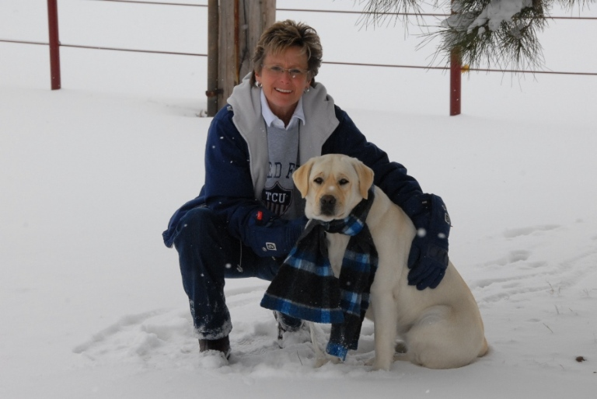

Ch. Devonshire’s Texas Tea

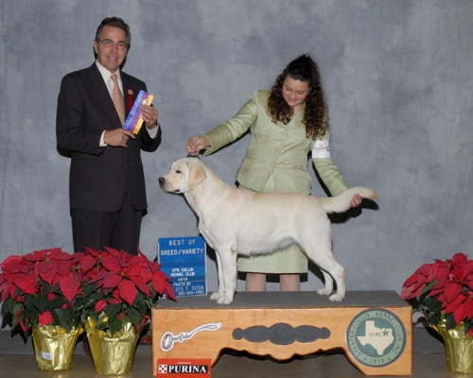

Judged by: Mr. Elliott B Weiss Shown by: Miss Collette Livingston

Show Highlights

08-01-2010 Longview Kennel Club Thomas Gomez Winners Bitch
10-17-2010 Tyler Tex Kennel Club Judy Webb Best of Winners(Major)
11-17-2010 Town & Country KC Maxine Beam Best of Breed
11-18-2010 Town & Country KC Loraine Boutwell Best Opposite Sex
11-20-2010 Canadian Valley KC Lorraine Bisso Best of Breed
12-10-2010 Trinity Valley KC Chris Walkowic Winners Bitch (Major)
12-11-2010 Greater Collin KC Elliott B Weiss Best of Breed (Major)
12-12-2010 Texas Kennel Club Mary Ann Alston Best of Winners(Major)

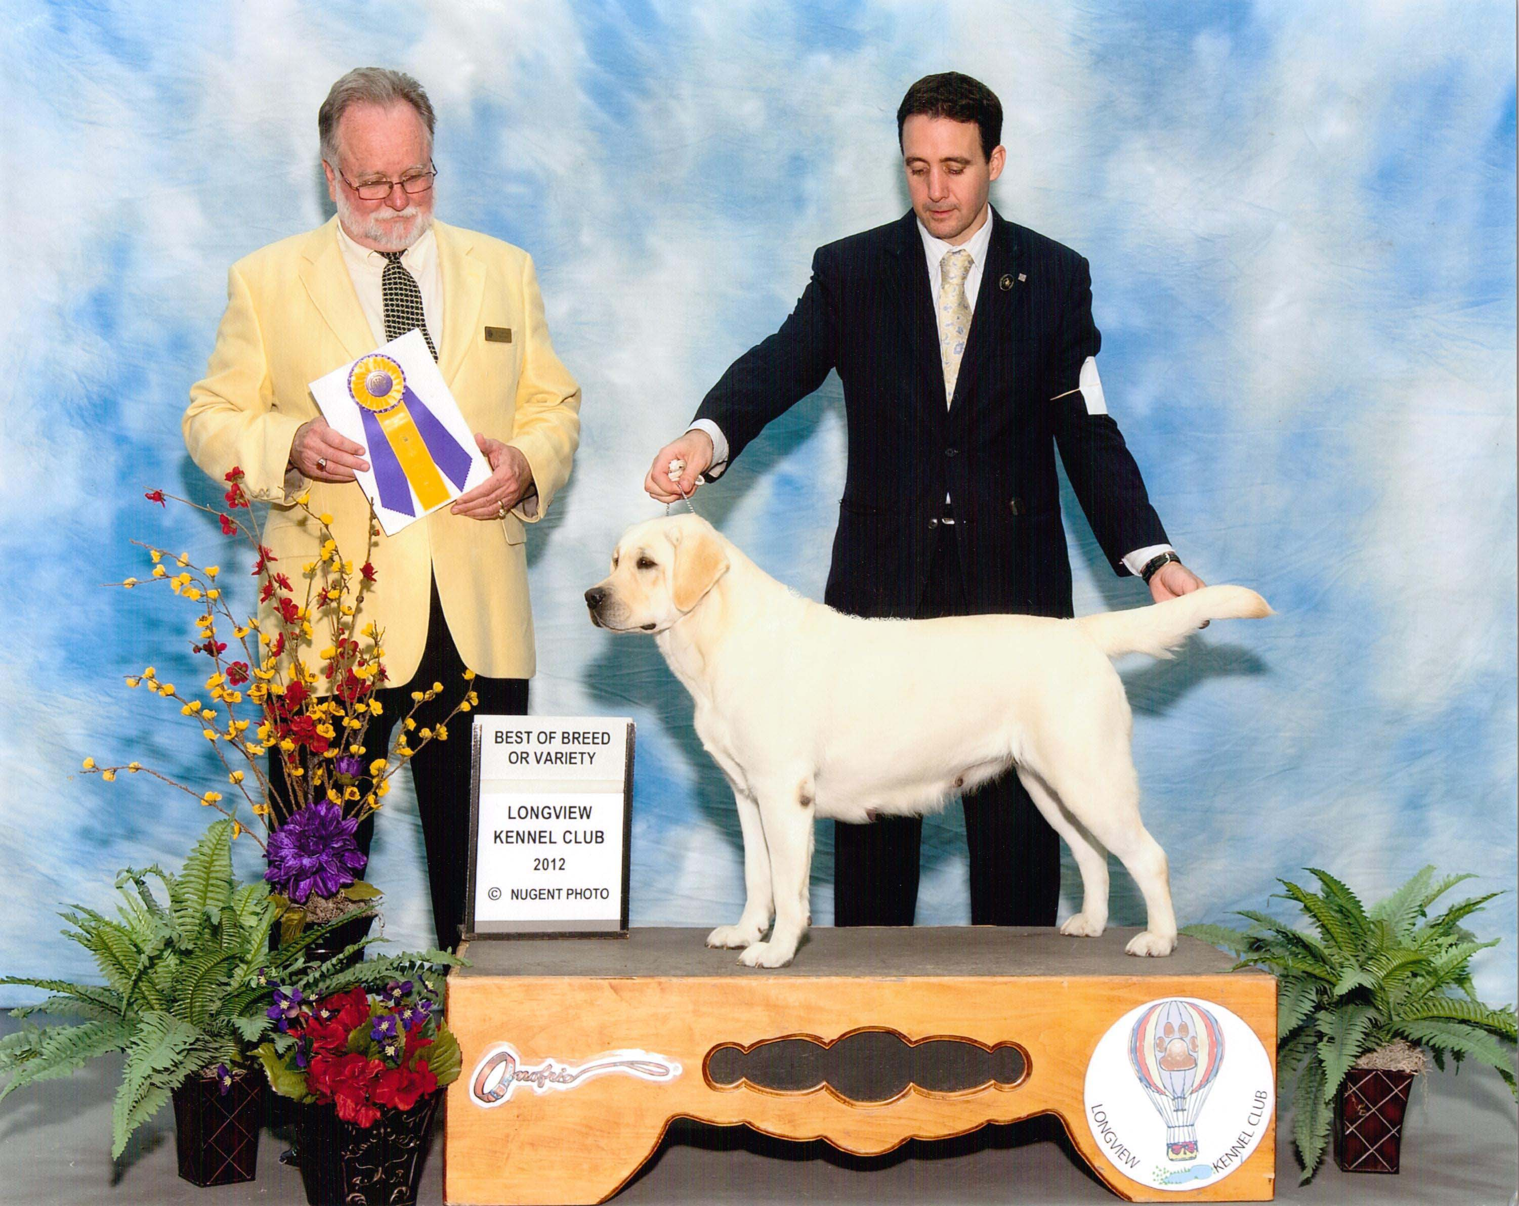
Judged by Dr. Clyde E. Shaw Shown by Brian Livingston

Points toward Grand Championship
7/6/12 Trinity Kennel Club Mrs. Paula Nykiel Select
7/8/12 Texas Kennel Club Mrs. Stephanie Hedgepath Select
7/20/12 Houston Kennel Club Mrs. Judy Webb BOS
7/28/12 Longview Kennel Club Dr. Clyde E. Shaw BB
7/29/12 Longview Kennel Club Mr. James R. White BB

Pedigree of
Ch. Devonshire’s Texas Tea
“Tipsy”
Ch. Devonshires Limited Edition Devonshires Hot Toddy
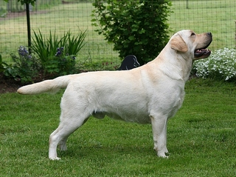 | 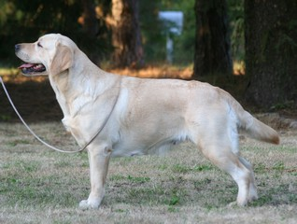

Am Ch Devonshires Limited Edition, WC  OFA Good/Elbows Normal  Eyes Clear, Heart Clear  EIC Clear  PRA Clear by Parentage | Timberland Woodsman At Lor-Al | Lor-Al's Direct Deposit
 | Timberland Woodsman At Lor-Al | Crossfire The Tempest At Timberland
 | Am Ch Devonshires Abby Lane | Am Ch Dickendal Daveron Gable
 | Am Ch Devonshires Abby Lane | By Jove Millicent Fenwick
Devonshires Hot Toddy  OFA Excellent  Elbows Normal  Eyes Clear  PRA Clear by Parentage | Am Ch Lobuff's Bobwhite At Chucklebrook | BISS Am Ch Boradors By George
 | Am Ch Lobuff's Bobwhite At Chucklebrook | BISS Am Ch Lobuff's Turtle Dove
 | Devonshires Tempest in a Tea POt | Am Ch Dickendall Daveron Gable
 | Devonshires Tempest in a Tea POt | Devonshires Time For Tia

