Pedigree for GRAND CHAMPION INDIE’S MOONLITE SAGE

Am Grand Champion  Sunnydaze Runninng  Across the Miles  OFA Hips Good  Elbows Normal  PRA Clear  Eyes Clear  EIC Clear | Polish Jr.Ch. Am. GR.Ch. Figero  DaFoz Herbu Zadora  --------------------------------  Can.Ch. Sunnydaze Runs With  Scissors | Trenlewood far Away Zadora  ------------------------------------------  Megi Psie Lobby  -------------------------------------------  BISS CH. Boradors by George, CGC  -------------------------------------------  Can Ch Sunnydaze Supernatural
Am Grand Champion  Devonshire's  Southern Comfort  OFA Hips Good  Elbows Normal  PRA Clear  Eyes Clear | Am.Ch. Zinfndel's Brigham  --------------------------------  Am.Ch.Devonshire's Darjeeling | Am.Ch. Tullamores Toberone  -------------------------------------------  Am.Ch. Tabatha's Confection  -------------------------------------------  Am.Ch. Lobuff Bobwhite At Chucklebrook JH  -------------------------------------------  Devonshire's Jasmine

Sire: MBISS, MEX. CAN. AMG CH. Sunnydaze Running Across the Miles

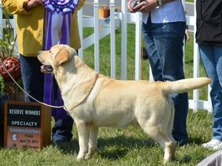

Dam: Am Grand Champion Devonshire’s Southern Comfort
