New River Valley of Narcotics Anonymous
Area Service Meeting
February 7, 2021
Held at Highland Park Community Church
Meeting opened by Lauren at 2pm with the Serenity Prayer, reading of 12 Traditions of Narcotics Anonymous by Crystal L, and the 12 Concepts of NA Service read by Kellie S.
Next NRVANA Area Service Meeting will be March 7, 2021 face to face (God willing) at HOW.
**Area Services Members and GSR contact information as of September, 2020**
Service Position
Chair | Lauren B.
VICE Chair | Crystal L.
Treasurer | Vacant
Secretary | Jessi J.
Policy Chair | Paula L.
Activities Chair | Amy N.
Outreach Chair | Brittany B.
Literature Chair | Chris E
RCM | Vacant
RCM Alternate | Vacant
VRCC | Vacant
Group GSR and Alternates
Principles Before Personalities (PBP) GSR | Sharon M.
Principles Before Personalities (PBP) Alt GSR | Brittany B.
Honesty, Open-mindedness, Willingness (H.O.W) GSR | Amy N.
HOW Alt. GSR | Ashley
Keep It Spiritually Simple (KISS) GSR | Kelli S
KISS Alternate GSR
Steps to Freedom GSR | Thomas L
Steps to Freedom Alt GSR | Vacant
Circle of Hope GSR | Ed. S.
Circle of Hope Alternate GSR | Jeffrey B.

Roll call for 7/5/2020
Service Position |  | Attendance | Absences since Apr. 2020
Chair | Lauren B. | Present | 0
Vice Chair | Crystal A. | Present | (09-06-20)
Treasurer | vacant |  | 0
Secretary | Jessi | Present | 0
Activities Chair | Amy N. | absent | (8/2/2020)(12/13/20)
Literature Chair | Chris E. | Absent | 2(4/5/2020)(02/07/21)
Policy Chair | Paula L. | Present
Outreach Chair | Brittany B. | Present | 0
RCM | Vacant
RCM Alternate | Vacant
VRCC | Vacant
Group | GSR or Alternate GSR | Attendance | Absences for the Group since Apr. 2020 | Voting Status
PBP | Sharon Mc.  Alt. GSR: Brittney B | Present | 0 | Eligible
HOW | Amy N.  Alt. GSR: Ashley | Present | 0 | Eligible
KISS | Kelli S.  Krysta M. | Present | 2 (7/5/2020) | Eligible
Circle of Hope | Ed | Absent | 3 (4/5/2020, 5/3/2020, 6/7/2020) (10/05/20) (2/7/21) | Not Eligible
HOW 2 MEETING | Paula L. | present | Present 12/1/2019, 7/5/2020 | Not eligible
Steps to freedom GSR | Thomas L. | Absent |  | Not eligible

- Read and approved February Area minutes.
- Mail collected, How bank statement.

Jared would like to start a group in narrows on fridays from 6-7pm. Address is 109 Mary St, Narrows, Va, 24134.

New nominations needed:
We continue to need nominations for Treasurer, RCM, Alt. RCM and VRCC. Please take these positions back to your group for discussion. Please be mindful that you must be present at Area to except all nominations and positions. Please take nomination back to your groups for vote, position will be elected at next ASC.

Treasurer's Report
Beginning balance (last ASC)

618.13

 | Credit | Debit | Total
Donations |  |  | 605.25
HOW | 5
PBP | 0
KISS | 20
Circle of Hope | 30
Literature | 0
Total | 55.00
Payouts |  |  | 0
Check 247 Donation Central Atlantic Region |  | $50.00
Chk 248 Free State |  | $19.80
Highland Park Church |  | $20.00
Total Payouts |  | $105.54
Deposits | $55.00
Ending balance |  |  | $554.71

Thanks for allowing me to serve,
Crystal L.

Subcommittee Reports
Activities Report:
Nothing to report at this time due to the recent passing of my father.

I’m loving service, Amy N.

Literature Report:
Absent

Thanks for allowing me to serve,
Chris E.

Policy Report:
See attached motions. Next policy meeting will be 02/25/21 before PBP.

Outreach Report: Nothing new to report at this time. I have updated the website.
Thanks for allowing me to serve,
Brittany

GSR Reports

PBP
PBP still meets on Friday and Saturday at 6pm in Pulaski. We have an average of 3 addicts in attendance at each meeting. We don't have any celebrations this month. We are making a $10 area donation. Thanks for allowing me to serve.

Sharon Mc

HOW:
HOW:
GSR: HOW still meets on Monday and Wednesday at 7 pm in Dublin. We have an average attendance of 10 addicts. Today we have an area donation of $25. On February 15th, Erica SW will celebrate 9 years and Jennifer M will be speaking.

Thanks for letting me serve!
Amy N.

KISS: Kiss is doing well we still meet on Tuesdays at 7 and Wednesday and Friday at 8 at the church in Christiansburg. We average about 10 people. We are donating $20 to area this month and we have one celebration on the 16th. Jade will be celebrating and Mike S. Might speak.

In loving service Kellie S.

Circle of Hope

Absent

Common Ground

We have 8-10 addicts and no celebrations this month.
Thanks for allowing me to serve.

Jared

New Business
Nominations;
Chair: KISS and HOW nominated Jessi J. PBP nominated Crystal L.
Jessi accepted. She has 7 years of clean time and has served at her home group opening meetings, served the group level as gsr for HOW, activities chair and secretary. She has served the Regional level as RCM.
She has an NA sponsor and makes 3 meetings a week.

Vice Chair: KISS and HOW nominated Kellie S. PBP nominated Jessi J.
Kellie S. Accepted the nomination she has 3 years of clean time. She has served her home group opening meetings and sponsoring women. She has served at the area level as GSR. She makes 3 meetings a week and has an NA sponsor.

Secretary: KISS and HOW nominated Ashley H. PBP nominated Kellie S.
Ashley accepted the nomination
She has 2 years of clean time. She has served the group level opening and chairing meetings, and sponsoring women, she has served the area as GSR alternate. She makes 2-3 meetings a week and has an NA sponsor.

Outreach: HOW nominated Jason C. PBP nominated Lauren B.
Lauren B accepted the nomination
She has 7 years of clean time, she has served her homegroup opening meetings, chairing meetings, sponsoring women. She’s served the area as chair, vice chair, and policy chair. She attends 2-3 meetings a week and has an NA sponsor.
Policy Chair: PBP, KISS, HOW all nominated Paula L.
Paula L. Accepted the nomination
She has 34 years of clean time. She has served in all levels of service for her home group. She has opened meetings, chaired meetings, sponsored women. She has held all area positions. She has an NA sponsor and makes 1-3 meetings a week.

Treasurer: HOW nominated Robert A. PBP nominated Erica S.
Erica S. Accepted the nomination.
She has 8 years of clean time. She has served her home group by opening and chairing meetings and sponsoring women. She has served the area as activities chair twice, policy chair, and vice chair. She makes 3 meetings a week, has an NA sponsor.

We still need a nominations for Literature Chair, RCM, RCM alternate, and vrcc.

Old Business

Open Forum
Jared from Common Ground mentioned they need key tags. We have instructed him on how to obtain them and offered to help in any way.

New policy motions. Please take these back to your home groups and vote on them. 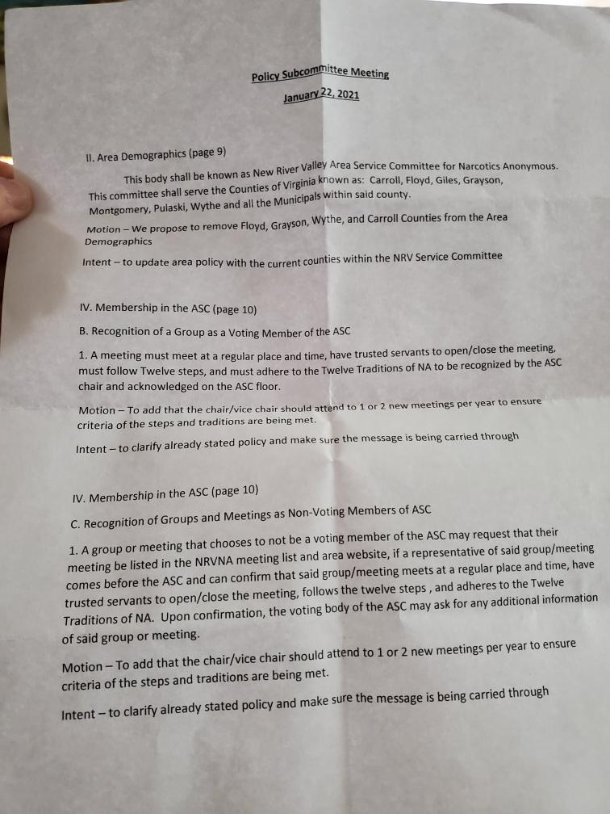

Meeting adjourned with Serenity Prayer.

Motions Log
 | Date of Motion | Description | Presented By | Presented To | Result
2017-2018.1 | October 2017 | Request that any addict may purchase literature at ASC | Literature Subcommittee | Groups | Passed 6-0-0 on 11/12/17
2017-2018.2 | November 2017 | $70.00 budget for policy printing | Policy Subcommittee | Groups | Passed 7-0-1 on 12/3/17
2017-2018.3 | December 2017 | Literature Subcommittee budget guidelines to read “monthly order should be sufficient to maintain predetermined stockpile amount of $750” | Policy Subcommittee | Groups | Passed 8-0-0 on 1/7/18
2017-2018.4 | January 2018 | We request change as follows: “For a group to regain their membership and voting privileges with the ASC, their GSR must attend two consecutive ASC meetings. Voting Privileges will be reinstated at their 2nd attendance to ASC.” | Policy Subcommittee | Groups | Passed 6-0-2 on 2/11/18
2017-2018.5 | January 2018 | Adding meetings to website when added to meeting list | Policy Subcommittee | Groups | Passed 6-0-2 on 2/11/18
2017-2018.6 | January 2018 | Currently Reads: “In the spirit of rotation, no individual should serve more than two consecutive years in the same position. No individual is eligible for re-election to any position they have held in the last 3 (three) years.” We request change as follows: Strike the second sentence completely. | Policy Subcommittee | Groups | Passed 4-2-2 on 2/11/18
2018.7 | February 2018 | Qualification of Vice-Chair to read “A willingness to serve. This is a one year commitment, preparing and becoming familiar with the job of chair if elected.” | Policy Subcommittee | Groups | Passed 4-0-1 on 3/4/18
2018.8 | February 2018 | We request changes as follows: “All reports need to be written and turned in to secretary to be included in the monthly minutes.” | Policy Subcommittee | Groups | Passed 5-0-0 on 3/4/18
2018.9 | February 2018 | We request changes as follows: “…Note: Any member may request a copy of the ASC minutes.” | Policy Subcommittee | Groups | Passed 5-0-0 on 3/4/18
2018.10 | March 2018 | We request changes as follows: “This is a one year commitment, preparing and becoming familiar with the job as RCM, if elected.” | Policy Subcommittee | Groups | Passed 6-0-0 on 4/8/18
2018.11 | April 2018 | Secretary Qualifications | Policy Subcommittee | Groups | Not passed 1-4-0 on 5/6/18
2018.12 | May 2018 | Section IX. Financial Guidelines B. Prudent Reserve | Policy Subcommittee | Groups | Not passed 2-2-1 on 6/10/18
2018.13 | May 2018 | D. Distribution of funds-Operating Expenses Number 6  Currently reads: Policy Subcommittee: $10 every 3 months for rent  We request changes as follow: Strike completely | Policy Subcommittee | Groups | Passed 4-0-1 on 6/10/18
2018.14 | May 2018 | We request changes as follows:  NRVANA will donate $30 at every regional committee meeting if funds are available | Policy Subcommittee | Groups | Passed 3-1-1 on 6/10/18
2018.15 | May 2018 | The outreach subcommittee would like to request funding to upgrade our website, in the amount of $35. | Outreach Subcommittee | ASC Floor | Passed on 5/6/18
2018.16 | July 2018 | Subcommittee Chair and Administrative Committee members can make motions only directly related to their respective subcommittee or positions. | Policy Subcommittee | Groups | Passed 5-0-0 on 8/6/18
2018.17 | July 2018 | Administrative positions cannot be ad hoc’d | Policy Subcommittee | Groups | Passed 3-2-0 on 8/6/18
2018.18 | July 2018 | Activities Subcommittee request an additional $50 for Summa’ Bash | Activities Subcommittee | ASC Floor | Passed on 7/8/18

