New River Valley of Narcotics Anonymous
Area Service Meeting
March 7, 2021
Held at Highland Park Community Church
Meeting opened by Lauren at 2pm with the Serenity Prayer, reading of 12 Traditions of Narcotics Anonymous by Erica S., and the 12 Concepts of NA Service read by Jessi J.
Next NRVANA Area Service Meeting will be April 11, 2021 face to face (God willing) at HOW.
**Area Services Members and GSR contact information as of March 8, 2021**
Service Position
Chair | Jessi J.
VICE Chair | Kellie S.
Treasurer | Erica S.
Secretary | Ashley H.
Policy Chair | Paula L.
Activities Chair | Amy N.
Outreach Chair | Lauren B.
Literature Chair | Chris E
RCM | Vacant
RCM Alternate | Vacant
VRCC | Vacant
Group GSR and Alternates
Principles Before Personalities (PBP) GSR | Sharon M.
Principles Before Personalities (PBP) Alt GSR | Brittany B.
Honesty, Open-mindedness, Willingness (H.O.W) GSR | Amy N.
HOW Alt. GSR | Ashley
Keep It Spiritually Simple (KISS) GSR | Kelli S
KISS Alternate GSR
Common Ground GSR | Jared L.
Common Ground Alt GSR | Vacant
Circle of Hope GSR | Ed. S.
Circle of Hope Alternate GSR | Jeffrey B.

Roll call for 3/8/2020
Service Position |  | Attendance | Absences since Apr. 2020
Chair | Lauren B. | Present | 0
Vice Chair | Crystal A. | Present | (09-06-20)
Treasurer | vacant |  | 0
Secretary | Jessi | Present | 0
Activities Chair | Amy N. | absent | (8/2/2020)(12/13/20)
Literature Chair | Chris E. | Absent | 2(4/5/2020)(02/07/21)
Policy Chair | Paula L. | Present
Outreach Chair | Brittany B. | Present | 0
RCM | Vacant
RCM Alternate | Vacant
VRCC | Vacant
Group | GSR or Alternate GSR | Attendance | Absences for the Group since Apr. 2020 | Voting Status
PBP | Sharon Mc.  Alt. GSR: Brittney B | Present | 0 | Eligible
HOW | Amy N.  Alt. GSR: Ashley | Present | 0 | Eligible
KISS | Kelli S.  Krysta M. | Present | 2 (7/5/2020) | Eligible
Circle of Hope | Ed | Absent | 3 (4/5/2020, 5/3/2020, 6/7/2020) (10/05/20) (2/7/21) | Not Eligible
HOW 2 MEETING | Paula L. | present | Present 12/1/2019, 7/5/2020 | Not eligible

- Read and approved February Area minutes.
- Mail not collected

Treasurer's Report
Beginning balance (last ASC)

554.71

 | Credit | Debit | Total
Donations |  |  | 554.71
HOW | 25
PBP | 0
KISS | 0
Circle of Hope | 0
Literature | 0
Total | 25
Payouts |  |  | 0
Check 252 Donation NA World Services |  | $25
Total Payouts |  | $25
Deposits | $0
Ending balance |  |  | $554.71

Attached in PDF is 2021’s projected budget. Due to minimum donations made during 2020, this projected budget is to cover essentials. Please take to home groups to discuss so we can vote on it at the next area.

Thanks for allowing me to serve,
Crystal L.

Subcommittee Reports
Activities Report:
Nothing to report

I’m loving service, Amy N.

Literature Report:
$20.94 on hand. Placing order this month to include last months order which was under the $10 minimum.
Thank you,
Chris E.

Policy Report:
We met Feb 26 at PBP. We started reviewing qualifications of officers. We have nothing to bring to area at this time.
Next subcommittee meeting is on March 19th at 5:30pm at PBP

Thanks for letting me serve,
Paula L.

Outreach Report: No report submitted.

GSR Reports

PBP
No report submitted by PBP

HOW:
GSR: HOW still meets on Monday and Wednesday at 7 pm in Dublin. We have an average attendance of 10 addicts. Today we have an area donation of $30. We don’t have any celebrations for March
Thanks for letting me serve!
Amy N.

KISS: Kiss is doing well we still meet on Tuesdays at 7 and Wednesday and Friday at 8 at the church in Christiansburg. We have an average of 7-10 people. We are donating $10 to area this month and have no celebrations.
Thanks for allowing me to serve,
Kellie S.

Circle of Hope

We still meet Thursday’s at 7pm at 704 Harding, Blacksburg, VA 24060. We hav moistly been joining the New Life Zoom meeting. Average of 2 people. $40 donation for the last 2 months.

Jeff B.

Common Ground

Common Ground is doing well. We meet Friday from 6-7pm at Narrows Public Library. We average 7-8 people. No celebrations this month. We have no donations.

Jared L.

New Business
Voted In:
Chair: Jessi J
Vice Chair: Kellie S.
Secretary: Ashley H.
Outreach: Lauren B.
Policy Chair: Paula L.
Treasurer: Erica S.
We still need nominations for RCM alternate.
Nominations:
Literature: Amy made a motion from the floor to nominate Chris E. Kellie S. seconded it. Chris E. accepted it.
Chris has over 2 years of clean time. He has served his home group by opening and chairing meetings. He has served as literature chair for area for 1 year. He attends 2 meetings a week. He does not have a NA sponsor.
RCM and VRCC: Amy made a motion from the floor to nominate Crystal L. Kellie S. seconded it. Crystal L. accepted it.
Crystal has 3 years of clean time. She has chaired meetings and served as the secretary and treasurer at the group level. She has served as chair, vice chair, secretary, interim treasurer, and alt. RCM for the ASC. She sponsors other women. She attends 3 meetings a week. She does have a NA sponsor.

Take these nominations back to home groups and they will be voted on at next area.

Paula L. announced that HOW2 that meets in Pulaski on Sunday’s at 6pm is now closed due to no attendance. Left over literature and material have been donated to Common Ground.

Old Business
N/A

Open Forum
Common Grounds meeting place is requiring someone from the town of Narrows to attend this meeting.
New policy motions. Please take these back to your home groups and vote on them. 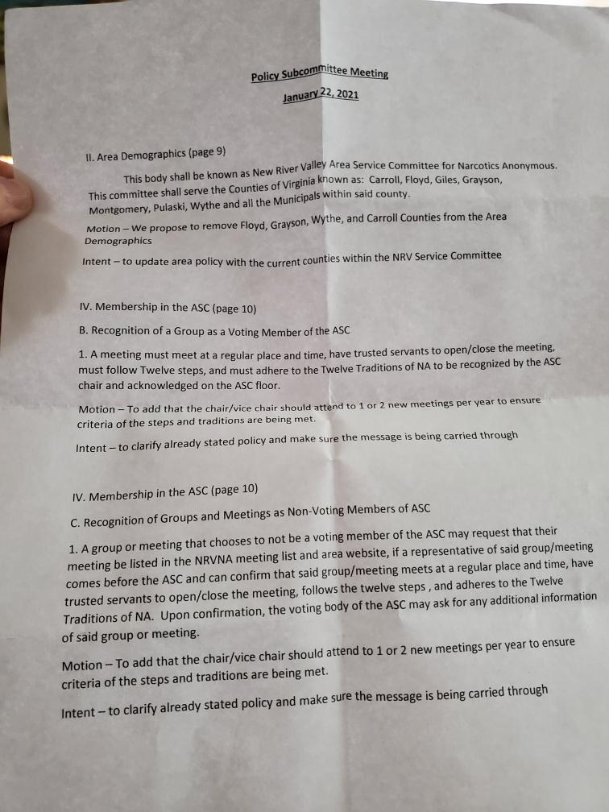

Meeting adjourned with Serenity Prayer.

Motions Log
 | Date of Motion | Description | Presented By | Presented To | Result
2017-2018.1 | October 2017 | Request that any addict may purchase literature at ASC | Literature Subcommittee | Groups | Passed 6-0-0 on 11/12/17
2017-2018.2 | November 2017 | $70.00 budget for policy printing | Policy Subcommittee | Groups | Passed 7-0-1 on 12/3/17
2017-2018.3 | December 2017 | Literature Subcommittee budget guidelines to read “monthly order should be sufficient to maintain predetermined stockpile amount of $750” | Policy Subcommittee | Groups | Passed 8-0-0 on 1/7/18
2017-2018.4 | January 2018 | We request change as follows: “For a group to regain their membership and voting privileges with the ASC, their GSR must attend two consecutive ASC meetings. Voting Privileges will be reinstated at their 2nd attendance to ASC.” | Policy Subcommittee | Groups | Passed 6-0-2 on 2/11/18
2017-2018.5 | January 2018 | Adding meetings to website when added to meeting list | Policy Subcommittee | Groups | Passed 6-0-2 on 2/11/18
2017-2018.6 | January 2018 | Currently Reads: “In the spirit of rotation, no individual should serve more than two consecutive years in the same position. No individual is eligible for re-election to any position they have held in the last 3 (three) years.” We request change as follows: Strike the second sentence completely. | Policy Subcommittee | Groups | Passed 4-2-2 on 2/11/18
2018.7 | February 2018 | Qualification of Vice-Chair to read “A willingness to serve. This is a one year commitment, preparing and becoming familiar with the job of chair if elected.” | Policy Subcommittee | Groups | Passed 4-0-1 on 3/4/18
2018.8 | February 2018 | We request changes as follows: “All reports need to be written and turned in to secretary to be included in the monthly minutes.” | Policy Subcommittee | Groups | Passed 5-0-0 on 3/4/18
2018.9 | February 2018 | We request changes as follows: “…Note: Any member may request a copy of the ASC minutes.” | Policy Subcommittee | Groups | Passed 5-0-0 on 3/4/18
2018.10 | March 2018 | We request changes as follows: “This is a one year commitment, preparing and becoming familiar with the job as RCM, if elected.” | Policy Subcommittee | Groups | Passed 6-0-0 on 4/8/18
2018.11 | April 2018 | Secretary Qualifications | Policy Subcommittee | Groups | Not passed 1-4-0 on 5/6/18
2018.12 | May 2018 | Section IX. Financial Guidelines B. Prudent Reserve | Policy Subcommittee | Groups | Not passed 2-2-1 on 6/10/18
2018.13 | May 2018 | D. Distribution of funds-Operating Expenses Number 6  Currently reads: Policy Subcommittee: $10 every 3 months for rent  We request changes as follow: Strike completely | Policy Subcommittee | Groups | Passed 4-0-1 on 6/10/18
2018.14 | May 2018 | We request changes as follows:  NRVANA will donate $30 at every regional committee meeting if funds are available | Policy Subcommittee | Groups | Passed 3-1-1 on 6/10/18
2018.15 | May 2018 | The outreach subcommittee would like to request funding to upgrade our website, in the amount of $35. | Outreach Subcommittee | ASC Floor | Passed on 5/6/18
2018.16 | July 2018 | Subcommittee Chair and Administrative Committee members can make motions only directly related to their respective subcommittee or positions. | Policy Subcommittee | Groups | Passed 5-0-0 on 8/6/18
2018.17 | July 2018 | Administrative positions cannot be ad hoc’d | Policy Subcommittee | Groups | Passed 3-2-0 on 8/6/18
2018.18 | July 2018 | Activities Subcommittee request an additional $50 for Summa’ Bash | Activities Subcommittee | ASC Floor | Passed on 7/8/18

