MONDAY
7:00 pm - 8:00 pm Dublin
H.O.W Group (O,D,HC)
Honesty, Open-Mindedness, Willingness
Highland Park Community Church
6144 Wright Ave Dublin, Va 24084
TUESDAY
7:00 pm - 8:00 pm Christiansburg
K.I.S.S (O,D,LS,HC)
Keep It Spiritually Simple
St Thomas Episcopal Church
103 E. Main St Christiansburg, Va 24073
WEDNESDAY
7:00 pm - 8:00 pm Dublin
H.O.W Group (O,LS, HC)
Honesty, Open-Mindedness, Willingness
Highland Park Community Church
6144 Wright Ave. Dublin, Va 24084

8:00 pm - 9:00 pm Christiansburg
K.I.S.S (O,LS,HC)
Keep It Spiritually Simple
St Thomas Episcopal Church
103 E Main St. Christiansburg, Va 24073
*Narcotics Anonymous is not in any way affiliated with the facilities where we meet.

THURSDAY
7:00 pm - 8:00 pm Blacksburg
Circle of Hope
Blacksburg United Methodist Church,
Christian Life Center
​(use lower side entrance)
706 Harding Ave, Blacksburg, Va 24060

7:00 pm - 8:00 pm Pearisburg
Steps To Freedom (O,HC)
First United Methodist Church
1101 Valley View Dr, Pearisburg, VA 24134

THURSDAY
7:00 pm- 8:00 pm Radford
One addict helping another (O, HC, D)
401 Peer Center
401 West Main Street
Radford, Va 24141

FRIDAY
6:00 pm - 7:00 pm Pulaski
PBP (O, D)
Principles Before Personalities
1st Presbyterian Church Annex (Manse)
72 Fourth St NW Pulaski, Va 24301

8:00 pm - 9:00 pm Christiansburg
K.I.S. S (O, HC)
St Thomas Episcopal Church
103 E Main St Christiansburg, Va 24073

SATURDAY
6:00 pm - 7:00 pm Pulaski
P.B.P (O, LS)
Principles Before Personalities
1st Presbyterian Church Annex (Manse)
72 Fourth St NW, Pulaski, Va 24301

SUNDAY
6:00pm-7:00pm Radford
One addict helping another (O, HC, D)
401 Peer Center
401 West Main Street
Radford, Va 24141

*All meetings are open to public unless otherwise noted

“We have never seen a person who lives the Narcotics Anonymous Program relapse.”
Basic Text
Recovery and Relapse…. page 79

“Now we know that the time has come when that tired old lie, “Once an addict always an addict,” will no longer be tolerated by either society or the addict himself. WE DO RECOVER.”
Basic Text
We Do Recover…. page 89

Suggestions:
- Come early, Stay late
- Attend 90 meetings your first 90 days
- Get phone numbers and use them
- Find a sponsor
- Keep coming back
- Don’t use no matter what

Meeting Key:
O- Open to All D-Discussion Meeting
HC-Handicap Accessible LS-Literature Study
V-Format Varies C-Closed (addicts only)
CL- Candle Lit

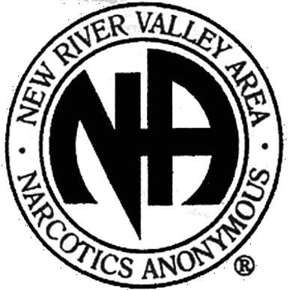
What Is the Narcotics Anonymous Program?
NA is a nonprofit fellowship or society of men and women for whom drugs had become a major problem. We are recovering addicts who meet regularly to help each other stay clean. This is a program of complete abstinence from all drugs. There is only one requirement for membership, the desire to stop using. We suggest that you keep an open mind and give yourself a break. Our program is a set of principles written so simply that we can follow them in our daily lives. The most important thing about them is that they work.
There are no strings attached to NA. We are not affiliated with any other organizations. We have no initiation fees or dues, no pledges to sign, no promises to make to anyone. We are not connected with any political, religious, or law enforcement groups, and are under no surveillance at any time. Anyone may join us regardless of age, race, sexual identity, creed, religion, or lack of religion.
We are not interested in what or how much you used or who your connections were, what you have done in the past, how much or how little you have, but only in what you want to do about your problem and how we can help. The newcomer is the most important person at any meeting, because we can only keep what we have by giving it away. We have learned from our group experience that those who keep coming to our meetings regularly stay clean.
We Do Recover

When at the end of the road we find that we can no longer function as a human being, either with or without drugs, we all face the same dilemma. What is there left to do? There seems to be this alternative: either go on as best we can to the bitter ends—jails, institutions or death—or find a new way to live. In years gone by, very few addicts ever had this last choice. Those who are addicted today are more fortunate. For the first time in man’s entire history, a simple way has been proving itself in the lives of many addicts. It is available to us all. This is a simple spiritual—not religious—program, known as Narcotics Anonymous.

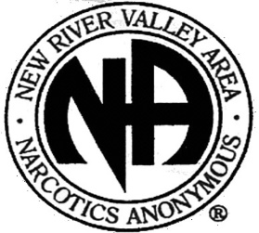
Who Is an Addict?
Most of us do not have to think twice about this question. We know! Our whole life and thinking was centered in drugs in one form or another—the getting and using and finding ways and means to get more. We lived to use and used to live. Very simply, an addict is a man or woman whose life is controlled by drugs. We are people in the grip of a continuing and progressive illness whose ends are always the same: jails, institutions, and death.

PHONE NUMBERS:

Meeting List
Updated/Printed April 2021

Have a drug problem?
We can help!

Phone Helpline:
800-777-1515

For more information,
please visit our website:
www.NRVANA.org
or email us at:
newriverna@gmail.com

