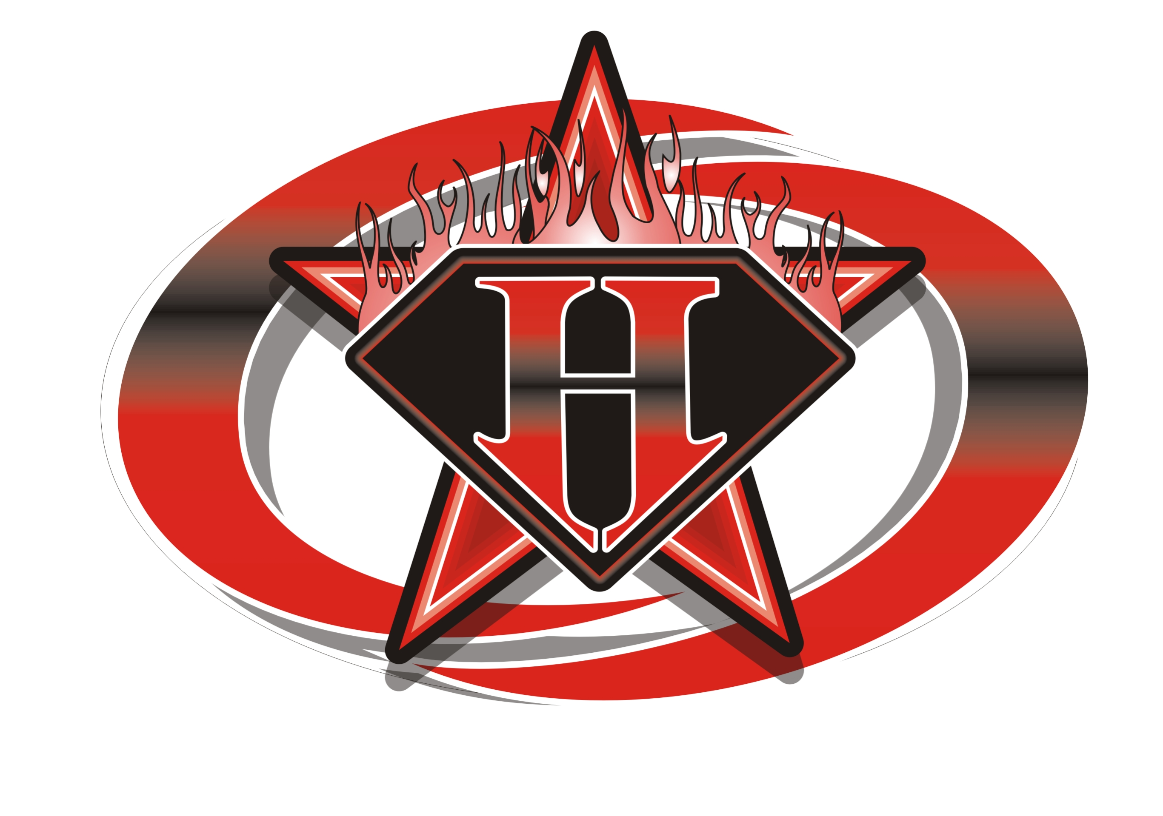

HOT SHOTS CHEERLEADING INC., WAIVER AND RELEASE OF LIABILITY

DISCLAIMER: Hot Shots Cheerleading and Tumbling Center, Inc. is not responsible for any injury (or loss of property) to any person while practicing, training, taking class, competing, participating in open gym, special events, demonstrations, exhibitions, or shows, or in any other way involved in gymnastics, cheerleading, preschool, or teams at Hotshots Cheerleading and Tumbling Center, Inc., for any reason whatsoever, including ordinary negligence on the part of Hot Shots Cheerleading and Tumbling Center, Inc., its owners, officers, agents, or employees.

In consideration of my participation, I hereby release and covenant not-to-sue Hotshots Cheerleading and Tumbling Center, Inc., the Hot Shots Cheerleading and Tumbling Center, Inc. Board of Directors and officers, the Hot Shots Cheerleading and Tumbling Center, Inc. Booster Club, and any of their employees, teachers, coaches, or agents, from any and all present and future claims resulting from ordinary negligence on the part of Hot Shots Cheerleading and Tumbling Center, Inc., or others listed for property damage, personal injury, or wrongful death, arising as a result of my engaging or receiving instruction in gymnastics, cheerleading, or any other activities or any activities incidental thereto, wherever, whenever, or however the same may occur. I hereby voluntarily waive any and all claims resulting from ordinary negligence, both present and future, that may be made by me, my family, my estate, heirs, or assigns.

Further, I am aware that cheerleading and gymnastics are vigorous sporting activities involving height and rotation in a unique environment, and as such pose the risk of injury. I understand that gymnastics, cheerleading, and related activities always involve certain risks, including but not limited to, death, serious neck and spinal injuries resulting in complete or partial paralysis, brain damage, and serious injury to virtually all bones, joints, muscles, and internal organs, and that the mats, pits, and other safety equipment and apparatus provided for my protections, including the active participation of a coach or teacher who will spot or assist in the performance of certain skills, may be inadequate to prevent serious injury. The risk of harm may be limited by all of the safety equipment and trained coaches, but never eliminated. I understand that participation in cheerleading, gymnastics, and related activities involves activities incidental to active participation in cheerleading and gymnastics, including moving from event to event, conditioning, stretching, and other activities which may leave me vulnerable to the reckless actions of other participants who may not have complete control over their actions or who may not see other students in the gym. I am voluntarily participating in this activity with knowledge of the risks involved and hereby agree to accept any and all inherent risks of property damage, personal injury, or death.

I further agree to indemnify and hold harmless Hot Shots Cheerleading and Tumbling Center, Inc., and all others listed for any and all claims arising as a result of my engaging in or receiving instruction in Hotshots Cheerleading and Tumbling Center, Inc. activities or any activities incidental thereto, whenever, wherever, or however the same may occur.

I understand that this waiver is intended to be as broad and as inclusive as permitted by the laws of the state of Georgia and agree that if any portion is held invalid, the remainder of the waiver will continue in full legal force and effect. I further agree that the venue for any legal proceedings shall be within the state of Georgia.

I affirm that I am of legal age and am freely signing this agreement. I have read this form and fully understand that by signing this form, I am giving up legal rights and or remedies which may be available to me for the ordinary negligence of Hot Shots Cheerleading and Tumbling Center, Inc., or any person listed above.

Parent/Guardian Signature ____________________________________________Date_________________

Athlete Name ________________________________________ Phone#_____________________________
Address___________________________________City_______________State________Zip____________

Email (optional-we will not sell your info!)____________________________________________________

