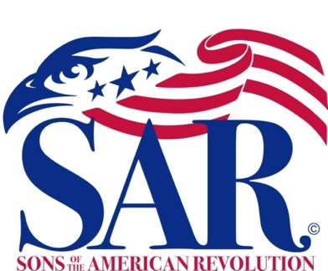

Sons of the American Revolution
Naples Chapter, Florida Society
Organized 30 April 1973

Policy Letter #2 31 March 2022

Subject: Naples Chapter Mentor Program.

Purpose: In order to enhance a more welcoming experience, educate new members about the SAR and support long-term retention efforts, the Naples Chapter will establish a Mentor Program based on the guidelines set by the Membership Committee of the NSSAR.

Authority:
- In outlining their goals in the development of Society-wide Mentor Programs, the NSSAR Membership Committee articulated the following:
  - We encourage every Society and Chapter to take this information and establish a Mentor Program (https://www.sar.org/wp-content/uploads/2021/04/SAR-Mentor-Program.pdf)
  - The SAR Mentor Program is part of the Americanism Contest, effective January 1, 2017
- The Naples Chapter Board of Directors met on 31 March 2022 with a quorum of 9 Directors. Our Board unanimously approved the establishment of a Chapter Mentor Program.

Discussion:
- The following are suggestions for identifying experienced chapter members for the role of mentor.
  - Is comfortable working with people
  - Has the time & energy to devote to the role
  - Can work with more than one at a time
  - Knows what a mentor is supposed to do
  - Understands the purpose, goals & objectives of the SAR & Naples Chapter
- Junior Members will not be assigned a Mentor
- If a Member does not wish to be assigned a Mentor, none will be assigned.

Resolved: The Naples Chapter Mentor Program will be activated on 01 April 2022 and will be presented to Chapter members during the 14 April 2022 Chapter meeting.

- Roles of the Mentor:
  - Will receive some instruction/training prior to being assigned to assist new members
  - The Mentor should be introduced to the new member when the Registrar informs the Chapter that the new member is registered at National
  - A Mentor should be prepared to fill this role for 12 Months
  - Ensure that the new member receives electronic copies of the New Members Manual and a list of the Chapter Officers and Directors

Chapter Officer Responsibilities:
- Naples Chapter Registrar will track membership status and inform the Chapter Assistant Secretary when a new member is registered at National
- Naples Chapter Assistant Secretary is responsible for the management and execution of the Naples Chapter Mentor Program.
- The Assistant Secretary will:
  - Maintain a roster of all Naples Chapter Mentor Volunteers
  - Once a new member is registered with National, assign a Mentor to the New Member
  - Ensure that the Mentor has electronic copies of the Mentor Checklist, the New Member Manual and the list of Chapter Officers and Directors
  - Update the Americanism Spreadsheet in lines 11E and 11F
  - Provide quarterly feedback to the BOD by assessing the progress of the Mentor Program
  - Encourage new members to write a short biographical sketch of his Patriot Ancestor

Original Signed
Philip R. Thieler
President

Encl
- Mentor Program Checklist
- New Member Manual
- Naples Chapter Officers and Directors

