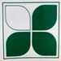
Kentwood Co-op's Junior Livestock Club
Become a member and enjoy discounts on bagged feed, shavings, and other show products.
Benefits:
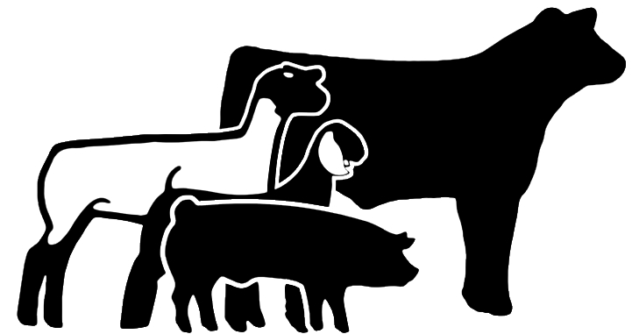
- Receive a 10% discount on all Honor Show Chow bagged feeds.
- Receive 10% discount on all Honor Show Chow supplements.
- Get a 10% discount on shavings, show supplies, etc.
- Receive coupons with first purchase of bagged feed.
- Purchases will be tracked to assist with the collecting of Purina Top Performers Grand Champion Prizes.
- Member points will be totaled and used to reward prizes at the end of the year.
Eligibility:
- Must be part of 4H, FFA, or an independent exhibitor showing at least one animal in 2019-2020.
How to Join:
- Exhibitor can register at Kentwood Co-Op or can send their completed applications to mscott@landolakes.com
- Members must mention that they are a Junior Livestock Producer and show their member card to receive benefits with every purchase.
- In a group? No Problem! We can register your group too!
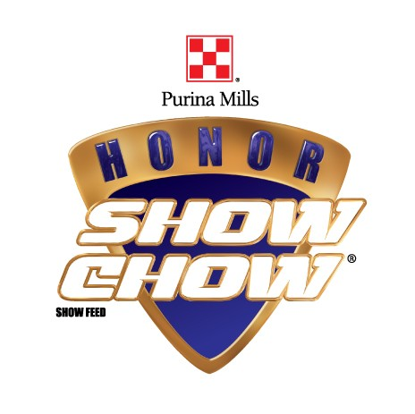
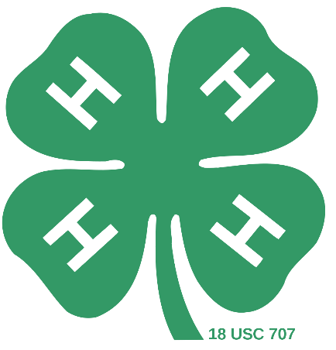
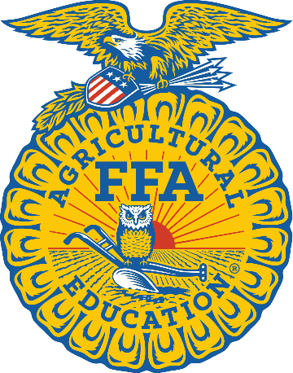
- Contact Our Honor Show Chow Specialist Mike Scott @ 302-897-7866 with any questions.

