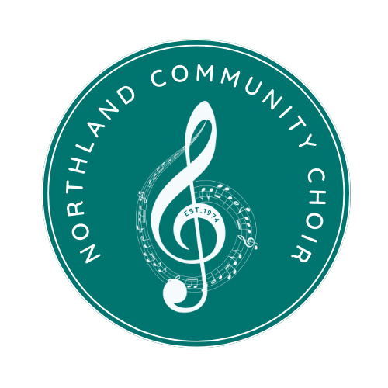

**NORTHLAND COMMUNITY CHOIR**

**SPONSORSHIP FORM**

**Yes! I would like to support the Northland Community Choir.**

As a certified 501(c)(3) organization, your contributions are tax-deductible, and your support will continue in our mission to Make Music Matter! Federal Tax #: 43-1344672

Name:

Business Name:

Address:

City: State: Zip:

Phone Number:

Email for tickets:

(if no email, tickets will be left at “will call”)

**Mark one sponsorship level:**

**☐ *Allegro* (Bronze Level) [$100-$199]**

**·**  Two complimentary tickets to the concert of the season

· Social media shout-out

**☐ *Encore* (Silver) [$200-$499]**

**·**  Four complimentary tickets to the concert of the season

· Social media shout-out

· Logo placement on concert programs and the choir’s website

**☐ *Fortissimo* (Gold) [$500-$999]**

**·** Four complimentary tickets to the concert of the season

· Social media shout-out

· Logo placement on concert programs and the choir’s website

· Logo placement on all concert posters and flyers

· Call-out recognition during performances

**☐ *Maestro* (Platinum) [$1,000+]**

**·**  Four complimentary tickets to each performance for the year

· Social media shout-out

· Logo placement on concert programs and the choir’s website

· Logo placement on all concert posters and flyers

· Call-out recognition during performances

· Custom thank-you gift from the choir

· Opportunities for custom/private performances

**☐ *Other Donation Amount:***

***Please include this sponsorship form and a check made out to Northland Community Choir in the amount of the sponsorship level to:***

**Northland Community Choir - PO Box 14221 Parkville, MO 64152**

**\*Northland Community Choir is a 501-C3. Please contact us for a copy of our certificate for tax purposes.**