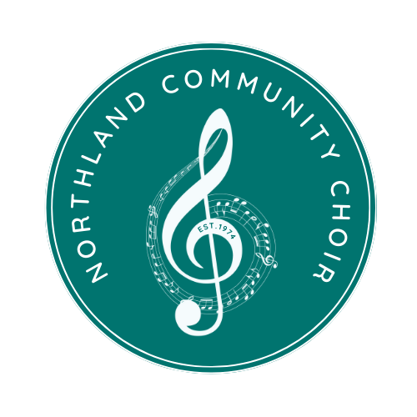
NORTHLAND COMMUNITY CHOIR
SPONSORSHIP FORM
Yes! I would like to support the Northland Community Choir.
As a certified 501(c)(3) organization, your contributions are tax-deductible, and your support will continue in our mission to Make Music Matter! Federal Tax #: 43-1344672
Name:
Business Name:
Address:
City: State: Zip:
Phone Number:
Email for tickets:
(if no email, tickets will be left at “will call”)
Mark one sponsorship level:
☐ Adagio [$75-$149]
· Two (2) complimentary tickets to the concert of the season
· Social media feature and promotion via Facebook and Instagram (~4.5k views)
☐ Andante [$150-$299]
· Up to four (4) complimentary tickets to the concert of the season
· Social media feature and promotion via Facebook and Instagram (~4.5k views)
· Logo placement on concert programs and the choir’s website
☐ Allegro [$300-$449]
- Up to six (6) complimentary tickets to the concert of the season
- Social media feature and promotion via Facebook and Instagram (~4.5k views)
- Logo placement on concert programs and the choir’s website
- Logo placement on all concert posters and flyers
- Call-out recognition during performances
☐ Presto [$450+]
- Up to eight (8) complimentary tickets to the concert of the season
- Social media feature and promotion via Facebook and Instagram (~4.5k views)
- Logo placement on concert programs and the choir’s website
- Logo placement on all concert posters and flyers
- Call-out recognition during performances
- Opportunity for co-branding/promotion during NCC appearance in Parkville Days Parade (August)
☐ Other Donation Amount:

Please include this sponsorship form and a check made out to Northland Community Choir in the amount of the sponsorship level to:
Northland Community Choir - PO Box 14221 Parkville, MO 64152
*Northland Community Choir is a 501-C3. Please contact us for a copy of our certificate for tax purposes.

