**Upper Yellowstone Snowmobile Club**

**Membership**

Name: ______________________________________________________________________

Business: ____________________________________________________________________

Address: ____________________________________________________________________

City – State – Zip: _____________________________________________________________

Phone: ___________________ Email: _____________________________________________

**New Member**: ◻ yes ◻ no

◻ **Individual Membership: $30.00** ◻ **Family Membership: $45.00**

◻ **Business Membership: $50.00**

**Totals**

UYSC Membership $_________________________

UYSC Business Membership $_________________________

Business Contribution $_________________________

Donation $_________________________

Annual Hog Roast Wristband _____ x $15.00 $_________________________

**Total Enclosed $_________________________**

**THANK YOU AGAIN FOR YOUR SUPPORT!!!!**

***PO Box 1111 Cooke City MT 59020 >>>> ridecookecity.com***

**--------------------------------------------------------------------------------------------------------------------------------------------**

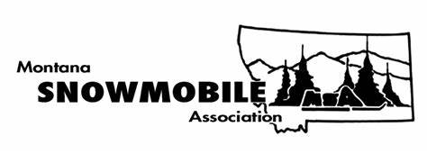

**Montana Snowmobile Association Membership**

**E-Mail: ___________________________________________________________________________**

**Name: ___________________________________________________________________________**

**Address: _________________________________________________________________________**

**City: ________________________________ ST: _______ Zip: ______________________________**

**Mobile Phone: __________________________ Home: ____________________________________**

**Club: _____________________________________________________________________________**

**Membership Type: ◻ Individual/Family $25 ◻ Club / Business $40**

***Please make separate payment for MSA Memberships***

***PO Box 56 Black Eagle, MT 59414 >>>>> www.snowmobilemt.org***