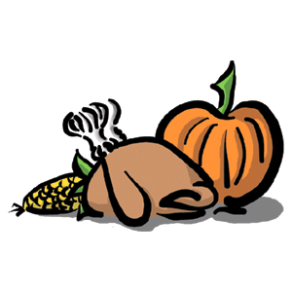
TRADITIONAL THANKSGIVING DINNER MENU:
TO START YOUR CHOICE OF:
BAKED ZITI OR ANTIPASTO PLATTER
FOLLOWED BY:
14-16 LBS. COOKED FRESH KILLED TURKEY
OUR SPECIAL HOMEMADE STUFFING WITH SAUSAGE MEAT, BAKED YAMS, STRING BEANS ALMONDINE, TOSSED GARDEN SALAD, CRANBERRY SAUCE, TURKEY GRAVY, DINNER ROLLS, AND OUR DELICIOUS HOMEMADE PROSCIUTTO BREAD
FOR DESSERT YOUR CHOICE OF:
APPLE OR PUMPKIN PIE
EVERYTHING YOU NEED FOR A COMPLETE THANKSGIVING FEAST
GOOD FOR 15 PEOPLE
ONLY!
$279.99

