horizontal line

**COMMUNICATIONS STRATEGIC PLAN**

**YORKTOWN JAA**

Created by Cierra Evans, Ellie Arrington, Briana Eddy, Grant Wallace, Sara Englert for COMM 330, Dr. Kyle Heuett

**BACKGROUND INFORMATION**

# Yorktown JAA

Location: 200S S 600 W Rd, Muncie, IN 47304

Website: www.yorktownjaa.com

Facebook: Yorktown JAA

* Followers 1,179
* Check-ins 1,287
* Liked 1,140

# GOALS

1. Add video introduction highlighting activities provided
2. Providing specific Covid-19 precautions page on website
3. Keep social media updated at least once a week
4. Direct text and email alerts for parents
5. Upselling merchandise

# Yorktown Demographics

* 11,171 Residents
* 4,436 Families (2018)

## Yorktown JAA Programs

* T-ball
* Single A baseball
* Double A baseball
* Triple A baseball
* Intermediate baseball
* Double A softball
* Triple A softball
* Travel baseball
* Travel softball
* Challenge League

**OVERVIEW**

**The goal of this communications strategy proposal is to provide the Yorktown JAA program with a plan to help them provide safe precautions for COVID-19 in 2021 along with a marketing plan to help increase awareness and enrollment for tee ball, baseball, and softball youth teams. The strategies discussed will provide parents and participants with more extensive and timely updates along with visual additions to the websites to help guide viewers. Additionally, this proposal also provides specific examples of updates and announcements that were incorporated in past years.**

**The proposal recommends that all social media platforms need to be regularly updated in a timely fashion. The Yorktown JAA has a website, Facebook, Twitter, and Instagram. However, some platforms are more updated and timely than others. Facebook seems to be the primary platform in which information is relayed. Instagram and Twitter are not as often updated. All platforms need to be updated more consistently and timely. The use of a social media coordinator would be very beneficial to keep parents updated.**

**An additional method would be to incorporate a video introduction of the players playing and interacting with one another. A fun video displayed on the homepage of the website would give viewers an idea of what a year looks like with the program. Children are also visual learners and this video will encourage kids to want to join the program.**

**Yorktown JAA 2020 Pandemic**

The Yorktown J.A.A. Baseball and Softball Organization took precautionary actions and provided plans for their consumers and families regarding COVID-19. On May 20th, the Yorktown J.A.A. Baseball and Softball Organization made an announcement on their Facebook page addressing their plans and actions associated with COVID-19. This was the only post made about the precautions the organization would be taking for the upcoming season. In the post, the organization first started with a greeting and connecting with the audience. This was a very comforting introduction and influenced the audience to feel more comfortable and at ease with the situation. Following this meeting, the post stated specifics on their plan regarding COVID-19 precautions. These precautions and guidelines included the following:

* **teams having two practices per week**
* **teams would have only one game per week**
* **eventually after Indiana opens back up teams will have two games per week**
* **players are required to social distance by not huddling up**
* **removing gates to the field**
* **not sharing equipment**
* **seating changed to lawn chairs**
* **extra cleaning to the facilities**
* **distancing at the concession stands**

Closing the post, the board thanks everyone for their cooperation and leaves his information for further questions. This post was very informative and appropriate due to most parents having accessibility to Facebook. However, this information was not displayed on any other platform including their main website. This does not provide very many platforms and outlets for their audience to gain this information.

**Please see the Appendix for examples of Facebook posts.**

**Last Year’s Highlights**

The Yorktown J.A.A. Baseball and Softball Organization utilized their communication through two specific channels: social media platforms and their website. These channels were used to inform the parents and children within their organization about updates throughout the year. Through the use of Facebook, Yorktown J.A.A Baseball and Softball updated their organization about COVID-19 and the precautions they were planning to follow in order to keep everyone safe. Although Facebook is the predominant social media platform for the organization, Twitter and Instagram are also used as a communication outlet. Within the Yorktown J.A.A. Baseball and Softball Organization, they used their website to showcase:

* **Current news**
* **Field status**
* **Merchandise**
* **Food sales**

The field status component of the home page provides updates for the fields due to availability and weather concerns. Merchandise and food sales are also a large aspect of the website that not only brings more viewers to the page, but is also a fundraising tactic for the organization. There is an additional site connected within the merchandise page that lets members of the organization purchase Yorktown J.A.A. gear. Within the food sales portion of the website, the page showcases the different sweet and savory treats for sale at games. The home page also allows visitors to be updated on:

* **Current news of the organization such as rosters**
* **Uniforms**
* **Picture day information**
* **Registration**
* **Other prominent topics.**

Sponsorships are also shown next to specific items on the food menu to show appreciation to the companies. The website allows companies to easily purchase sponsorships to advertise their business while benefiting the organization.

**Please see Appendix for examples of food menu boards with sponsorships.**

**Strategies for 2021**

**The Yorktown J.A.A. Baseball and Softball Organization had multiple strategies that communicated well to its members last year.** The Yorktown J.A.A. Baseball and Softball Organization had multiple forms of social media and a well structured website which contributed to the success of the organization. The organization also did a nice job of up-selling their program by advertising their merchandise and concession food on their website. These aspects are good strategies for the Yorktown J.A.A Baseball and Softball Organization to continue in the future.

Some changes that Yorktown J.A.A. Baseball and Softball Organization should implement to maximize communication would be to constantly keep up to date on all social media platforms. Any information or posts should be updated at least once a week to keep members in the loop. Having someone specifically in charge of Twitter, Facebook, and Instagram would be easiest in order to accomplish this goal.

**Examples of weekly Twitter/ Facebook posts should include:**

* Birthday shoutouts
* Individual and team accomplishments
* Weekly updates about upcoming schedules

Additionally, the Yorktown J.A.A Baseball and Softball Organization should keep its news updated on the website. Weekly news updates would benefit members without any forms of social media. Also, with COVID-19 now being an issue, it is more important than ever to keep in contact with parents and players about any new information. The Yorktown J.A.A Baseball and Softball Organization should have an easily accessible COVID-19 information page on their website, which should include information about what the organization is doing to protect its coaches, players, and fans along with information about what would happen if a coach or player were to test positive.

Tactics that the Yorktown J.A.A. Baseball and Softball Organization should adopt for their 2021 season would be the addition of text or email alerts that parents would have the ability to sign up for. This would help with any last minute changes or delays that may occur. The Yorktown J.A.A. Baseball and Softball Organization should also look into making a video giving a brief rundown about their program. They should also include pictures and videos of the previous years and explain how a normal season typically looks.

**Benefits of Strategies**

The pandemic has limited the opportunities for parents and children to be able to see the fun activities that the organization provides. With that being said, **a promotional video introduction of the program** would give parents and children the opportunity to see current players having fun before they are able to be in-person. The video would also be beneficial to the stakeholders because it will make their website look more professional and fun, and hopefully develop into more people using the website. Another aspect that could be added to the website is to **provide a specific COVID-19 precautions page** to help everyone receive information more efficiently. The precautions page would be valuable to the Yorktown J.A.A. Baseball and Softball Organization because it would give guidelines for social distancing and mask mandates for the upcoming season. This would be valuable to the stakeholders because it would give their members more reassurance that they will be safe at these events, resulting in them following the directions on the website.

**Additionally, hiring a social media manager** would make these changes much easier to implement. It would be beneficial to the Yorktown J.A.A. Baseball and Softball Organization because they will always have an innovative and easily navigated website due to this addition. Another component that the social media manager would be responsible for is keeping the website updated and organized, while constantly adding new content onto the website as it flourishes. The next idea that we would like to adopt are **text and email updates for parents.** This would be very beneficial to the Yorktown J.A.A. Baseball and Softball Organization because they can keep in close contact with parents/guardians to keep their children safe and healthy.

The proposal of goals that we have offered are ones that could be easily implemented and would be beneficial to the organization and its stakeholders. Some benefits of our strategies that we have presented are that:

* **The Yorktown J.A.A. Baseball and Softball Organization will have cultivated an updated version of their website that would be easier for everyone to peruse**
* **the presence of having clearer communication between coaches and parents.**

However, if the Yorktown J.A.A. Baseball and Softball Organization chooses not to implement these ideas into reality, social media would be frustrating for parents wanting to connect on the website, which would put another communication barrier on the rest of the organization. Additionally, by not adding a COVID-19 precautions page, this could display that the organization isn’t concerned for members’ health and safety. Taking the time to show concern for others goes a long way into making the members feel safe about bringing their kids to events. Along with this, by not having direct text and email updates, this would only limit parents and participants to more vital informational updates that could be received much faster and easier than only checking the website and social media.

**Conclusion**

**This communications proposal plan is outlined specifically for the outcome of increased awareness and enrollment for tee ball, baseball, and softball youth leagues. With a social media coordinator keeping all platforms updated and timely, parents and participants can follow the program's updates more regularly. Additionally, direct email and text alerts will provide more timely updates for parents who may miss social media updates. Along with this, the use of an introduction video would give parents and kids a better idea of what the program provides including all the fun participants have. This is visual aid that helps viewers become more engaged in the program. These strategies could easily grab more participants to the program. Parents will be more inclined to be a part of an organization that is up to date with parents and kids will be so excited to join after watching the video provided. These strategies result for a great upcoming year!**

**Appendix**

**Facebook Posts**

**Award Post Weather Update**

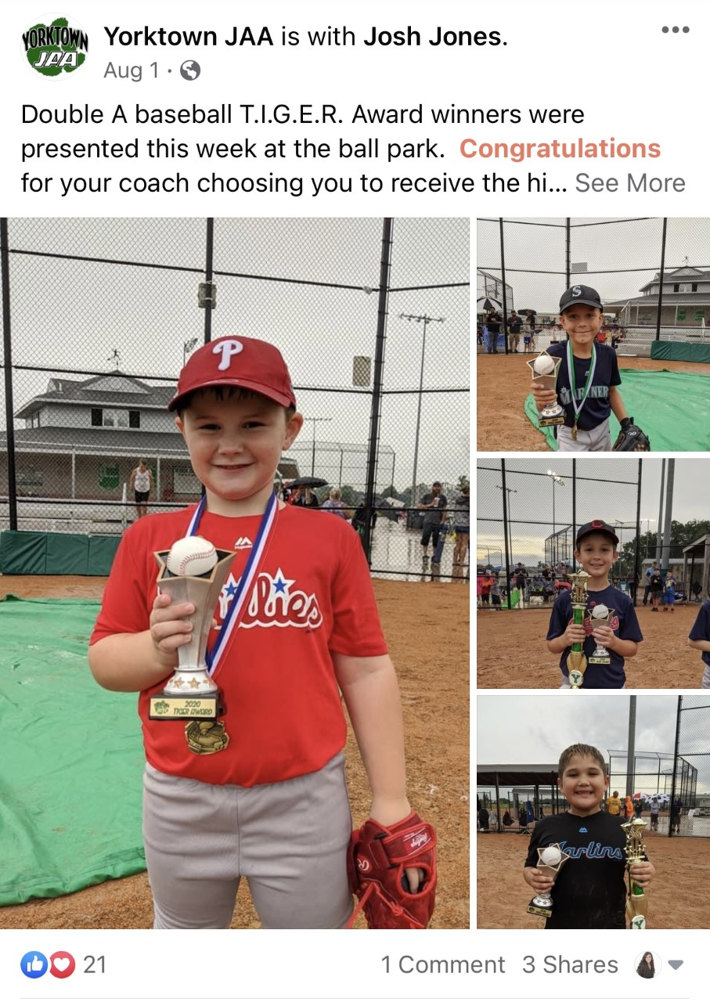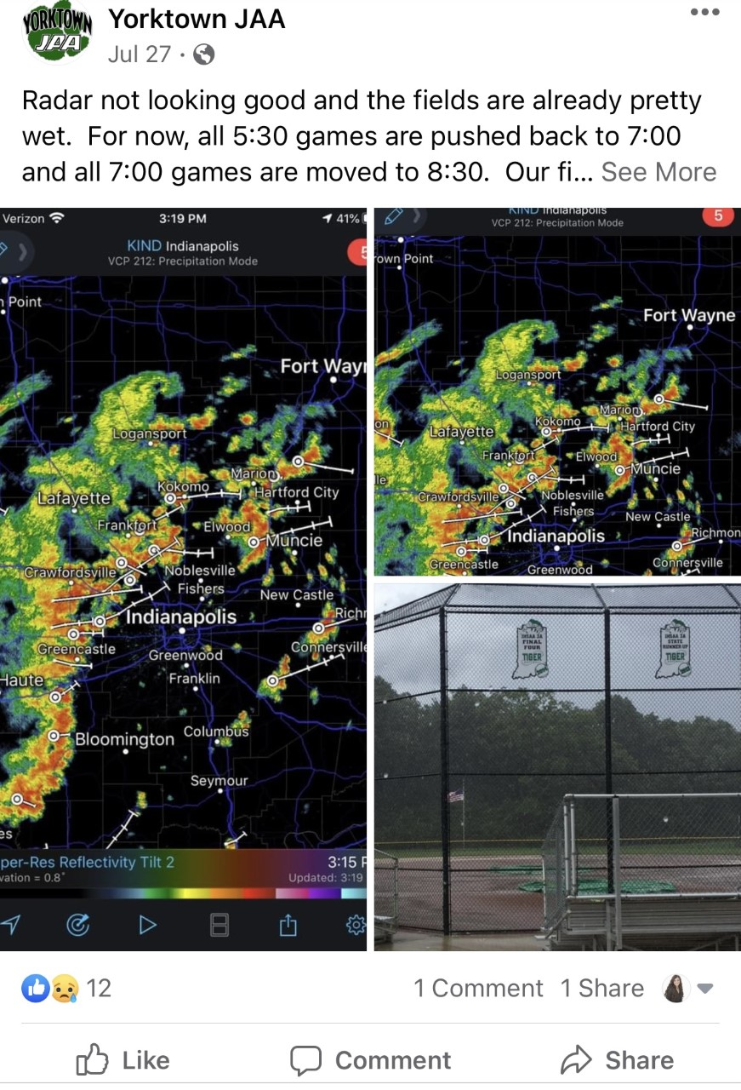

**Sponsorship Post** 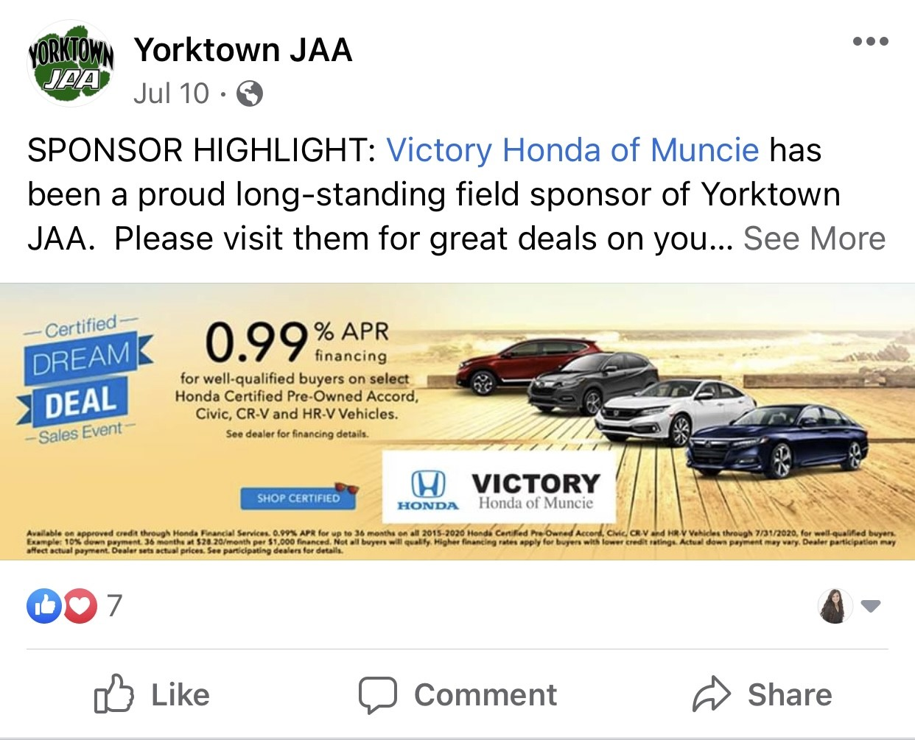

**COVID-19 Update**

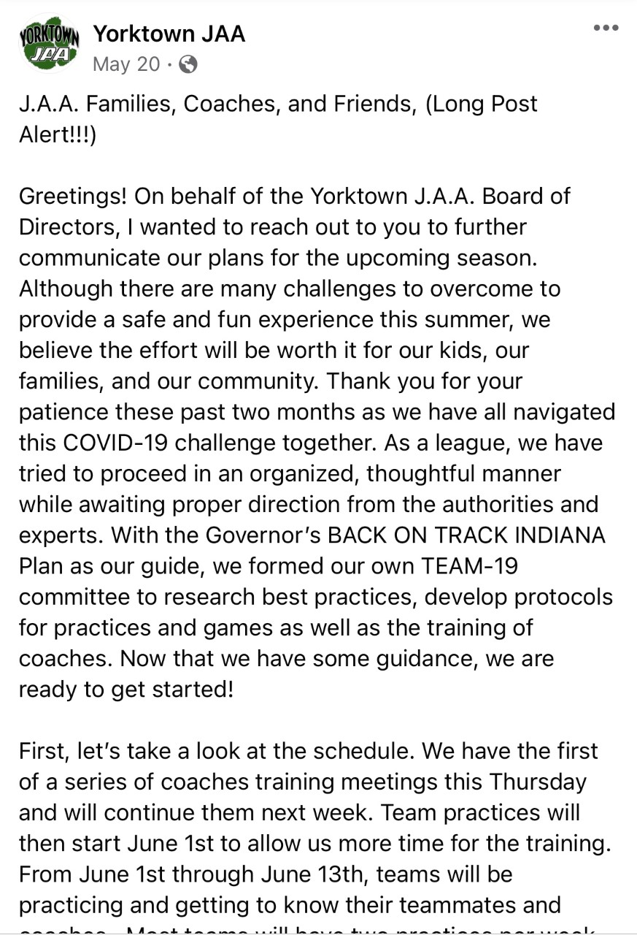 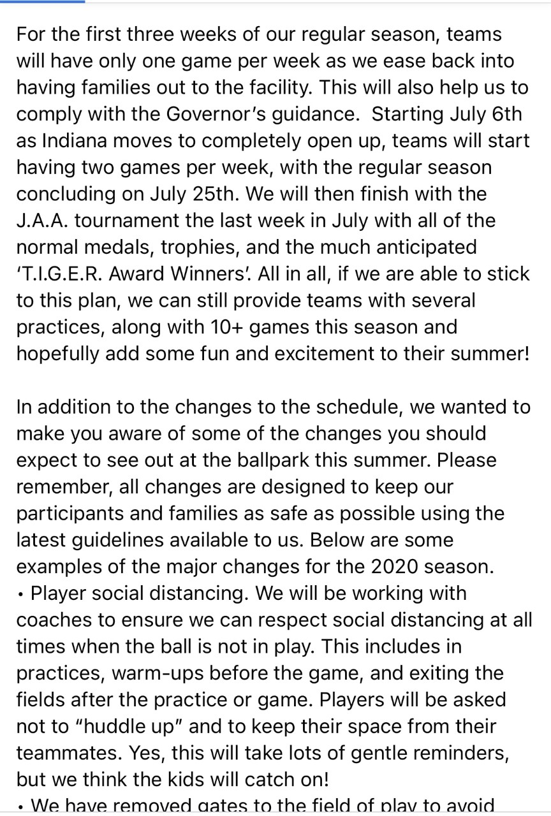

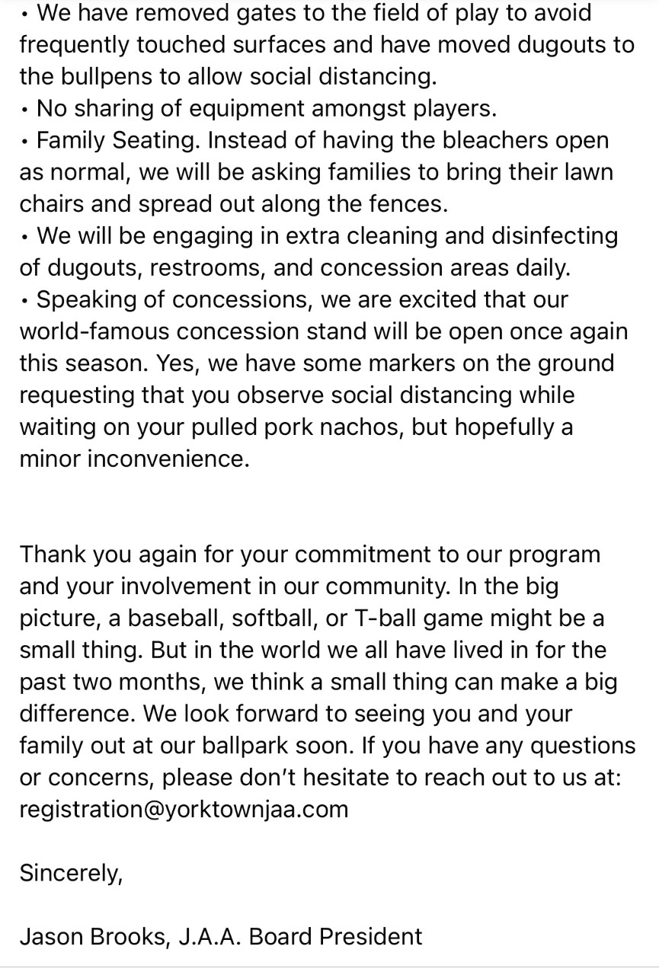

**Food Menu Board with Sponsorships**

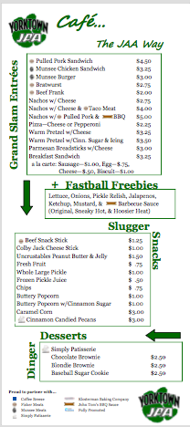

**Introduction Video**

[**https://www.youtube.com/watch?v=atuCR_lx8h0**](https://www.youtube.com/watch?v=atuCR_lx8h0)