Critical Care 100 video
Design Document
How to review the Design Document
This design document serves as our blueprint. It provides the screen content, interactions, graphical treatments, and any additional materials for the course. It has a seat time of approximately 30 minutes.
As you review, please verify that the content, interactions, and graphical treatments are accurate, complete, and acceptable. Where they are not, please provide the required edits using the MS Word Track Changes feature.
Please review with the following in mind:
- Is there content that needs correcting or editing?
- Is the audio script ready to be recorded? What edits need to be made to make it ready?
- Does the course appear to be the correct length for the required content?
- Do the suggested graphics illustrate the course content sufficiently, and if not, what graphics need to be added?
Document History
Date | Action | Initials
071921 | Part 1 First Draft | MD

Table of Contents:
X10001 – Welcome 3
X10002 – Academy Journey 6
X10003 – Rationale 12
X10004 – Target Market and Positioning 20
X10005 – Features and Benefits 33
X10006 – Underwriting Guidelines 33
X10007 – Lifeline 33
X10008 – Optional Deep dive 33
X10010 – Certification 33
X100011 – Closing 33

X10001 – Welcome
Screen Notes: Isometric design; Update branding (Use BPI-AIA); Use avatar of leaders/trainers from AIA; Add background music and sound effects for button clicks.
Audio | Text on Screen | Graphics/Programming Notes
 | Critical Care 100  Sign-up | 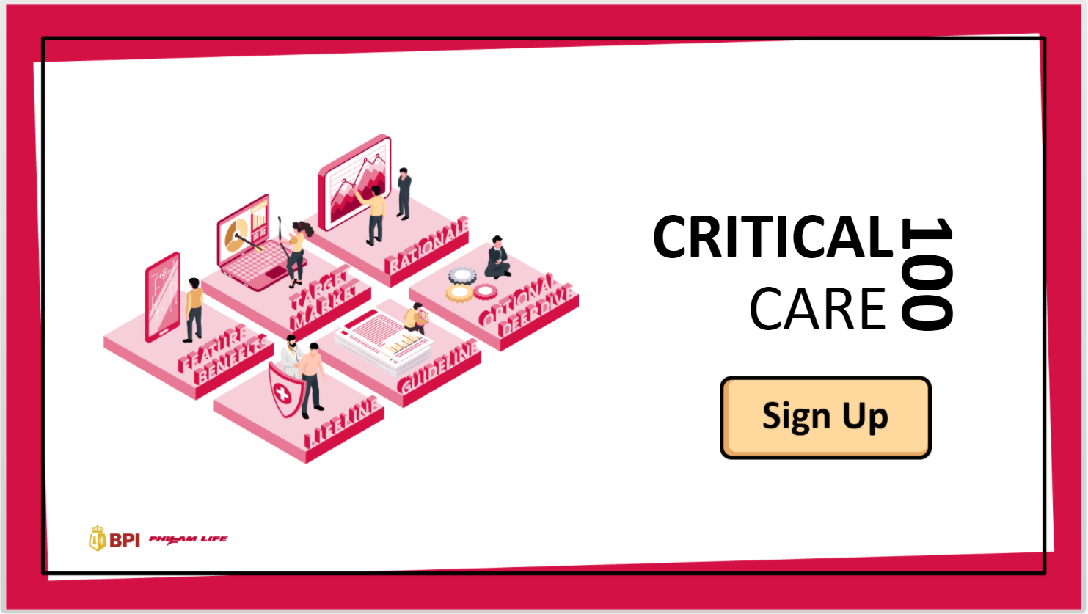  Display the main topics on the left and add a Sign-up button.  Add background music and sound effects where applicable.
 |  | The learner selects Sign-Up to move to the next screen.
X10001_1a: Welcome to the Critical Care 100 Virtual academy. We are delighted to have you! This is an exciting time for learning as this course enables you to think, learn, and apply the information you need to be successful in your role as a bancassurance executive at BPI-AIA.  X10001_1b: In this course, you will build critical skills that you need for today and tomorrow, and be able to discover the importance and the rationale behind the product Critical Care 100, assess your client’s needs and readiness by understanding how CC100 is positioned to benefit your loved ones in every situation, and examine the features and benefits of CC100 and know how comprehensive it is. | Welcome to CC100 Academy.  We are delighted to have you! This is an exciting time for learning as this course enables you to think, learn, and apply the information you need to be successful in your role as a Bancassurance Sales Executive at BPI-AIA.  In this course, you will build critical skills that you need for today and tomorrow, and be able to:  - Discover the importance and the rationale behind the product Critical Care 100.  - Assess your client’s needs and readiness by understanding how CC100 is positioned to benefit your loved ones in every situation.  - Examine the features and benefits of CC100 and know how comprehensive it is.  Back  Complete Registration | Show the half-body avatar of a leader on the left side of the screen and display the Welcome message.  This time, show only the avatar’s face and position it on the lower right portion of the screen.  Show the course objectives.
Return to the Title screen when the learner selects Back.
Advance to X10001_3 when the learner selects Complete Registration.
X10001_2: We thank you in advance for your active participation in this course. Let’s make it official by filling out the registration form below. | We thank you in advance for your active participation in this course. Let’s make it official by filling out the registration form below.  Name:  Location:  Pick an avatar!  Back  Submit | Continue to show the avatar’s face on the bottom right portion of the screen.  Show a registration form with a text entry box for the learner’s name and location. Show 3-5 avatar choices and allow the learner to select one for his/her ID.  The learner is required to provide the information needed before moving on to the next screen.  Add a Submit button and a Back button.
Return to X10001_1 when the learner selects Back.
Advance to X10001_3 when the learner selects Submit.
X10001_3: Great! You now have your registration card. This serves as your entry ticket for any classes available in this course. Each subject has an equivalent unit. To complete the course and get awarded a certificate, you need to complete at least 22 units and get a passing score of 85% in the final certification exam, at the end of the course. Ready to learn? | Here’s your registration card.  This serves as your entry ticket for any classes available in this course.  Each subject has an equivalent unit. (e.g. Rationale – 3 units, Target Market – 2 units, etc.)  To complete the course and get awarded a certificate, you need to:  - Complete at least 22 units.  - Get a passing score of 85% in the final certification exam at the end of the course.  Ready to learn?  Back  Proceed to the Academy | Show the registration card with the learner’s name, location, and chosen avatar.  Flash the registration instructions.  Add a Proceed to the Academy button and a Back button.
Return to the X10001_2 when the learner selects Back.
Advance to X10002_1 when the learner selects Proceed to the Academy.

X10002 – Academy Journey
Screen Notes: Branching slides
Audio | Text on Screen | Graphics/Programming Notes
X10002_1a: Let’s meet your instructors!  X10002_1b: View the Subject Offerings and the corresponding units here.  X10002_1c: Ready to take the test? Get certified here. | Academy hallway  Meet Your Instructors  Let’s meet your instructors!  Our Subject Offerings  View the subject offerings and the corresponding units here.  Get Certified  Ready to take the test? Get certified here.  Home | Split the screen into three hallways. In the first hallway, add a Meet Your Instructors button. In the second hallway, add an Our Subject Offerings button. In the third hallway, add a Get Certified button.  When the learner hovers over the button, play the corresponding voice-over.  Add a Home button at the top right corner of the screen.
Return to the X10001_1 when the learner selects Home.

Proceed to X10002_2 when the learner selects Meet Your Instructors.

Proceed to X10002_3 when Learner selects Our Subject Offerings.

Proceed to X10002_4 when Learner selects Get Certified and has not completed 22 units.

Proceed to X10002_5 when Learner selects Get Certified and has already completed 22 units.
X10002_2: Select each avatar to know more information about your instructor. | Meet Your Instructors  Select each avatar for more information.  John  [John has been with BPI-AIA as a trainer for six years now. He believes that knowing the why behind what we do is crucial to the success of our role as a BSE.]  Subject Offerings:  CC100: Rationale – 3 units  CC100: Target Market and Positioning – 6 units  Close (X)  Paula  [Paula knows the ins and outs of our product offerings. She understands the technicalities and can articulate information in a way that BSE can easily grasp.  Subject Offerings:  CC100: Features & Benefits – 6 units  CC100: UW Guidelines – 2 units  Close (X)  Jane  [Jane is known for her customer service skills. She is great with empathy and knows how to position our product to match the needs of our target segments.  Subject Offerings:  CC100: Lifeline – 5 units  CC100: Optional Deep Dive – 3 units  Close (X)  Home | Display three avatars on the screen together with their names. Add a Home button at the top right portion, so the learner can select it to return to the hallway.  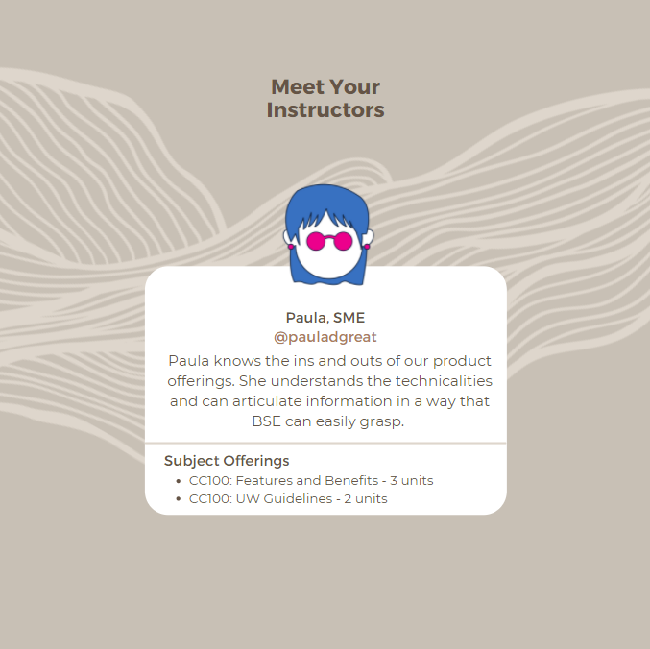  Once the learner selects an avatar, flash a short description of the instructor, the list of topics covered, and the number of units for each topic.  Add a Close button at the top-right portion, so the learner can return to the Instructors page.
Return to X10002_1 when the learner selects Home.
Return to X10002_2 when learner selects Close (X).
X10002_3: Select a subject you want to explore. Click the Start Class button to begin. | Our Subject Offerings  Select a subject of your choice.  Rationale: Why was CC100 created? Find out the why behind our product to encourage your clients and help them understand the importance of being covered with CC100.  Units: 3  Instructor: John  Start Class  Target Market and Positioning: Who is our target market? Find out about our target segments, so you can learn how to position the product that matches your client’s present and future needs.  Units: 6  Instructor: John  Start Class  Features and Benefits: What does CC100 offer? Learn about our comprehensive coverage and understand how it benefits the insured and their loved ones.  Units: 6  Instructor: Paula  Start Class  Underwriting Guidelines: What are the important information you shouldn’t miss about CC100? Learn about the Underwriting guidelines, so you will be prepared to answer technical questions.  Units: 2  Instructor: Paula  Start Class  Lifeline: How does CC100 work? Paint a picture of how CC100 protects the insured in each phase of life.  Units: 5  Instructor: Jane  Start Class  Optional Deep dive: What else should you know more about CC100? Explore articles, websites, documents, and any additional resources helpful to you to go above and beyond what you already know.  Units: 3  Instructor: Jane  Start class  Go back |   Display the isometric view of the subject offerings. Allow the learner to hover over each topic. For each topic hovered, display a short topic description, units to earn, and the name of the instructor.  Add a Start Class button.  For each class completed, add a checkmark to indicate completion, or stars representing the number of units earned.
Return to the X10002_1 when the learner selects Go back.

Go to X10003_1 when the learner selects Start Class in Rationale subject.

Go to X10004_1 when the learner selects Start Class in Target Market and Positioning subject.

Go to X10005_1 when the learner selects Start Class in Features and Benefits subject.

Go to X10006_1 when the learner selects Start Class in Underwriting Guidelines subject.

Go to X10007_1 when the learner selects Start Class in Lifeline subject.

Go to X10008_1 when the learner selects Start Class in Optional Deep dive subject.
X10002_4: Sorry, you are not qualified to take the certification exam yet. You need to complete the pre-requisite classes and earn at least 22 units to proceed. Return to this page when you have accumulated the required units. | Get Certified  Sorry, you are not qualified to take the certification exam yet. You need to complete the pre-requisite classes and earn at least 22 units to proceed.  Return to this page when you have accumulated the required units.  Go back | Display the text and the required number of units to proceed. Add a Go Back button that takes the learner back to the hallway.
X10002_5: Great job in completing at least 22 units! You are now qualified to take the certification exam. Before you proceed, here are some reminders to take note of. | Get Certified  Great job in completing at least 22 units! You are now qualified to take the certification exam.  Before you proceed, here are some reminders:  - There are 15 questions drawn randomly from a question bank.  - The passing score is 85% or equivalent to 13 points.  - A retake is available after each failed attempt.  If you are ready, click Start to begin.  Back  Start | Show the learner’s accumulated units and flash the reminders before showing the Start button.
Return to the X10002_1 when the learner selects Back.
Proceed to X10009 when the learner selects Start.

X10003 – Rationale
Screen Notes: Interactive slide + Video animation
Audio | Text on Screen | Graphics/Programming Notes
X10003_1a: Hi! I am John, your instructor. Welcome to CC100: Rationale class.  X10003_1b: Today, I will introduce what CC100 is, the rationale behind it, and most importantly, why you and I need it.  X10003_1c: To mark complete in this subject, I ask that you actively participate by doing the following: Answer questions, watch videos, and take notes. Does this sound good to you? | [John] Hi ______! I am John, your instructor. Welcome to CC100: Rationale class.  [John] Today, I will introduce what CC100 is, the rationale behind it, and most importantly, why you and I need it.  [John] To mark complete in this subject, I ask that you actively participate by doing the following:  - Answer questions  - Watch videos  - Take notes  Does this sound good to you?  No  Yes | Show John’s half-body avatar in the classroom background with a whiteboard. Flash the speech bubble one by one.  For the last paragraph, show John’s face on the bottom right portion of the screen. Flash the checklist written on the board. Allow the learner to select between Yes and No buttons.
Proceed to X10003_2 when the learner selects No.
Proceed to X10003_3a when the learner selects Yes.
X10003_2: Oh, do you need some time? You can come back later when you are ready or review my requirements and confirm participation. | [John] Oh, do you need some time? You can come back later when you are ready or review my requirements and confirm participation.  Home  Review requirements | Flash speech bubble and allow the learner to select between a Home button and a Review Requirements button.  When learner selects Review Requirements. replay X10003_1c.
Return to X10002_1 when the learner selects Home.
Return to X10003_1c when the learner selects Review requirements.
X10003_3: Great! Let’s get started. First, let’s define Critical Care 100. Which of the following descriptions on Critical Care 100 do you think is/are true? | [John] Great! Let’s get started. First, let’s define Critical Care 100. Which of the following descriptions on Critical Care 100 do you think is/are true?  - It is a comprehensive health and life insurance plan.  - It is created for Filipinos who aim to spend more time with their loved ones without missing the opportunities of a lifetime.  - It aims to protect and encourage Filipinos to live healthier lifestyles.  Back  I’m done! | Flash speech bubble to the left and the multiple answer question format to the right. Give the learner one attempt to answer without revealing the correct answers. Add an “I’m done” button that takes the learner to X10003_4.
Return to X10003_1 when the learner selects Back.
Proceed to X10003_4 when the learner selects I’m done.
X10003_4: Thanks for participating. We’ll go back to this question later and see if you got all the answers correct. | [John] Thanks for participating. We’ll go back to this question later and see if you got all the answers correct.  Back  Next | Show the text on the screen.  Show the Back and Next buttons.
Return to X10003_3 when the learner selects Back.
Proceed to X10003_5 when the learner selects Next.
X10003_5: As a Bancassurance Sales Executive, you need to know what the product is about and the why behind it. Each product has a purpose custom fit for our client’s present and future needs. Regardless of their age and status, they trust that you believe in the product you offer and you genuinely know it by heart. So, grab a pen and a paper, or open a digital notepad if you like, and write down your thoughts as you watch the following videos. | [John] As a Bancassurance Sales Executive (BSE), you need to:  - Know what the product is about and the purpose behind it.  Each product has a purpose custom fit for our client’s present and future needs.  [John] Regardless of the age and status, our clients trust that you believe in the product you offer and you genuinely know it by heart.  [John] So, grab a pen and a paper, or open a digital notepad if you like, and write down your thoughts as you watch the following videos.  [Video 1] The Rationale behind Critical Care 100.  [Video 2] Critical Care 100-A Health and Life Insurance Plan from BPI-Philam!  [Video 3] See Yourself Through with Critical Care 100!  Back  Next | Continue to show speech bubbles and show the text on the screen. Add three video boxes with a play button in the center of each. Display the video title.  When the learner clicks a video, open the video in a different layer and reveal a Close (X) button at the top-right portion when the timeline ends. The learner has to complete all three videos before the next button is unlocked.
Return to X10003_4 when the learner selects Back.
Proceed to X10003_6 when the learner completes all three videos and selects Next.
X10003_6: What are your key takeaways from the videos you have seen? | [John] What are your key takeaways?  [Enter text here]  Back  Submit (>) |   Flash the question and add a text entry box where learners can type in what they have learned.  Add a Submit icon and allow the learner to press Enter on the keyboard when done.
Return to X10003_5 when the learner selects Back.
Proceed to X1003_7 when the learner clicks Submit or presses Enter on the keyboard.
X10003_7a: Thanks for sharing yours! Here’s my take. Critical Care 100 is a comprehensive health and life insurance plan that allows you to enjoy lifetime health protection from up to 100 critical illnesses until age 100 so you can always live a happy and worry-free life with your family! Those numbers on the video we've seen don't lie. We can't deny that critical illness, accidents, death are all unfortunate events that we can’t foresee.  X10003_7b: Businesses, salaries, real estate, investments, and other sources of income are all hard-earned money, and we want to spend it on what we love. That's why we have Critical Care 100 – a comprehensive coverage that allows you to still spend time with your loved ones without missing the opportunity of a lifetime.  X10003_7c: Now, I'd like to discuss how Critical Care 100 helps protect and encourage Filipinos to live healthier lifestyles. Are you familiar with the Philam Vitality program? | [John] Thanks for sharing yours! Here’s my take.  Critical Care 100 is a comprehensive health and life insurance plan that allows you to enjoy lifetime health protection from up to 100 critical illnesses until age 100 so you can always live a happy and worry-free life with your family!  Those numbers on the video we’ve seen don’t lie. We can’t deny that critical illness, accidents, death are all unfortunate events that we can’t foresee.  Businesses, salaries, real estate, investments, and other sources of income are all hard-earned money, and we want to spend it on what we love.  That's why we have Critical Care 100 – a comprehensive coverage that allows you to still spend time with your loved ones without missing the opportunity of a lifetime.  [John] Now, I’d like to discuss how Critical Care 100 helps protect and encourage Filipinos to live a healthier lifestyle. Are you familiar with Philam Vitality?  Yes, I know it.  No, tell me more. | Show John's takeaway afterward, and highlight important points – which were all taken from the choices in X10003_3.  In the last paragraph, flash a “Yes, I know it” and a “No, tell me more” button.
Proceed to X10003_8 when the learner selects Yes, I know it.
Proceed to X10003_9 when the learner selects No, tell me more.
X10003_8: I'm glad that you are in the know! It is at our organization's core to help Filipinos live longer, healthier, and better lives. That's why Critical Care 100 also offers the Philam Vitality program that aims for a real behavior change. Watch this video to recap how Philam Vitality works. | [John] I’m glad that you are in the know! It is at our organization’s core to help Filipinos live longer, healthier, and better lives. That’s why Critical Care 100 also offers the Philam Vitality program that aims for a real behavior change. Watch this video to recap how Philam Vitality works.  [Video] How Philam Vitality works  Back  Next | Flash the text on the screen and add a video box with a Play button. The learner has to watch the video until the end to activate the Next button.
Return to X10003_7 when the learner selects Back.
Proceed to X10003_10 when the learner selects Next.
X10003_9: No worries! We have a separate class that teaches you everything about the Philam Vitality program. But just to give you an overview, Philam Vitality aims for a real behavior change. Therefore, your role as a BSE doesn’t stop by offering Critical Care 100 and other insurance products to our clients.  You also serve as a Vitality ambassador where you will embody the Vitality brand by helping Filipinos live longer, healthier, and better lives; and encourage and empower your clients to take charge of their health by participating in Philam Vitality – a wellness program that gives rewards by simply living a healthy lifestyle! Curious how it works? Watch this video to find out. | [John] No worries! We have a separate class that teaches you everything about the Philam Vitality program. But just to give you an overview, Philam Vitality aims for a real behavior change. Therefore, your role as a BSE doesn’t stop by offering Critical Care 100 and other insurance products to our clients.  You also serve as a Vitality ambassador where you will:  - Embody the Vitality brand by helping Filipinos live longer, healthier, and better lives.  - Encourage and empower your clients to take charge of their health by participating in Philam Vitality – a wellness program that gives rewards by simply living a healthy lifestyle!  Curious how it works? Watch this video to find out.  [Video] How Philam Vitality works  Back  Next | Flash the text on the screen and add a video box with a Play button. The learner has to watch the video until the end to activate the Next button.
Return to X10003_7 when the learner selects Back.
Proceed to X10003_10 when the learner selects Next.
X10003_10: Wow. Time flies so fast! We’re already close to finishing the class. Let’s wrap it up by reviewing our pre-discussion question. | [John] Wow. Time flies so fast! We’re already close to finishing the class. Let’s wrap it up by going back to our pre-discussion question.  Which of the following descriptions on Critical Care 100 do you think is/are true?  - It is a comprehensive health and life insurance plan.  - It is created for Filipinos who aim to spend more time with their loved ones without missing the opportunities of a lifetime.  - It aims to protect and encourage Filipinos to live healthier lifestyles.  Back  Submit | Flash the multiple answer format on the screen. Allow the learner to select answers and click Submit to validate.  A, B, and C are the correct answers.
Return to the previous slide visited (X10003_8 or X10003_9) when the learner selects Back.
Proceed to X1003_11 when the learner selects correct/incorrect answers and clicks Submit.
X10003_11: Thanks for participating! All the descriptions are true. Let’s summarize what we’ve learned: | Thanks for participating! All the descriptions are true.  Let’s summarize what we’ve learned:  Click each question to reveal the answer.  What is CC100?  Critical Care 100 is a comprehensive health and life insurance plan that covers up to 100 critical illnesses until age 100.  Why do we need CC100?  Critical Illnesses, though some are curable, can affect not just our health, but also our finances, dreams, and relationships when we are not prepared. Treatment costs are expensive and the road to recovery is long. With CC100, there is guaranteed protection for you and your family, whatever uncertainty lies ahead.  What is Critical Care 100’s vision?  With Critical Care 100, Filipinos can spend more time with their loved ones without missing the opportunities of a lifetime.  What is Philam Vitality?  Philam Vitality is a science-backed program that lets individuals take charge of their health by helping them lead healthier lifestyles to get more out  of life, whilst being protected against risk with greater control over what it costs them.  Back  Next | Show the text on the screen. List down the questions and allow the learner to click each question to reveal the answer.  The learner has to click all questions to unlock the Next button.
Return to X10003_10 when the learner selects Back.
Proceed to X10003_12 when the learner selects Next.
X10003_12: Congratulations on completing Critical Care 100: Rationale class! Here's your reward. | (John) Congratulations on completing the Critical Care 100: Rationale class! Here's your reward:  3 units  Back  View Our Subject Offerings | Add a short animation to show the Rationale subject checked from the list. Highlight the 3 units.  Add a Back and a View Subject Offerings button.
Return to X10003_11 when the learner selects Back.
Return to X10002_3 when the learner selects View Our Subject Offerings.

X10004 – Target Market and Positioning
Screen Notes: Click and show functionality with audio examples.

Audio | Text on Screen | Graphics/Programming Notes
X10004_1a: Hi! I am John, your instructor. Welcome to CC100: Target Market and Positioning class.  X10004_1b: Today, we will find out who is the target market for Critical Care 100 and learn how to position Critical Care 100 in each segment.  X10004_1c: To mark complete in this subject, I ask that you actively participate by doing the following: Complete activity and get a passing score in the knowledge check at the end of our class. Does this sound good to you? | [John] Hi ______! I am John, your instructor. Welcome to CC100: Target Market and Positioning class.  [John] Today, we will find out who is the target market for Critical Care 100 and learn how to position Critical Care 100 in each segment.  [John] To mark complete in this subject, I ask that you actively participate by doing the following:  - Complete an activity  - Get a passing score in the knowledge check  Does this sound good to you?  No  Yes | Show John's half-body avatar in the classroom background with a whiteboard. Flash the speech bubble one by one.  For the last paragraph, show John's face on the bottom right portion of the screen. Flash the checklist written on the board. Allow the learner to select between Yes and No buttons.
Proceed to X10004_2 when the learner selects No.
Proceed to X10004_3a when the learner selects Yes.
X10004_2: Oh, do you need some time? You can come back later when you are ready or review my requirements and confirm participation. | [John] Oh, do you need some time? You can come back later when you are ready or review my requirements and confirm participation.  Home  Review requirements | Flash speech bubble and allow the learner to select between a Home button and a Review Requirements button.  When learner selects Review Requirements. replay X10004_1c.
Return to X10002_1 when the learner selects Home.
Return to X10004_1c when the learner selects Review requirements.
X10004_3: Great! Let’s get started. First, let’s define Critical Care 100. Which of the following descriptions on Critical Care 100 do you think is/are true? | [John] Great! Let’s start with a Drag an activity.  Our target market for Critical Care 100 is divided into three segments. Can you guess where they belong?  Drag and drop the clients to their corresponding segments. Hover over the information (i) icon to have a hint for each segment.  Clients (Drag)  Money-Smart Millennials  Budget Proficient Employees  Family Comes First  Next-Gen  Executives and Professionals  Entrepreneurs  Land-Based Professionals  Beneficiaries with Children  Sea-based officers and Up  Segments (Drop)  For Personal Segment  For Preferred Segment  For Of Segment  Back  Submit | Flash speech bubble to the left. Show the instructions on the screen.  For each client, display a picture with its title. For each segment, add a house where the learner can drop who they think belongs to that segment.  Give the learner one attempt to answer by clicking the Submit button.
Return to X10004_1 when the learner selects Back.
Proceed to X10004_4 when the learner selects Submit.
X10004_4: Nice try! We'll discuss more our target market in the next slides. | [John] Nice try! We’ll get into detail in the next slides.  Correct answers  - For Personal Segment  Money-smart millennials, Budget proficient employees, and Family Comes First individuals.  - For Preferred Segment  Next-gen, Executives & Professionals, and Entrepreneurs.  - For Of Segment  Land-based professionals, Beneficiaries with children, and Sea-based officers, and up  Back  Next | Show the correct answers. Add a Back and Next button.
Return to X10004_3 when the learner selects Back.
Proceed to X10004_5 when the learner selects Next.
X10004_5: Let’s get to know our target market for Critical Care 100. Critical Care is a comprehensive health and life insurance that protects up to 100 critical illnesses until age 100. As a Bancassurance Sales Executive (BSE), your role is to identify your clients' needs by doing the following: Identify the segment they belong to, and know who they are – their age, marital status, occupation, and more. Once you have identified their needs, you will be able to understand their situation better and position Critical Care 100 as the perfect plan that matches their current and future needs. So, grab a pen and a paper, or open a digital notepad if you like, and write down your thoughts as you watch the following videos. | [John] Let’s get to know our target market for Critical Care 100!  Critical Care is a comprehensive health and life insurance that protects up to 100 critical illnesses until age 100.  [John] As a Bancassurance Sales Executive (BSE), your role is to identify your clients’ needs by doing the following:  - Identify the segment they belong to  - Know who they are through demographics (age, marital status, occupation, etc.)  Once you have identified their needs, you will be able to analyze their situation better and position Critical Care 100 as the perfect plan that matches their current and future needs.  [John] Let’s check out an interactive diagram to learn more about our target market’s demographics.  Back  Next
Return to X10004_4 when the learner selects Back.
Proceed to X10004_6 when the learner selects Next.
X10004_6: Critical Care 100 aims to protect Filipinos who belong in these three segments. Scrub the age scale to learn about the demographics for each segment. | Who is our Target Market?  Critical Care 100 aims to protect Filipinos who belong in these three segments:  Scrub the age scale to learn about the demographics for each segment.  - For Personal Segment  Profile: Money-smart millennials, Budget proficient employees, and Family Comes First individuals.  Age range: 25-45  Marital status: Single with dependents, married with young families  Occupation: Corporate employees/Professionals holding office and junior manager levels  Average Daily Balance (ADB): 500k below  - For Preferred Segment  Profile: Next-gen, Executives & Professionals, and Entrepreneurs.  Age range: 25-65  Marital status: Single with dependents, married with young families  Occupation: Professional holding office and senior manager levels, business owners  ADB: 500k above  - For Of Segment  Profile: Land-based professionals, Beneficiaries with children, and Sea-based officers & up.  Age range: 0-65  Marital status: Single with dependents, married with young families  Occupation: Teachers, nurses, sales and service, sea-based officers  ADB:  Back  Next | 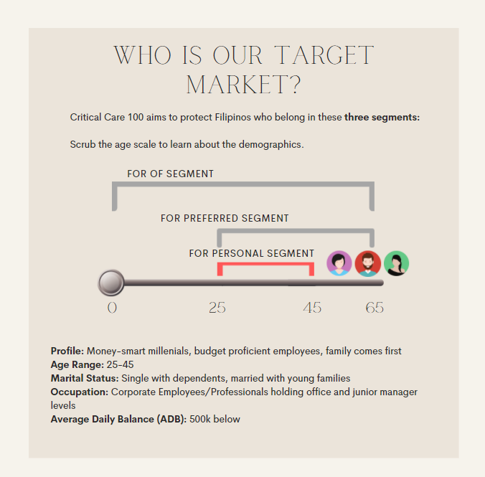 Show an interactive age scale where the learner can scrub the scale to see the demographics for each segment.  Add profile pictures for each segment for better representation.
Return to X10004_5 when the learner selects Back.
Proceed to X10004_7 when the learner selects Next.
X10004_7: How can Critical Care 100 answer the needs of each segment? Hear their sentiments and discover how you can position Critical Care 100. | (John) How can Critical Care 100 answer the needs of each segment?  Hear their sentiments and discover how you can position Critical Care 100.  Hear from Janet, the teacher >  Hear from Jung, the business owner >  Hear from Shannon, the junior manager >  Back  Next | Show the text on the screen. Add three boxes with icons to represent each client. (Janet, Jung, Shannon). Allow the learner to click each box. Each box directs the learner to another layer.  Add a Back button.  When the learner has visited all three boxes, activate the Next button.
Return to X10004_6 when the learner selects Back.
Proceed to X10004_8 when the learner selects Hear from Janet, the teacher.
Proceed to X10004_9 when the learner selects Hear from Jung, the business owner.
Proceed to X10004_10 when the learner selects Hear from Shannon, the junior manager.
Proceed to X10004_10 when learner has visited X10004_8, X10004_9, and X10004_10 and selects Next.
X10004_8: (Janet) As an educator myself, I want to give my children a secure future through quality education. Despite being young and healthy, I work in a stressful environment, so I’d like to be financially prepared in case of any eventuality. | Hear from Janet, the teacher  Janet is a 33 y/o medical professor working at the University of the Philippines. She is married with 2 toddlers.  Listen to her sentiments  “As an educator myself, I want to give my children a secure future through quality education. Despite being young and healthy, I work in a stressful environment. I’d like to be financially prepared so my children won’t have to worry about anything in the future.  How can we help?  Janet belongs to the For Of Segment. She wants to SECURE her children and PREPARE financially on top of it all.  With Critical Care 100, Janet can enjoy rewards for living a healthy lifestyle while having peace of mind that she and her loved ones have guaranteed funds to help recover when critical illness strikes.  Close (X) | Display Janet’s case. Add a “Listen to her sentiments” button, and a “How can we help?” button. Pop up the audio (Use a different voice) and text for each.  Add a Close (X) button.
 |  | Return to X10004_7 when the learner selects Close.
X10004_9: (Jung) As an entrepreneur and investor, I want to see where my money goes. I prefer quick access to funds for our daily needs and emergencies. I like to know how I can best keep and transfer my wealth to my son. | Hear from Jung, the business owner  Jung is 49 y/o and is a single dad. He runs his restaurant and is into stocks and trades.  Listen to his sentiments  “As an entrepreneur and investor, I want to see where my money goes. I prefer quick access to funds for our daily needs and emergencies. I like to know how I can best keep and transfer my wealth to my son.  How can we help?  Jung belongs to the For Preferred Segment. He wants to PLAN for his future so he and his son will be READY with anything.  With Critical Care 100, he will have ready access to a comprehensive and lifetime guaranteed critical care coverage so he and his son can continue to have a life free of worries.  Close (X) | Display Jung’s case. Add a “Listen to his sentiments” button, and a “How can we help?” button. Pop up the audio (Use a different voice) and text for each.
 |  | Return to X10004_7 when the learner selects Close.
X10004_10: (Shannon) As a breadwinner, I’d like to protect my wealth and my family’s lifestyle in any eventuality. For me, family comes first. | Hear from Shannon, the junior manager  Shannon is 27 y/o, single, and works as a junior manager in a car company. She is the family’s breadwinner.  Listen to her sentiments  “As a breadwinner, I’d like to protect my wealth and my family’s lifestyle in any eventuality. For me, family comes first.”  How can we help?  Shannon belongs to the For Personal Segment. She wants to PROTECT her wealth so she and her family can live the lifestyle she wants.  With Critical Care 100, Shannon can have a critical illness solution that rewards a healthy lifestyle, provides comprehensive, immediate, and guaranteed protection for her and her loved ones.  Close (X) | Display Shannon’s case. Add a “Listen to her sentiments” button, and a “How can we help?” button. Pop up the audio (Use a different voice) and text for each.
 |  | Return to X10004_7 when the learner selects Close.
X10004_11: Our clients may have different sentiments and priorities, yet, everyone wants to live a worry-free life. To position Critical Care 100, conduct a needs analysis where clients rank their needs in order of priority. By doing so, you will be able to identify what they truly need and how CC100 can be the perfect solution. | (John) Our clients may have different sentiments and priorities, yet, everyone wants to live a worry-free life. To position Critical Care 100, conduct a needs analysis where clients rank their needs in order of priority. By doing so, you will be able to identify what they truly need and how CC100 can be the perfect solution.  [survey form]  How can we help you?  - Protect  As a breadwinner, I’d like to protect my wealth and my family’s lifestyle in any eventuality.  - Ready  I’d like to have quick access to funds for my daily needs and emergencies.  - Secure  I want to give my children a secure future through quality education.  - Prepare  I’d like to be financially capable in the event of serious medical conditions.  - Grow  I’d like to grow my wealth to be able to live a comfortable life in my retirement years.  - Plan  I’d like to know how I can best keep & transfer my wealth to my loved ones.  Back  Next | 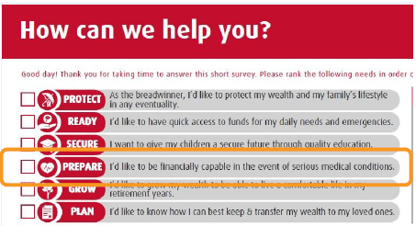Flash the text on the screen. Show John’s avatar and display a screenshot of the survey form used by BSEs to assess the client’s needs.
Return to X10004_7 when the learner selects Back.
Proceed to X10004_12 when the learner selects Next.
X10004_12: Wow. Time flies so fast! We’re already close to finishing the class. Let’s sum it up with a short video. | (John) Wow. Time flies so fast! We’re already close to finishing the class. Let’s sum it up with a short video.  [Target Market and Positioning Summary video]  Play  Back  Next | Show the text on the screen. Place the video in the center of the screen and add a Play button. Activate the Next button at the end of the video’s timeline.
Return to the X10004_11 when the learner selects Back.
Proceed to X10003_13 when the learner selects Next.
X10004_13: Can you pass the test? Let’s check what you’ve learned by answering all three questions correctly. | Can you pass the test? Let’s check what you’ve learned by answering all three questions correctly.  BACK  START THE TEST | Build a short knowledge check with 3 multiple-choice questions. The learner has to answer all three questions correctly to move on to the next slide. This knowledge check has unlimited attempts. Add a Start the test button that takes the learner to the first question.
Return to X10004_12 when the learner selects Back.
Proceed to TM&P Q1 when the learner selects Start the test.
TM&P Q1: | - Monica is a budget-proficient employee. She's only 25 but is the family's breadwinner. How would you position Critical Care 100 so she will consider it as a need? Select the best answer.  - With CC100, Monica can enjoy retirement and pass on her wealth to her loved ones.  - With CC100, Monica can have comprehensive, immediate, and guaranteed protection for herself and her loved ones.  - With CC100, Monica can have peace of mind that she will have guaranteed funds to help recover when critical illness strikes.  Submit  [Incorrect caption A]  Oops. Positioning CC100 as a retirement benefit would not entice Monica as she is still young. Please select a different answer.  [Incorrect caption C]  Oops. Although CC100 provides guaranteed funds to support critical illness recovery, it is not the best way to position CC100 since Monica still considers herself young and healthy.  [Correct caption B]  You got it right! Even though she is young and budget proficient, she is her family’s breadwinner. Therefore, she needs immediate and guaranteed protection so she can ensure her family is supported should unforeseen event such as critical illness, death, or accident happens.  Continue | Show the first question and the three choices.  When the learner clicks Submit, validate the answer by showing the corresponding incorrect/correct captions.  Add a Retry button in the incorrect captions so the learner can select another answer.  Add a Continue button in the correct caption so the learner can move on to the next question.
 |  | Proceed to TM&P Q2 when the learner gets the correct answer and selects Continue.
TM&P Q2: | - Which of the three segments does a Money-smart millennial belong to?  - For Personal Segment  - For Of Segment  - For Preferred Segment  [Incorrect Caption B and C]  Incorrect. Please try again.  [Correct Caption A]  Correct! Money smart millennial falls under the Personal Segment.  Continue | Show the second question and the three choices.  When the learner clicks Submit, validate the answer by showing the corresponding incorrect/correct captions.  Add a Retry button in the incorrect captions so the learner can select another answer.  Add a Continue button in the correct caption so the learner can move on to the next question.
 |  | Proceed to TM&P Q3 when the learner gets the correct answer and selects Continue.
TM&P Q3: | - As a BSE, what is the most ideal thing to do to position CC100 best?  - Ask your client’s age and marital status.  - Create a proposal based on your client’s average daily balance alone.  - Ask your client to rank her needs according to priority.  [Incorrect caption A]  Oops. Asking your client’s age and marital status is not enough to identify what he or she needs.  [Incorrect caption B]  Oops. Basing your Critical Care 100 proposal only on your client’s average daily balance is not correct. There are more factors to consider.  [Correct caption C]  Correct! Assess their needs through a survey form where they can rank their needs in order of priority.  Back  Continue | Show the third question and the three choices.  When the learner clicks Submit, validate the answer by showing the corresponding incorrect/correct captions.  Add a Retry button in the incorrect captions so the learner can select another answer.  Add a Continue button in the correct caption so the learner can move on to X10003_14.
 |  | Return to the previous slide when the learner selects Back. Proceed to X10003_14 when the learner selects Continue.
X10003_14: Congratulations on completing Critical Care 100: Rationale class! Here's your reward. | (John) Congratulations on completing the Critical Care 100: Target Market and Positioning class! Here’s your reward:  6 units  Back  View Our Subject Offerings | Add a short animation to show the Target Market and Positioning subject checked from the list. Highlight the 6 units.  Add a Back and a View Subject Offerings button.
Return to X10004_13 when the learner selects Back.
Return to X10002_3 when the learner selects View Our Subject Offerings.

