Total Care Max elearning
Design Document
How to review the Design Document
This design document serves as our blueprint. It provides the screen content, interactions, graphical treatments, and any additional materials for the course. It has a seat time of about 30 minutes.
As you review, please verify that the content, interactions, and graphical treatments are accurate, complete, and acceptable. Where they are not, please provide the required edits using the MS Word Track Changes feature.
Please review with the following in mind:
- Is there content that needs correcting or editing?
- Is the audio script ready to be recorded? What edits need to be made to make it ready?
- Does the course appear to be the correct length for the required content?
- Do the suggested graphics illustrate the course content sufficiently, and if not, what graphics need to be added?
Document History
Date | Action | Initials
091421 | Part 1 First Draft (Value Proposition) | MD
091721 | Part 2 First Draft (Target Market) | MD
092121 | Part 3 First Draft (Features/Benefits & Lifeline) | MD

Table of Contents:
X10001 — Welcome 3
X10002 — Academy Journey 7
X10003 — Value Proposition 13

X10001 — Welcome
Screen Notes: Isometric design. Update branding (Use BPI-AIA).
Audio | Text on Screen | Graphics/Programming Notes
 | Introduction to Total Care Max |   Pattern the overall look and feel with TOTAL CARE MAX. When hovered, show the text.
 |  | The learner selects the Arrow button to move to the next screen.
X10001_1a: Be a Protection Partner of Choice Academy: Introduction to Total Care Max. We are delighted to have you! This is an exciting time for learning as this course enables you to think, learn, and apply the information you need to be successful in your role as a bancassurance executive at BPI-AIA.  X10001_1b: In this course, you will build critical skills that you need for today and tomorrow, and be able to: Explain the importance of Total Care Max, based on the current realities; Assess how Total Care Max can address our clients’ needs by understanding the product’s value proposition and who our target market is; and discuss the features, benefits, lifeline, and underwriting guidelines of Total Care Max. | Be a Protection Partner of Choice Academy: Introduction to Total Care Max  We are delighted to have you! This is an exciting time for learning as this course enables you to think, learn, and apply the information you need to be successful in your role as the Protection Partner of Choice of our clients.  In this course, you will build critical skills that you need for today and tomorrow, and be able to:  - Explain the importance of Total Care Max, based on the current realities  - Assess how Total Care Max can address our clients’ needs by understanding the product’s value proposition and who our target market is  - Discuss the features, benefits, lifeline, and underwriting guidelines of Total Care Max  Back  Complete Registration |  Show the course objectives.
Return to the Title screen when the learner selects Back.
Advance to X10001_3 when the learner selects Complete Registration.
X10001_2: We thank you in advance for your active participation in this course. Let’s make it official by filling out the registration form below. | We thank you in advance for your active participation in this course. Let’s make it official by filling out the registration form below.  Name:  Location:  Pick an avatar.  Back  Submit |   Show a registration form with a text entry box for the learner’s name and location. Show 3–5 avatar choices and allow the learner to select one.  The learner is required to provide the information needed before moving on to the next screen.  Add a Submit button and a Back button.
Return to X10001_1 when the learner selects Back.
Advance to X10001_3 when the learner selects Submit.
X10001_3: Great! You now have your registration card. This serves as your entry ticket for any classes available in this course. Each subject has an equivalent unit. To complete the course and get awarded a certificate, you need to complete 26 units and get a passing score of 85% in the final certification exam at the end of the course. Ready to learn? | Here’s your registration card.  This serves as your entry ticket for any classes available in this course.  Each subject has an equivalent unit. (for example, Value Proposition — 3 units, Target Market — 6 units, etc.)  To complete the course and get a certificate, you need to:  - Complete 26 units.  - Get a passing score of 85% in the final certification exam at the end of the course.  Ready to learn?  Back  Proceed to the Academy | Show the registration card with the learner’s name, and location.  Flash the registration instructions.  Add a Proceed to the Academy button and a Back button.
Return to the X10001_2 when the learner selects Back.
Advance to X10002_1 when the learner selects Proceed to the Academy.

X10002 — Academy Journey
Screen Notes: Branching slides
Audio | Text on Screen | Graphics/Programming Notes
X10002_1a: Let’s meet your instructors!  X10002_1b: View the Subject Offerings and the corresponding units here.  X10002_1c: Ready to take the test? Get certified here.  X10002_1d: Start from the beginning. | Academy hallway  Meet Your Instructors  Let’s meet your instructors.  Our Subject Offerings  View the subject offerings and the corresponding units here.  Get Certified  Ready to take the test? Get certified here.  Home  Start from the beginning. | Split the screen into four hallways.  When the learner hovers over the button, play the corresponding voice-over.
Return to the X10001_1 when the learner selects Home.

Proceed to X10002_2 when the learner selects Meet Your Instructors.

Proceed to X10002_3 when Learner selects Our Subject Offerings.

Proceed to X10002_4 when Learner selects Get Certified and has not completed 26 units.

Proceed to X10002_5 when Learner selects Get Certified and has already completed 26 units.
X10002_2: Select each avatar to know more information about your instructor. | Welcome, [learner’s name]  Meet your instructors!  Ben  [Ben has been with BPI-AIA as a trainer for five years now. He believes that knowing the why behind what we do is crucial to the success of our role as a Protection Partner of Choice.]  Subject Offerings:  TCM: Value Proposition – 3 units  TCM: Target Market – 6 units  Close (X)  Patty  [Patty knows the ins and outs of our product offerings. She is also great at winning our clients by relating the products to match their current situation and need.  Subject Offerings:  TCM: Features & Benefits — 9 units  Close (X)  Iris  [Iris understands the technicalities and can articulate information in a way that a Protection Partner of Choice can easily grasp.]  Subject Offerings:  TCM: UW Guidelines — 6 units  TCM: Deep Dive — 3 units  Close (X)  Home | 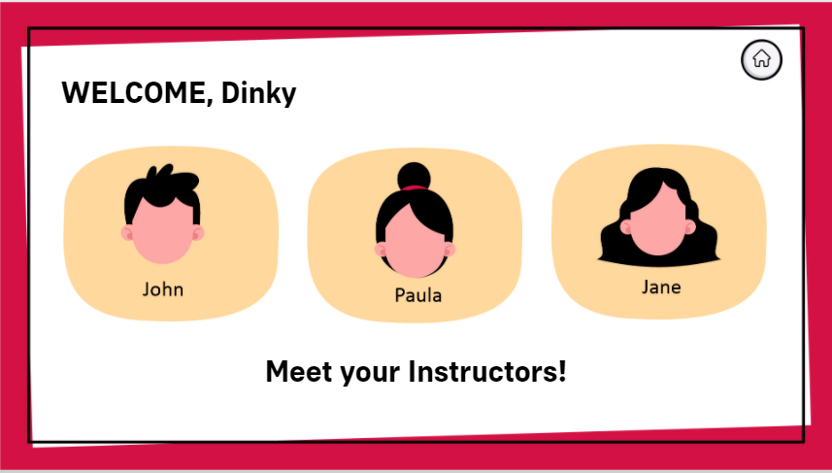  Display three avatars on the screen together with their names. Add a Home button at the top-right part so the learner can select it to return to the hallway.  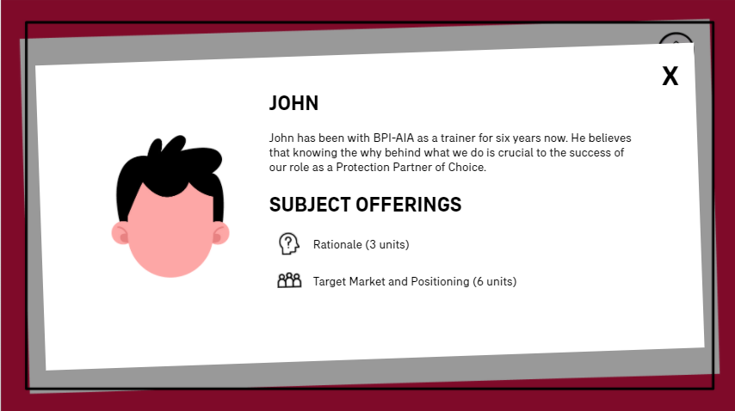  Once the learner selects an avatar, flash a short description of the instructor, the list of topics covered, and the number of units for each topic.  Add a Close button at the top-right part so the learner can return to the Instructors page.
Return to X10002_1 when the learner selects Home.
Return to X10002_2 when learner selects Close (X).
X10002_3: Select a subject you want to explore. Click the Start Class button to begin. | Our Subject Offerings  Select a subject of your choice.  Value Proposition: Why was Total Care Max created? Find out the why behind our product to encourage your clients and help them understand the importance of being covered with Total Care Max.  Units: 3  Instructor: Ben  Start Class  Target Market: Who will benefit the most from this product? Find out about our target market segments so you can learn how to position the product that matches your client’s present and future needs.  Units: 6  Instructor: Ben  Start Class  Features and Benefits: What does Total Care Max offer? Learn about our comprehensive coverage and understand how it benefits the insured and their loved ones.  Units: 9  Instructor: Patty  Start Class  Underwriting Guidelines: What are the important information you shouldn’t miss about Total Care Max? Learn about the Underwriting guidelines so you will be prepared to answer technical questions.  Units: 6  Instructor: Iris  Start Class  Optional Deep dive: What else should you know more about TOTAL CARE MAX? Explore articles, websites, documents, and any additional resources helpful to you to go above and beyond what you already know.  Units: 2  Instructor: Iris  Start class  Go back | 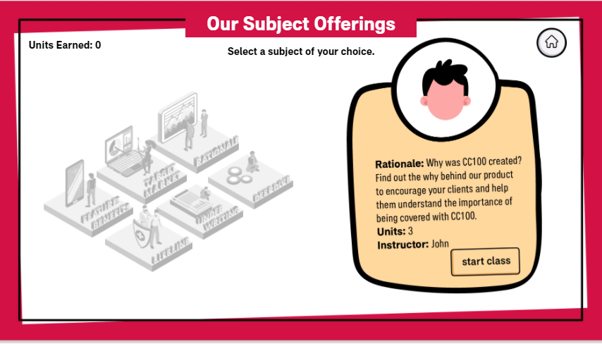  Display the isometric view of the subject offerings. Allow the learner to hover over each topic. For each topic hovered, display a short topic description, units to earn, and the name of the instructor.  Add a Start Class button.  For each class completed, add an indicator for completion and update the units earned.
Return to the X10002_1 when the learner selects Go back.

Go to X10003_1 when the learner selects Start Class in Rationale subject.

Go to X10004_1 when the learner selects Start Class in Target Market and Positioning subject.

Go to X10005_1 when the learner selects Start Class in Features and Benefits subject.

Go to X10006_1 when the learner selects Start Class in Underwriting Guidelines subject.

Go to X10007_1 when the learner selects Start Class in Lifeline subject.

Go to X10008_1 when the learner selects Start Class in Optional Deep dive subject.
X10002_4: Sorry, you are not qualified to take the certification exam yet. You need to complete the pre-requisite classes and earn 26 units to proceed. Return to this page when you have accumulated the required units. | Get Certified  Sorry, you are not qualified to take the certification exam yet. You need to complete the pre-requisite classes and earn 26 units to proceed.  Return to this page when you have accumulated the required units.  Go back | Display the text and the required number of units to proceed. Add a Go Back button that takes the learner back to the hallway.
X10002_5: Great job in completing 26 units! You are now qualified to take the certification exam. Before you proceed, here are some reminders to take note of. | Get Certified  Great job in completing 26 units! You are now qualified to take the certification exam.  Before you proceed, here are some reminders:  - There are 15 questions drawn randomly from a question bank.  - The passing score is 85% or equivalent to 13 points.  - A retake is available after each failed attempt.  If you are ready, click Start to begin.  Back  Start | Show the learner’s accumulated units and flash the reminders before showing the Start button.
Return to the X10002_1 when the learner selects Back.
Proceed to Final Certification when the learner selects Start.

X10003 — Value Proposition
Screen Notes: Interactive slide + Video animation
Audio | Text on Screen | Graphics/Programming Notes
X10003_1a: Hi! I am Ben, your instructor. Welcome to Total Care Max: Value Proposition class.  X10003_1b: Today I will introduce what Total Care Max is, the rationale behind it, and most importantly, why you and I need it.  X10003_1c: To mark complete in this subject, I ask that you actively participate by doing the following: Answer questions, watch a video, and take notes. Does this sound good to you? | [Ben] Hi ______. I am Ben, your instructor. Welcome to TCM: Value Proposition class.  [Ben] Today, I will introduce to you what Total Care Max is, the rationale behind it, and most importantly, why you and I need it.  [Ben] To mark complete in this subject, I ask that you actively participate by doing the following:  - Answer questions  - Watch a video  - Take notes  Does this sound good to you?  No  Yes | Show Ben with a speech bubble. Flash texts.  Allow the learner to select between Yes and No buttons.
Proceed to X10003_2 when the learner selects No.
Proceed to X10003_3a when the learner selects Yes.
X10003_2: Oh, do you need some time? You can come back later when you are ready or review my requirements and confirm participation. | [Ben] Oh, do you need some time? You can come back later when you are ready or review my requirements and confirm participation.  Home  Review requirements | Flash speech bubble and allow the learner to select between a Home button and a Review Requirements button.  When learner selects Review Requirements. Replay X10003_1c.
Return to X10002_1 when the learner selects Home.
Return to X10003_1c when the learner selects Review requirements.
X10003_3: Great! Time to get started. But first, let’s do a quick survey. Which of the following statements do you think is/are true about Total Care Max? | [Ben] Great! Time to get started. But first, let’s do a quick survey. Which of the following statements do you think is/are true about Total Care Max?  - It is your all-in-one protection partner for today, tomorrow, and always.  - It is a peso-denominated variable life insurance plan with Critical Illness and Medical Benefit Riders.  - It gives better value for money and fits well within your budget so that you can focus on what matters most.  Back  Done | 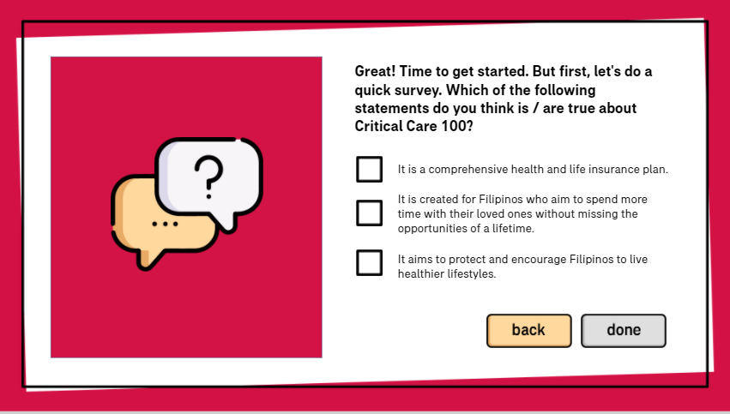Flash speech bubble to the left and the multiple answer question format to the right. Give the learner one attempt to answer without revealing the correct answers. Add an “Done” button that takes the learner to X10003_4.
Return to X10003_1 when the learner selects Back.
Proceed to X10003_4 when the learner selects I’m done.
X10003_4: Thanks for participating. We’ll go back to this question later and see if you got all the answers correct. | [Ben] Thanks for participating. We’ll go back to this question later and see if you got all the answers correct.  Back  Next | Show the text on the screen.  Show the Back and Next buttons.
Return to X10003_3 when the learner selects Back.
Proceed to X10003_5 when the learner selects Next.
X10003_5: As a Protection Partner of Choice, you need to know what the product is about and the why behind it. Each product has a purpose custom fit for our client’s present and future needs. Regardless of their age and status, they trust that you believe in the product you offer and you genuinely know it by heart. So, grab a pen and a paper, or open a digital notepad, if you like, and write down your thoughts as you watch this video. | [Ben] As a Protection Partner of Choice, you need to:  - Know what the product is about and the why behind it.  Each product has a purpose custom fit for our client’s present and future needs.  [Ben] Regardless of the age and status, they trust that you believe in the product you offer and you genuinely know it by heart.  [Ben] So, grab a pen and a paper, or open a digital notepad if you like, and write down your thoughts as you watch this video.  [Video 1] The Rationale behind Total Care Max  Back  Next | Continue to show speech bubbles and show the text on the screen.    Add a video box that learner can click. Add a Back and Next button. Play the video in another layer. The learner has to finish the video until the end to get to the Back button.
Return to X10003_4 when the learner selects Back.
Proceed to X10003_6 when the learner completes all three videos and selects Next.
X10003_6: What are your takeaways from the video you have seen? | [Ben] What are your takeaways?  [Enter text here]  Back  Submit (>) | 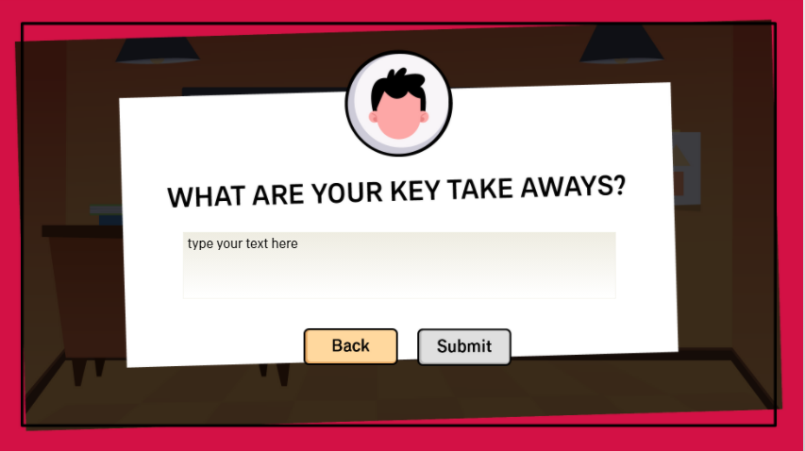  Flash the question and add a text entry box where learners can type in what they have learned.  Add a Submit icon and allow the learner to Click Enter on the keyboard when done.
Return to X10003_5 when the learner selects Back.
Proceed to X1003_7 when the learner clicks Submit or presses Enter on the keyboard.
X10003_7a: Thanks for sharing yours! Here’s my take. Total Care Max is a peso-denominated variable life insurance plan with Critical Illness and Medical Benefit Riders, available in flexible premium-paying variants. It strengthens our Protection Trinity proposition to our customers through providing Protection, Critical Illness and Medical coverage in a single plan.  X10003_7b: This pandemic has surely changed the way we live. Filipinos, are now, more than ever, eager to protect what matters the most. With Total Care Max, our customers can have a comprehensive protection solution for today, tomorrow, and always.  X10003_7c: Now, I’d like to discuss how Total Care Max helps protect and encourage Filipinos to live a healthier lifestyle. Are you familiar with AIA Vitality? | [Ben] Thanks for sharing yours! Here’s my take.  Total Care Max is a peso-denominated variable life insurance plan with Critical Illness and Medical Benefit Riders, available in flexible premium-paying variants.  Total Care Max strengthens our Protection Trinity proposition to our customers through providing Protection, Critical Illness and Medical coverage in a single plan.  [Ben] Now, I’d like to discuss how Total Care Max helps protect and encourage Filipinos to live a healthier lifestyle. Are you familiar with AIA Vitality?  Yes, I know it.  No, tell me more. | Show Ben's takeaway afterward, and highlight important points — which were all taken from the choices in X10003_3.  In the last paragraph, flash a “Yes, I know it” and a “No, tell me more” button.
Proceed to X10003_8 when the learner selects Yes, I know it.
Proceed to X10003_9 when the learner selects No, tell me more.
X10003_8: I’m glad that you are in the know! It is at our organization’s core to help Filipinos live longer, healthier, and better lives. That’s why Total Care Max is integrated with AIA Vitality, which aims to drive positive behavior change in the lifestyle of our clients. Watch this video to recap how AIA Vitality works. | [Ben] I’m glad that you are in the know! It is at our organization’s core to help Filipinos live longer, healthier, and better lives. That’s why Total Care Max is integrated with AIA Vitality, which aims to drive positive behavior change in the lifestyle of our clients. Watch this video to recap how AIA Vitality works.  [Video] How Philam Vitality works  Back  Next | Flash the text on the screen and add a video box with a Play button. The learner has to watch the video until the end to activate the Next button.
Return to X10003_7 when the learner selects Back.
Proceed to X10003_10 when the learner selects Next.
X10003_9: No worries! We have a separate class that teaches you everything about the AIA Vitality program. But just to give you an overview, AIA Vitality aims for a real behavior change. Therefore, your role as a Protection Partner of Choice doesn’t stop by offering Total Care Max and other insurance products to our clients.  You also serve as a Vitality ambassador where you will embody the Vitality brand by helping Filipinos live longer, healthier, and better lives; and encourage and empower your clients to take charge of their health by participating in AIA Vitality — a wellness program that gives rewards by simply living a healthy lifestyle! Curious how it works? Watch this video to find out. | [Ben] No worries! We have a separate class that teaches you everything about the AIA Vitality program. But just to give you an overview, AIA Vitality aims for a real behavior change. Therefore, your role as a Protection Partner of Choice doesn’t stop by offering Total Care Max and other insurance products to our clients.  You also serve as a Vitality ambassador, where you will:  - Embody the Vitality brand by helping Filipinos live longer, healthier, and better lives.  - Encourage and empower your clients to take charge of their health by participating in AIA Vitality – a wellness program that gives rewards by simply living a healthy lifestyle.  Curious how it works? Watch this video to find out.  [Video] How Philam Vitality works  Back  Next | Flash the text on the screen and add a video box with a Play button. The learner has to watch the video until the end to activate the Next button.
Return to X10003_7 when the learner selects Back.
Proceed to X10003_10 when the learner selects Next.
X10003_10: Wow. Time flies so fast. We’re already close to finishing the class. Let’s wrap it up by reviewing our pre-discussion question. | [Ben] Wow. Time flies so fast! We’re already close to finishing the class. Let’s wrap it up by going back to our pre-discussion question.  Which of the following descriptions on Total Care Max do you think is/are true?  - It is your all-in-one protection partner for today, tomorrow, and always.  - It is a peso-denominated variable life insurance plan with Critical Illness and Medical Benefit Riders.  - It gives better value for money and fits well within your budget so that you can focus on what matters most.  Back  Submit | Flash the multiple answer format on the screen. Allow the learner to select answers and click Submit to validate.  A, B, and C are the correct answers.
Return to the previous slide visited (X10003_8 or X10003_9) when the learner selects Back.
Proceed to X1003_11 when the learner selects correct/incorrect answers and clicks Submit.
X10003_11: Thanks for participating! All the descriptions are true. Let’s summarize what we’ve learned: | Thanks for participating! All the descriptions are true.  Let’s summarize what we’ve learned:  Click each question to reveal the answer.  What is TOTAL CARE MAX?  Total Care Max is a peso-denominated variable life insurance plan with Critical Illness and Medical Benefit Riders, available in flexible premium-paying variants.  Why do we need TOTAL CARE MAX?  This pandemic has caught us off-guard. Yet, this experience gave us a better outlook in life. It made us realize what really matters most to us. Filipinos are now, more than ever, willing to prioritize health and wellness. That’s why, we have Total Care Max as an answer to this need. Total Care Max is the comprehensive insurance we all need.  What is Total Care Max value proposition for customers?  Your all-in-one protection partner for today, tomorrow, and always.  What is AIA Vitality?  AIA Vitality is a science-backed program that lets individuals take charge of their health by helping them lead healthier lifestyles, to get more out of life while being protected against risk, with greater control over what it costs them.  Back  Next | Show the text on the screen. List down the questions and allow the learner to click each question to reveal the answer.  The learner has to click all questions to unlock the Next button.
Return to X10003_10 when the learner selects Back.
Proceed to X10003_12 when the learner selects Next.
X10003_12: Congratulations on completing Total Care Max: Rationale class! Here's your reward. | (Ben) Congratulations on completing the Total Care Max: Rationale class! Here's your reward:  3 units  Back  View Our Subject Offerings | Add a short animation to show the Rationale subject checked from the list. Highlight the 3 units.  Add a Back and a View Subject Offerings button.
Return to X10003_11 when the learner selects Back.
Return to X10002_3 when the learner selects View Our Subject Offerings.

X10004 — Target Market
Screen Notes: Click and show functionality with audio examples.

Audio | Text on Screen | Graphics/Programming Notes
X10004_1a: Hi! I am Ben, your instructor. Welcome to TOTAL CARE MAX: Target Market class.  X10004_1b: Today, we will find out who is the target market for Total Care Max and learn how to position Total Care Max in each segment.  X10004_1c: To mark complete in this subject, I ask that you actively participate by doing the following: Complete the activities and get a passing score in the knowledge check at the end of our class. Does this sound good to you? | [Ben] Hi ______! I am Ben, your instructor. Welcome to TOTAL CARE MAX: Target Market class.  [Ben] Today, we will find out who is the target market for Total Care Max and learn how to position Total Care Max in each segment.  [Ben] To mark complete in this subject, I ask that you actively participate by doing the following:  - Complete the activities  - Get a passing score in the knowledge check  Does this sound good to you?  No  Yes | Show Ben's half-body avatar in the classroom background with a whiteboard. Flash the speech bubble one by one.  For the last paragraph, show Ben's face on the bottom-right part of the screen. Flash the checklist written on the board. Allow the learner to select between Yes and No buttons.
Proceed to X10004_2 when the learner selects No.
Proceed to X10004_3a when the learner selects Yes.
X10004_2: Oh, do you need some time? You can come back later when you are ready or review my requirements and confirm participation. | [Ben] Oh, do you need some time? You can come back later when you are ready or review my requirements and confirm participation.  Home  Review requirements | Flash speech bubble and allow the learner to select between a Home button and a Review Requirements button.  When learner selects Review Requirements. Replay X10004_1c.
Return to X10002_1 when the learner selects Home.
Return to X10004_1c when the learner selects Review requirements.
X10004_3: Let’s get started. Total Care Max is ideal for whom? Flip each image to find out.  X10004_3a: Can afford to spare PHP *200/day and doesn’t have a comprehensive medical and critical illness (CI) coverage yet.  X10004_3b: Need a starter solution that gives them better value for money.  X10004_3c: Are looking to upgrade their existing protection portfolio by getting a product that provides higher coverage. | [Ben] Let’s get started. Total Care Max is ideal for whom? Flip each image to find out.  Total Care Max is ideal for clients who:  [Image 1]  Can afford to spare PHP *200/day and doesn’t have a comprehensive medical and critical illness (CI) coverage yet.  *Varies according to suited package for the client  [Image 2]  Need a starter solution that gives them better value for money.  [Image 3] Are looking to upgrade their existing protection portfolio by getting a product that provides higher coverage.  Back  Next | Flash speech bubble to the left. Show the instructions on the screen.  For each image/graphic, allow learners to flip it to reveal the text. Refer to page 19 of source file.    Add a check icon to indicate that the image has been clicked.
Return to X10004_1 when the learner selects Back.
Proceed to X10004_4 when the learner selects Next.
X10004_4: | [Ben] The target market for Total Care Max are split into:  (Table 1) High Value market (Primary)  (Table 2) Mass market (Personal)  Get to know more about our target market by hearing their background and stories. Select a table to join.  (Table 1) High Value Market  JENNY, the Millennial  About Jenny:  Jenny’s age is between 25-40 years old, with company-paid medical benefits, single without dependents, and has a cashflow of about 140,000 PHP monthly.  Interested in:  Health and Savings  Optimal Payment schedule: 20 pay  Background:  - Seeks a work-life balance, including flexible working hours and immediate gratification.  - Wants to do things that would serve a purpose and influence the world in every way they could  - Fears missing out and tries to do everything they can on their own at the earliest age possible  - Loves to share their progress to the world  - Looks into their peers’ and family’s successes to attain their own  Current situation:  - Experiencing lower levels of vitality and well-being than other generations  - Taking up management position and is very stressed  - Taking physical/mental fitness activity to keep happy and healthy  - Social media is her bestfriend.  Challenges/Gap:  - Where to better and easily allocate finances to start planning for the future while continuing to perform their current role.  TCM Solution:  “An all-in-one protection solution that empowers me to live healthy today as I build for an aspired tomorrow.”  #LivingtheDream #TCMTakesCareofMe  JIMMY, the Entrepreneur  About Jimmy:  Jimmy’s age is between 35-50 years old, without health care benefits, married with dependents, and has a cashflow of about 450,000 PHP monthly.  Interested in:  Health and Savings  Optimal Payment schedule: 10 pay  Background:  - Main provider in the family  - Balancing personal and business finances  - Tends to deprioritize taking care of their health  - Shoulders unexpected medical expense for employees  - Wants to build a legacy and enjoy his retirement years  Current situation:  - Emergency funds have been allocated to support both family and employees – 60% of employees are from SMEs  - Limited business operations due to quarantine restrictions  - Business is slowly recovering from pandemic  - Splits his time between old and new media  - Values independence and makes smart purchase decisions after careful online research  - Found a way to stay active and decompress through cycling  Challenges/Gap:  - How to stay confident that both personal and business finances are taken care of  - How to protect short and long term liquidity of the family and business in times of medical situations  TCM Solution:  “An all-in-one solution that protects my business finances against unexpected expenses that can disrupt my liquidity, so that I can secure my family’s future.”  JIN, the Professional  About Jin:  Jin’s age is between 35-50 years old, married with dependents, family most probably do not have sufficient medical coverage, and has a cashflow of about 350,000 PHP monthly.  Interested in:  Life, Savings, and Health  Optimal Payment schedule: 10 pay  Background:  - Company-paid benefits are limited and does not fully extend to dependents  - Highly exposed and faces more risk due to their line of work  - Finds work-life balance a challenge  - Wants to maintain quality standard of living and provide a comfortable life to their family  Current situation:  - Prone to Covid-19 and other viral diseases  - Overworked this pandemic  - Fears that he or his family gets infected  - Stays strong because of family’s support and positive thinking  - Provides teleconsultation  Challenges/Gap:  - Continuous support to the family and protection of liquidity in times of unforeseen events  - Wealth preservation, they want to pass a legacy to their children even if the inevitable comes due to being exposed to health threats in their profession  TCM Solution:  “An all-in-one solution that gives me peace of mind, given my line of work, allowing me and my family to achieve our dreams.”  ---  (Table 2) Mass Market  CLAIRE, The Middle Manager  About Claire:  Jin’s age is between 25-40 years old, with company-paid benefits, single without dependents, and has a cashflow of about 90,000 PHP monthly.  Interested in:  All benefits  Optimal Payment schedule: Pay-to-65  Background:  - HMO coverage is usually only 150,000-200,000 PHP  - Have flexible benefits with their company which may lessen their coverage  - Company benefits are not always portable  - Continuous to operate despite strict lockdowns  - Stress at work, poor health management that can lead to critical illnesses  Current situation:  - Finds it difficult to find work-life balance  - Would like to live better by eating healthy and exercising frequently  - Value convenience given the hectic schedule  - Takes budgeting seriously, using budgeting tools to properly allocate income for household and lifestyle expenses  - With Philhealth that can only cover a certain percentage of cost  - Avails online services (food delivery, e-consultations, grocery shopping, etc.)  Challenges/Gap:  - Liquidity and mobility a concern with a new “surge” in COVID cases  - More exposed to COVID-19 as they are APORs and are allowed to go to work  TCM Solution:  “A 5-in-1, long term protection solution that fits my budget so I can focus on taking charge of my career and my health.”  BRIANNA, The Dependent  About Brianna:  Brianna’s age is between 18-35 years old, with no health or medical coverage, household size is 4.4, and has a cashflow of minimum 90,000 PHP monthly.  Interested in:  Health, Critical Illness (CI), and Savings  Optimal Payment schedule: Pay-to-65  Background:  - Part of the children/siblings, stay-at-home spouse, self-employed/freelancer demographics  - Only coverage is a company-extended HMO that has limited benefits  - Indirectly exposed to COVID-19 risk due to APOR (Authorized Person Outside of Residence) family member  Current situation:  - Doing things together at home with family due to lockdown situation  - General rise in cost of goods  - Rising awareness to stay fit and healthy  Challenges/Gap:  - Uncertainties can drain the pocket of the family’s finances  - Fear spreading COVID-19 to other members of family due to APOR going to work  TCM Solution:  “Our 5-in-1 protection solution that takes care of me and my loved ones through tough times and enables us to enjoy living healthy together.”  MARSALI, The Healthcare worker  About Marsali:  Marsali’s age is between 35-50 years old, married with dependents, overseas worker with remittance of about 2800 USD monthly.  Interested in:  Medical and Critical Illness (CI)  Optimal Payment schedule: Pay-to-65  Background:  - Wants to give children a good life through quality education  - Wants kids to finish in a reputable school so that they can have good job opportunities and don’t have to go abroad  - Wants to get back all the time lost working abroad by retiring early and reuniting with her family  - Dreams of building a family home, and buying a car that can be used for travel with her family once the pandemic subsides  Current situation:  - Always worried about the over-all well-being of her family  - Have to stay longer to earn more and save for uncertain times  - Have to stay abroad longer due to COVID-19 restrictions and not seeing her family for such a long time  - Always worried about allocating time and resources to send remittance  Challenges/Gap:  - Can’t extend medical benefits to family in the PH  - Need to properly allocate part of income for remittance, daily living expenses while abroad, and savings for the future  TCM Solution:  “An all-in-one solution that provides me and my family peace of mind while we fight the effects of the pandemic and realize our dream of reuniting when the right time comes.”  JAMIE, The Tenured Seafarer  About Jamie:  Jamie’s age is between 30-50 years old, tenured OFW, married with dependents, with remittance of about 2800 USD monthly.  Interested in:  Medical and Critical Illness (CI)  Optimal Payment schedule: Pay-to-65  Background:  - Desires to come home for good as soon as possible to be with their family  - Worked hard at the start of career and continues to climb the ranks up in order to earn more, invest, start a business to be able to provide their family a comfortable life  Current situation:  - Only covered when in contract  - While on-board or off-board, they are exposed to health hazards due to the nature of their work and unhealthy lifestyle  - Protected by the mandatory insurance for OFWs for Life and Accidental Death  - Worried about unexpected expenses that might drain hard-earned savings all at once  Challenges/Gap:  - Threat of out-of-pocket expenses draining their lifetime’s worth of savings  - Properly manage finances to make sure that their hard-earned money can be used by the family to build their future  TCM Solution:  “An all-in-one solution that provides me peace of mind that my family has medical and CI coverage to prepare them against any medical emergencies even while I’m working overseas.”  Back  Next | Show the avatar with the speech bubble. Flash two tables with people sitting on it.    The first table represents the High Value market with 3 people sitting.  The second table represents the Mass market with 3 adults and 1 teenager sitting.    Learner has to select a table. When a table is selected, zoom in on that table and add an indicator at the top of their heads so learner knows it is clickable.    When a character is selected, show the content.  For table 1 reference:  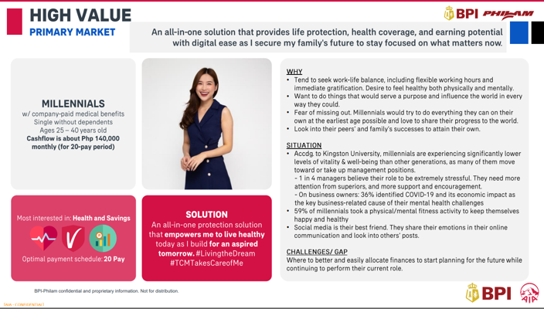  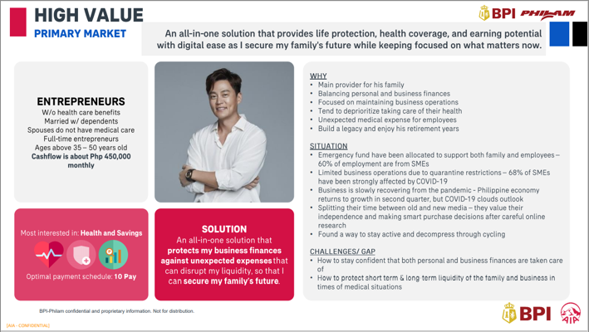  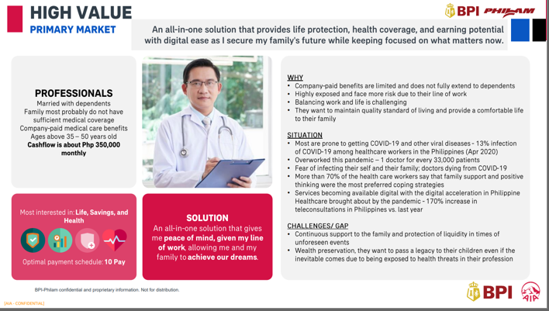  For table 2 reference:  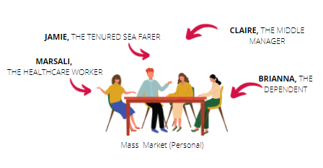  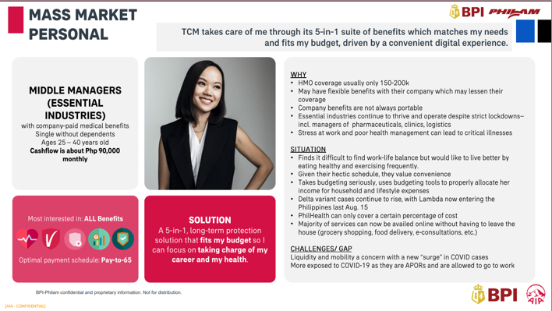  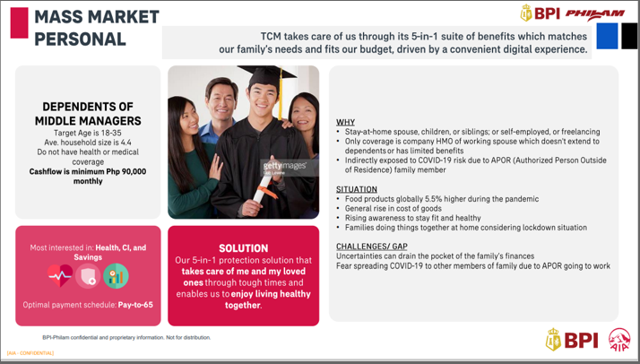  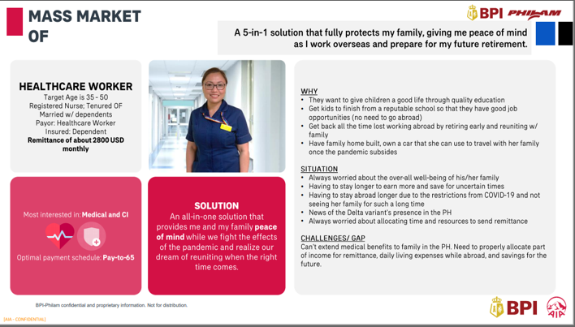  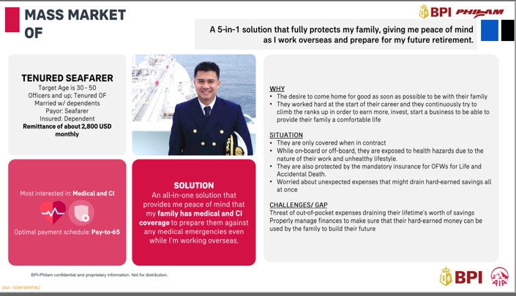
Return to X10004_3 when the learner selects Back.
Proceed to X10004_5 when the learner selects Next.
X10004_5: | [Ben] Great work! We are close to the end of our class. Let’s sum up what we have learned so far.  [Ben] With Total Care Max, our customers will get:  - All-in-one protection: A comprehensive protection plan with life insurance coverage and health benefits, giving crucial protection while protecting your family’s future.  - Potential savings: Grow your account’s savings by having access to fund/s with high growth and earning potential.  - Be rewarded: Option to add AIA Vitality, a program that rewards you for being healthy and boosts your protection coverage by as much as 50%.  Back  Next |   Show a summary of what our customers will get from Total Care Max. Make it interactive and use consistent icons for easier retention.
X10004_6: | [Ben] Here’s how we can position Total Care Max for each target market:  High Value Market  “An all-in-one solution that provides life protection, health coverage, and earning potential with digital ease as I secure my family’s future to stay focused on what matters now.”  Mass market (Top Personal)  “TCM takes care of me through its 5-in-1 suite of benefits which matches my needs and fits my budget, driven by a convenient digital experience.”  Mass market (Tenured OFW)  A 5-in-1 solution that fully protects my family, giving me peace of mind as I work overseas and prepare for my future retirement.”  Back  Next | 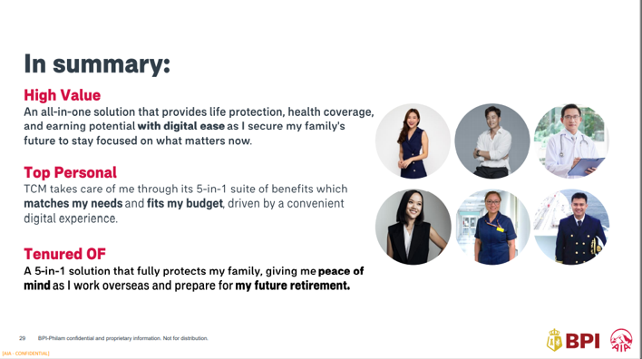  Show a summary of the target market. Add the representations for each market.
X10004_7: Our clients may have different sentiments and priorities, yet everyone wants to live a worry-free life. To better position Total Care Max, conduct a needs analysis where clients rank their needs in order of priority. By doing So you will be able to identify what they truly need and how TOTAL CARE MAX can be the perfect solution. | (Ben) Our clients may have different sentiments and priorities, yet everyone wants to live a worry-free life. To better position Total Care Max, you can use the Survey Form that our clients accomplish to rank their needs in order of priority, followed by accomplishing the Financial Wellness Needs Analysis (FWNA) on iPos. By doing so, you will be able to identify what they truly need and determine how TOTAL CARE MAX can address this.  [survey form]  How can we help you?  - Protect  As a breadwinner, I’d like to protect my wealth and my family’s lifestyle in any eventuality.  - Ready  I’d like to have quick access to funds for my daily needs and emergencies.  - Secure  I want to give my children a secure future through quality education.  - Prepare  I’d like to be financially capable in the event of serious medical conditions.  - Grow  I’d like to grow my wealth to be able to live a comfortable life in my retirement years.  - Plan  I’d like to know how I can best keep & transfer my wealth to my loved ones.  Back  Next | 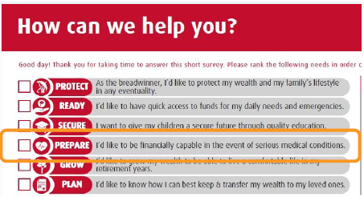Flash the text on the screen. Show Ben’s avatar and display a screenshot of the survey form used by BSEs to assess the client’s needs.
Return to X10004_7 when the learner selects Back.
Proceed to X10004_12 when the learner selects Next.
X10004_8: | (Ben) Well, that’s a lot of information! Let’s test and your memory and see if you can answer these questions correctly.  BACK  START THE TEST | Build a short knowledge check with 3 multiple-choice questions. The learner has to answer all three questions correctly to move on to the next slide. This knowledge check has unlimited attempts. Add a Start the test button that takes the learner to the first question.
Return to the X10004_7 when the learner selects Back.
Proceed to TM1 when the learner selects START THE TEST.
TM1 | - Monica is a middle manager for a local pharmaceutical company. She's only 30 but is the family's breadwinner. How would you position Total Care Max so she will consider it as a need? Select the best answer.  - With TOTAL CARE MAX, Monica will have an all-in-one solution that provides life protection, health coverage, and earning potential with digital ease as she secures her family’s future to stay focused on what matters now.  - TOTAL CARE MAX will take care of Monica through a 5-in-1 suite of benefits that matches her needs and fits her budget, driven by a convenient digital experience. (Correct)  - With TOTAL CARE MAX, Monica will get a 5-in-1 solution that fully protects her family, giving her peace of mind as she works overseas and prepare for her future retirement.  Submit  [Incorrect caption A]  Oops. Monica belongs to the mass market so an emphasis on budget is preferred over an emphasis on digital convenience.  [Incorrect caption C]  Oops. Monica is only 30 years old and doesn’t work overseas so she doesn’t worry that much on her future retirement.  [Correct caption B]  You got it right! Since Monica belongs to the mass market, she needs an all-in-one solution that matches her needs and most importantly, fits her budget.  Continue | Show the first question and the three choices.  When the learner clicks Submit, validate the answer by showing the corresponding incorrect/correct captions.  Add a Retry button in the incorrect captions so the learner can select another answer.  Add a Continue button in the correct caption so the learner can move on to the next question.
 |  | Proceed to TM2 when the learner gets the correct answer and selects Continue.
TM2 | - Which target market does a tenured seafarer, remitting 2800 USD per month, belongs to?  - Mass market (Correct)  - High Value market  - Private market  [Incorrect Caption B and C]  Incorrect. Please try again.  [Correct Caption A]  Correct! A tenured seafarer remitting 2,800 USD monthly falls under the Mass market category.  Continue | Show the second question and the three choices.  When the learner clicks Submit, validate the answer by showing the corresponding incorrect/correct captions.  Add a Retry button in the incorrect captions so the learner can select another answer.  Add a Continue button in the correct caption so the learner can move on to the next question.
 |  | Proceed to TM&P_Q3 when the learner gets the correct answer and selects Continue.
TM3 | - As a Protection Partner of Choice, what is the ideal thing to do to position TOTAL CARE MAX?  - Ask your client’s age and marital status.  - Create a proposal based on your client’s monthly cashflow alone.  - Ask your client to rank her needs according to priority and use the FWNA to identify the client’s needs.  [Incorrect caption A]  Oops. Asking your client’s age and marital status is not enough to identify what he or she needs.  [Incorrect caption B]  Oops. Basing your Total Care Max proposal only on your client’s monthly cashflow is not correct. There are more factors to consider.  [Correct caption C]  Correct! Assess their needs through a survey form where they can rank their needs in order of priority.  Back  Continue | Show the third question and the three choices.  When the learner clicks Submit, validate the answer by showing the corresponding incorrect/correct captions.  Add a Retry button in the incorrect captions so the learner can select another answer.  Add a Continue button in the correct caption so the learner can move on to X10003_14.
 |  | Return to the previous slide when the learner selects Back. Proceed to X10003_14 when the learner selects Continue.
X10004_9: Congratulations on completing Total Care Max: Target Market class! Here's your reward. | (Ben) Congratulations on completing the Total Care Max: Target Market class! Here’s your reward:  6 units  Back  View Our Subject Offerings | Add a short animation to show the Target Market subject checked from the list. Highlight the 6 units.  Add a Back and a View Subject Offerings button.
Return to X10004_8 when the learner selects Back.
Return to X10002_3 when the learner selects View Our Subject Offerings.

X10005 — Features and Benefits
Screen Notes:
Audio | Text on Screen | Graphics/Programming Notes
X10005_1a: Hi! I am Patty, your instructor. Welcome to TOTAL CARE MAX: Features and Benefits class.  X10005_1b: Today, we will discuss what makes Total Care Max different from our other products, and how these features will benefit our clients.  X10005_1c: To mark complete in this subject, I ask that you actively participate by doing the following:  - Remember all 9 features of Total Care Max  - Identify how each benefit complements each other to provide a comprehensive solution to our client’s needs  - Integrate everything you have learned so far about Total Care Max.  - Pass the learning checkpoint  This subject takes up a big chunk in the certification questions. Make sure to pay attention and study well. Okay? | [Patty] Hi ______! I am Patty, your instructor. Welcome to TOTAL CARE MAX: Features and Benefits class.  [Patty] Today, we will discuss the features and benefits of Total Care Max and understand how this product helps our clients in every step of the way.  [Patty] To mark complete in this subject, I ask that you actively participate by doing the following:  - Remember all 9 features of Total Care Max  - Identify how each benefit complements each other to provide a comprehensive solution to our client’s needs  - Integrate everything you have learned so far about Total Care Max  - Pass the learning checkpoints in between features.  I’m not sure  Got it! | Show Patty’s half-body avatar in the classroom background with a whiteboard. Flash the speech bubble one by one.  For the last paragraph, show Patty’s face on the bottom-right part of the screen. Flash the checklist written on the board. Allow the learner to select between Got it! and I’m not sure buttons.
Proceed to X10005_2 when the learner selects No.
Proceed to X10005_3a when the learner selects Yes.
X10005_2: Oh, do you need some time? You can come back later when you are ready or review my requirements and confirm participation. | [Patty] Oh, do you need some time? You can come back later when you are ready or review my requirements and confirm participation.  Home  Review requirements | Flash speech bubble and allow the learner to select between a Home button and a Review Requirements button.  When learner selects Review Requirements, replay X10005_1c.
Return to X10002_1 when the learner selects Home.
Return to X10005_1c when the learner selects Review requirements.
X10005_3: Great! Let’s have a quick overview of Total Care Max before we get into details. | [Patty] Great! Let’s have a quick overview of Total Care Max before we get into details.  Total Care Max is a comprehensive protection solution that combines the best features of these three products:  (show pyramid)  Life Ready Plus  - An affordable whole life protection plan  Critical Care 100  - A comprehensive health and life insurance plan that covers up to 100 critical illnesses  MedLife Protect Plus  - An investment-linked life and health insurance that gives better access to medical care | Flash speech bubble to the left. Show the instructions on the screen.  Show the pyramid of products and highlight each product mentioned.  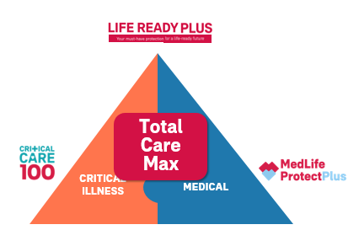  Add a Back and Next button.
Return to X10005_2 when the learner selects Back.
Return to X10005_4 when the learner selects Next.
X10005_4: Total Care Max has the following benefits.  X10005_4b: Let’s explore the first feature: Life Insurance Coverage. | Total Care Max has the following benefits:  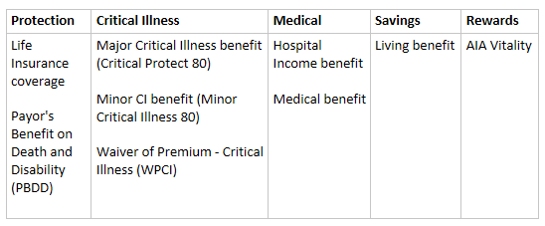  Let’s explore the first feature: Life Insurance Coverage  (click Life Insurance coverage)  Back | Show the table used in Value Proposition but changed the benefits into features.  Here’s the reference: (You can reuse the icons/add more)  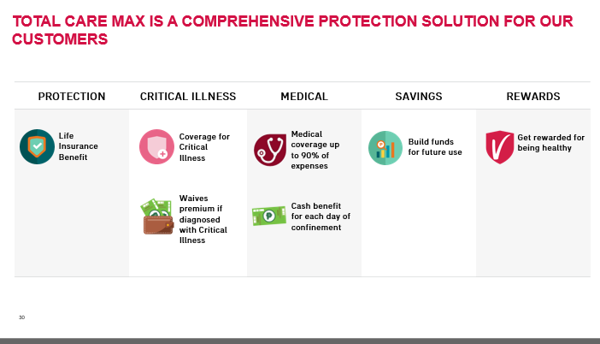  Highlight/Make it big the Life Insurance Benefit icon and make it clickable.
X10005_5A: With the life insurance benefit, the insured will get insurance protection coverage until 100. The death benefit shall be the higher of the following:  Face amount is equal to the basic annual premium x the Death Benefit Multiplier + 125% of all top-up premiums less 125% of all partial withdrawals made;  Account Value; and Minimum Guaranteed Death Benefit.  X10005_5B: Have the peace of mind knowing that your loved ones will receive financial support that can address their needs in case the unexpected happens.  X10005_5C: There are three pay-periods available for Total Care Max. The Death Benefit Multiplier depends on the chosen pay period and the age the policy has been issued.  X10005_5D: In this example, the insured, Juan Dela Cruz, is 45 years old. He opted for a 20-pay period which means he will finish the payment when he reaches 65 years old. He has an annual premium of 69,616 pesos for a Face Amount of 1 million pesos. He is protected with the Life Insurance benefit until age 100.  X10005_5E: If the insured dies due to a natural cause at the age of 55, his beneficiaries will receive the death benefit payout whichever is higher among the three: Face amount of 1 million pesos, Account value earned amounting to 231,828 pesos, or Minimum Guaranteed Death benefit of 348,080 pesos. In this case, the highest is the face amount amounting to 1 million pesos. | Life Insurance Coverage  ADVANTAGES:  - Insured will get insurance protection coverage until age 100.  - The Death Benefit shall be the higher of the following:  (1) Face Amount = (Basic Annual Premium* x DBM) plus 125% of all Top-Up premiums less 125% of all partial withdrawals made  (2) Account Value (the total amount the policy has accumulated based on the variable life units acquired since policy issuance)  (3) Minimum Guaranteed Death Benefit**  *Excluding rider premiums and top-ups as these have separate coverage  ** The Minimum Guaranteed Death Benefit shall be 500% of the Basic Annual Premium plus 125% of top-ups made less 125% of withdrawals made  BENEFITS:  Have peace of mind knowing that your loved ones will receive financial support that can address their needs in case the unexpected happens.  PAY PERIOD:  10-pay  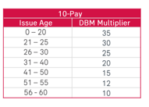  20-pay  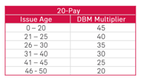  Pay-to-age 65  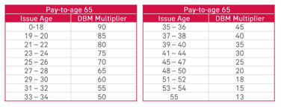  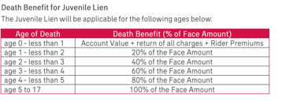  LIFELINE EXAMPLE:  (Sync VO X10005_5D)  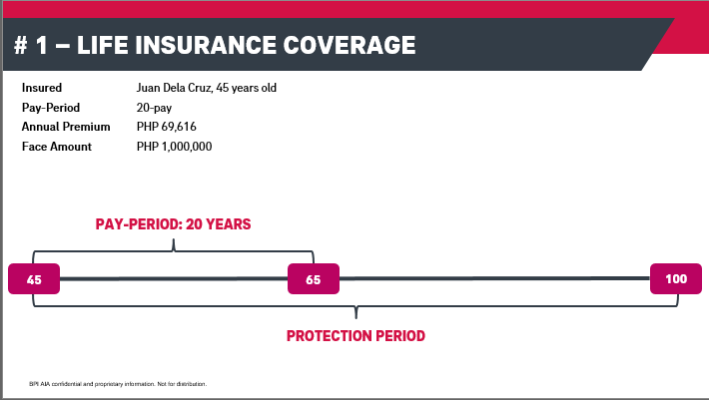  (Sync VO X10005_5E)  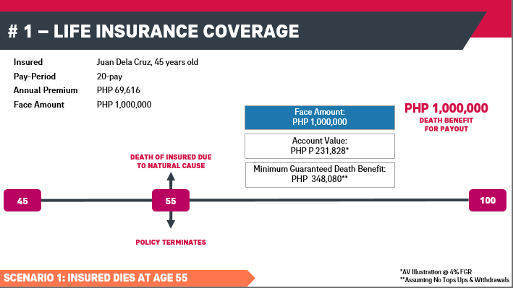 | Split the screen into four sections/clickable boxes.  Expand the content when learner clicks it.  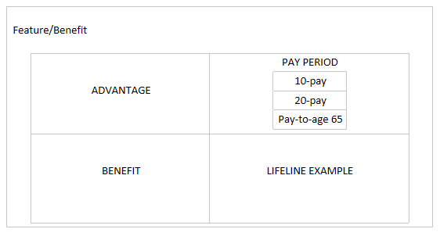  Separate the content in layers to avoid too many texts.  ADVANTAGES:  Allow learner to reveal each death benefit conditions one at a time.  BENEFITS:  Add an image where a family is receiving financial support.  PAY PERIOD:  Show the three pay-periods and their tables. Include Death Benefit for Juvenile Lien table.  LIFELINE EXAMPLE:  Circle/Highlight the information mentioned in the voice over. It should sync with the voice over. Copy the illustration from the powerpoint. See references below:  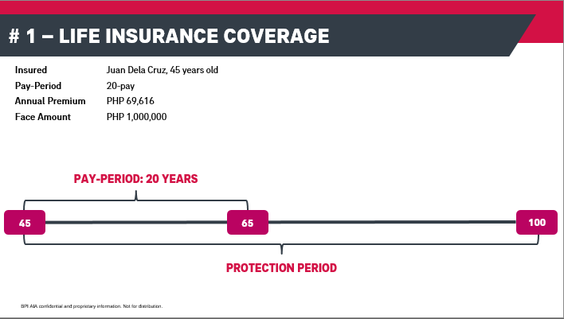  When voice over is done, show the next illustration.  When all elements of Life Insurance coverage has been visited, show a Back button or a Return button to the Features table and proceed to the next one.
X10005_6: Let’s explore the next feature: Major Critical Illness Coverage. | Let’s explore the next feature: Major Critical Illness Coverage.  (click Major CI)  Back | This time, highlight the next feature: Major CI benefit. Make it clickable.
X10005_7a: With the Major Critical Illness coverage, insured will get a lump sum cash benefit in case he/she is diagnosed with any of the 57 listed Major Critical Illnesses including cancer, heart attack, and stroke, until age 80.  X10005_7b: Stay one step ahead of life’s uncertainties and focus on living your life to the fullest knowing that your finances are covered should you get critically ill.  X10005_7c: Critical Protect80 issue ages are as follows.  X10005_7d: These are the 57-covered major critical illnesses.  X10005_7e: Let’s continue to use the case of Juan Dela Cruz. Aside from the life insurance benefit that the insured gets from availing Total Care Max, he also has a Critical Protect 80 coverage from the date of purchase up to the age of 80 years old.  X10005_7f: If the insured gets diagnosed with a major critical illness, say for example, with end stage lung disease at the age of 50, his CP80 rider will terminate and he will get a lump sum cash benefit with a face amount of 1 million pesos. Just note that the insured must survive 14 days after diagnosis to receive CP80 benefit.  X10005_7g: Some important items to remember. | Major Critical Illness Coverage (CriticalProtect80 – Mandatory rider)  ADVANTAGE:  - Insured will get a lump sum cash benefit in case he/she is diagnosed with any of the 57 listed Major Critical Illnesses including cancer, heart attack, and stroke, until age 80.  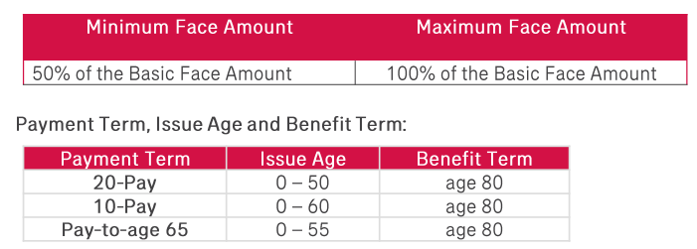  BENEFIT:  - Stay one step ahead of life’s uncertainties and focus on living your life to the fullest knowing that your finances are covered should you get critically ill.  ISSUE AGES  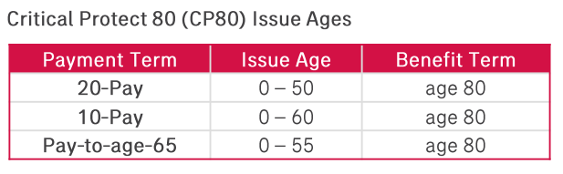  COVERED CRITICAL ILLNESSES  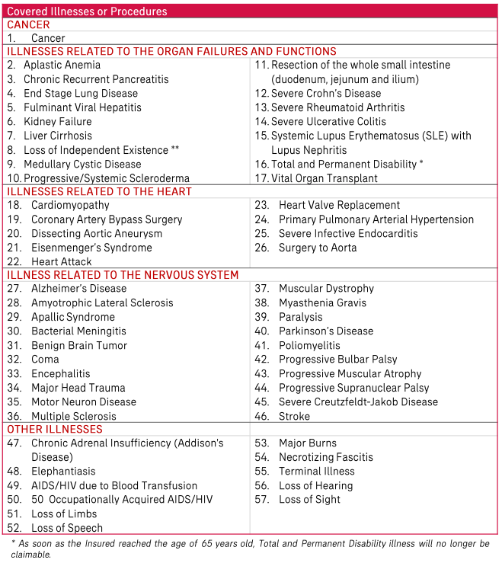  LIFELINE EXAMPLE:  (Sync vo X10005_7e)  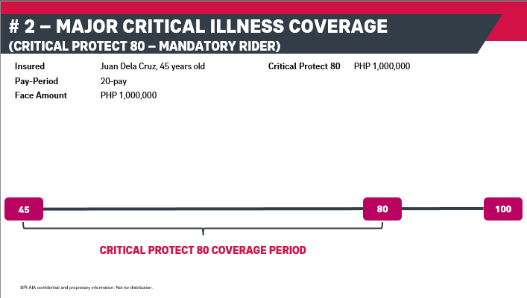  (Sync vo X10005_7f)  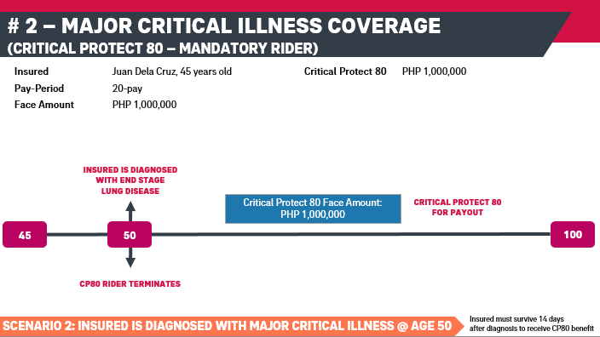  (Sync vo X10005_7g)  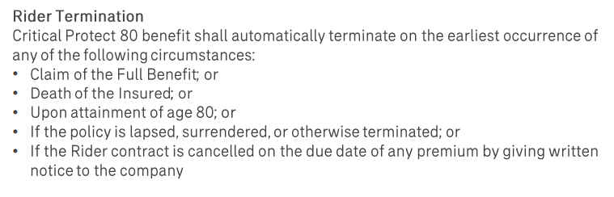 | Split the screen into four sections/clickable boxes.  Expand the content when learner clicks it.  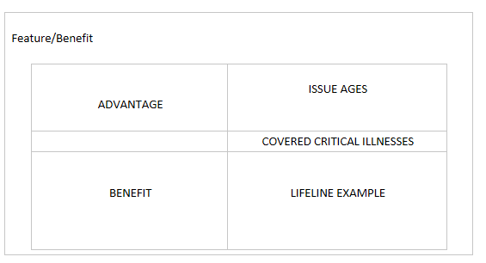  Circle/Highlight the information mentioned in the voice over. It should sync with the voice over. Copy the illustration from the powerpoint. See references below:
X10005_8: Let’s explore the third feature: Minor Critical Illness Coverage. | Let’s explore the third feature: Minor Critical Illness Coverage.  (click Minor CI)  Back | This time, highlight the next feature: Minor CI benefit. Make it clickable.
X10005_9a: With the Minor Critical Illness coverage, insured will receive 25% (up to a max. of PHP 1,000,000) of his/her major critical illness coverage in advance if he/she is diagnosed with any of the 34 covered minor critical illnesses. This feature can be used only once until age 80.  X10005_9b: Stay one step ahead of life’s uncertainties and focus on living your life to the fullest knowing that your finances are covered should you get critically ill.  X10005_9c: These are the 34-covered major critical illnesses.  X10005_9d: If the insured has a 1 million pesos face amount for the Major CI coverage, the insured will get a minor critical illness 80 coverage amounting to 250 thousand pesos, which is the 25% of his Major Critical Illness coverage face amount. He is covered until the age of 80.  X10005_9e: If on the other hand, the insured only suffered from a minor critical illness upon reaching 50, say for example, a less severe kidney disease, the insured his MCI80 rider will terminate and he will get a lump sum cash benefit amounting to the 25% of his Major CI face amount coverage which is 250 thousand pesos. Just note that the insured must survive 14 days after diagnosis to receive MCI80 benefit.  X10005_9f: If after claiming the MIC80 cash payout, the insured, this time, gets diagnosed with a major CI at the age of 60, he will get a cash payout from his Critical Protect80 remaining face amount amounting to 750 thousand pesos. Afterwards, his CP80 will also terminate.  X10005_9g: Some important items to remember. | Minor Critical Illness Coverage (Minor Critical Illness 80 – Optional rider)  ADVANTAGE:  - Insured will receive 25% (up to a max. of PHP 1,000,000) of his/her major critical illness coverage in advance if he/she is diagnosed with any of the 34 covered minor critical illnesses. This feature can be used only once until age 80.  BENEFIT:  - Stay one step ahead of life’s uncertainties and focus on living your life to the fullest knowing that your finances are covered should you get critically ill.  (sync vo X10005_9c)  COVERED CRITICAL ILLNESSES  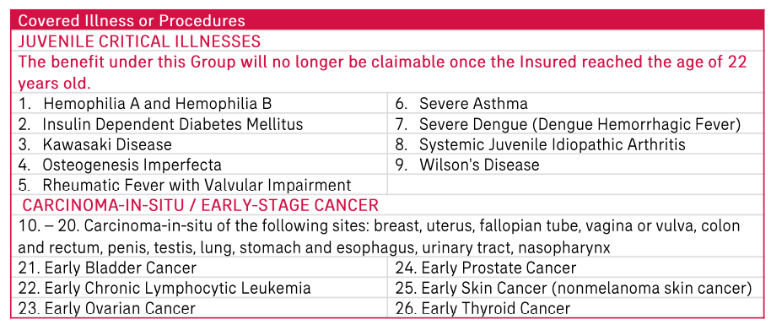  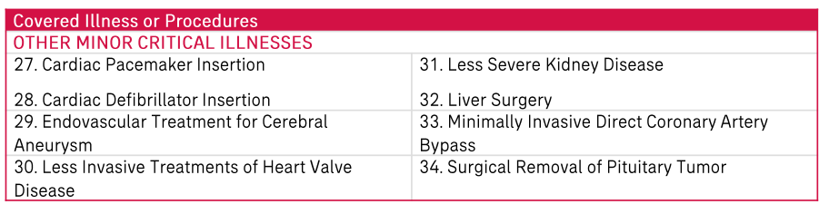  LIFELINE EXAMPLE:  (Sync vo X10005_9d)  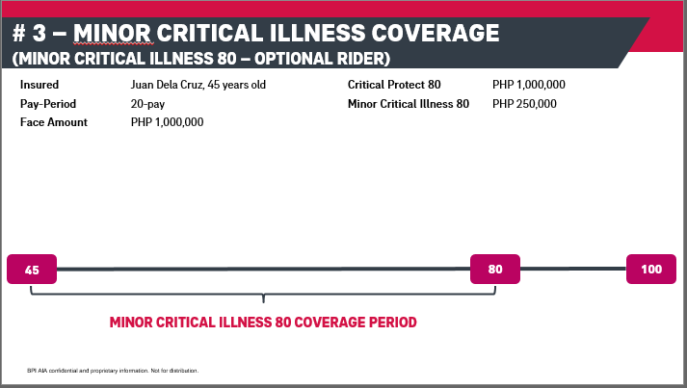  (Sync vo X10005_9e)  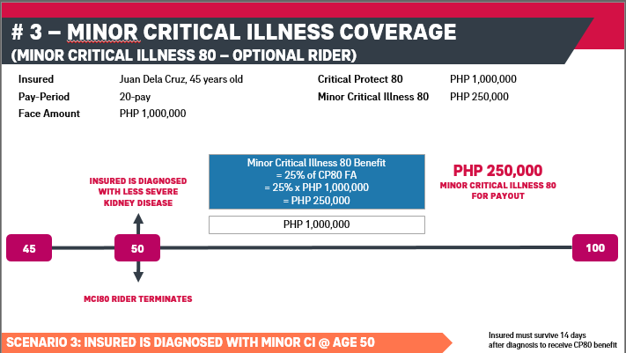  (Sync vo X10005_9f)  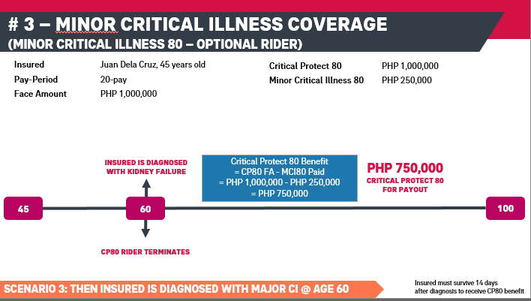  (Sync vo X10005_9g)  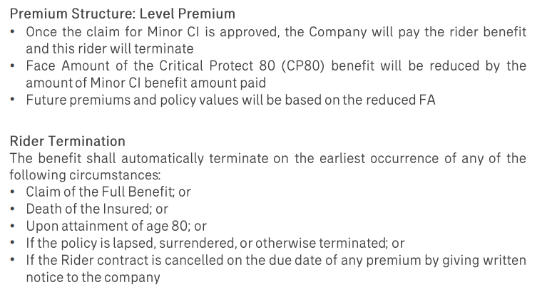
X10005_10: Let’s explore the forth feature: Daily Hospital Income (Hospital Income Benefit- Conditionally Required Rider) | Let’s explore the forth feature: Daily Hospital Income (Hospital Income Benefit – Conditionally Required Rider)  (click Minor CI)  Back | This time, highlight the next feature: Hospital Income benefit. Make it clickable.
X10005_10a: Insured will receive a cash amount equal to the package chosen for each day of hospital confinement due to a covered illness or injury on the recommendation of a licensed physician, up to a maximum of 365 days with respect to the same confinement. No minimum number of days is required to be able to receive this cash benefit.  X10005_10b: The Hospital Income Benefit Issue Ages are as follows:  X10005_10c: Live with confidence and lessen the impact of potential income loss due to hospital confinement.  X10005_10d: Some important items to remember.  X10005_10e: For this example, the insured has added Plan A equivalent to 1,000 pesos Daily Hospital Income benefit up to the age of 65.  X10005_10f: Let’s use the previous scenario and add Hospital Income Benefit. If the insured gets diagnosed and confined in the hospital for 15 days with less severe kidney disease, he will receive the daily hospital benefit of 1,000 per day confined. In 15 days confinement, he will get 15 thousand pesos.  X10005_10g: This time, if the insured is hospitalized not for a minor CI disease but for a major one, say for example, kidney failure, that lasted for 30 days confinement, he will receive 30,000 pesos.  X10005_10h: Just remember the following circumstances as basis for rider termination. | Daily Hospital Income (Hospital Income Benefit – Conditionally Required Rider)  ADVANTAGE:  Insured will receive a cash amount equal to the package chosen for each day of hospital confinement due to a covered illness or injury on the recommendation of a licensed physician, up to a maximum of 365 days with respect to the same confinement. No minimum number of days is required to be able to receive this cash benefit.  HOSPITAL INCOME BENEFIT ISSUE AGES:  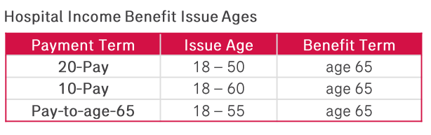  BENEFIT:  Live with confidence and lessen the impact of potential income loss due to hospital confinement.  NOTES:  If insured already has existing policies with the Hospital Income Benefit rider, the Coordination of Benefit Limit will be applicable:  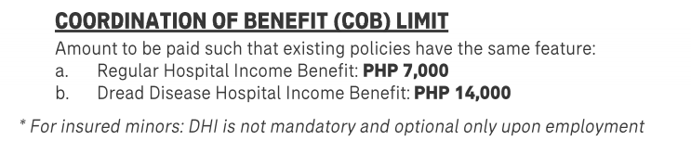  LIFELINE EXAMPLE:  (Sync vo X10005_10e)  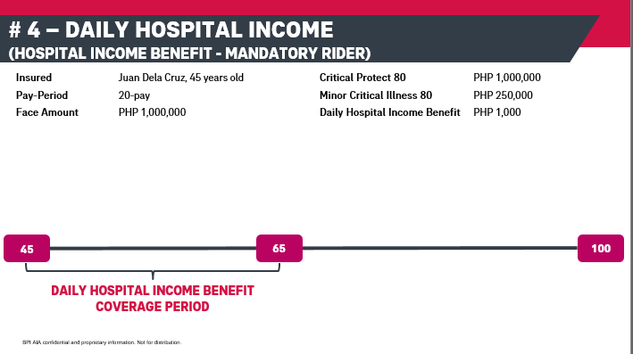  (Sync vo X10005_10f)  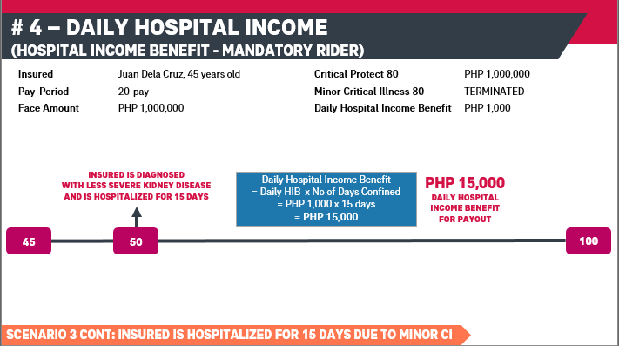  (Sync vo X10005_10g)  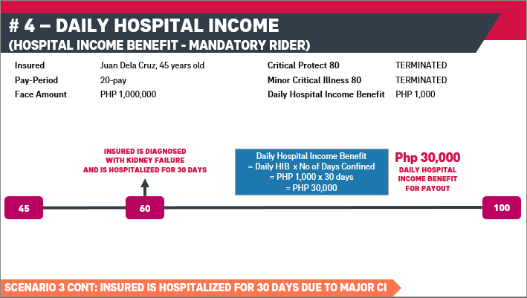  (Sync vo X10005_10h)  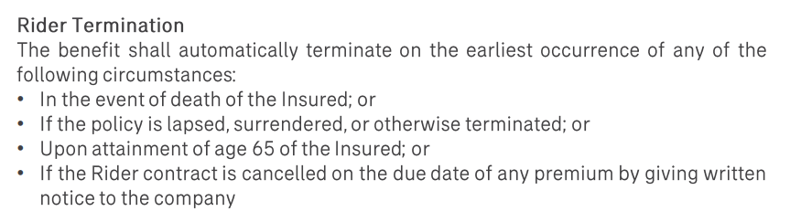
X10005_11: Let’s explore the fifth feature: Medical Benefit Coverage (Medical Benefit – Optional Rider) | (click Medical Benefit)  Back | This time, highlight the next feature: Medical benefit. Make it clickable.
X10005_11a: The insured will be covered with a medical benefit that covers in-patient hospitalization expenses. This rider will follow a 90%-10% co-payment set-up, with 90% to be covered by Avega, our HMO partner, and 10% to be covered by the insured.  X10005_11b: The Medical Benefit Issue Ages are as follows:  X10005_11c: Increase your comprehensive protection by ensuring you have enough medical benefits to cover potential in-patient expenses in the future.  X10005_11d: Some important items to remember.  X10005_11e: In this example, the insured has added the Medical Benefit Plan A with an annual benefit limit of 500 thousand pesos and a lifetime benefit limit of 2.5 million pesos. The insured is covered with the medical benefit until the age of 65.  X10005_11f: If the insured is hospitalized at the age of 50 due to a minor critical illness like in our previous example, the medical benefit through Avega can cover in-patient hospital expenses amounting to the 90% of the total hospital bill net of Philhealth. In this example, the total hospital bill net of Philhealth is 450 thousand pesos. Therefore, Avega can cover 405 thousand pesos and the remaining 45 thousand pesos of the hospital bill will be shouldered by the insured.  X10005_11g: In this next illustration, we calculate the remaining Annual Benefit Limit and Lifetime benefit limit based on the previous scenario. If the insured used up 405,000 pesos from his annual benefit of 500,000 pesos, then he only has 95 thousand pesos remaining annual benefit limit to be used up in that same year. The same amount will be deducted to his lifetime benefit limit of 2.5 million pesos. He now has 2million and 95 thousand pesos remaining lifetime benefit limit.  X10005_11h: But what happens if the insured is confined once again in the same year? Let’s take a look. In this scenario, the insured is hospitalized the same year due to dengue. The total hospital bill net of Philhealth is 120,000 pesos. The 90% of the total hospital bill net of Philhealth is amounting to 108 thousand pesos. Take a look at the Annual Benefit limit. Due to the previous claim, the remaining annual benefit limit is only 95,000 pesos. Therefore, Avega can only cover 95,000 pesos. The remaining balance of 13,000 pesos plus the 10% copay of 12,000 pesos,, 25,000 pesos in total shall be shouldered by the insured. The insured has used up his annual benefit limit.  X10005_11i: The same computation is applicable in this illustration where the insured gets hospitalized with a Major Critical illness instead of a Minor critical illness and used up his annual benefit limit. However, the moment the insured gets hospitalized with a major critical illness, the medical benefit gets terminated automatically.  X10005_11j: Just remember the following circumstances as basis for rider termination. | Medical Benefit Coverage (Medical Benefit – Optional Rider)  ADVANTAGE:  The insured will be covered with a medical benefit that covers in-patient hospitalization expenses. This rider will follow a 90%-10% co-payment set-up, with 90% to be covered by Avega, our HMO partner, and 10% to be covered by the insured.  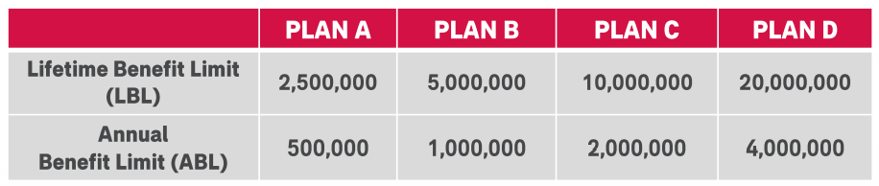  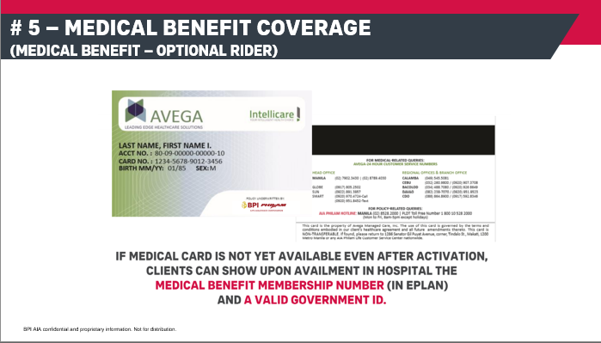  MEDICAL BENEFIT ISSUE AGES:  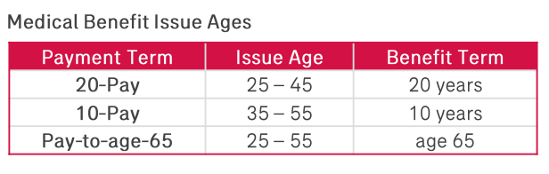  (Sync vo X10005_11c)  BENEFIT:  Increase your comprehensive protection by ensuring you have enough medical benefits to cover potential in-patient expenses in the future.  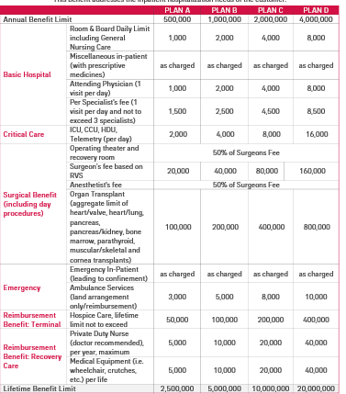  (Sync vo X10005_11d)  NOTES:  - Pre-existing conditions are not covered within the 1st policy year. Furthermore, they must be declared for them to be covered on the 2nd policy year. Otherwise, they will not be covered.  - What are pre-existing conditions?  - Conditions existing prior to effective date of coverage  - Professional advice sought for such illness prior effective date of coverage  - Nature of disease or illness can be clinically determined to have started prior coverage whether the member is aware or not  - The following are considered PEC: hypertension, goiter, asthma, TB, gall or kidney stones, diabetes, myoma, arthritis, scoliosis, hernia, prostate disorders  - Insured is required to file for Philhealth before any Medical Benefit is computed and paid out. In case Insured is not a Philhealth member, Insured must shoulder and pay the Philhealth portion of the bill.  - If the insured already has an existing policy with the Medical Benefit rider from BPI AIA or AIA PH, this rider cannot be attached to the Total Care Max policy.  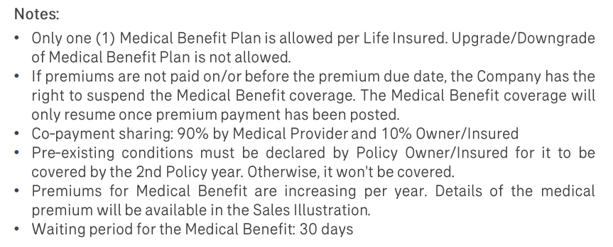  LIFELINE EXAMPLE:  (Sync vo X10005_11e)  (Sync vo X10005_11f)  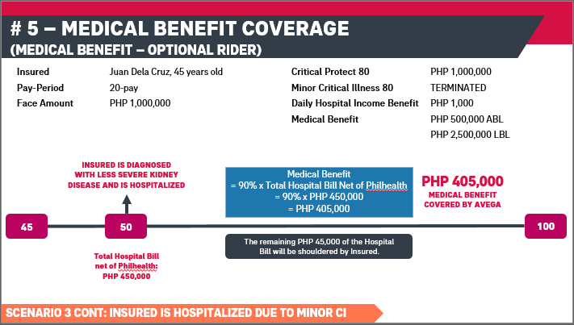  (Sync vo X10005_11g)  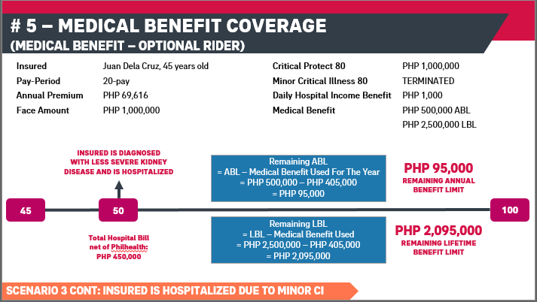  (Sync vo X10005_11h)  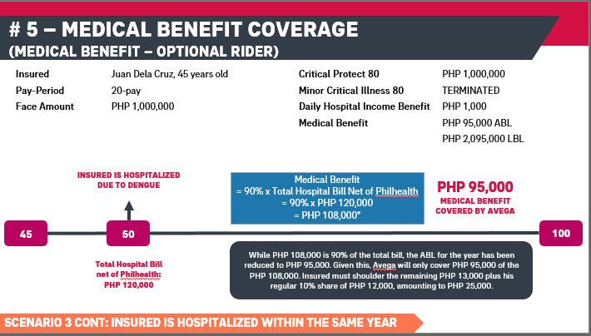  (sync vo X10005_11i)  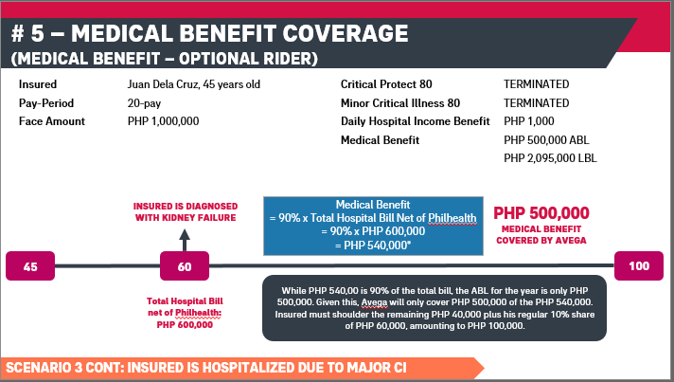  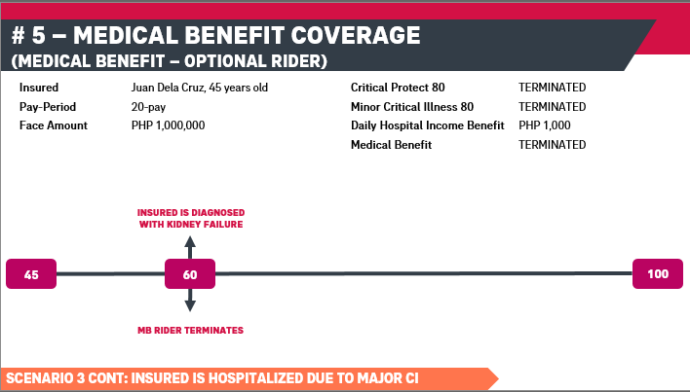  (sync vo X10005_11j)  Rider Termination:  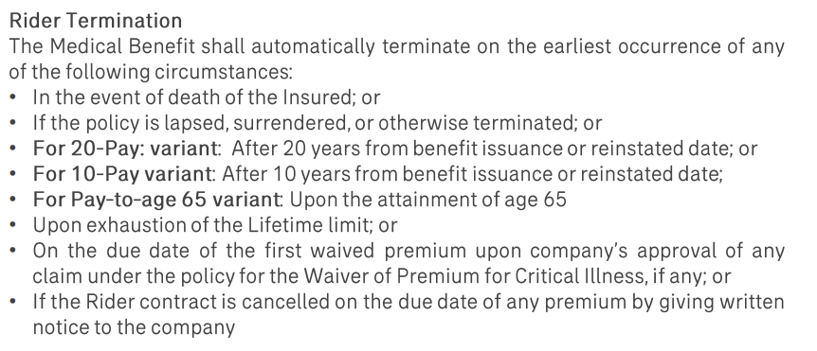 | ADVANTAGE:  Also show the Avega card.
X10005_12: Let’s explore the sixth feature: Waiver of Premium – Critical Illness (WPCI – Conditionally Required Rider) | (click WPCI)  Back | This time, highlight the next feature: Medical benefit. Make it clickable.
Return to X10005_11 when the learner selects Back.
Proceed to X10006_4 when the learner selects Next.
X10005_13a: The insured’s Basic Annual Premium, Rider Premiums (except Medical Benefit rider, if attached), and Special Top-Up Premiums (if any) will be waived in case he / she is diagnosed with any of the listed Major Critical Illnesses during the premium paying period.  X10005_13b: The Waiver of Premium for Critical Illness Issue Ages are as follows:  X10005_13c: Ensure that your policy remains in force even if your finances are hampered by the diagnosis of a critical illness.  X10005_13d: Let’s continue using our existing scenario. In this illustration, the insured is diagnosed with a major critical illness at the age of 60. He still has 5 remaining years to pay off the premiums. But because of the waiver of premium for critical illness added in his plan, the remaining premiums for the next 5 years are waived except for the medical benefit, and he remains covered with the life protection until the age of 100.  X10005_13e: Just remember the following circumstances as basis for rider termination. | Waiver of Premium – Critical Illness (WPCI – Conditionally Required Rider)  ADVANTAGE:  The insured’s Basic Annual Premium, Rider Premiums (except Medical Benefit rider, if attached), and Special Top-Up Premiums (if any) will be waived in case he / she is diagnosed with any of the listed Major Critical Illnesses during the premium paying period.  WAIVER OF PREMIUM FOR CRITICAL ILLNESS ISSUE AGES:  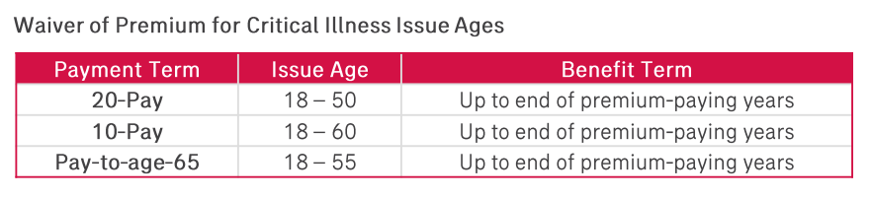  (Sync vo X10005_13c)  BENEFIT:  Ensure that your policy remains in force even if your finances are hampered by the diagnosis of a critical illness.  LIFELINE EXAMPLE:  (Sync vo X10005_13d)  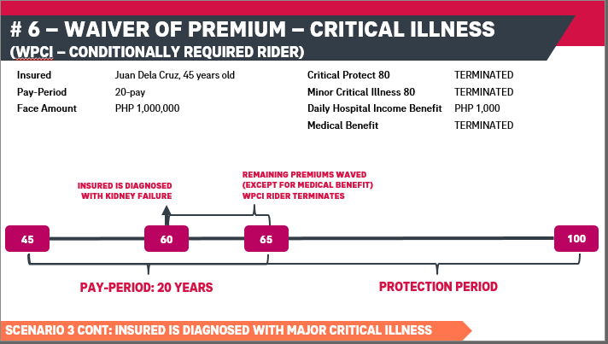  (Sync vo X10005_13e)  Rider Termination:  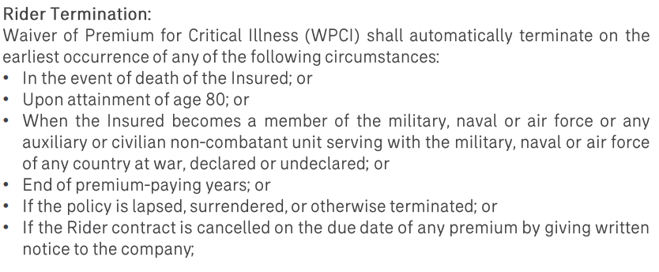
Return to X10005_12 when the learner selects Back.
Proceed to X10005_14 when the learner selects Next.
X10005_14: Let’s explore the seventh feature: Payor’s Benefit on Death and Disability (PBDD – Optional rider) | (click PBDD)  Back | This time, highlight the next feature: PBDD. Make it clickable.
X10005_15a: The policy’s Basic Annual Premium, Rider Premiums (except Medical Benefit rider, if attached), and Special Top-Up Premiums (if any) will be waived in case of Death or Total & Permanent Disability of the Payor during the premium paying period.  X10005_15b: The Payor’s benefit on Death and Disability Issue Ages are as follows:  X10005_15c: Have peace of mind knowing that your loved one’s protection coverage remains intact in case your financial ability to pay is affected due to life’s risks.  X10005_15d: Let’s have a new scenario to illustrate the Payor’s benefit on Death and Disability. In this scenario, the insured is Maria Dela Cruz. She is 3 years old. The payor for Maria’s Total Care Max plan is her mother, Clara dela Cruz who is 36 years old. The paying period is 20 years. Therefore, Clara will be able to finish the payment when Maria reaches 23 years old.  X10005_15e: Just remember the following circumstances as basis for rider termination. | Payor’s Benefit on Death and Disability (PBDD – Optional rider)  ADVANTAGE:  The policy’s Basic Annual Premium, Rider Premiums (except Medical Benefit rider, if attached), and Special Top-Up Premiums (if any) will be waived in case of Death or Total & Permanent Disability of the Payor during the premium paying period.  PAYOR’S BENEFIT ON DEATH AND DISABILITY ISSUE AGES:  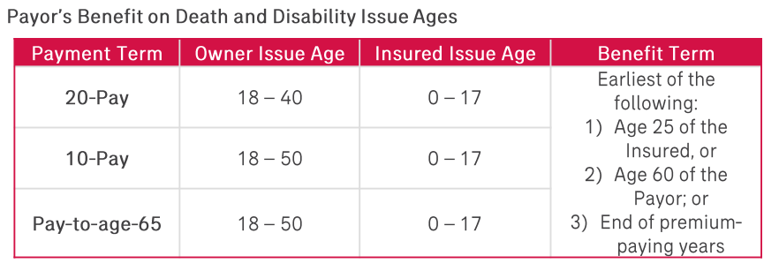  (Sync vo X10005_15c)  BENEFIT:  Ensure that your policy remains in force even if your finances are hampered by the diagnosis of a critical illness.  LIFELINE EXAMPLE:  (Sync vo X10005_15d)  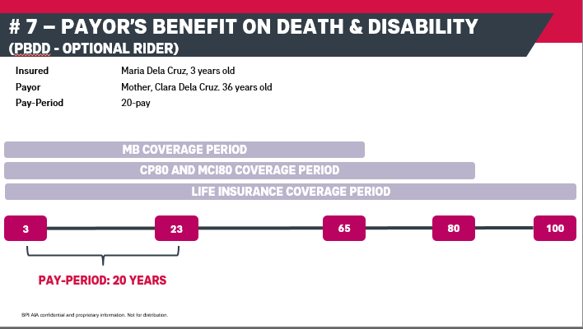  (Sync vo X10005_13e)  Rider Termination:
X10005_13: Stop on a red light. It’s a learning checkpoint! Complete the activities as you wait for the light to turn green. | [Patty] Stop on a red light! It’s a learning checkpoint! Complete the activities as you wait for the light to turn green.  (Activity 1)  Which are guaranteed? Optional? Sort the following benefits to their right category.  (Drag)  Death Benefit, Major Critical Illness Benefit, Minor Critical Illness Benefit, AIA Vitality, Gender Specific Benefit, Recovery Benefit, Payor’s Benefit for Death and Disability  (Drop)  Guaranteed  Optional  Back  Submit  [Incorrect caption] Incorrect. Please try again.  [Correct caption]  Your answer is correct.  Continue | Add a checkpoint background with a red traffic light.  Build a drag and drop activity where the features are scattered in the screen. The learner needs to sort them by dragging and dropping it to where they belong (Guaranteed or Optional).  Correct answers:  Guaranteed  - Death Benefit, Major CI, Minor CI, Philam Vitality  Optional  - Gender Specific, Recovery, Payor’s benefit for death and disability  Give the learner unlimited # of attempts. Show incorrect/correct captions upon clicking Submit.
Return to X10005_3 when the learner selects Back.
Return to X10005_1c when the learner selects Continue.
F&B_Q1 | (Activity 2)  Respond to the client’s inquiry by selecting the best answer among the statements provided.  - I am interested with Total Care Max but I don’t know how the death benefit works. Can you explain it to me?  - Death benefit is equal to the guaranteed face amount, not affected by any critical illness claim.  - Death benefit is equal to the face amount less any minor critical illness claim.  - Death benefit is the amount your loved ones received should you die tomorrow.  - Death benefit is equal to the cash value of the policy at time of death.  [Incorrect caption]  Incorrect. Please try again.  [Correct caption]  Correct. The face amount is a pool of fund shared between the death, major CI, and minor CI benefits. Hence, if the insured has successfully claimed 25% of the Face Amount in the past because of a minor critical illness, the cash benefit paid is deducted from Face Amount that the beneficiaries will receive upon death of the insured before age 100.  Continue | Change the red light to yellow.  Show a client with a speech bubble. Place the question inside the speeh bubble and flash the multiple choices.  The learner has unlimited attempts for each question. To validate, show the correct/incorrect feedback.  Add a Continue button in the Correct caption so the learner can proceed to the next question.  The correct answer for Scenario 1 is B.
 |  | Proceed to F&B_Q2 when the learner gets the correct answer and selects Continue.
F&B_Q2 | - What will I get from the Recovery benefit?  - 10% of the original face amount per year up to 5 years  - 10% of the original face amount per year up to 10 years  - 20% of the original face amount per year up to 65 years old  - 20% of the original face amount per year up to 5 years  [Incorrect caption]  Incorrect. Please try again.  [Correct caption]  Correct. The Recovery benefit is an optional benefit that can be added to the Total Care Max coverage. It entitles the insured to get a cash benefit amounting to the 10% of the original face amount per year up to 5 consecutive years.  Continue | The correct answer for Scenario 2 is A.
 |  | Proceed to F&B_Q3 when the learner gets the correct answer and selects Continue.
F&B_Q3 | - What happens to the death benefit if I get diagnosed with a major critical illness?  - You will receive 100% of the face amount and policy will continue to be in effect.  - You will receive 100% of the face amount and policy will terminate.  - You will receive 25% of your face amount or 1 million pesos whichever is lower.  - Your beneficiary will receive 100% of the face amount.  (Incorrect caption)  Incorrect. Please try again.  (Correct caption B)  When the insured is diagnosed with a major critical illness, the lump sum cash equivalent to the 100% of the face amount is advanced. Hence, the policy automatically terminates as the face amount is already used up.  Back  Continue | The correct answer for Scenaro 3 is B.
 |  | Return to the previous slide when the learner selects Back. Proceed to X10005_6 when the learner selects Continue.
X10005_6: Green means Go! You have successfully completed the learning checkpoint. | (Patty) Green means Go! You have successfully completed the learning checkpoint.  Back  Next | Change the yellow light to green. Show the pop up text on the screen.
Proceed to X10005_5 when the learner selects Back.
Proceed to X10005_7 when the learner selects Next.
X10005_7: Congratulations on completing Total Care Max: Features and Benefits class! Here's your reward. | (Patty) Congratulations on completing the Total Care Max: Features and Benefits class! Here’s your reward:  6 units  Back  View Our Subject Offerings | Add a short animation to show the units earned.  Add a Back and a View Subject Offerings button.
Return to X10005_6 when the learner selects Back.
Return to X10002_3 when the learner selects View Our Subject Offerings.

