**MEDICAL SCHEDULING PROCEDURE**

1. Schedule the appointment get the details
2. Add the appointment details to the calendar
3. Text the client appointment details
4. Save text message with appointment details in case software (Litify, Filevine, etc)
5. Update management if needed

**GOOGLE CALENDAR STEPS**

1. Go to your Google Calendar. This can be found in your Gmail. It is in the upper right hand corner. See image below:

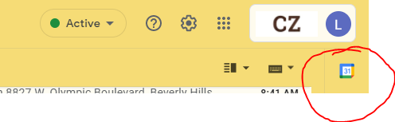

1. Click the Calendar Symbol and it will open a new tab that looks like the image below:

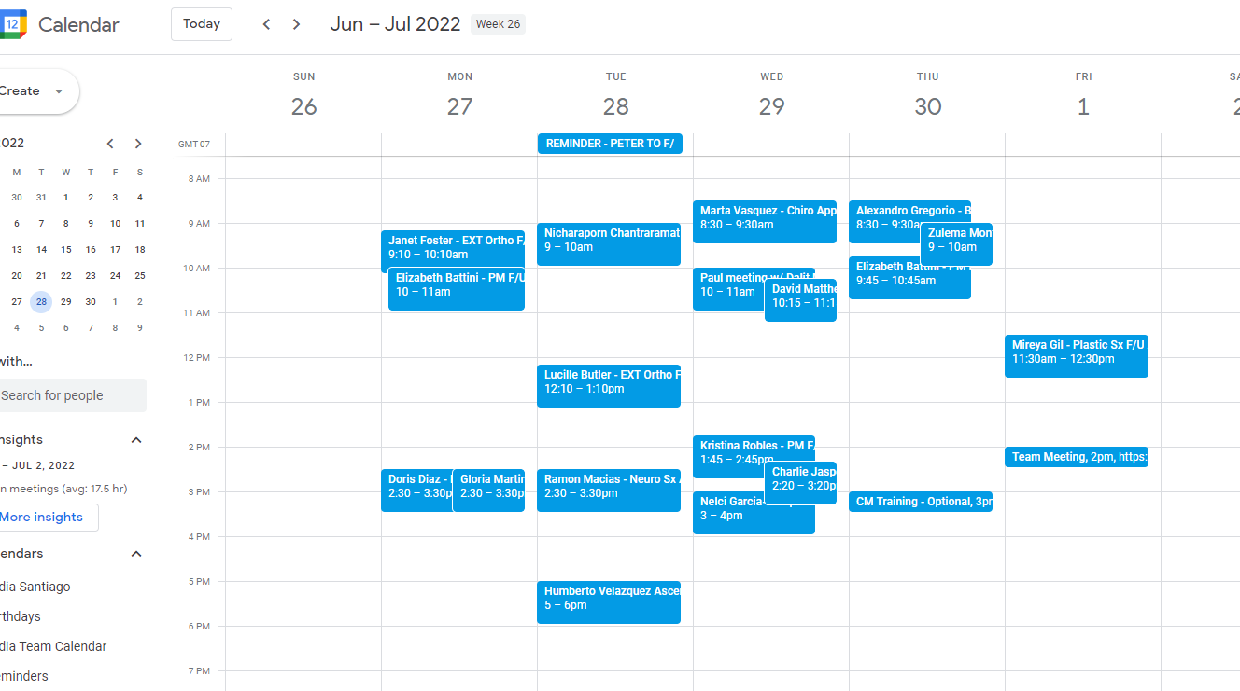

1. Select the Create Button, see image below:



1. Select Create Event, see image below:

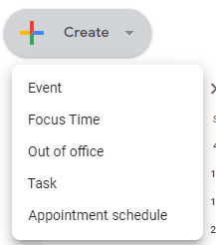

1. Once you select create **event** you get the screen below: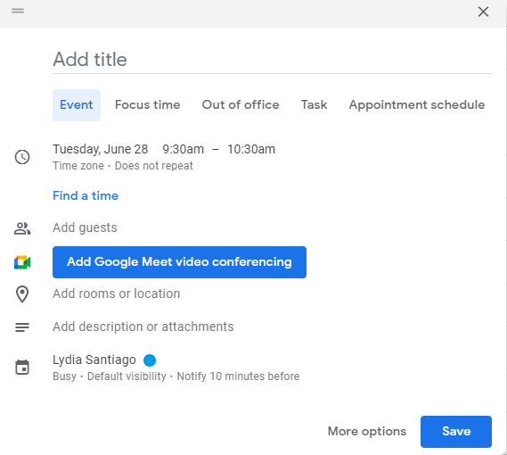
2. The sections that says “add Title” do the following
   1. Type the client name – Type of doctor visit or procedure
   2. ie. Lydia Santiago – Chiro
   3. See sample image below:

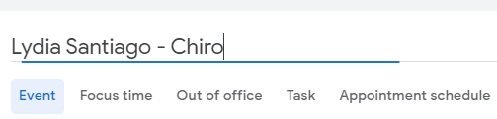

1. There is a date section, please put the appointment date and time. See below
   1. Date:

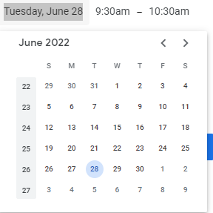

* 1. Time:

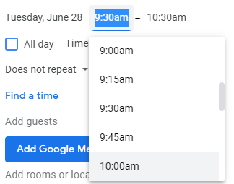

1. In the Description section we will add the following



* 1. Client Name – Phone number | Lydia Santiago – 424-703-2198
  2. Date and time of appointment
  3. Facility and/or Doctors name
  4. Facility/Doctors address or specify if the appointment is telemed
  5. Facility/Doctors phone number

Once you put in the above details you will get the below:

The last and most important part is to hit the save button.



This calendar will help you keep track of medical appointments and it will provide you with a treatment timeline. Please see below:

