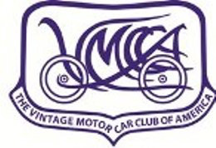
Volume 27, Issue 11
November 2025

Eastern Idaho VMCCA Chapter

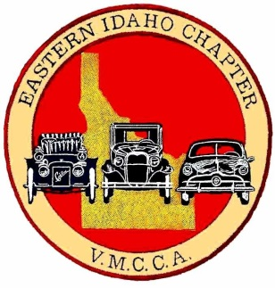
Chapter Officers
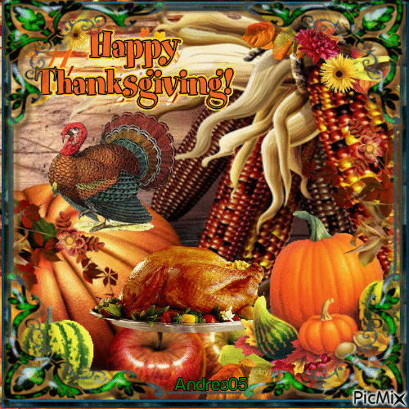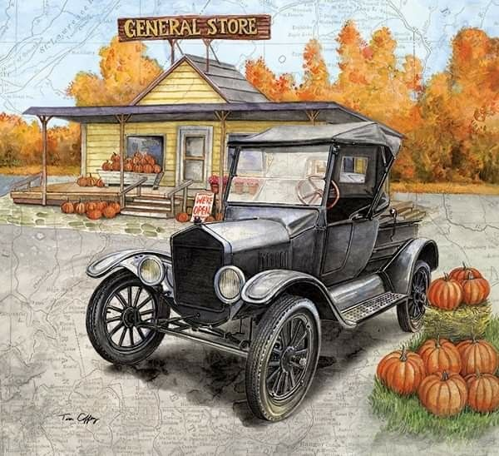
The Gas Line

From the President’s Corner:
Hello, and thanks to those who attended the September meeting at the IF Library. I also want to thank our Vice President, Scott Skinner, for leading the September meeting. I had surgery on August 25th and was not ready to attend the meeting.

As a side note, my surgery was a complete success and recovery is going well. I hope to start going to the Tuesday cruises and future car shows.

Please think about who you would like to nominate for our secretary. We will take nominations and volunteers at the October meeting and elect the new Secretary.

Speaking of October, please plan on helping out with our Fall Market Lake Cleanup on October 3rd and consider attending the car show at the Nice Spot on October 4th. Mark and Diane will have the final details at the October meeting on October 2nd.

I plan to be at the October meeting and look forward to seeing everyone at future events and car shows.

That is all for now. I hope you are able to attend our next meeting at the Idaho Falls, Library.
.
Bob Thompson

President Bob Thompson
(208) 520-4598
3rgt@mail.com

Vice President Scott Skinner
(208) 313-0443
skinners@byu.edu

Secretary: Ginger Rounds Houx
gingerrounds@hotmail.com

Treasurer Joy Eagle
(208) 529-9450
joyfuleagle@aol.com
Eagle /Transition to Holly Crawley

Board of Directors
Mark Schwartzenberger
John Walrath
Bill Beery
Gary Schwartzenberger

Page 2
Eastern Idaho VMCCA Newsletter

November – Lewis and Carole
Rounds
December – Christmas Party

Meeting treats
Club Activities
EIVMCCA Meeting Minutes – 10/2/2025.

The meeting was held at Aero Mark. There were twenty-four members in attendance. President Bob Thompson conducted the meeting. Treasury report from Joy Eagle, $14,461.16 in one account. Minutes read by Ginger Rounds.

Old business: No old business

New business:
November meeting will be held on the 8th of November to coincide with the membership drive. See more details under activities.

Membership fees are increasing to $50.00 for the electronic Bulb Horn and $58.00 for the paper copy. Please note this for the upcoming membership drive.

Christmas party is tentatively scheduled for 12/12/2025 @ 1200 noon at North Hi-way Café. There will still be a white elephant gift, (bring one get one) and no costume for this year. Please bring an item (canned goods etc.) for the food bank. Monetary gifts accepted.

Please think of a nomination for secretary. You can e-mail Bob Thompson at 3grt@mail.com with your nomination. This is important as we will be voting on 11/08/2025.

Discussion of having a reginal tour again starting from Idaho Falls, consider this to see if we have the numbers to do it.

Activities:
October
Nice Spot October 4th from 9-12

Spencer drive is on the 10th. Meet at Outback at 10:00. Leave at 10:30.
Market lake clean-up on October 17th. Meet at Outback at 0800 and leave at 0830. Bring good walking shoes, grabber, gloves and proper clothing for the weather and terrain.

November
Membership drive on November 8th. Meet at the Indian at 0900 and leave at 0930. Garage tour on the same day. Starting at Lewis Rounds will supply coffee and donuts-snacks. It was voted on to hold the monthly meeting at the first garage, Ginger Rounds located at 13973 N 35th E, Idaho Falls ID 83401. We can fill out the membership forms there as well.

National news:
Numbers are down for the tours and for memberships. Please look at the web site for national nominees for the positions they have open for their profiles.
National is looking for volunteers for national tours. Whether it is a coffee stop or to help organize.

November – Membership Drive
December - Christmas Party
NATIONAL EVENTS
TBD

Newsletter Editor Bobby Lane
(512) 848-1040
bdlane67@outlook.com

S end your car photos for our club website and the newsletter to:
bdlane67@outlook.com
Eastern Idaho VMCCA Chapter
P. O. Box 2347
Idaho Falls, Idaho 83403-2347
Page 3
The Gas Line
Spencer Drive – Photos: Provided by Scott Skinner October 10, 2025
