* 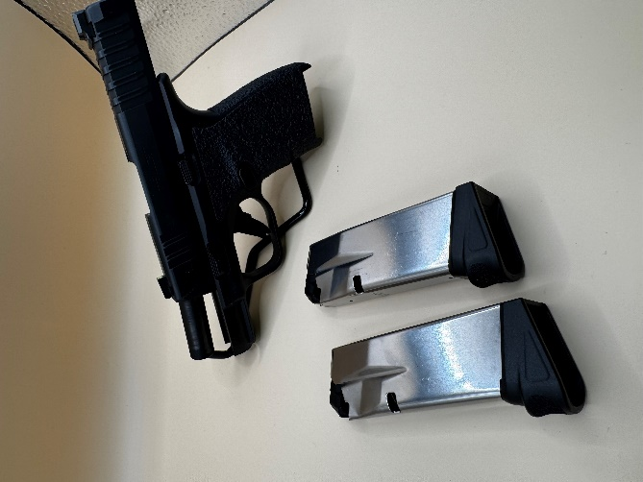**Springfield Armory Hellcat 9mm (JRFEX-3) = $460**

*Comes with x 2-12rd. mags, has 40 rounds shot through it.*

*Included is the original case, manual, and the factory warranty will transfer to new owner.*

*Also includes inside waistband holster.*

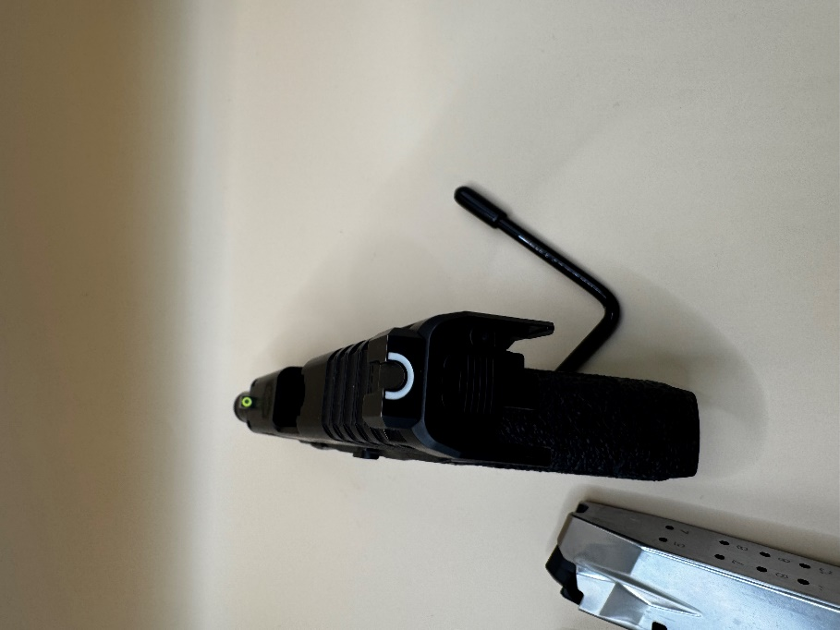

* 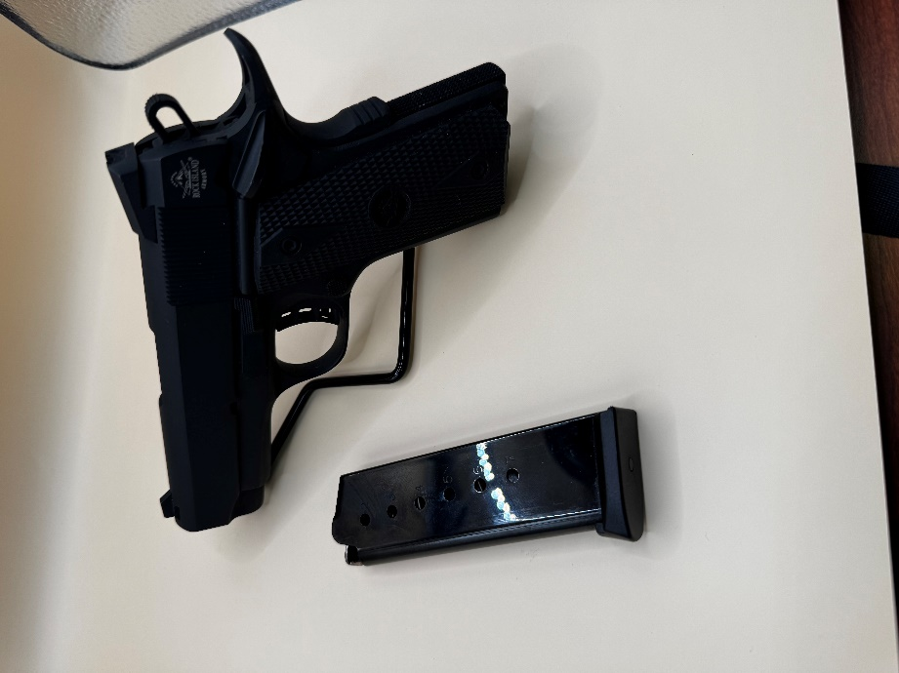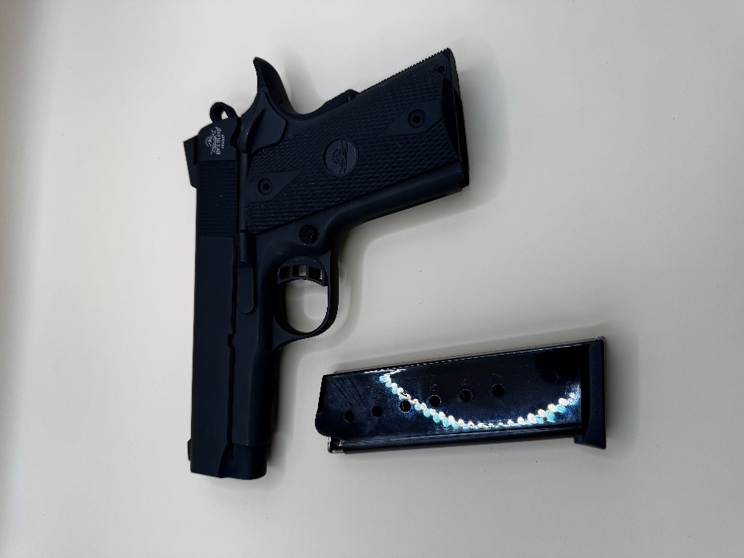**Rock Island Armory 1911 Tactical Compact, .45 ACP, 3.5" Barrel, 7+1rds = $350 (JRFEX-4)**

*Comes with x1-7rd. mag, has 20 rounds shot through it.*

*Included is the original case, manual, and the factory warranty will transfer to new owner.*

* 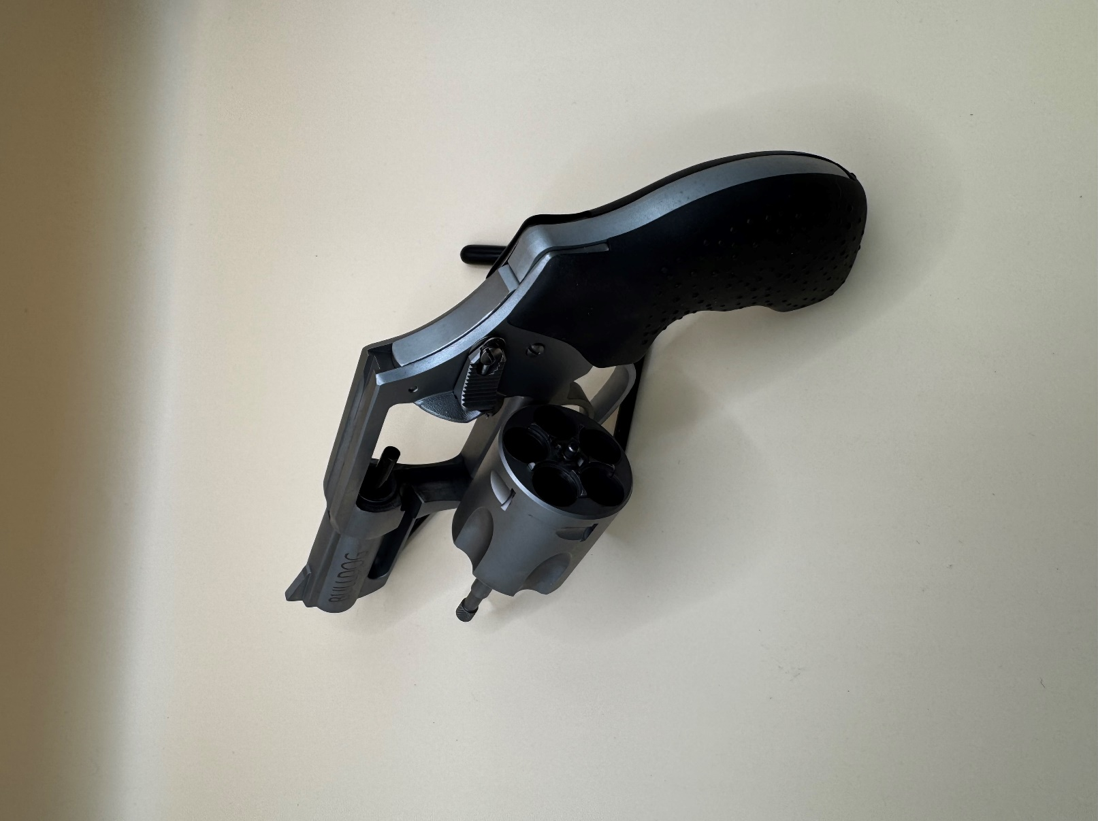**Charter Arms Bulldog, Revolver, .44 Special, Hammerless = $ 300 (JRFEX-5)**

**Specifications:**

* Caliber: .44 Special
* **Action: Revolver (double action only)**
* Capacity: 5
* **Barrel length: 2.5"**
* Frame: Stainless steel
* **Grips: Full rubber**
* Sights: Fixed
* **Overall weight: 21 ozs.**

*Has 15 rounds shot through it.*

*Included is the original case, manual, and the factory warranty will transfer to new owner.*

***Charter Arms® Bulldog .44 Special Snubnose Revolver. Personal protection and concealed carry excellence in a true powerhouse.***

***If you're looking for a safe, reliable revolver powerful enough for serious home protection but with the size and functionality for effective concealed carry Charter®'s .44 Special is an outstanding double-duty choice for the job.****Don't leave home without it.*

***Bulldog .44 Special Snubnose Revolver special features:***

* *Barrel is threaded into frame for added strength*
* ***Fewer internal parts for better reliability***
* *No side plate means a more powerful frame*
* ***Strong frame locks cylinder yoke into place other revolvers use a small retention screw, which can loosen***
* *4-point cylinder lock-up encompasses the collar, crane, cylinder stop, and hand*
* ***Full hammer block safety system: trigger must be in full firing position before hammer falls***
* ***Backed by Charter's lifetime warranty.***